Additional file 1
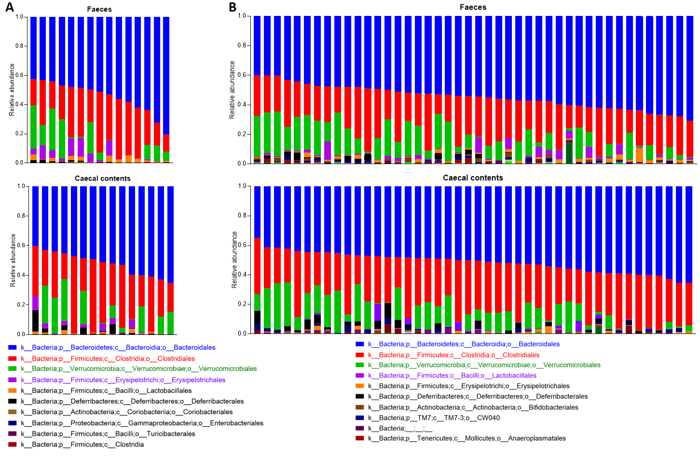

Figure S1. Similar bacterial components in the faecal and caecal microbiomes. Phylogenetic composition of faecal and caecal microbiomes at the order level when tumours reached (A) 50 mm³ (n = 15) and (B) 350 mm³ (n = 44). Samples were collected from faeces and caecal contents, and sorted by Bacteroidales proportion.

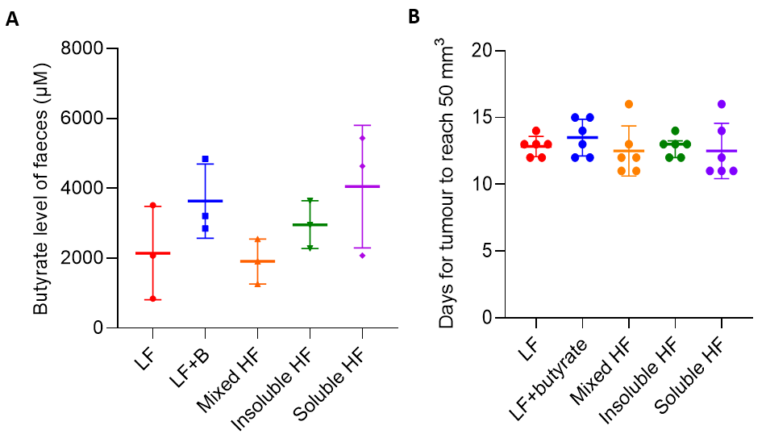
Figure S2. Faecal butyrate levels and time taken for tumours to reach 50 mm³. (A) Butyrate levels in the faeces at the time of culling. (B) All mice were culled when tumours reached 50 mm³, between 11 to 16 days after tumour inoculation, mean 12.8 (SD ± 1.4) days.

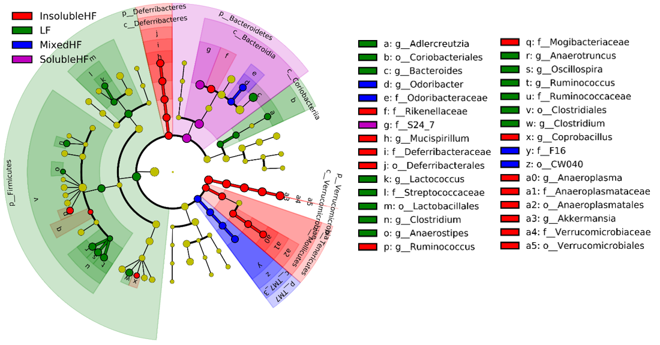
Figure S3. Differences in composition of the gut microbiome when tumours reached 350 mm³. Taxonomic cladogram from LEfSe showing differences in bacterial taxa at the genus level in the IR cohort when the tumours reached 350 mm³. The low fibre diet increased Adlercreutzia, Coriobacteriales, Bacteroides, Lactococcus, Streptococcaceae, Lactobacillales, Oscillospira, Ruminococcus, Ruminococcaceae, Clostridiales, Clostridium, the high mixed fibre increasing Odoribacter, Odoribacteraceae, F16, CW040, the high insoluble fibre diet increased Rikenellaceae, Mucispirillum, Deferribacteraceae, Deferribacterales, Ruminococcus, Mogibacteriaceae, Coprobacillus, Anaeroplasma, Anaeroplasmataceae, Anaeroplasmatales, Akkermansia, Verrucomicrobiaceae, Verrucomicrobiales, and the high soluble fibre diet increased S24-7.

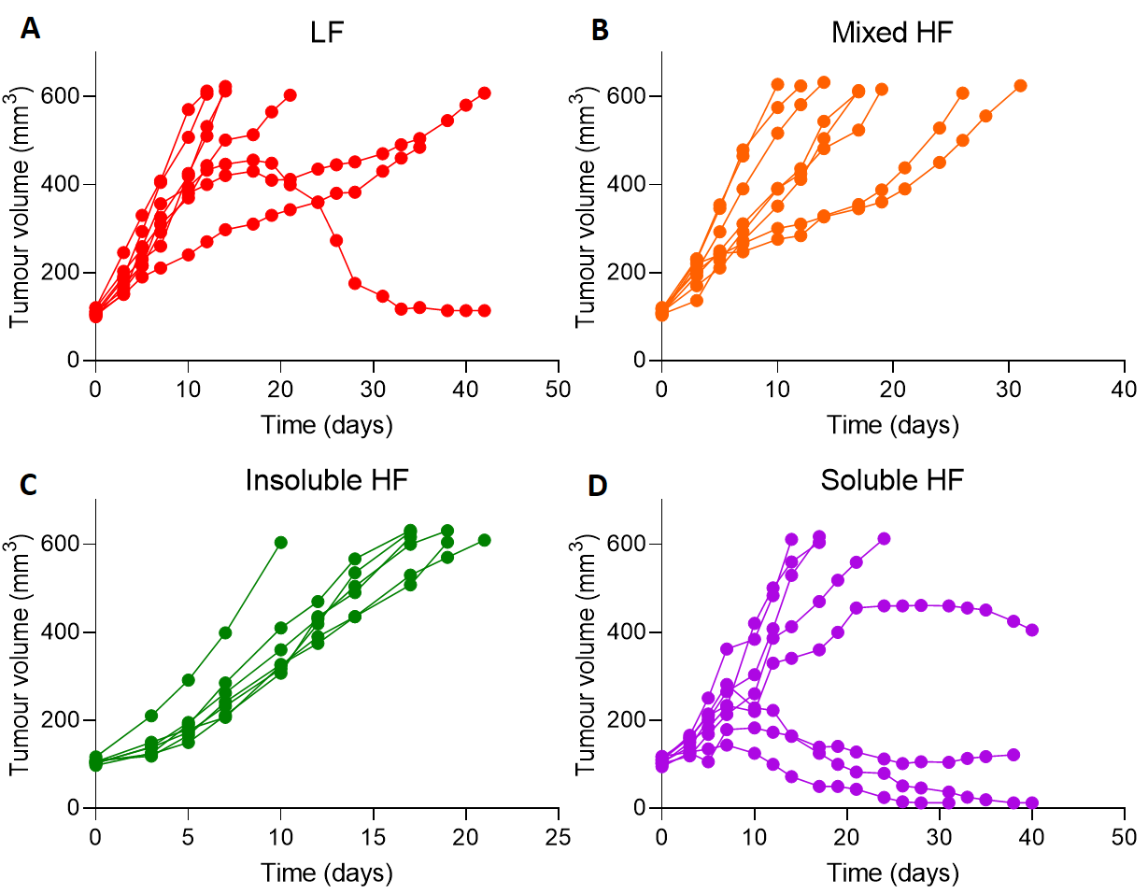

Figure S4. Individual mouse tumour growth curves. Tumour growth in RT112 flank xenografts irradiated with 6 Gy IR, in mice fed low fibre (A), high mixed fibre (B), high insoluble fibre (C) and high soluble fibre diets (D) (n = 8 for each group).

Figure S5. Cell survival analysis of RT112 bladder tumour cells treated with SCFAs and bacterial supernatants. (A) Inhibition of cell viability of RT112 cells single SCFA and combined SCFAs mixture in a time-dependent manner (N=3). The combined SCFAs denote the mixtures of 10 mM butyrate, 10 mM propionate, 10 mM butyrate for the left-hand graph and the mixtures of 10 mM butyrate, 5 mM propionate, 1.7 mM butyrate for the right-hand graph. (B) Reduced cell survival of RT112 cells by bacterial supernatants at day 3 (N=1). BA+LP denotes the cross-feeding of B. acidifaciens and L. plantarum, while Bif+LP denotes the cross-feeding of Bifidobacterium and L. plantarum. *P<0.05; **P<0.01; ***P<0.001.

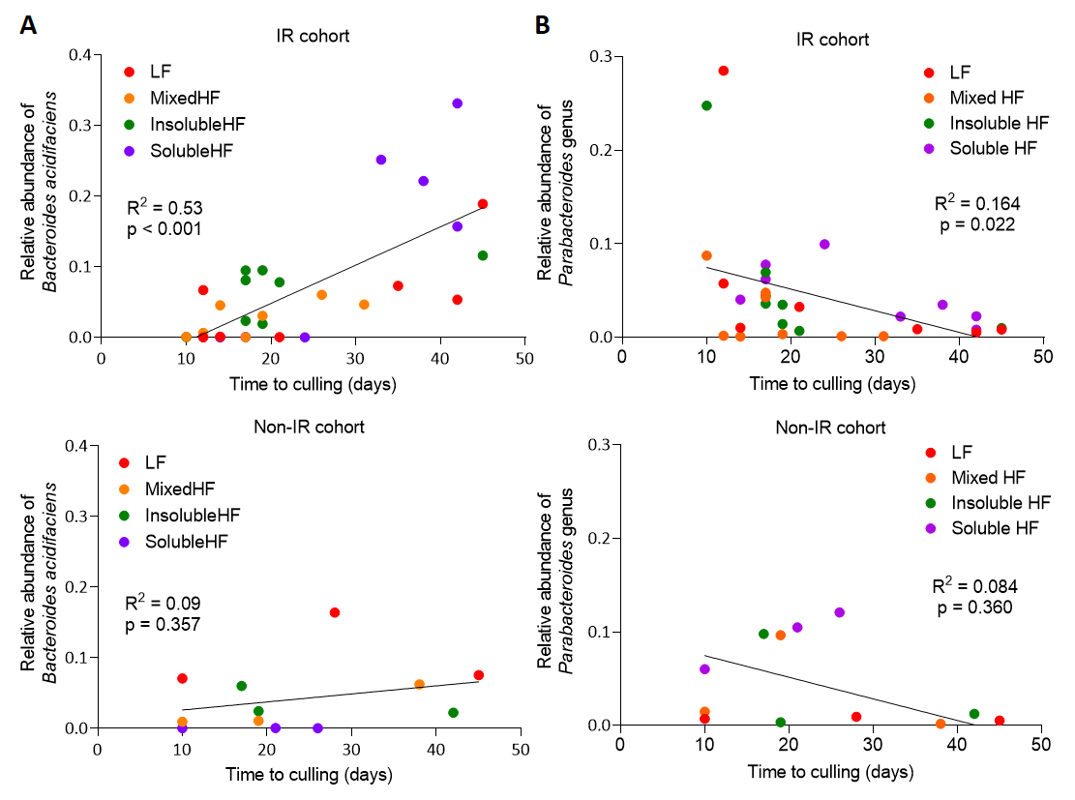

Figure S6. Correlation of time to culling with B. acidifaciens or Parabacteroides genus abundance different groups. (A) Correlation between time of culling versus (A) B. acidifaciens abundance (IR cohort, R² = 0.53, p < 0.001; Non-IR cohort, R² = 0.09, P = 0.357) or Parabacteroides genus abundance (IR cohort, R² = 0.164, P = 0.022; Non-IR cohort, R² = 0.084, P = 0.360) in the gut microbiome.

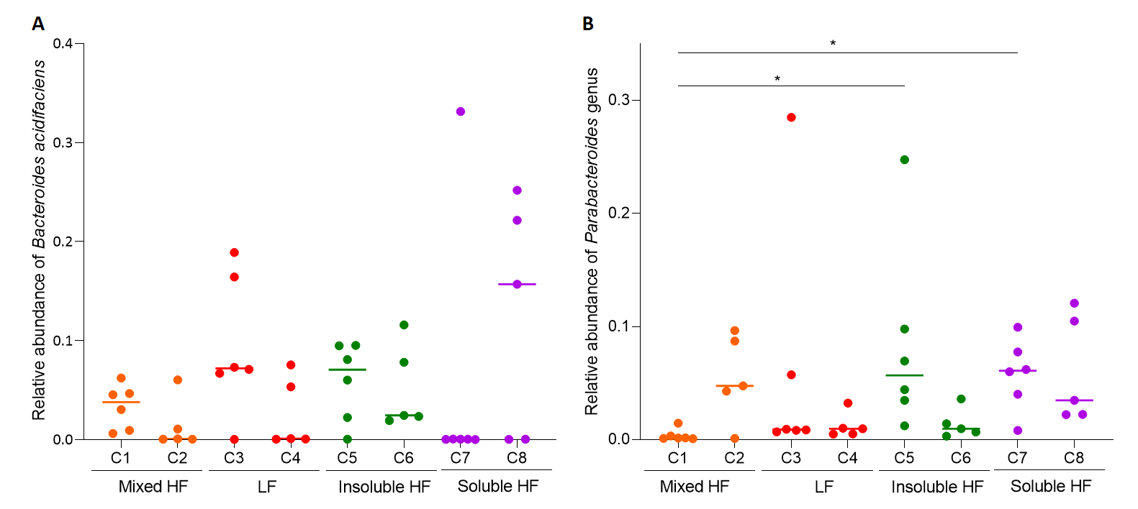
Figure S7. Effect of cage location of mice on relative abundance of B. acidifaciens and Parabacteroides genus. Comparison of (A) B. acidifaciens (p=0.200) or (B) Parabacteroides genus (p=0.005) abundance among mice from cage 1 (C1) to cage 8 (C8) by Kruskal-Wallis test.

Table S1. Rodent diets used in the study with varying levels of cellulose or inulin per 4000 kcal.
 | Low fibre |  |  | High insoluble fibre |  | High soluble fibre |  | High mixed fibre
 | 2 gm Cellulose/3850kcal |  |  | 100 gm Cellulose/3850kcal |  | 100 gm Inulin/3850kcal |  | 50 gm Cellulose  + 50 gm Inulin/3850kcal
 | gm% | kcal% |  | gm% | kcal% | gm% | kcal% | gm% | kcal%
Protein | 21 | 20 |  | 19 | 20 | 20 | 20 | 20 | 20
Carbohydrate | 67 | 64 |  | 61 | 64 | 59 | 60 | 60 | 62
Fat | 7 | 16 |  | 7 | 16 | 7 | 16 | 7 | 16
Total |  | 100 |  |  | 100 |  | 96 |  | 96
kcal/gm | 4.20 |  |  | 3.81 |  | 3.95 |  | 3.88
Ingredient | gm | kcal |  | gm | kcal | gm | kcal | gm | kcal
Casein | 200 | 800 |  | 200 | 800 | 200 | 800 | 200 | 800
L-Cystein | 3 | 12 |  | 3 | 12 | 3 | 12 | 3 | 12
Corn starch | 397.486 | 1590 |  | 397.486 | 1590 | 359.986 | 1440 | 378.736 | 1515
Maltodextrin 10 | 132 | 528 |  | 132 | 528 | 132 | 528 | 132 | 528
Sucrose | 100 | 400 |  | 100 | 400 | 100 | 400 | 100 | 400
Cellulose, BM200 | 2 | 0 |  | 100 | 0 | 0 | 0 | 50 | 0
Inulin | 0 | 0 |  | 0 | 0 | 100 | 0 | 50 | 75
Soybean oil | 70 | 630 |  | 70 | 630 | 70 | 630 | 70 | 630
t-Butylhydroquinone | 0.014 | 0 |  | 0.014 | 0 | 0.014 | 0 | 0.014 | 0
Mineral mix S10022G | 35 | 0 |  | 35 | 0 | 35 | 0 | 35 | 0
Vitamin mix V10037 | 10 | 40 |  | 10 | 40 | 10 | 40 | 10 | 40
Choline bitartrate | 2.5 | 0 |  | 2.5 | 0 | 2.5 | 0 | 2.5 | 0
Total | 952 | 4000 |  | 1050 | 4000 | 1012.5 | 4000 | 1031.25 | 4000
Total Cellulose (gm/kg diet) | 2.1 |  |  | 95.2 |  | 0 |  | 48.5
Inulin (gm/kg diet) | 0 |  |  | 0 |  | 98.8 |  | 48.5

Table S2. Details mouse diets, cages, B. acidifaciens relative abundance and time of culling
Diet | Low fibre
Cage | 3 |  |  |  |  |  | 4
ID | C3.3 | C3.1 | C3.10 | C3.30 | C3.NM | C3.4 | C4.10 | C4.1 | C4.NM | C4.30 | C4.3
IR/Non-IR | Non-IR | IR | IR | IR | IR | Non-IR | Non-IR | IR | IR | IR | IR
B.acidifaciens abundance | 0.164 | 0.000 | 0.067 | 0.189 | 0.073 | 0.071 | 0.075 | 0.000 | 0.053 | 0.001 | 0.001
Parabacteroides genus abundance | 0.009 | 0.285 | 0.057 | 0.008 | 0.009 | 0.007 | 0.005 | 0.032 | 0.005 | 0.010 | 0.010
Time for tumour to treble in volume | 17 | 6 | 6 | 6 | 14 | 5 | - | 9 | 8 | 7 | 8
Time to culling (days) | 28 | 12 | 12 | 45 | 35 | 10 | 45 | 21 | 42 | 14 | 14
Diet | Mixed high fibre
Cage | 1 |  |  |  |  |  | 2
ID | C1.NM | C1.10 | C1.3 | C1.1 | C1.30 | C1.4 | C2.10 | C2.NM | C2.3 | C2.30 | C2.1
IR/Non-IR | IR | IR | IR | Non-IR | Non-IR | IR | IR | IR | IR | Non-IR | IR
B.acidifaciens abundance | 0.045 | 0.030 | 0.047 | 0.009 | 0.062 | 0.006 | 0.001 | 0.000 | 0.000 | 0.011 | 0.060
Parabacteroides genus abundance | 0.001 | 0.003 | 0.001 | 0.015 | 0.002 | 0.002 | 0.087 | 0.048 | 0.043 | 0.096 | 0.001
Time for tumour to treble in volume | 6 | 7 | 10 | 4 | - | 5 | 5 | 9 | 7 | 7 | 14
Time to culling (days) | 14 | 19 | 31 | 10 | 38 | 12 | 10 | 17 | 17 | 19 | 26
Diet | Insoluble high fibre
Cage | 5 |  |  |  |  |  | 6
ID | C5.3 | C5.30 | C5.1 | C5.10 | C5.NM | C5.4 | C6.NM | C6.1 | C6.3 | C6.30 | C6.10
IR/Non-IR | Non-IR | IR | Non-IR | IR | IR | IR | IR | IR | IR | IR | Non-IR
B.acidifaciens abundance | 0.060 | 0.081 | 0.022 | 0.095 | 0.001 | 0.095 | 0.019 | 0.023 | 0.078 | 0.116 | 0.024
Parabacteroides genus abundance | 0.098 | 0.069 | 0.012 | 0.035 | 0.248 | 0.044 | 0.014 | 0.036 | 0.007 | 0.010 | 0.003
Time for tumour to treble in volume | 6 | 8 | 20 | 8 | 6 | 10 | 10 | 10 | 10 |  | 11
Time to culling (days) | 17 | 17 | 42 | 19 | 10 | 17 | 19 | 17 | 21 | - | 19
Diet | Soluble high fibre
Cage | 7 |  |  |  |  |  | 8
ID | C7.1 | C7.10 | C7.3 | C7.NM | C7.30 | C7.4 | C8.NM | C8.1 | C8.10 | C8.3 | C8.30
IR/Non-IR | Non-IR | IR | IR | IR | IR | IR | IR | Non-IR | IR | IR | Non-IR
B.acidifaciens abundance | 0.000 | 0.000 | 0.000 | 0.001 | 0.331 | 0.000 | 0.221 | 0.000 | 0.252 | 0.157 | 0.000
Parabacteroides genus abundance | 0.060 | 0.078 | 0.099 | 0.062 | 0.008 | 0.040 | 0.035 | 0.105 | 0.022 | 0.022 | 0.121
Time for tumour to treble in volume | 6 | 10 | 11 | 9 | 12 | 7 | - | 7 | - | - | 12
Time to culling (days) | 10 | 17 | 24 | 17 | 42 | 14 | 38 | 21 | 33 | 42 | 26

