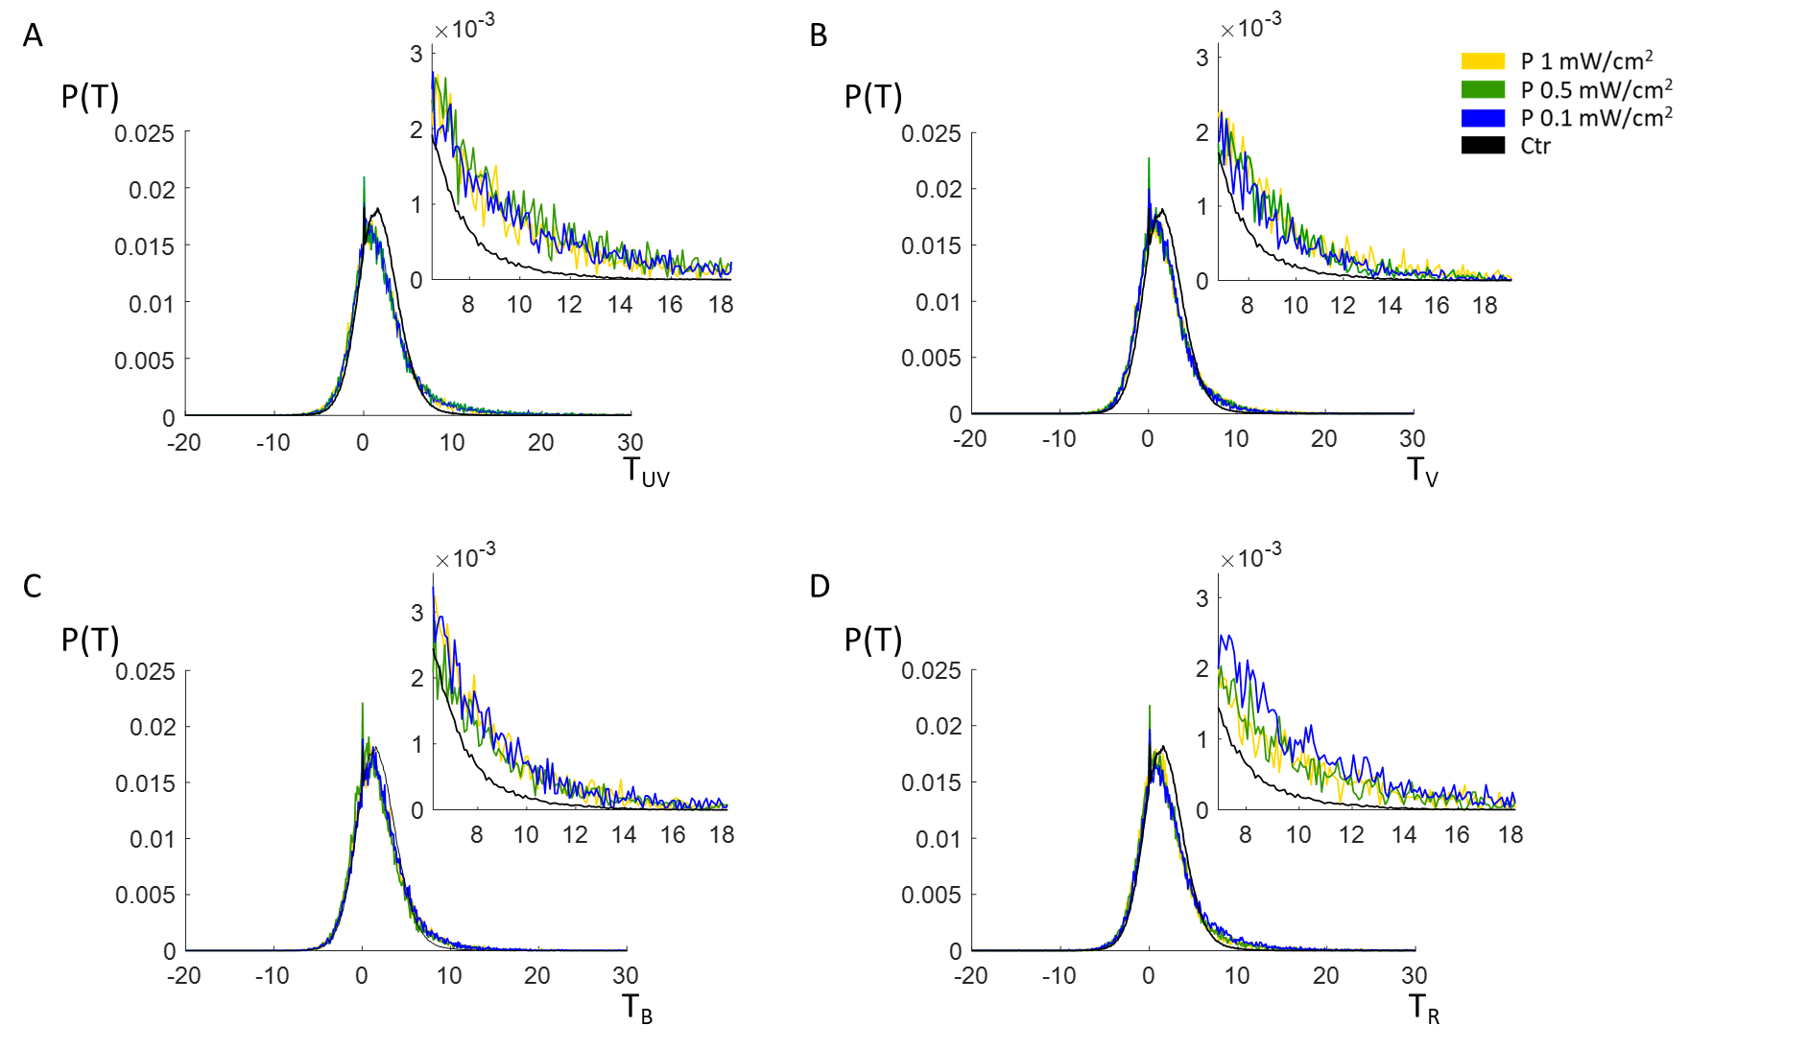

Additional file 8: Figure S8. T distributions at different stimulus intensities for stimulated and control larvae at 5 dpf. Normalized T distributions obtained at three different stimulus intensities (1 mW/cm², 0.5 mW/cm², 0.1 mW/cm², yellow, green and blue traces, respectively; see legend) compared with control (black trace). T distributions are shown in linear scale and are reported for each stimulus (A, L₁; B, L₂; C, L₃; D, L₄). The insets on the left are enlarged views of the graphs.

