Fig S1. The statistics of miRNAs.
A. The number of known and novel miRNAs (miRs) in six miRNA libraries of larval beetles. B. The number of miRNAs which are up-regulated and down-regulated after low temperature acclimation. Control (25 ℃); AC, low temperature acclimation (4 ℃).

Fig S2. Validation of the expression of down-regulated miRNAs after cold acclimation by qPCR.
The data are shown as mean ± s.e.m. Student’s t-test with two-tailed was used to test the different significance, *P < 0.05, **P < 0.01, ***P < 0.001. Control (25 ℃); AC, low temperature acclimation (4 ℃).

Fig S3. Phylogenetic tree of ACOXs and the predicted sites of Mal-miR-31-5p.
A. Maximum-likelihood (ML) phylogeny based on protein sequences of ACOXs from Homo sapiens (Hsa), Mus musculus (Mmu), Drosophila melanogaster (Dme), C. elegans (Cel) and Monochamus alternatus (Mal).The ML tree was constructed using Mega 6 with default settings and 1000 bootstrap replicates. Multiple sequence alignment was conducted using ClustalW2.0 with default setting. Mal-ACOX1 is a target of miR-31-5p in M. alternatus. B. The putative target sites of Mal-miR-31-5p in acox1 genes from different animals using RNAhybrid. C. The relative position of target site of Mal-miR-31-5p on acox1 genes in different species. The gene structures were illustrated by IBS 1.0.1.

Fig S4. The amount of asc-C9 after cold acclimation in both laboratory and field.
A. The concentration of asc-C9 in control (25 ℃) and low temperature acclimation (AC, 4 ℃) larval beetles in laboratory (n = 8). Student’s t test was used for the significance analysis, ***P < 0.001. The beetles used in this experiment were collected at 15 Oct. 2017. B. The concentration of asc-C9 from October to December in field.

Fig S5. The effect of Asc-△C6 (negative control) on beetle cold hardiness.
A. The effect of asc-△C6 on the supercooling points (SCPs) of the last instar larval beetles (n = 20). B. The effect of asc-△C6 on mortality of the last instar larval beetles (n = 10 for each treatment). Lethal temperature causing 50% mortality (LT50) was determined by probit regression. The data in A and B are shown as mean ± s.e.m. Student’s t-test with two-tailed was used to test the different significance. △C6, asc-△C6 fed beetles; Control beetles. The last larval beetles used in A and B were collected at 20-25 Oct. 2019.

Fig S6. The expression of cryoprotectants related genes after asc-C9 treatment.
A. The number differently expressed genes (DEGs) between control and asc-C9 fed beetles in RNA-seq. B. The number of genes in the significantly enriched processes (P < 0.05). C. Hierarchical clustering of the expression of the genes related to the synthesis and metabolism of these three cryoprotectants based on RNA-seq (n = 3).
D. qPCR of the genes in the pathway of the synthesis and metabolism of the three cryoprotectants (n = 6). The data were shown as mean ± s.e.m. Student’s t-test with two-tailed was used to test the different significance. *P < 0.05; **P < 0.01; ***P < 0.001. Genes legends: Tpp, trehalose-phosphate phosphatase; Gp, glycogen phosphorylase; A1e, aldose-1-epimerase; Akr, aldo-keto reductase; Pgk, phosphoglycerate kinase; Gpi, glucose-6-phosphate isomerase; Pfk, 6-phospho-fructokinase; Suc, succinyl-CoA ligase; Eno, enolase; Idh, isocitrate dehydrogenase; FBPase, fructose-1,6-bisphosphatase; Pgm, phosphoglycerate mutase; G1P, glucose-1-phosphate; GAP, glyceraldehyde-3-phosphate.

Fig S7. The expression of mRNA and protein of acox1 after RNAi.

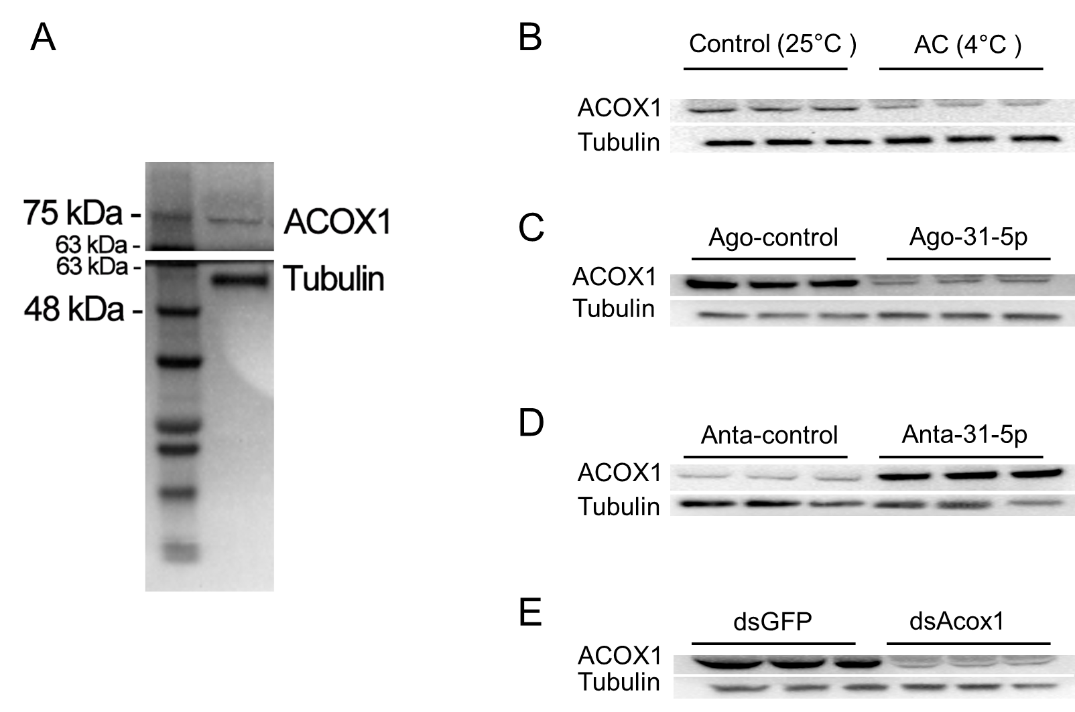
Fig S8. The original western blot figures in this study.
A. The size of ACOX1 (about 75 kDa) and Tubulin (about 56 kDa) in M. alternatus. B, C, D and E. The original western blot figure of ACOX1 and Tubulin after cold acclimation (4 °C) (B), injection of agomir-31-5p (C) and antagomir-31-5p (D), and RNAi (E). They were cropped and correspond to Figure 4A, 4B, 4C and Figure S7, respectively. The last larval beetles used in A, B and D were all collected at 10-15 Nov. 2017, while beetles in C and E were collected at 5 Oct. 2017.

