Additional file 1 for
Potential role of horizontally acquired antibacterial genes in the adaptive radiation of ladybird beetles

Hao-Sen Li^{1#}, Xue-Fei Tang^{1#}, Yu-Hao Huang^{1#}, Ze-Yu Xu¹, Mei-Lan Chen^{1,2}, Xue-Yong Du¹, Bo-Yuan Qiu¹, Pei-Tao Chen¹, Wei Zhang¹, Adam Ślipiński³, Hermes E. Escalona³, Robert M. Waterhouse⁴, Andreas Zwick³, Hong Pang¹*

1 State Key Laboratory of Biocontrol, School of Life Sciences / School of Ecology, Sun Yat-sen University, Guangzhou 510275, China
2 School of Environment and Life Science, Nanning Normal University, Nanning 530001, China
3 Australian National Insect Collection, CSIRO, GPO Box 1700, Canberra ACT 2601, Australia
4 Department of Ecology and Evolution, University of Lausanne and Swiss Institute of Bioinformatics, 1015 Lausanne, Switzerland
# theses authors contributed equally to this work
* corresponding author: Hong Pang
Email: lsshpang@mail.sysu.edu.cn

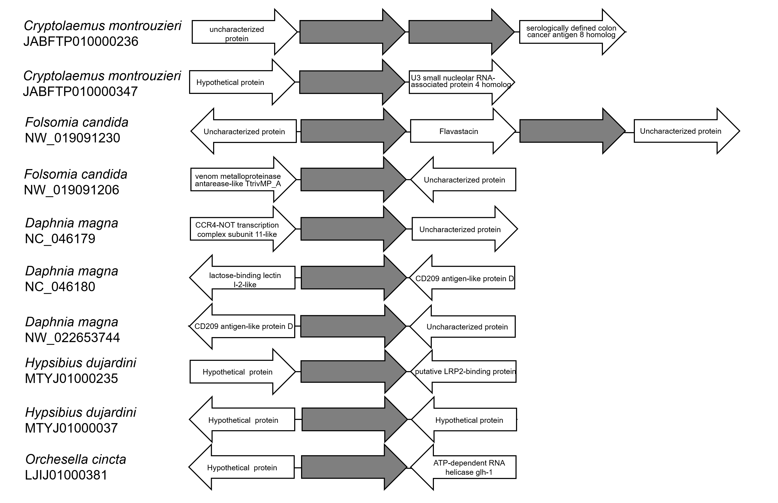
Figure S1 Flanking genes of the eukaryotic cwh genes predicted from five high-quality genomes. The contigs/scaffolds containing putative eukaryotic cwh genes are shown. The cwh genes are coloured in grey. BLAST searches suggests that these flanking genes are closely related to eukaryotic genes.

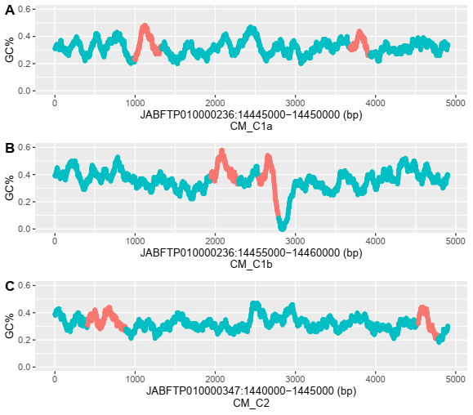
Figure S2 Guanine-Cytosine contents (GC%) (100 bp sliding window) of cwh coding sequences (red) of the ladybird Cryptolaemus montrouzieri (A: CM-C1a; B: CM-C1b; C: CM-C2) are compared to their introns and flanking sequences (blue).

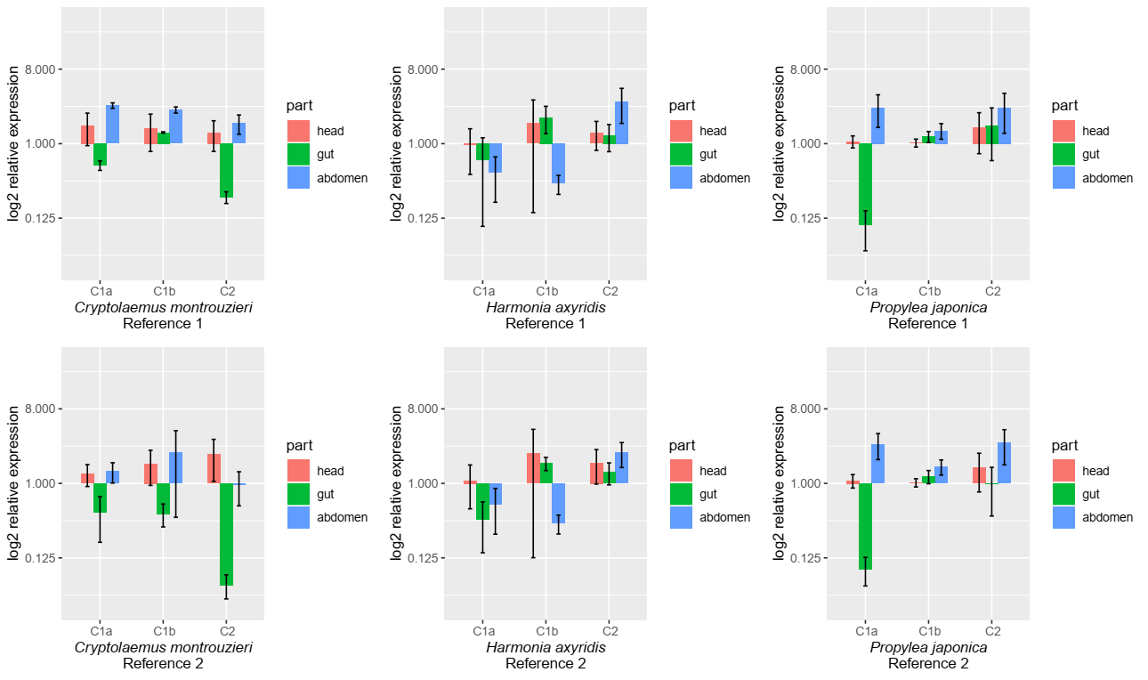
Figure S3 Spatial expression of ladybird cwh genes. The expression patterns of cwh genes (C1a, C1b and C2, or C1 and C2) in different body parts were tested in Cryptolaemus montrouzieri, Harmonia axyridis and Propylea japonica. Expression levels of cwh were normalized to those of two reference genes (see details of reference genes in Table S2). Relative expression of each cwh gene in comparison to the average level of that gene in head was analyzed by the 2^{-ΔΔCt} method to calculate the fold changes. Error bars show ± standard errors with five biological replicates. No significant difference between treatments (p <0.05) was detected.

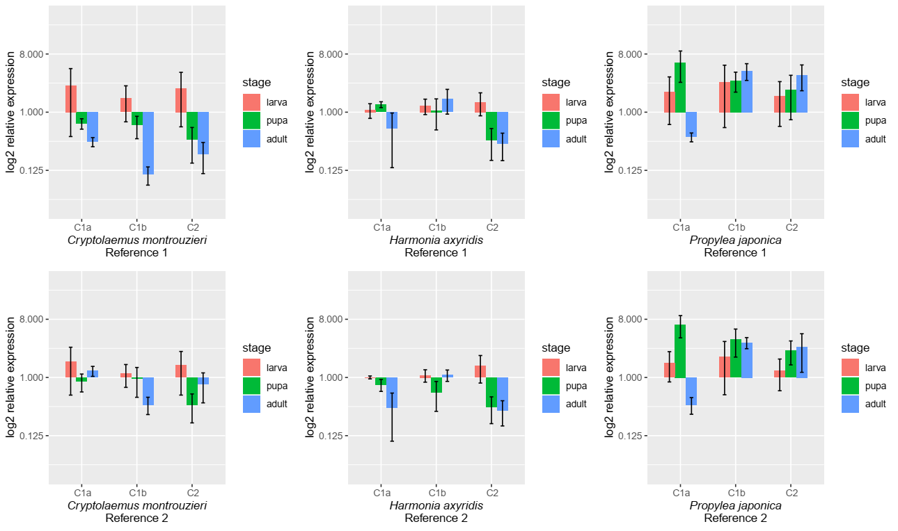
Figure S4 Temporal expression of ladybird cwh genes. The expression patterns of cwh genes in different life stages were tested in Cryptolaemus montrouzieri, Harmonia axyridis and Propylea japonica. Expression levels of cwh were normalized to those of two reference genes (see details of reference genes in Supplementary Table 2). Relative expression of each cwh gene in comparison to the average level of that gene in larva was analyzed by the 2^{-ΔΔCt} method to calculate the fold changes. Error bars show ± standard errors with five biological replicates. No significant difference between treatments (p <0.05) was detected.

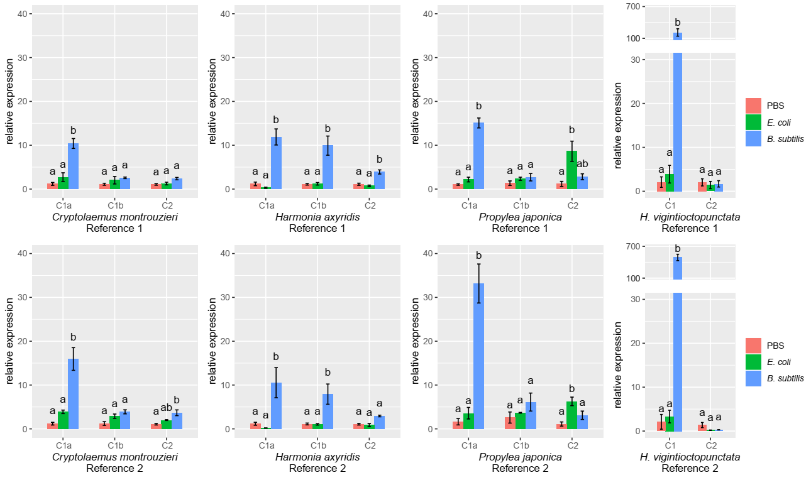
Figure S5 Evidence of the antibacterial activity of ladybird cwh genes: upregulation of cwh in response to bacterial infection. The expression patterns of cwh genes (C1a, C1b and C2, or C1 and C2) in response to bacterial infection (E. coli and B. subtilis) were tested in Cryptolaemus montrouzieri, Harmonia axyridis, Propylea japonica and Henosepilachna vigintioctopunctata. PBS treatments were used as control. Expression levels of cwh were normalized to those of two reference genes (see details of two reference genes in Supplementary Table 2). Relative expression of each cwh gene in comparison to the average level of that gene in PBS treatment was analyzed by the 2^{-ΔΔCt} method to calculate the fold changes. Error bars show ± standard errors with five biological replicates. Bars with the same letter are not significantly different (p ≥0.05).

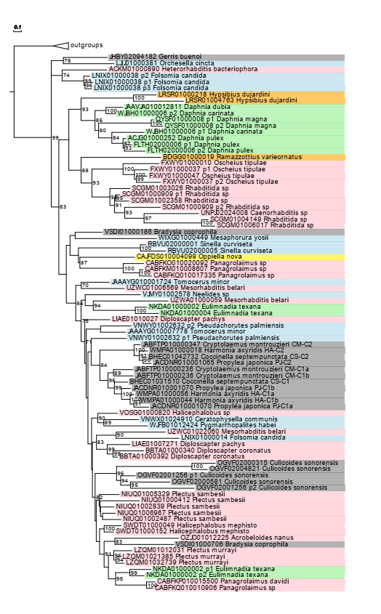
Figure S6 The phylogenetic tree of eukaryotic cwh genes identified from NCBI whole genome shotgun (WGS) assemblies. Redundancy at 90% identity at the protein level between sequences was eliminated using CD-HIT. Sequences containing stop codon were also removed from analysis. The tree was reconstructed by the maximum likelihood method and rooted by the representative bacterial cwh genes. Only node supports >70 are shown. Contig/scaffold and species names of genes are colour-coded according to taxonomic group of organisms (Pink: Nematoda; orange: Tardigrada; yellow: Chelicerata; blue: Branchiopoda; green: Collembola; grey: Insecta).

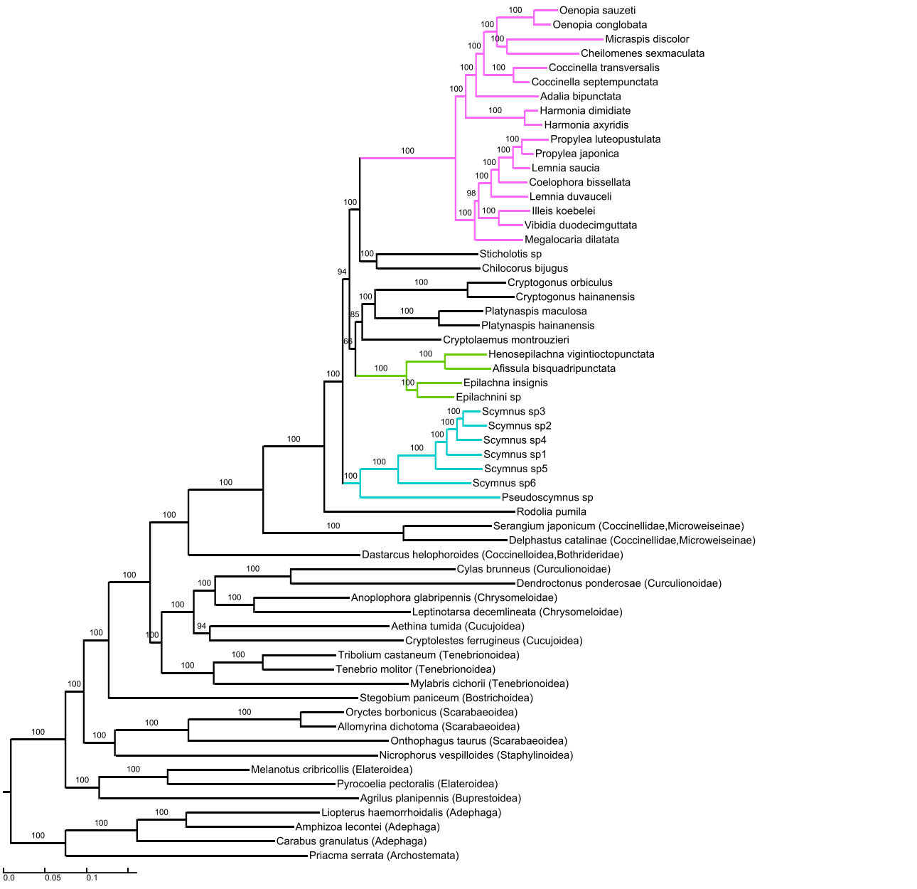
Figure S7 Phylogenetic tree of Coccinellidae and their Coleoptera outgroups reconstructed by 819 single-copy genes and maximum likelihood method. Node supports represent bootstrap values. Three major monophyletic clades of Coccinellinae include Coccinellini (red), Epilachini (green) and Scymnini (blue) are colour-coded.

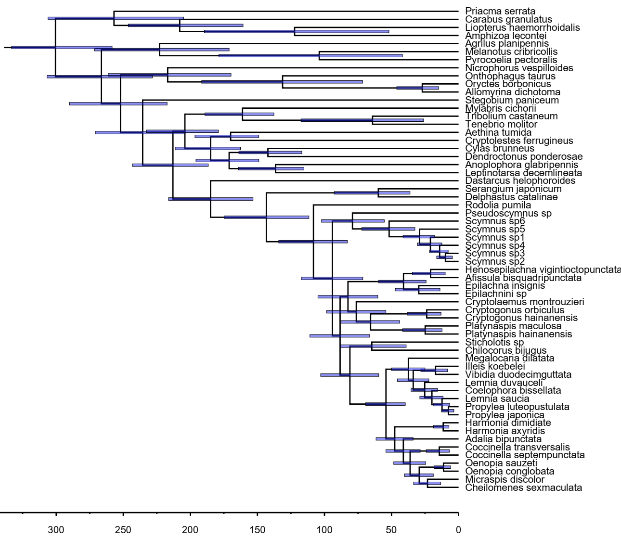
Figure S8 Phylogenetic tree of Coccinellidae and their Coleoptera outgroups reconstructed by 819 single-copy genes and maximum likelihood method. Divergence time was estimated using MCMCTREE method and 12 fossils for calibration. Horizontal bars represent 95% confidence intervals.

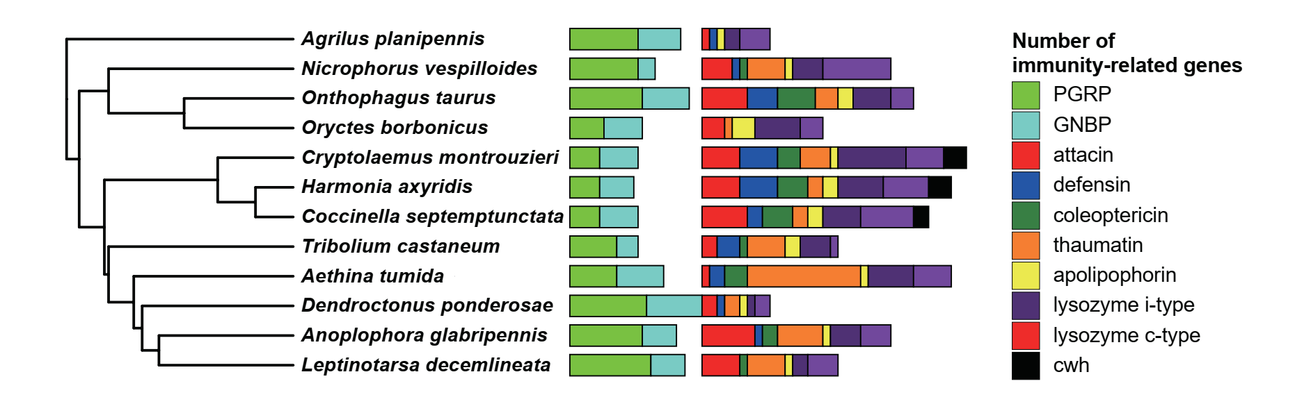
Figure S9 Number of immunity-related genes involving in bacteria recognition (left) and defense execution (right) in the published Coleoptera genomes [18, 19, 28, 48-54]. Species phylogenetic tree was adapted from Mckenna et al. 2019 [19].

Table S1 The cwh genes from ladybird genomes (G) or transcriptomes (T) for analyses of genome characteristics (GENO), expression in different body parts (PART) and developmental stages (STAGE), expression during bacterial infection by injection (INJECT), recombinant expression (EXPRE), antibacterial activity (ANTIB) and RNAi strain construction (RNAI).
Species | G/T | Gene | Gene ID | GENO | PART | STAGE | INJECT | EXPRE | ANTIB | RNAI
Cryptolaemus  montrouzieri | G, T | cwh1 | CM-C1a | Done | Done | Done | Done | Done | Done | Done
Cryptolaemus  montrouzieri | G, T | cwh1 | CM-C1b | Done | Done | Done | Done | - | - | Done
Cryptolaemus  montrouzieri | G, T | cwh2 | CM-C2 | Done | Done | Done | Done | - | - | Done
Harmonia  axyridis | G, T | cwh1 | HA-C1a | Done | Done | Done | Done | - | - | -
Harmonia  axyridis | G, T | cwh1 | HA-C1b | Done | Done | Done | Done | Done | Done | -
Harmonia  axyridis | G, T | cwh2 | HA-C2 | Done | Done | Done | Done | - | - | -
Coccinella  septempunctata | G, T | cwh1 | CS-C1 | Done | - | - | - | - | - | -
Coccinella  septempunctata | G, T | cwh2 | CS-C2 | Done | - | - | - | - | - | -
Propylea  japonica | G, T | cwh1 | PJ-C1a | Done | Done | Done | Done | - | - | -
Propylea  japonica | G, T | cwh1 | PJ-C1b | Done | Done | Done | Done | - | - | -
Propylea  japonica | G, T | cwh2 | PJ-C2 | Done | Done | Done | Done | - | - | -
Henosepilachna  vigintioctopunctata | T | cwh1 | HV-C1 | - | - | - | Done | - | - | -
Henosepilachna  vigintioctopunctata | T | cwh2 | HV-C2 | - | - | - | Done | - | - | -

Table S2 Primers for ladybird cwh genes used for quantitative PCR (qPCR). Sequences are given for the forward (F) and reverse (R) primers and the annealing temperature used for PCR (Tm) with each primer pair.
Species | Gene ID | F/R | Primer sequence (5’ - 3’) | Tm
Cryptolaemus  montrouzieri | CM-C1a | F | GGCAGTAAAATCGGGAATGT | 55
Cryptolaemus  montrouzieri | CM-C1a | R | CGGAAGAAAGAGGAGCATC | 55
Cryptolaemus  montrouzieri | CM-C1b | F | TTTATGATGCTCCTCTTTCTGAT | 55
Cryptolaemus  montrouzieri | CM-C1b | R | AACTGGTGATTTCCGATTTTC | 55
Cryptolaemus  montrouzieri | CM-C2 | F | CAGTGAAAATGGACGATAAGG | 55
Cryptolaemus  montrouzieri | CM-C2 | R | TAATAACCCAAGCCACCCA | 55
Cryptolaemus  montrouzieri | Reference 1:  CM-RPS23 | F | ACAAGGGCTGCTGGACTGAT | 55
Cryptolaemus  montrouzieri | Reference 1:  CM-RPS23 | R | CCTTCGGAGGAAAGGCTTCA | 55
Cryptolaemus  montrouzieri | Reference 2:  CM-β-tubulin | F | CACGGAAGGTACTTGACTGTTG | 55
Cryptolaemus  montrouzieri | Reference 2:  CM-β-tubulin | R | GCTGCTGTTCTTGTTTTGGATG | 55
Harmonia  axyridis | HA-C1a | F | GTCTGTCGCCAACCTTACC | 60
Harmonia  axyridis | HA-C1a | R | TGGTCACAACCACCAGTAGG | 60
Harmonia  axyridis | HA-C1b | F | AACCGTCAACATTGGGGAGG | 60
Harmonia  axyridis | HA-C1b | R | CATTGCGACCATTCCAGCAC | 60
Harmonia  axyridis | HA-C2 | F | TGGGGAGGTAGCGTAATTGG | 60
Harmonia  axyridis | HA-C2 | R | GCTTGCTGGGGCATCATAGA | 60
Harmonia  axyridis | Reference 1:  HA-RPS13 | F | ACAGACGAAGTGTCCCAACA | 60
Harmonia  axyridis | Reference 1:  HA-RPS13 | R | CCTGAGCAACTCCAAGGGAAT | 60
Harmonia  axyridis | Reference 2:  HA-RPL28 | F | CAGAACCTAGCAACCTCACCA | 60
Harmonia  axyridis | Reference 2:  HA-RPL28 | R | AGGTCTCTGACAGACTACGGT | 60
Propylea  japonica | PJ-C1a | F | AGCCTTGACTGATAGAGAAA | 55
Propylea  japonica | PJ-C1a | R | GCTTCCACCCCAATAAGAC | 55
Propylea  japonica | PJ -C1b | F | ATGCTGGAATGATGGTGATA | 55
Propylea  japonica | PJ -C1b | R | TTTAGGATTGTTGTAATGATCGC | 55
Propylea  japonica | PJ-_C2 | F | TATTGGGTCTGTCTGTCGTA | 55
Propylea  japonica | PJ-_C2 | R | GCATTGGGGCATCATAAAT | 55
Propylea  japonica | Reference 1:  PJ-RPS18 | F | CGCTGGTGATTCCAGATAAA | 55
Propylea  japonica | Reference 1:  PJ-RPS18 | R | GACGACCTACACCTTTGATG | 55
Propylea  japonica | Reference 2:  PJ-EF1α | F | CTGGAAAGACCACAGAAGAAA | 55
Propylea  japonica | Reference 2:  PJ-EF1α | R | GAGGAGGGAATTCTTGGAAAG | 55
Henosepilachna  vigintioctopunctata | HV-C1 | F | GAATGGGTGGCTTGGGTGAT | 60
Henosepilachna  vigintioctopunctata | HV-C1 | R | CTAGGCTCAGTGACGTCGAA | 60
Henosepilachna  vigintioctopunctata | HV-C2 | F | GAACCTGTTGAGGGGCAGAT | 60
Henosepilachna  vigintioctopunctata | HV-C2 | R | CACCAATTTTGCTTCCACCC | 60
Henosepilachna  vigintioctopunctata | Reference 1:  HV-GADPH | F | ACTGCCGATGTTTCTGTTGT | 60
Henosepilachna  vigintioctopunctata | Reference 1:  HV-GADPH | R | GCTTCTTTGACTGCCTTTTTGA | 60
Henosepilachna  vigintioctopunctata | Reference 2:  HV-actin | F | CTCCGTGTAGCCCCAGAAG | 60
Henosepilachna  vigintioctopunctata | Reference 2:  HV-actin | R | GGTCATCTTTTCCCTGTTAGCC | 60

Table S3 Transcriptome data used for 1. study of transcriptome response of cwh-RNAi of Cryptolaemus montrouzieri and 2. detection of ladybird cwh genes and species phylogeny reconstruction.
Transcriptome response of cwh-RNAi
cwh RNAi-strain | Replicate | Species | SRA accession
CM-C1a-RNAi | R1 | Cryptolaemus montrouzieri | SRR11566201
CM-C1a-RNAi | R2 | Cryptolaemus montrouzieri | SRR11566200
CM-C1a-RNAi | R3 | Cryptolaemus montrouzieri | SRR11566199
CM-C1b-RNAi | R1 | Cryptolaemus montrouzieri | SRR11566206
CM-C1b-RNAi | R2 | Cryptolaemus montrouzieri | SRR11566205
CM-C1b-RNAi | R3 | Cryptolaemus montrouzieri | SRR11566202
CM-C2-RNAi | R1 | Cryptolaemus montrouzieri | SRR11566198
CM-C2-RNAi | R2 | Cryptolaemus montrouzieri | SRR11566197
CM-C2-RNAi | R3 | Cryptolaemus montrouzieri | SRR11566196
GFP control | R1 | Cryptolaemus montrouzieri | SRR11566195
GFP control | R2 | Cryptolaemus montrouzieri | SRR11566204
GFP control | R3 | Cryptolaemus montrouzieri | SRR11566203
Ladybird cwh detection and species phylogeny
Subfamily | Tribe | Species | SRA accession
Coccinellinae | Coccinellini | Oenopia sauzeti | SRR11576248
Coccinellinae | Coccinellini | Oenopia conglobata | SRR11576247
Coccinellinae | Coccinellini | Micraspis discolor | SRR11576236
Coccinellinae | Coccinellini | Cheilomenes sexmaculata | SRR11576225
Coccinellinae | Coccinellini | Coccinella transversalis | SRR11576220
Coccinellinae | Coccinellini | Coccinella septempunctata | SRR11576219
Coccinellinae | Coccinellini | Adalia bipunctata | SRR11576248
Coccinellinae | Coccinellini | Harmonia dimidiata | SRR11576218
Coccinellinae | Coccinellini | Harmonia axyridis | SRR9649801
Coccinellinae | Coccinellini | Propylea luteopustulata | SRR11576217
Coccinellinae | Coccinellini | Propylea japonica | SRR9649789
Coccinellinae | Coccinellini | Lemnia saucia | SRR11576216
Coccinellinae | Coccinellini | Coelophora bissellata | SRR11576215
Coccinellinae | Coccinellini | Lemnia duvauceli | SRR11576246
Coccinellinae | Psylloborini | Illeis koebelei | SRR11576245
Coccinellinae | Psylloborini | Vibidia duodecimguttata | SRR11576244
Coccinellinae | Coccinellini | Megalocaria dilatata | SRR11576243
Coccinellinae | Sticholotini | Sticholotis sp. | SRR11576242
Coccinellinae | Chilocorini | Chilocorus bijugus | SRR11576241
Coccinellinae | Aspidimerini | Cryptogonus orbiculus | SRR11576240
Coccinellinae | Aspidimerini | Cryptogonus hainanensis | SRR11576239
Coccinellinae | Platynaspini | Platynaspis maculosa | SRR11576238
Coccinellinae | Platynaspini | Platynaspis hainanensis | SRR11576237
Coccinellinae | Scymnini | Cryptolaemus montrouzieri | SRR2971116
Coccinellinae | Epilachnini | Henosepilachna vigintioctopunctata | SRR11576235
Coccinellinae | Epilachnini | Afissula bisquadripunctata | SRR11576234
Coccinellinae | Epilachnini | Epilachna insignis | SRR11576233
Coccinellinae | Epilachnini | Epilachnini sp. | SRR11576232
Coccinellinae | Scymnini | Scymnus sp3 | SRR11576231
Coccinellinae | Scymnini | Scymnus sp2 | SRR11576230
Coccinellinae | Scymnini | Scymnus sp4 | SRR11576229
Coccinellinae | Scymnini | Scymnus sp1 | SRR11576228
Coccinellinae | Scymnini | Scymnus sp5 | SRR11576227
Coccinellinae | Scymnini | Scymnus sp6 | SRR11576226
Coccinellinae | Scymnini | Pseudoscymnus sp. | SRR11576224
Coccinellinae | Noviini | Rodolia pumila | SRR11576223
Microweiseinae | Serangiini | Serangium japonicum | SRR11576222
Microweiseinae | Serangiini | Delphastus catalinae | SRR11576221
Coleoptera outgroups
Suborder | Superfamily | Species | Data source
Polyphaga | Coccinelloidea | Dastarcus helophoroides | SRR1201401
Polyphaga | Curculionoidae | Cylas brunneus | SRR3397644
Polyphaga | Curculionoidea | Dendroctonus ponderosae | OrthoDB 10
Polyphaga | Chrysomeloidae | Anoplophora glabripennis | OrthoDB 10
Polyphaga | Chrysomeloidae | Leptinotarsa decemlineata | OrthoDB 10
Polyphaga | Cucujoidea | Aethina tumida | OrthoDB 10
Polyphaga | Cucujoidea | Cryptolestes ferrugineus | ERR2260793
Polyphaga | Tenebrionoidea | Tribolium castaneum | OrthoDB 10
Polyphaga | Tenebrionoidea | Tenebrio molitor | SRR1291244
Polyphaga | Tenebrionoidea | Mylabris cichorii | SRR1996329
Polyphaga | Bostrichoidea | Stegobium paniceum | SRR1963786
Polyphaga | Scarabaeoidea | Oryctes borbonicus | OrthoDB 10
Polyphaga | Scarabaeoidea | Allomyrina dichotoma | SRR5837491
Polyphaga | Scarabaeoidea | Onthophagus taurus | OrthoDB 10
Polyphaga | Staphylinoidea | Nicrophorus vespilloides | OrthoDB 10
Polyphaga | Elateroidea | Melanotus cribricollis | SRR6286841
Polyphaga | Elateroidea | Pyrocoelia pectoralis | SRR5936558
Polyphaga | Buprestoidea | Agrilus planipennis | OrthoDB 10
Adephaga | Dytiscoidea | Liopterus haemorrhoidalis | SRR5892098
Adephaga | Dytiscoidea | Amphizoa lecontei | SRR5892093
Adephaga | Caraboidea | Carabus granulatus | SRR596983
Archostemata | Cupedoidea | Priacma serrata | SRR596769

Table S4 Information of the putative eukaryotic cwh genes detected from NCBI whole genome shotgun (WGS) assemblies. The protein sequence of cwh gene of Cryptolaemus montrouzieri (CM_C1a) was used as query to search against the dataset of NCBI whole genome shotgun (WGS) assemblies using tBLASTn. Eukaryotic hits with E-values lower than 10⁻¹⁰ and coverage >90% are considered as cwh homologs.
group | species | region | evalue | identity
Nematoda | Acrobeloides nanus | OZJO01012225.1:7645-7223 | 1.76E-29 | 44%
Nematoda | Acrobeloides nanus | OZJO01015288.1:16180-15782 | 2.57E-14 | 36%
Nematoda | Caenorhabditis sp. | UNPJ02017940.1:1427-1804 | 8.81E-17 | 37%
Nematoda | Caenorhabditis sp. | UNPJ02024008.1:598-975 | 8.89E-18 | 40%
Nematoda | Caenorhabditis sp. | UNPJ02025204.1:713-1090 | 2.88E-15 | 38%
Nematoda | Caenorhabditis sp. | UNPJ02025949.1:5822-5445 | 2.03E-17 | 40%
Nematoda | Caenorhabditis sp. | UNPJ02025949.1:6873-7250 | 1.03E-14 | 38%
Nematoda | Caenorhabditis sp. | UNPJ02027279.1:3243-2866 | 2.00E-16 | 39%
Nematoda | Diploscapter coronatus | BBTA01000340.1:29321-29701 | 9.06E-40 | 56%
Nematoda | Diploscapter coronatus | BBTA01000392.1:318628-319011 | 5.41E-43 | 60%
Nematoda | Diploscapter pachys | LIAE01007271.1:50106-50483 | 2.37E-43 | 60%
Nematoda | Diploscapter pachys | LIAE01010027.1:66919-67302 | 1.71E-51 | 64%
Nematoda | Halicephalobus mephisto | SWDT01000049.1:519338-519721 | 9.24E-49 | 64%
Nematoda | Halicephalobus mephisto | SWDT01000152.1:4033-4416 | 1.28E-49 | 65%
Nematoda | Halicephalobus mephisto | SWDT01000174.1:94091-94474 | 2.64E-49 | 63%
Nematoda | Halicephalobus sp. | VOSG01000820.1:8528-8911 | 6.21E-51 | 67%
Nematoda | Heterorhabditis bacteriophora | ACKM01000890.1:94162-93821 | 9.21E-26 | 50%
Nematoda | Mesorhabditis belari | UZWA01000059.1:689505-689368;  687137-686853 | 2E-17 | 50%
Nematoda | Mesorhabditis belari | UZWA01000803.1:11788-12078;  12265-12435 | 2.69E-12 | 54%
Nematoda | Mesorhabditis belari | UZWA01000997.1:11478-11266;  10963-10679 | 1.31E-23 | 54%
Nematoda | Mesorhabditis belari | UZWA01001084.1:17950-17624;  17433-17266 | 7E-10 | 38%
Nematoda | Mesorhabditis belari | UZWC01006569.1:19-420 | 6.70E-44 | 56%
Nematoda | Mesorhabditis belari | UZWC01007018.1:28-423 | 3.57E-24 | 44%
Nematoda | Mesorhabditis belari | UZWC01022060.1:19-432 | 1.35E-39 | 51%
Nematoda | Mesorhabditis belari | UZWC01027784.1:1006-1404 | 2.63E-31 | 45%
Nematoda | Micoletzkya japonica | UENP01006484.1:461-907 | 3.59E-22 | 39%
Nematoda | Oscheius sp. | LNBV01010190.1:1196-819 | 2.47E-17 | 37%
Nematoda | Oscheius sp. | LTAH01046216.1:9-335 | 3.67E-15 | 38%
Nematoda | Oscheius tipulae | FXWY01000010.1:1488323-1488712 | 8.27E-23 | 40%
Nematoda | Oscheius tipulae | FXWY01000037.1:171565-171284 | 4.61E-11 | 42%
Nematoda | Oscheius tipulae | FXWY01000037.1:175255-174812 | 1.38E-17 | 39%
Nematoda | Oscheius tipulae | FXWY01000037.1:175795-176181 | 1.39E-28 | 48%
Nematoda | Oscheius tipulae | FXWY01000047.1:60530-60928 | 1.83E-26 | 46%
Nematoda | Panagrolaimus davidi | CABFKP010008280.1:849-1226 | 4.57E-34 | 50%
Nematoda | Panagrolaimus davidi | CABFKP010015500.1:1143-1523 | 3.37E-44 | 63%
Nematoda | Panagrolaimus davidi | CABFKP010022085.1:889-512 | 3.99E-29 | 47%
Nematoda | Panagrolaimus sp. | CABFKM010001479.1:34-420 | 7.46E-50 | 61%
Nematoda | Panagrolaimus sp. | CABFKM010003694.1:392-45 | 2.86E-23 | 44%
Nematoda | Panagrolaimus sp. | CABFKM010008607.1:7328-6948 | 2.54E-31 | 48%
Nematoda | Panagrolaimus sp. | CABFKO010020092.1:2258-1941;  1928-1692 | 1.72E-21 | 46%
Nematoda | Panagrolaimus sp. | CABFKQ010010906.1:368-757 | 4.13E-47 | 60%
Nematoda | Panagrolaimus sp. | CABFKQ010017335.1:453-79 | 1.08E-27 | 43%
Nematoda | Plectus murrayi | LZQM01012031.1:453-836 | 2.51E-47 | 59%
Nematoda | Plectus murrayi | LZQM01021385.1:2656-3039 | 6.81E-49 | 63%
Nematoda | Plectus murrayi | LZQM01032739.1:171-557 | 2.40E-50 | 60%
Nematoda | Plectus sambesii | NIUQ01000412.1:48420-48803 | 8.71E-36 | 52%
Nematoda | Plectus sambesii | NIUQ01002487.1:1108-1488 | 5.26E-41 | 58%
Nematoda | Plectus sambesii | NIUQ01002839.1:7192-7560 | 2.55E-44 | 63%
Nematoda | Plectus sambesii | NIUQ01003208.1:9403-9789 | 4.23E-46 | 62%
Nematoda | Plectus sambesii | NIUQ01005329.1:2730-3110 | 3.59E-42 | 59%
Nematoda | Plectus sambesii | NIUQ01006967.1:5961-6347 | 4.16E-46 | 62%
Nematoda | Rhabditida sp. | SCGM01000909.1:6842-6468 | 2.76E-23 | 44%
Nematoda | Rhabditida sp. | SCGM01000909.1:9915-10286 | 7.50E-32 | 52%
Nematoda | Rhabditida sp. | SCGM01002358.1:5142-4768 | 5.46E-31 | 49%
Nematoda | Rhabditida sp. | SCGM01003026.1:4771-4526;  4472-4359 | 8.56E-24 | 55%
Nematoda | Rhabditida sp. | SCGM01004149.1:2903-2538 | 1.13E-20 | 38%
Nematoda | Rhabditida sp. | SCGM01006017.1:1929-2294 | 2.88E-20 | 37%
Tardigrada | Hypsibius dujardini | LMYF01000532.1:23224-22835 | 2.05E-28 | 46%
Tardigrada | Hypsibius dujardini | LMYF01000669.1:10029-9640 | 1.33E-29 | 46%
Tardigrada | Hypsibius dujardini | LMYF01006863.1:5672-6079 | 1.25E-29 | 46%
Tardigrada | Hypsibius dujardini | LRSR01000218.1:10029-9640 | 1.33E-29 | 46%
Tardigrada | Hypsibius dujardini | LRSR01000757.1:23224-22835 | 2.05E-28 | 46%
Tardigrada | Hypsibius dujardini | LRSR01004763.1:5672-6079 | 1.25E-29 | 46%
Tardigrada | Hypsibius dujardini | MTYJ01000037.1:494610-494999 | 2.06E-28 | 46%
Tardigrada | Hypsibius dujardini | MTYJ01000235.1:3940-4347 | 1.26E-29 | 46%
Tardigrada | Ramazzottius varieornatus | BDGG01000019.1:345935-346372 | 4.04E-20 | 38%
Chelicerata | Hypochthonius rufulus | LBFL01041407.1:3481-3101 | 6.29E-48 | 65%
Chelicerata | Hypochthonius rufulus | LBFL01042719.1:369-1 | 7.36E-46 | 61%
Chelicerata | Oppiella nova | CAJFDS010004099.1:1621-1998 | 1.29E-15 | 38%
Chelicerata | Oppiella nova | CAJFDS010004099.1:6277-5885 | 2.94E-30 | 44%
Chelicerata | Oppiella nova | CAJFDS010004099.1:7870-7487 | 1.22E-17 | 40%
Chelicerata | Oppiella nova | CAJFDS010004099.1:9778-9401 | 2.15E-14 | 38%
Chelicerata | Oppiella nova | CAJFDS010022624.1:1604-1981 | 5.62E-16 | 37%
Chelicerata | Platynothrus peltifer | LBFO01036928.1:365-3 | 7.76E-48 | 61%
Branchiopoda | Daphnia carinata | WJBH01000006.1:1668180-1667812 | 6.99E-37 | 54%
Branchiopoda | Daphnia carinata | WJBH01000006.1:443250-442870 | 5.22E-39 | 57%
Branchiopoda | Daphnia dubia | JAAVJA010001593.1:19200-18814 | 9.8E-36 | 51%
Branchiopoda | Daphnia dubia | JAAVJA010012811.1:718-1104 | 2.37E-37 | 52%
Branchiopoda | Daphnia magna | LRGB01000725.1:784325-784498;  784540-784713 | 1.19E-27 | 55%
Branchiopoda | Daphnia magna | LRGB01022416.1:4-333 | 2.13E-20 | 45%
Branchiopoda | Daphnia magna | QYSF01000007.1:2565594-2565421;  2565379-2565206 | 1.38E-27 | 55%
Branchiopoda | Daphnia magna | QYSF01000007.1:2571318-2570950 | 1.19E-34 | 54%
Branchiopoda | Daphnia magna | QYSF01000008.1:8848551-8848937 | 2.33E-23 | 45%
Branchiopoda | Daphnia magna | QYSF01000008.1:8857018-8857401 | 1.41E-26 | 45%
Branchiopoda | Daphnia magna | QYSF01000032.1:5160-4774 | 5.12E-25 | 45%
Branchiopoda | Daphnia pulex | ACJG01000252.1:11845-12228 | 1.34E-33 | 50%
Branchiopoda | Daphnia pulex | ACJG01000252.1:13254-13640 | 1.46E-36 | 52%
Branchiopoda | Daphnia pulex | ACJG01001303.1:4166-4297;  4405-4533 | 6.39E-17 | 50%
Branchiopoda | Daphnia pulex | FLTH02000006.1:2850045-2849659 | 1.49E-34 | 50%
Branchiopoda | Daphnia pulex | FLTH02000006.1:2851664-2851278 | 4.31E-33 | 48%
Branchiopoda | Daphnia pulex | FLTH02000083.1:285275-284904 | 6.89E-13 | 38%
Branchiopoda | Daphnia pulex | FLTH02000356.1:19570-19974 | 5.38E-17 | 39%
Branchiopoda | Eulimnadia texana | NKDA01000002.1:8949492-8949082 | 7.7E-37 | 50%
Branchiopoda | Eulimnadia texana | NKDA01000002.1:8957137-8956751 | 1.75E-44 | 58%
Branchiopoda | Eulimnadia texana | NKDA01000002.1:8960861-8960472 | 7.07E-33 | 49%
Branchiopoda | Eulimnadia texana | NKDA01000002.1:9659598-9659449;  9659068-9658826 | 2E-12 | 59%
Branchiopoda | Eulimnadia texana | NKDA01000004.1:8849217-8848831 | 7.89E-46 | 58%
Branchiopoda | Eulimnadia texana | NKDA01000004.1:8851632-8851411;  8851052-8850819 | 8E-47 | 42%
Collembola | Ceratophysella communis | VNWX01024910.1:717-340 | 5.07E-49 | 61%
Collembola | Folsomia candida | LNIX01000014.1:470241-470654 | 1.84E-29 | 48%
Collembola | Folsomia candida | LNIX01000038.1:617278-616907 | 4.00E-35 | 54%
Collembola | Folsomia candida | LNIX01000038.1:625216-625079;  625070-624837 | 6.27E-25 | 70%
Collembola | Folsomia candida | LNIX01000038.1:646084-645704 | 3.73E-35 | 52%
Collembola | Mesaphorura yosii | WIXG01000449.1:43507-43923 | 2.77E-23 | 42%
Collembola | Neelides sp. | VJMY01002578.1:2567-2421;  2284-2063 | 9.66E-15 | 49%
Collembola | Orchesella cincta | LJIJ01000381.1:109294-109653 | 1.65E-24 | 47%
Collembola | Pseudachorutes palmiensis | VNWY01002632.1:3255-3644 | 9.72E-49 | 63%
Collembola | Pseudachorutes palmiensis | VNWY01002632.1:4853-5242 | 1.02E-47 | 62%
Collembola | Pygmarrhopalites habei | WJFB01012424.1:1008-1388 | 1.49E-42 | 57%
Collembola | Pygmarrhopalites habei | WJFB01020784.1:483-863 | 1.51E-28 | 47%
Collembola | Sinella curviseta | RBVU02000001.1:64318940-64318560 | 1.41E-28 | 47%
Collembola | Sinella curviseta | RBVU02000005.1:45453492-45453103 | 4.27E-30 | 48%
Collembola | Tomocerus minor | JAAAYG010001724.1:6732-7112 | 1.12E-49 | 65%
Collembola | Tomocerus minor | JAAAYG010006526.1:6505-6885 | 3.55E-46 | 61%
Collembola | Tomocerus minor | JAAAYG010007778.1:46897943-46898323 | 6.12E-41 | 55%
Collembola | Tomocerus minor | JAAAYG010007778.1:47183510-47183890 | 1.74E-42 | 56%
Insecta | Bradysia coprophila | VSDI01000186.1:1934289-1934675 | 4.00E-44 | 60%
Insecta | Bradysia coprophila | VSDI01000706.1:6287186-6286830 | 2.00E-29 | 50%
Insecta | Contarinia nasturtii | VYII01002452.1:c130149-129787 | 3.00E-36 | 56%
Insecta | Culicoides sonorensis | OGVF02000315.1:163261-163698 | 9.00E-23 | 39%
Insecta | Culicoides sonorensis | OGVF02000581.1:c1387-1004 | 5.00E-35 | 51%
Insecta | Culicoides sonorensis | OGVF02001256.1:53322-53702 | 7.00E-44 | 59%
Insecta | Culicoides sonorensis | OGVF02001256.1:53964-54344 | 3.00E-16 | 40%
Insecta | Culicoides sonorensis | OGVF02004821.1:648-1073 | 1.00E-27 | 44%
Insecta | Gerris buenoi | JHBY02094181.1:710-820;  JHBY02094182.1:1598-1861 | 4.00E-23 | 57%

Table S5 Selection pressures of cwh1 and cwh2 across Coccinellinae calculated by SLAC in HYPER software (p value threshold of 0.05).
 | No. of sequences | dN/dS | Total sites | Negative | Positive
cwh1 | 43 | 0.144 | 162 | 97 | 1
cwh2 | 41 | 0.159 | 199 | 106 | 0

Table S6 Primers for ladybird cwh used for cloning. Sequences are given for the forward (F) and reverse (R) primers and the annealing temperature used for PCR (Tm) with each primer pair.
Species | Gene ID | F/R | Primer sequence (5’ - 3’) | Tm
Cryptolaemus  montrouzieri | CM-C1a | F | ATGAGTGACAGAGAAACTTTCGCT | 60
Cryptolaemus  montrouzieri | CM-C1a | R | TCATTGTTTGGCCTTGTAAAACACATGATC | 60
Harmonia  axyridis | HA-C1b | F | ATGAGTGACCGAGATATTTTTGCCA | 60
Harmonia  axyridis | HA-C1b | R | TCATTTTTCTTTGTAGAATACATGATTGCCAAC | 60

Table S7 Primers for constructing cwh-RNAi strains of Cryptolaemus montrouzieri. Promoter sequences of T7 RNA polymerase are bolded.
Target gene | Primer name | Primer sequence (5’ - 3’)
CM-C1a | CM-C1aF | GAAGCTAGAGGCGAACCTGA
CM-C1a | CM-C1aR | CGGAAGAAAGAGGAGCATCA
CM-C1a | CM-C1aT7F | GGATCCTAATACGACTCACTATAGGGAAGCTAGAGGCGAACCTGA
CM-C1a | CM-C1aT7R | GGATCCTAATACGACTCACTATAGGCGGAAGAAAGAGGAGCATCA
CM-C1b | CM-C1bF | GGATGGCAGAGAAGTTTTCG
CM-C1b | CM-C1bR | GCTCGGGTTGTTGTAGTGGT
CM-C1b | CM-C1bT7F | GGATCCTAATACGACTCACTATAGGGGATGGCAGAGAAGTTTTCG
CM-C1b | CM-C1bT7R | GGATCCTAATACGACTCACTATAGGGCTCGGGTTGTTGTAGTGGT
CM-C2 | CM-C2F | CCCGGTGCAACTGTTCTAAT
CM-C2 | CM-C2R | AGAACTTCCGGTGGGATCTT
CM-C2 | CM-C2T7F | GGATCCTAATACGACTCACTATAGGCCCGGTGCAACTGTTCTAAT
CM-C2 | CM-C2T7R | GGATCCTAATACGACTCACTATAGGAGAACTTCCGGTGGGATCTT
Control | GFPF | AAGGGCGAGGAGCTGTTCACCG
Control | GFPR | CAGCAGGACCATGTGATCGCGC
Control | GFPT7F | GGATCCTAATACGACTCACTATAGGAAGGGCGAGGAGCTGTTCACCG
Control | GFPT7R | GGATCCTAATACGACTCACTATAGGCAGCAGGACCATGTGATCGCGC

Table S8 Information of fossils used for calibration points in the species phylogenetic analysis. MRCA: most recent common ancestor.
No. | Calibrated node | Note | Fossil taxa | Min. age | Reference
1 | Crown Coccinellini | Coccinella sodoma | Coccinellidae - Coccinellini | 33.9 | [84]
2 | Crown Serangiini | Serangium kalandyki | Coccinellidae - Serangiini | 33.9 | [85]
3 | Crown Coccinellidae | Rhyzobius antiquus | Coccinellidae - Coccidulini | 48.6 | [86]
4 | Crown Coccinelloidea | Archelatrius marinae | Coccinelloidea- Latridiidae | 125.5 | [87]
5 | Crown Chrysomeloidea | Cretoprionus liutiaogouensis | Chrysomeloidea - Cerambycidae | 122.5 | [88]
6 | Crown Curculionoidea | Nanophydes ovatus | Curculionoidea - Brentidae | 155.7 | [89]
7 | Crown Cucujoidea | Nitidulina eclavata | Cucujoidea - Nitidulidae | 155.7 | [90]
8 | Crown Tenebrionoidea | Jurallecula grossa | Tenebrionoidea - Tenebrionidae | 155.7 | [91]
9 | MRCA of Bostrichoidea  + Cucujiformia | Paradermestes jurassicus | Bostrichoidea - Dermestidae | 155.7 | [92]
10 | MRCA of  Staphylinoidea +  Scarabaeoidea | Juraesalus atavus | Scarabaeoidea - Lucanidae | 155.7 | [93]
11 | MRCA of Buprestoidea + Elateroidea | Ancestrimorpha volgensis | Buprestoidea - Buprestidae | 164.7 | [94]
12 | Crown Adephaga | Sogdodromeus altus | Caraboidea -  Trachypachidae | 221.5 | [95]

