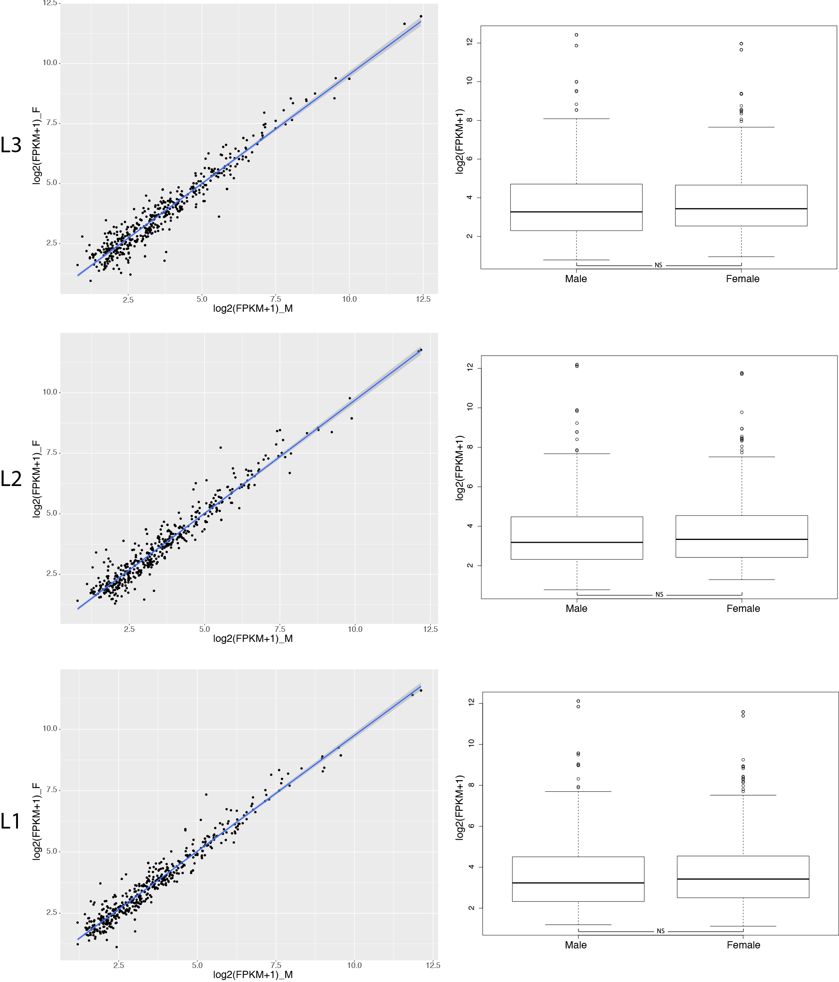
Additional file 10: Figure S6: Left panels show gene expression correlation between male and female transcriptomes for each gene on the X chromosome. The analysis was performed for the three different legs and regressions were fitted from a linear model. Right panels indicate average gene expression differences between males and females on the X chromosome for the three legs.

