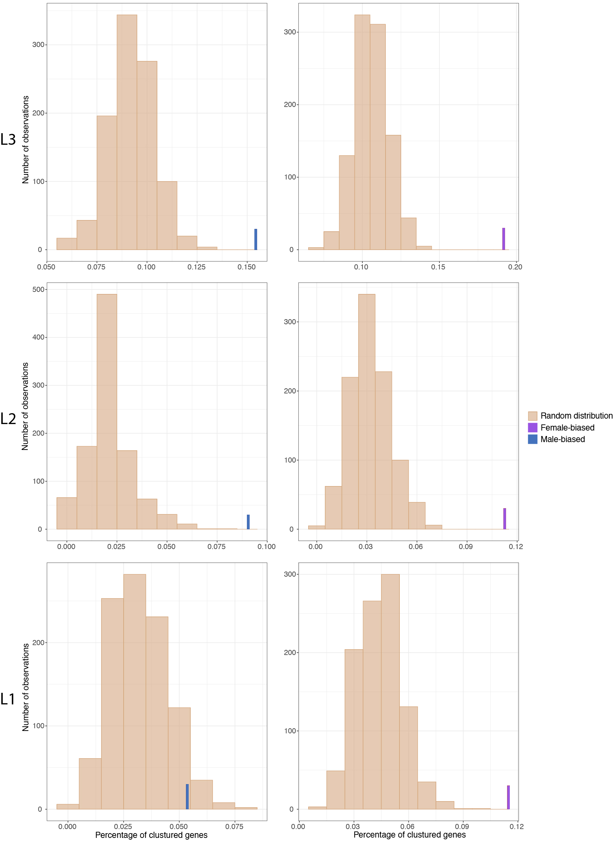
Additional file 12: Figure S8: Distributions of the proportion of clustered sex-biased genes (at least two consecutive sex-biased genes) generated through 1000 random iterations in each leg separately. Blue and purple bars correspond to the observed proportions of male- and female-biased genes, respectively, in the three legs.

