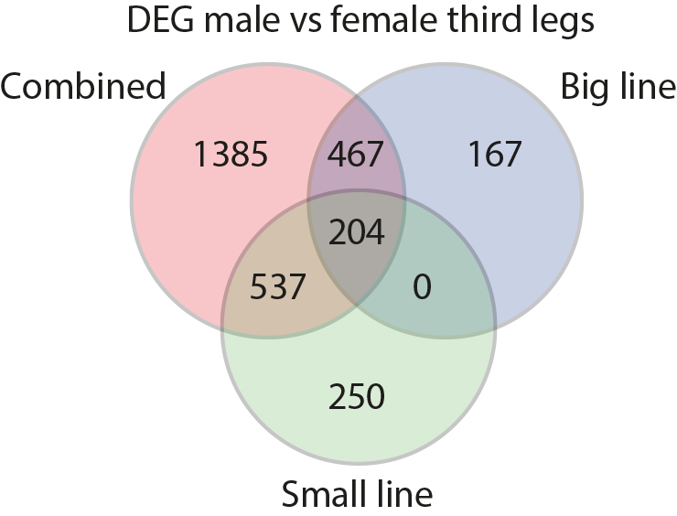
Additional file 16: Figure 9: Venn diagrams on sex-biased genes identified on the two lines separately or combined (see material and methods for more details).

