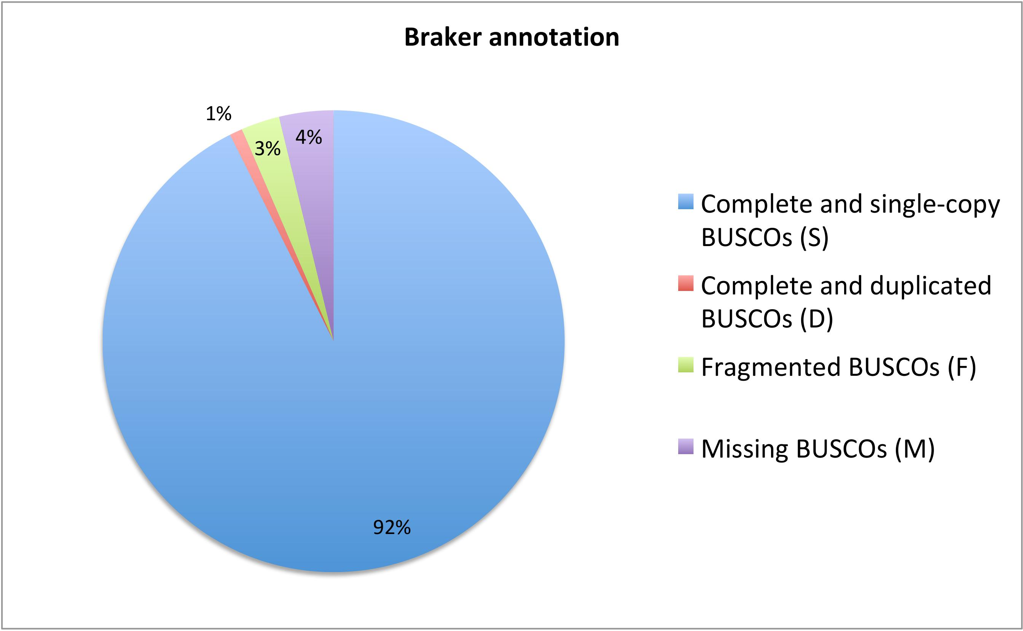
Additional file 2: Figure S1: Diagram of BUSCO analysis run for the 26 130 genes identified from Braker annotation.

