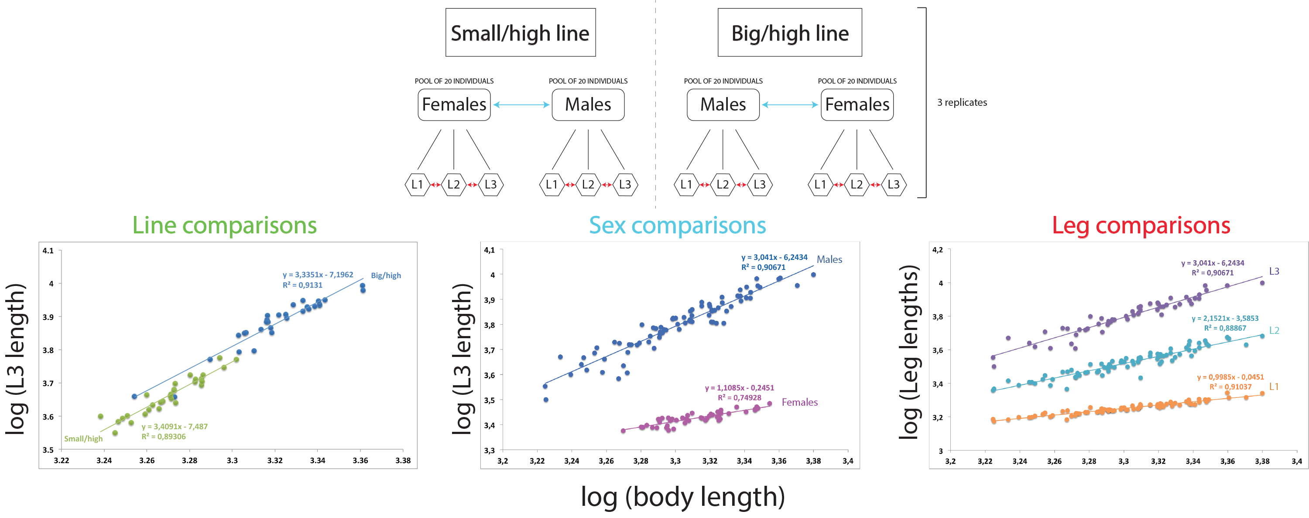
Additional file 3: Figure S2: Experimental design of the comparative transcriptomic analysis. Top panel represents the three different conditions used in the transcriptomic analysis, namely the line, sex and leg conditions. The comparative transcriptomics was performed on three replicates and a pool of 20 individuals per replicate. Bottom panel indicates allometric differences between all three conditions.

