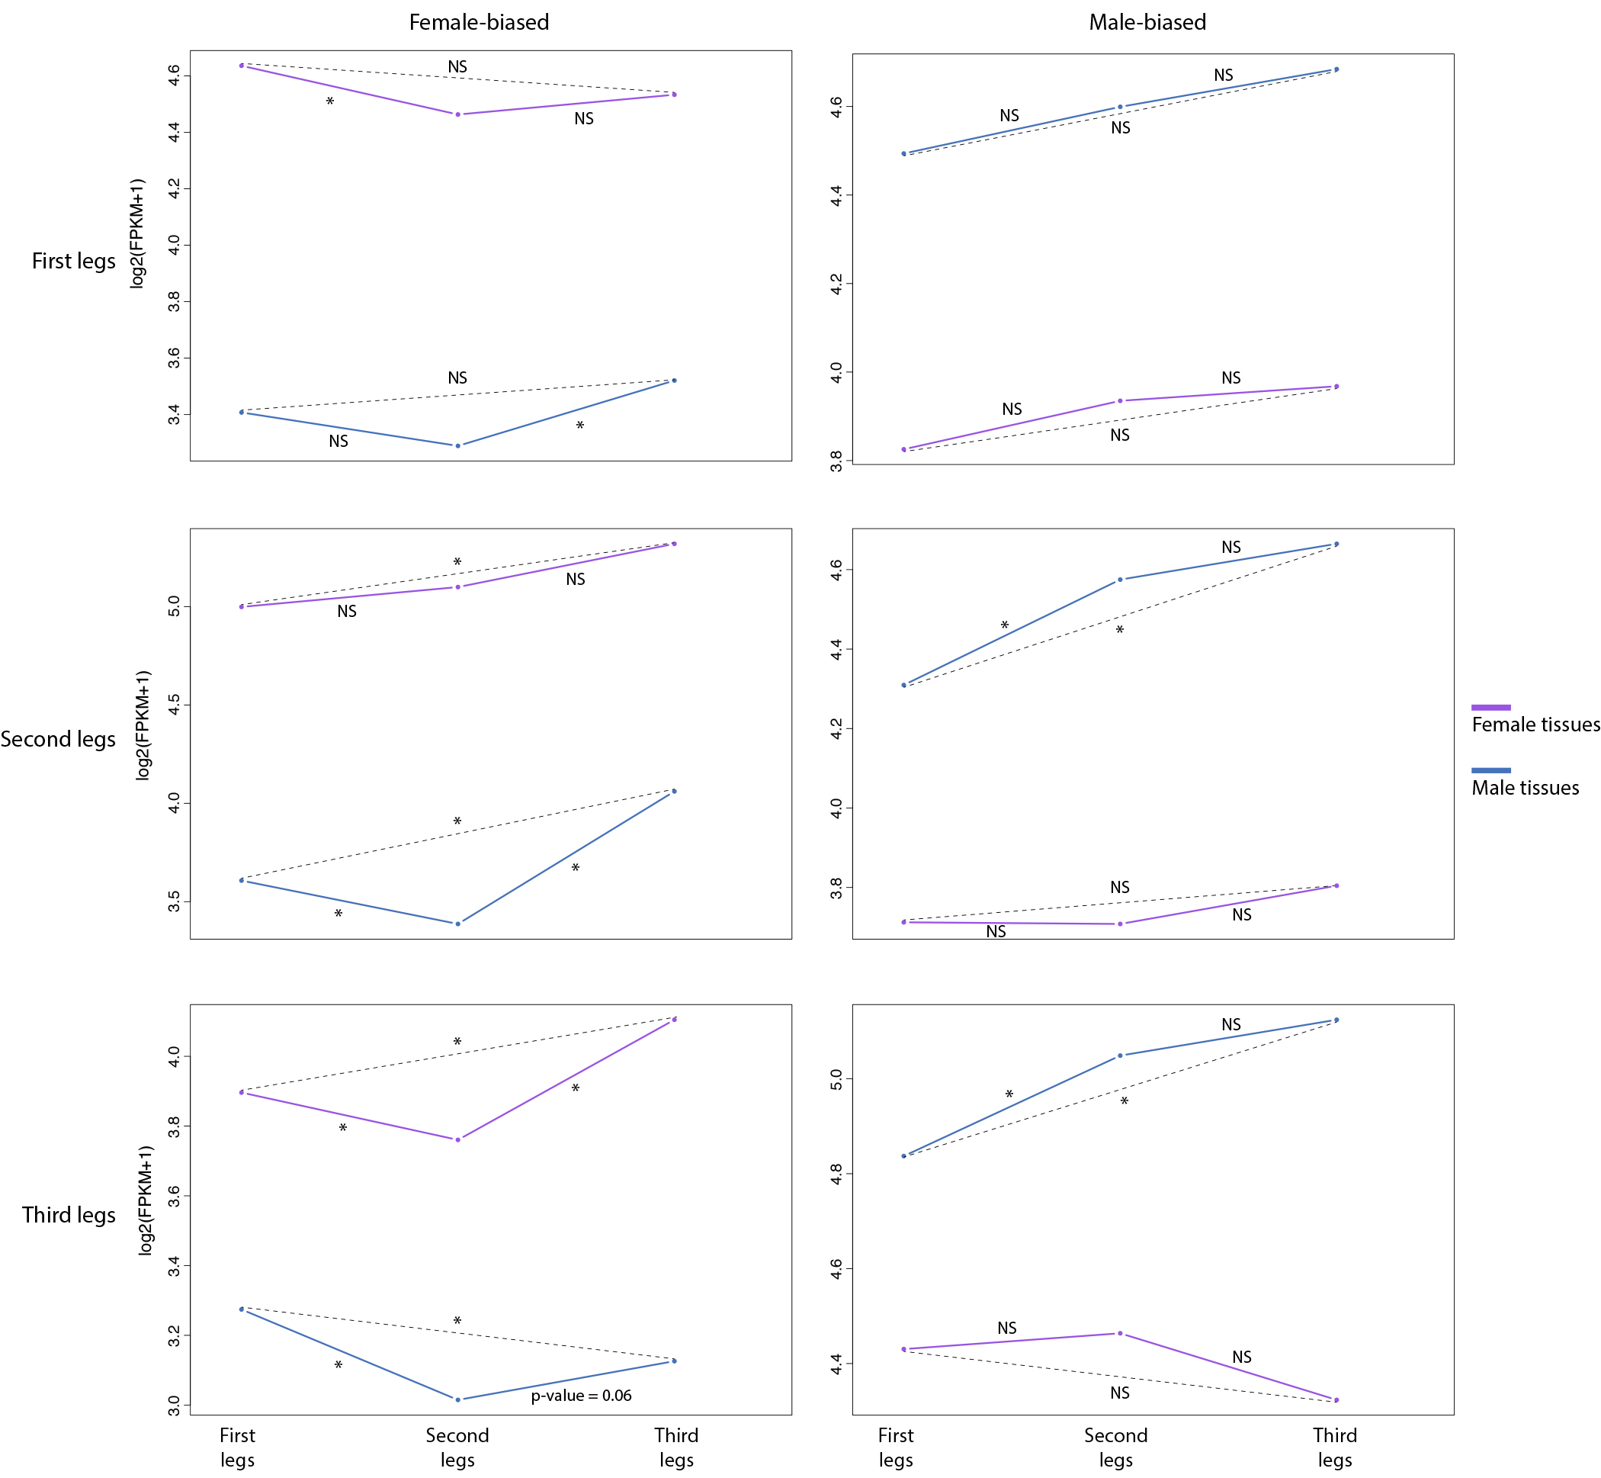
Additional file 5: Figure S3: Comparison of gene expression (log2FPKM+1) across legs for male- and female-biased genes identified in each leg respectively.

