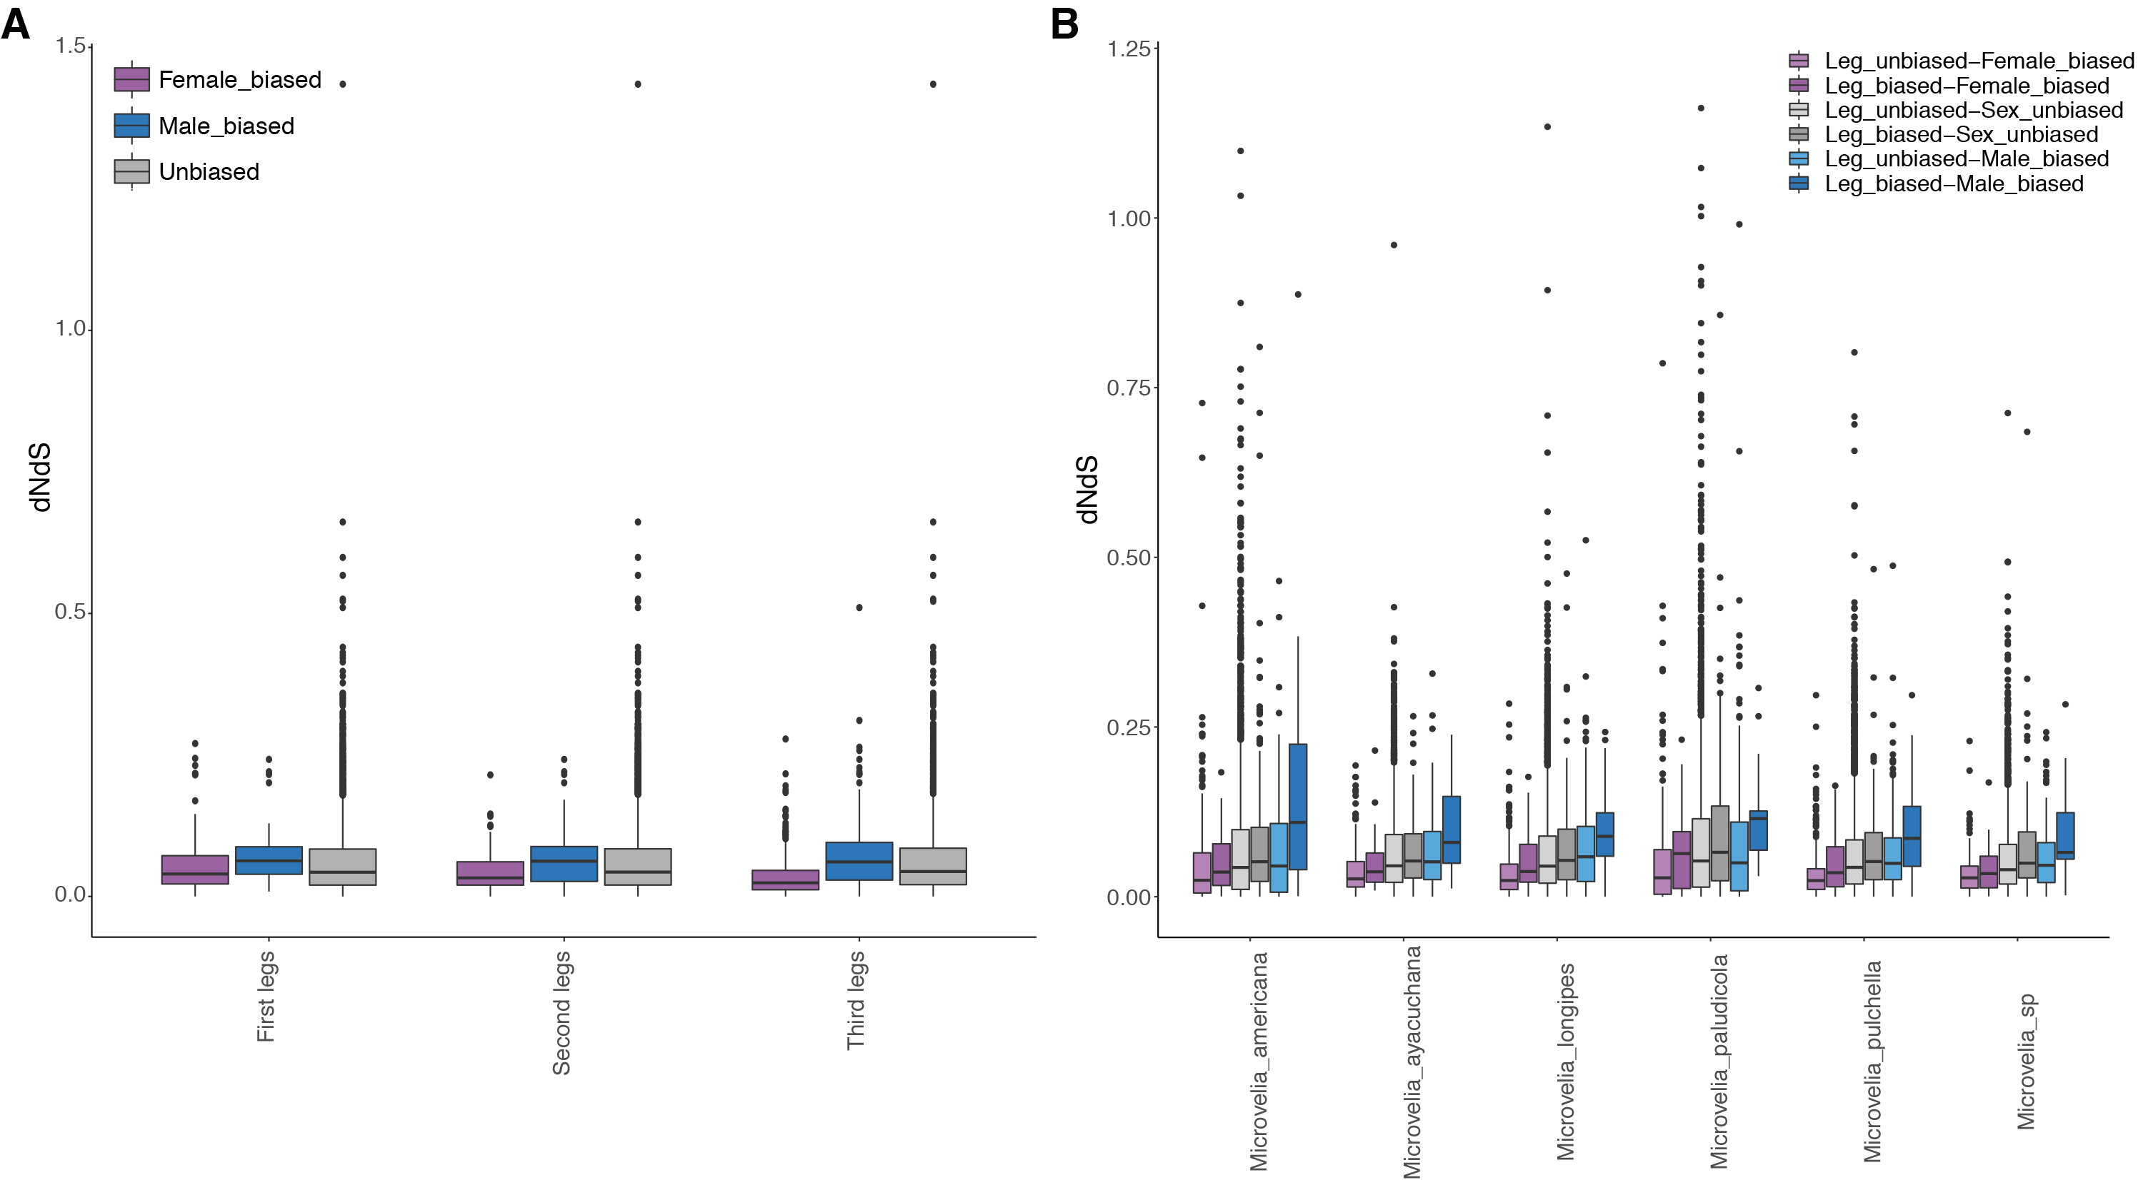
Additional file 9: Figure S5: Interaction plots on dNdS medians on the six Microvelia species.

