This file contains:

the analysis of homologue chromosomes contact frequencies at the 22A, 51C, 58A, 68E and 96E attP insertion sites: 22A (Bloomington Drosophila Stock Center (BDSC) #24481), 51C (BDSC #24482), 58A (BDSC #24484), 68E (BDSC #24485), 96E (BDSC #24487).

Description:
- For the analysis Haplotype-resolved Hi-C contacts from accessions GSM3428928 and GSM3428929 were used (AlHaj Abed J, Erceg J, Goloborodko A, Nguyen SC et al. Highly structured homolog pairing reflects functional organization of the Drosophila genome. Nat Commun 2019 Oct 3;10(1):4485. PMID: 31582763).
- Contact maps of 2 Mb regions centered on the insertion sites of transgenes (indicated by dashed lines). cis-Mat or cis-Pat — cis interactions occurring within maternal or paternal chromosome, respectively. thom — trans interactions between homologous chromosomes. O/E – observed over expected on that genomic separation contact frequency. Bottom left map (thom/cis) shows depletion of contacts near 58A attP insertion site.
- Processed Hi-C contact pairs with high mapping quality (MAPQ>30) on both sides were aggregated in 20kb genomic bins to produce Hi-C contact matrices using the cooler v0.8.10 package (https://doi.org/10.1093/bioinformatics/btz540). Matrices were iteratively corrected (http://dx.doi.org/10.1038/nmeth.2148) after low-quality bin filtering using cooler balance function with default parameters. Contact frequency as a function of genomic separation was calculated by averaging normalised contact frequency along diagonals of contact matrices using cooltools v0.3.2 package (https://github.com/open2c/cooltools).

- 22A
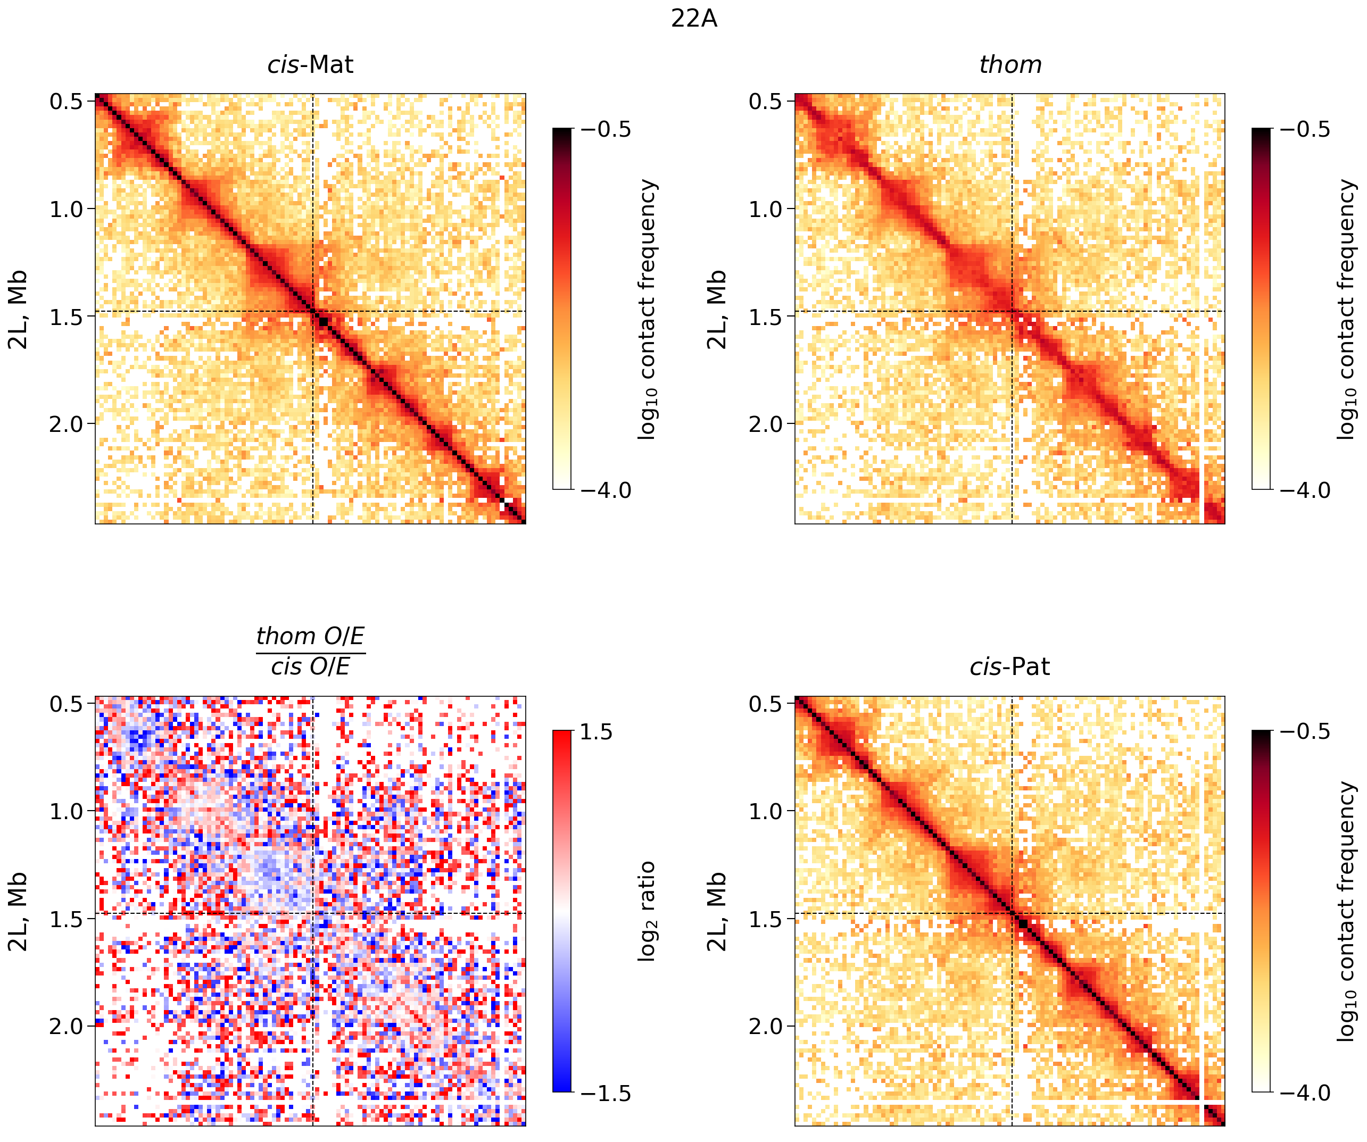

- 51C
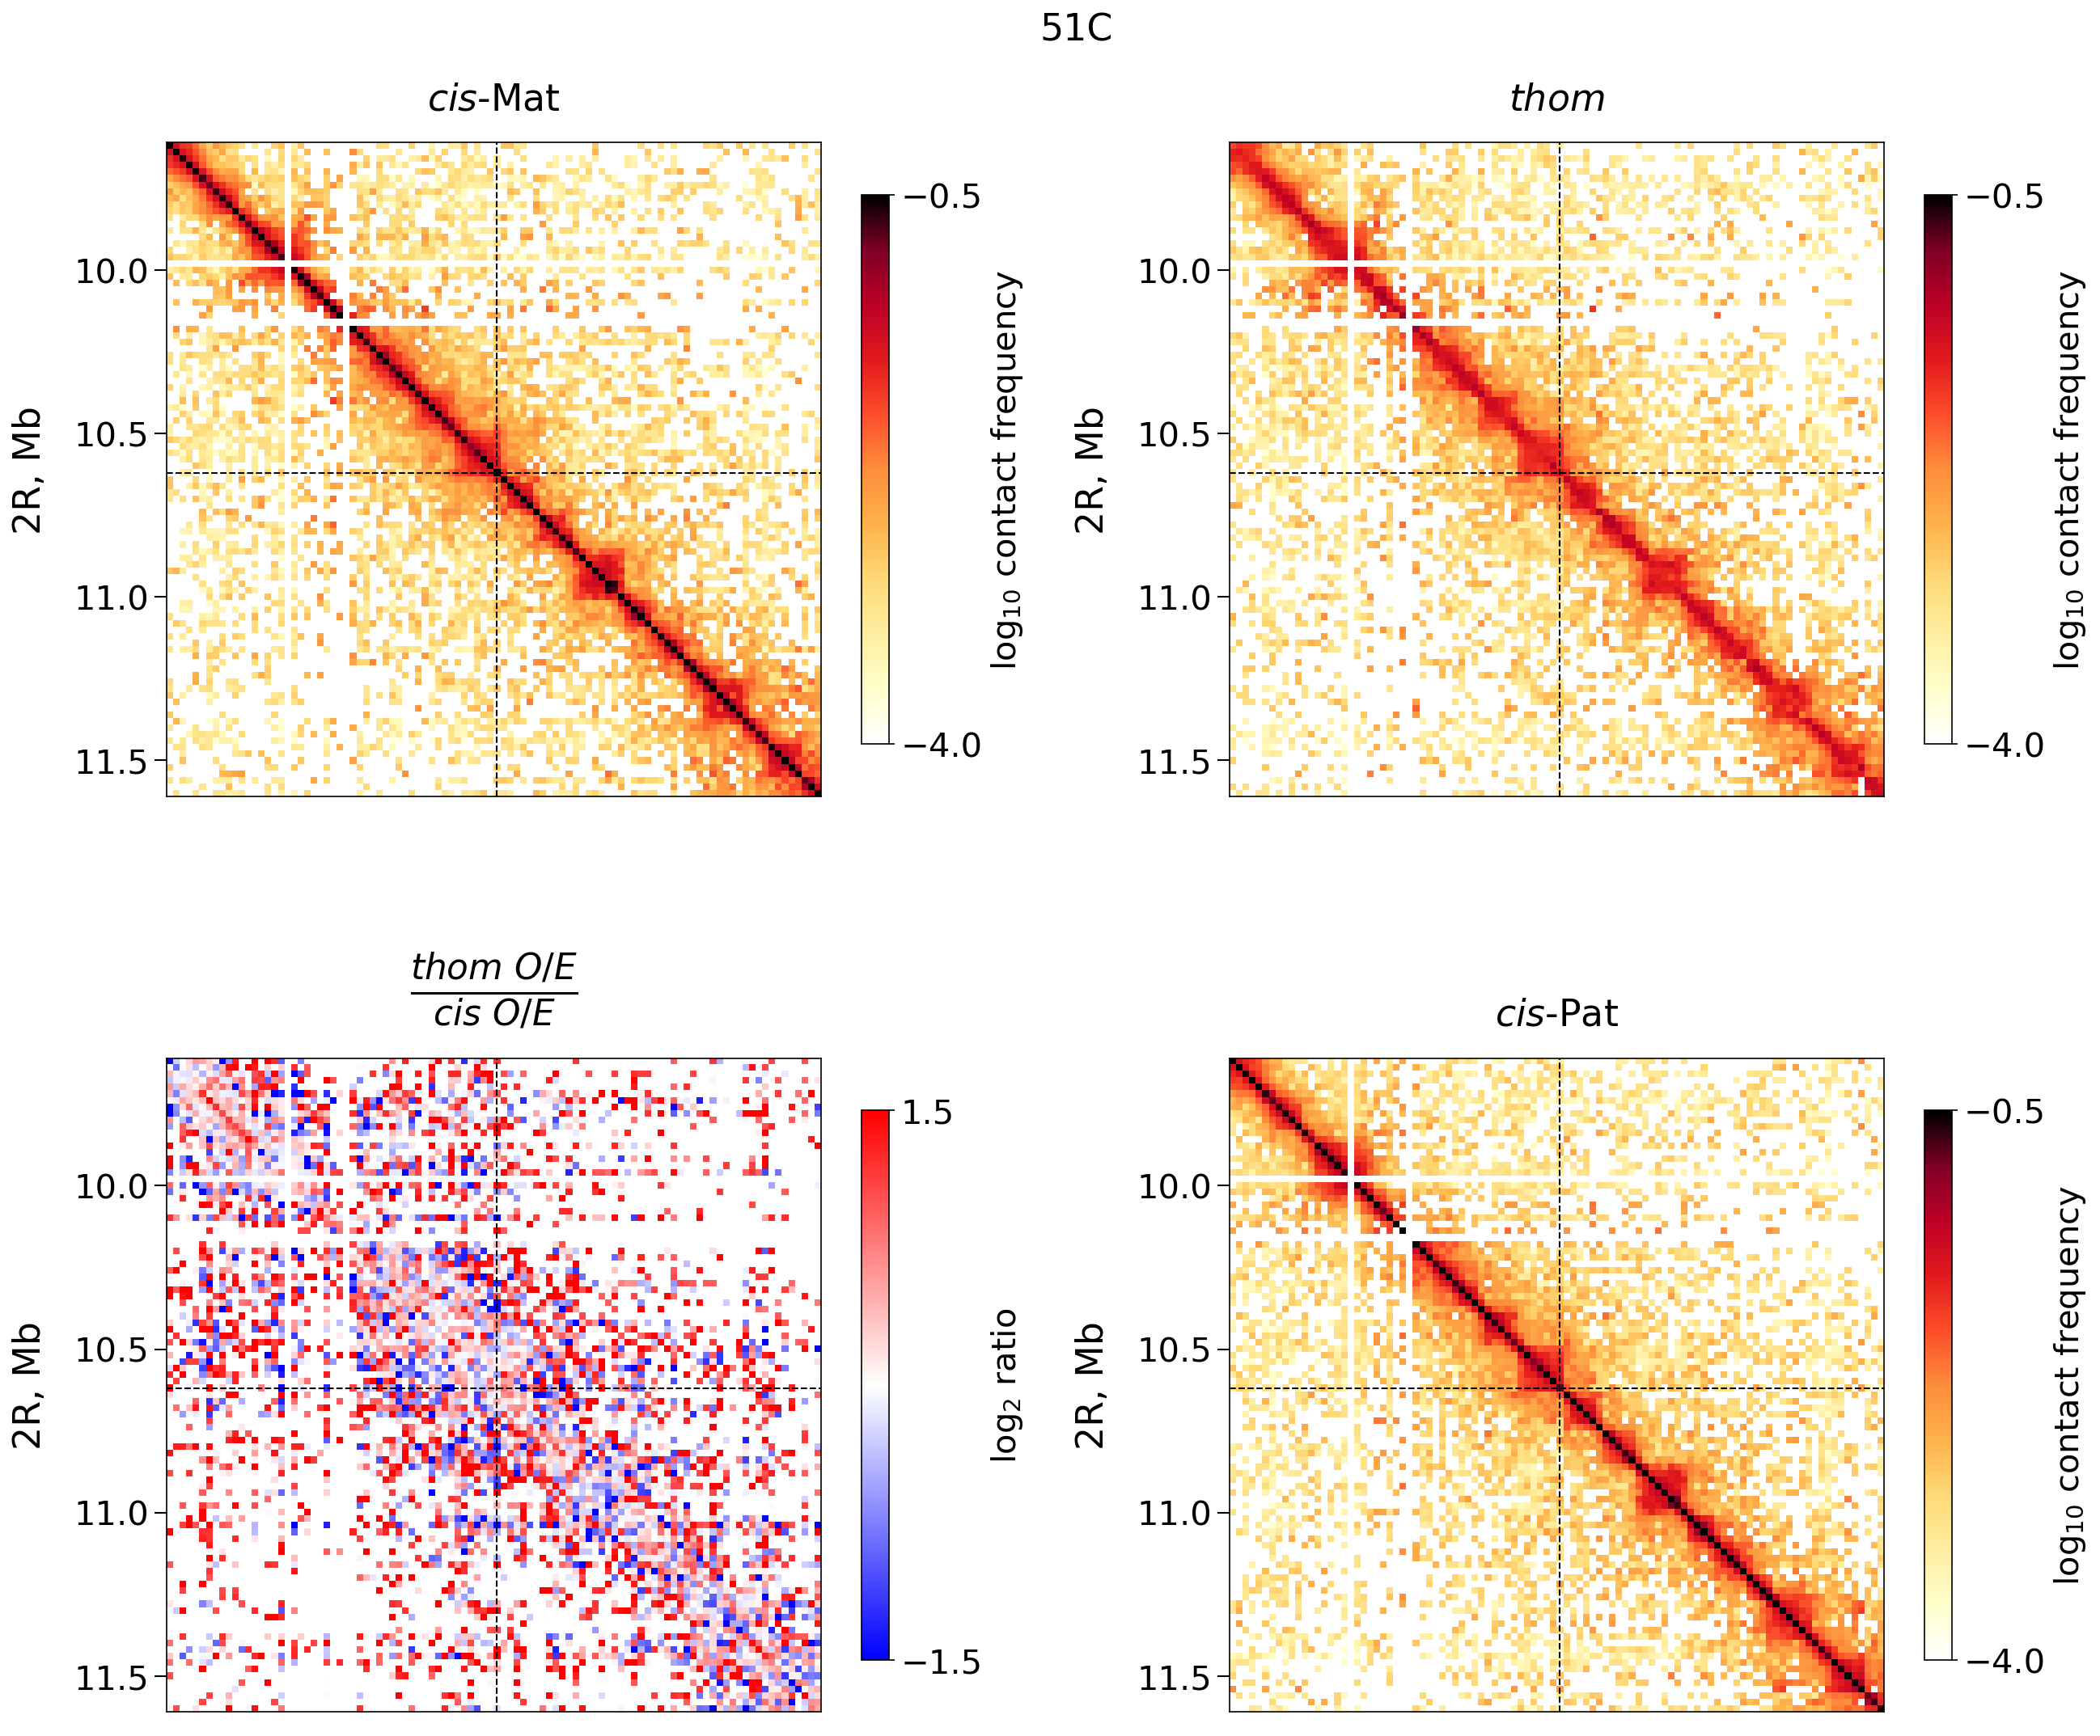

- 58A
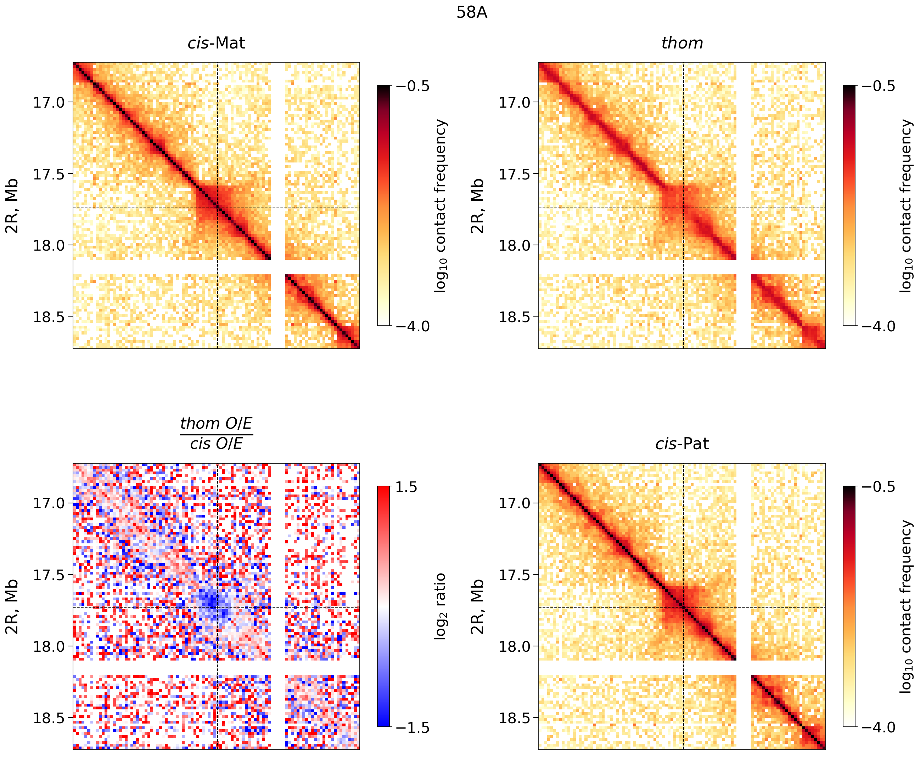

- 68E
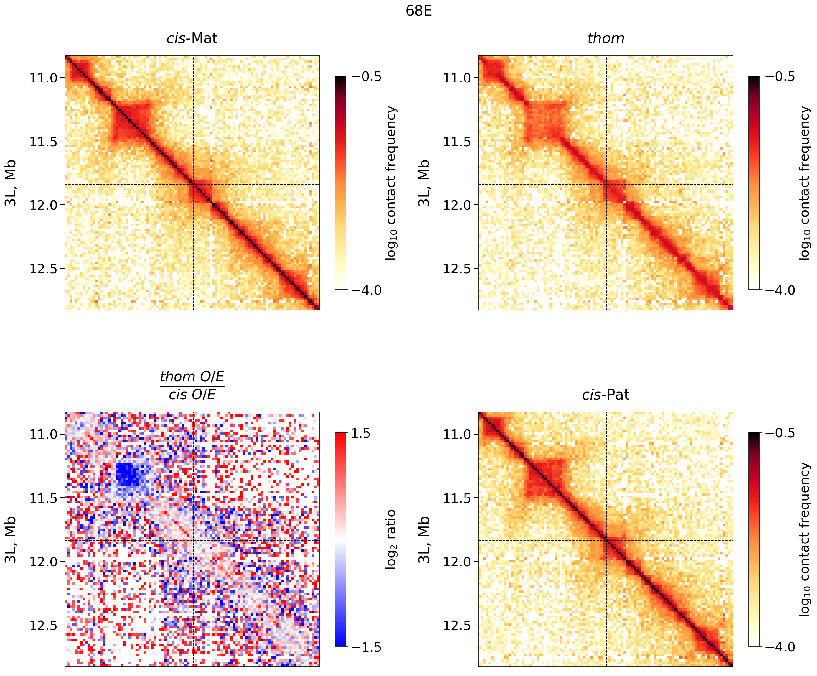

- 96E
