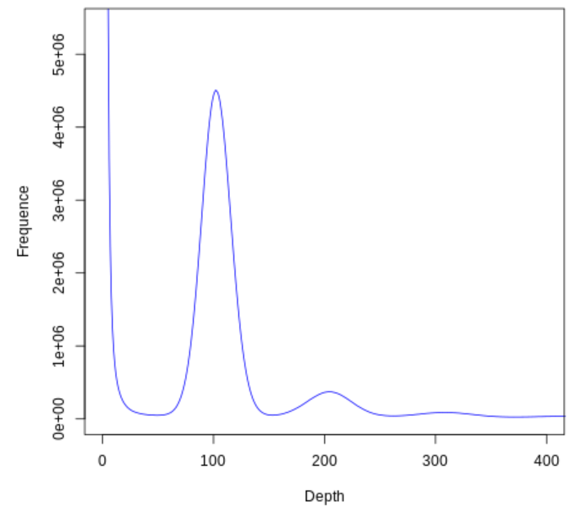
Figure S1. Frequency distribution of depth of K-mer = 17 in genome survey of field pennycress.

