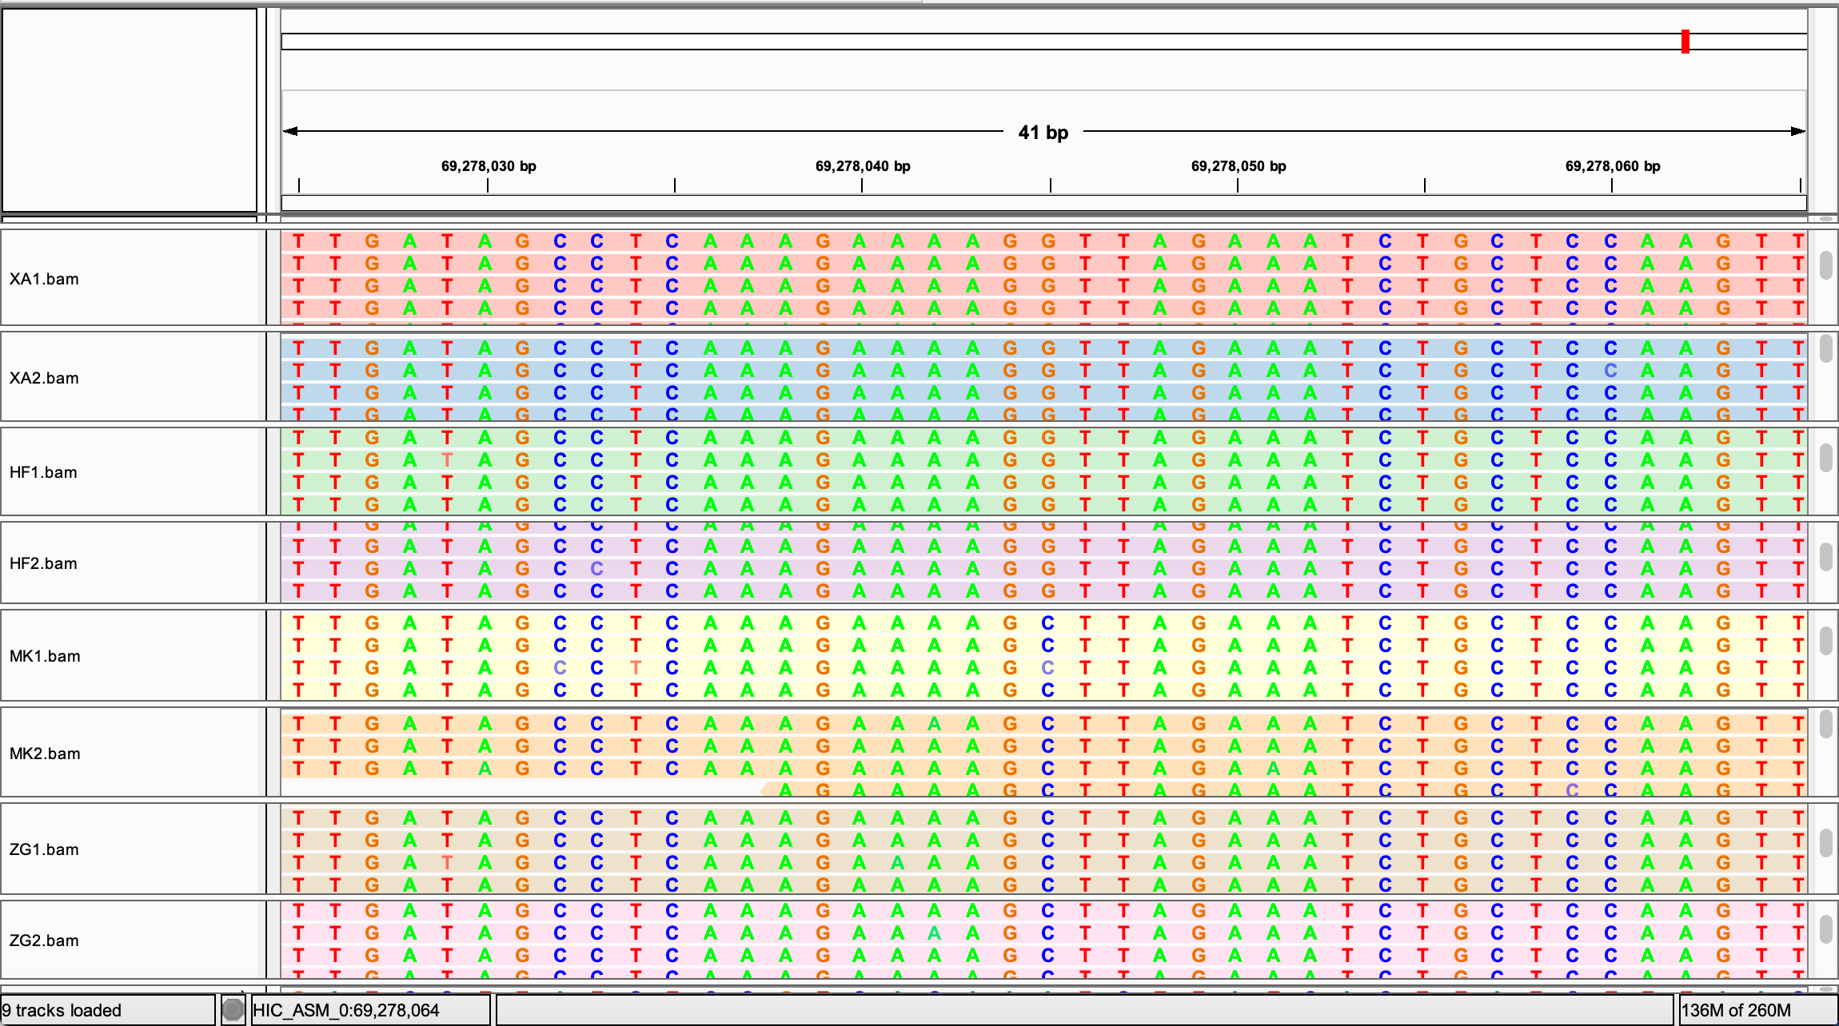
Figure S6. Mapping re-sequenced short reads of four populations to the reference genome and the coverage of the FLC region using IGV. The red dotted box shows the mutation site (G>C).

