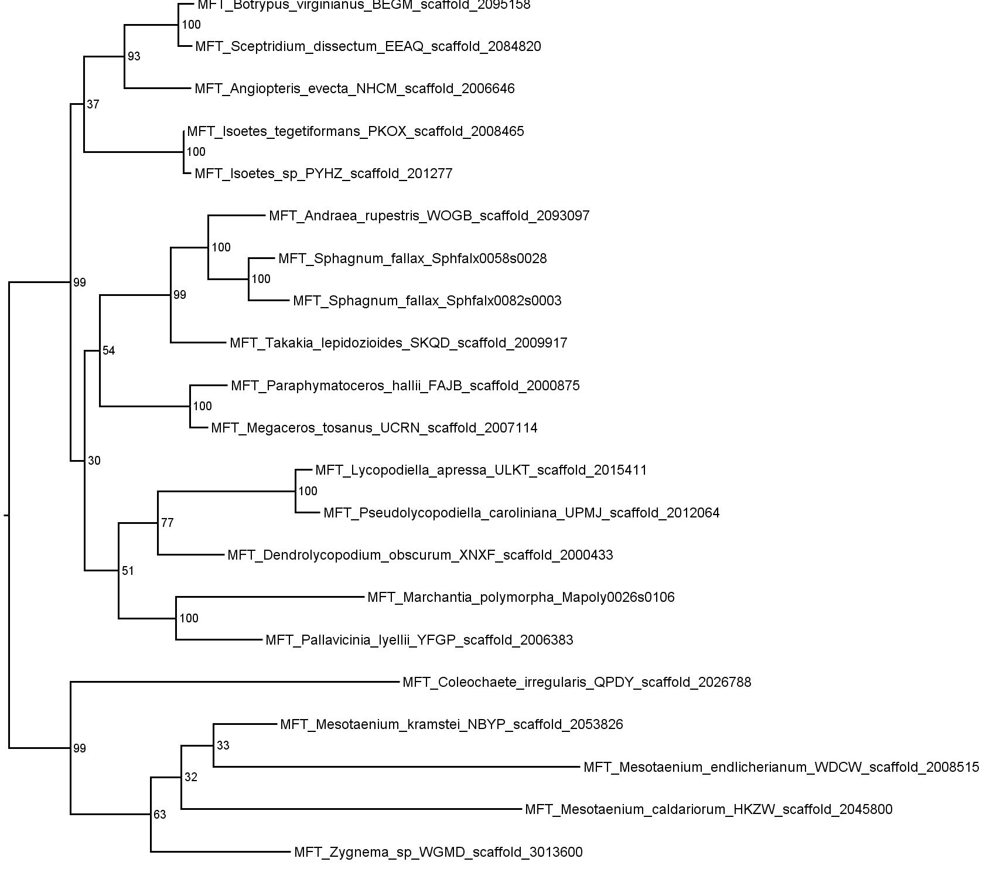

Additional File 4: Basal land plant MFT phylogeny
Nucleotide-level maximum likelihood analysis implemented in PhyML using a TIM2ef+G+I model, on the basal land plant MFT sequences (21 sequences, 519 characters). The tree was rooted with charophyte algal sequences. Phylogram showing the most likely tree, including bootstrap values at all nodes.

