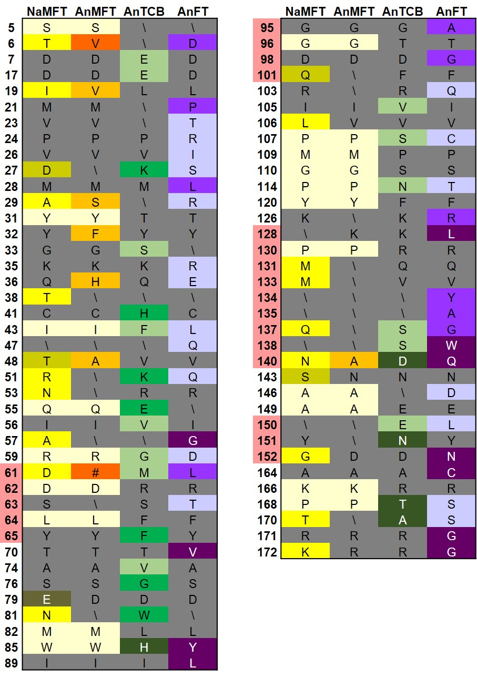

Additional File 8: Unique characteristics of EuPEBP protein families
Diagram showing residues at which major EuPEBP families have unique amino acids, not found in other families. NaMFT = non-angiosperm MFT. AnMFT = angiosperm MFT, AnTCB = angiosperm TCB and AnFT = angiosperm FT (without monocot proteins). Unique residues are coloured, non-unique (or non-conserved) residues are shown in grey. The lighter shades are consensus amino acids (50%>75%), the mid shades are conserved (75%>90%) and the dark shades are highly conserved (>90%). Amino acids that are shared between all MFT proteins are shown in beige. The position of the 14-3-3 interaction, P-loop and LYN triad motifs are shown in pink shading of the number column. # = residue absent, \ = no consensus.

