ADDITIONAL FILE 1

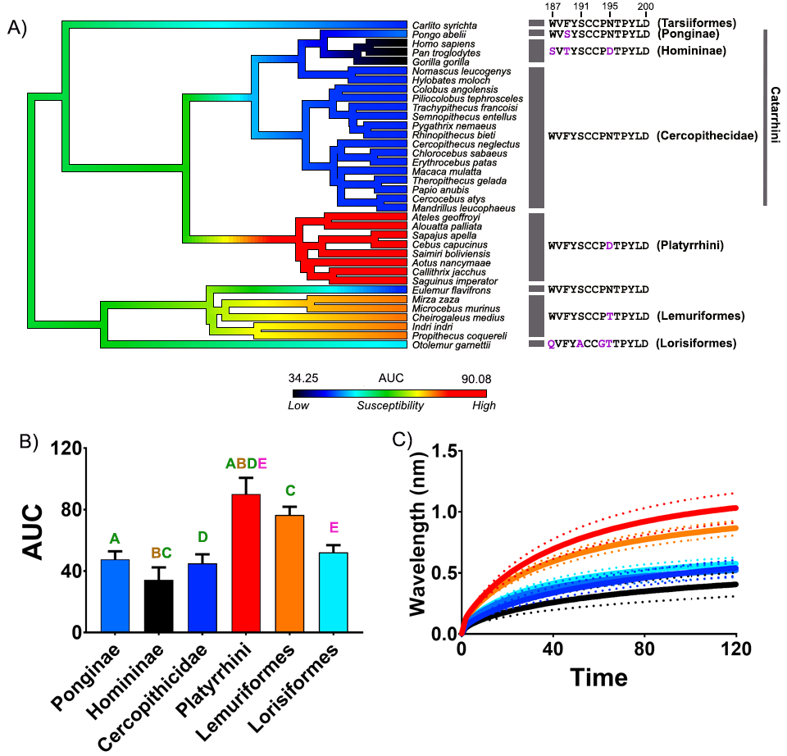
Fig. S1. The effects of venom from an additional African cobra species (Naja nubiae) against the nAChR orthosteric site mimotopes from seven clades of primates. A) Ancestral state reconstruction of the area under the curve (AUC) values of the binding of N. nubiae against the primate mimotopes. B) Bar graphs represent the mean AUC values of the adjacent curve graphs. C) Curve graphs show the mean wavelength shift (nm) in light with binding of venoms over a 120 second association phase. The venom was tested in triplicate (n=3). Error bars on all graphs represent the SEM. AUC values were statistically analysed using a one-way ANOVA with a Tukey’s comparisons multiple comparisons test comparing to the native mimotope. A statistical significance is indicated by matching letters with the colours of letter indicating the level of significance; brown p<0.001, green p<0.01, pink p<0.05. All raw data and statistical analyses outputs can be found in Additional file 2.
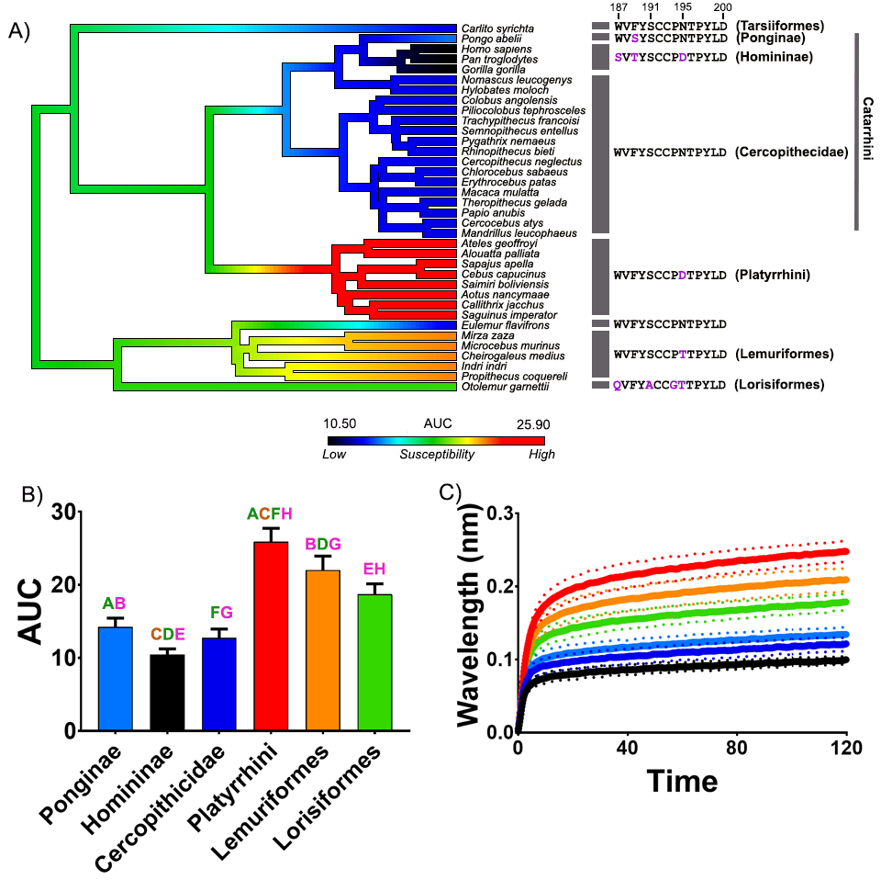 Fig. S2. The effects of venom from an additional African cobra species (Naja haje) against the nAChR orthosteric site mimotopes from seven clades of primates. A) Ancestral state reconstruction of the area under the curve (AUC) values of the binding of N. haje against the primate mimotopes. B) Bar graphs represent the mean AUC values of the adjacent curve graphs. C) Curve graphs show the mean wavelength shift (nm) in light with binding of venoms over a 120 second association phase. The venom was tested in triplicate (n=3). Error bars on all graphs represent the SEM. AUC values were statistically analysed using a one-way ANOVA with a Tukey’s comparisons multiple comparisons test comparing to the native mimotope. A statistical significance is indicated by matching letters with the colours of letter indicating the level of significance; brown p<0.0001, green p<0.001, pink p<0.05. All raw data and statistical analyses outputs can be found in Additional file 2.

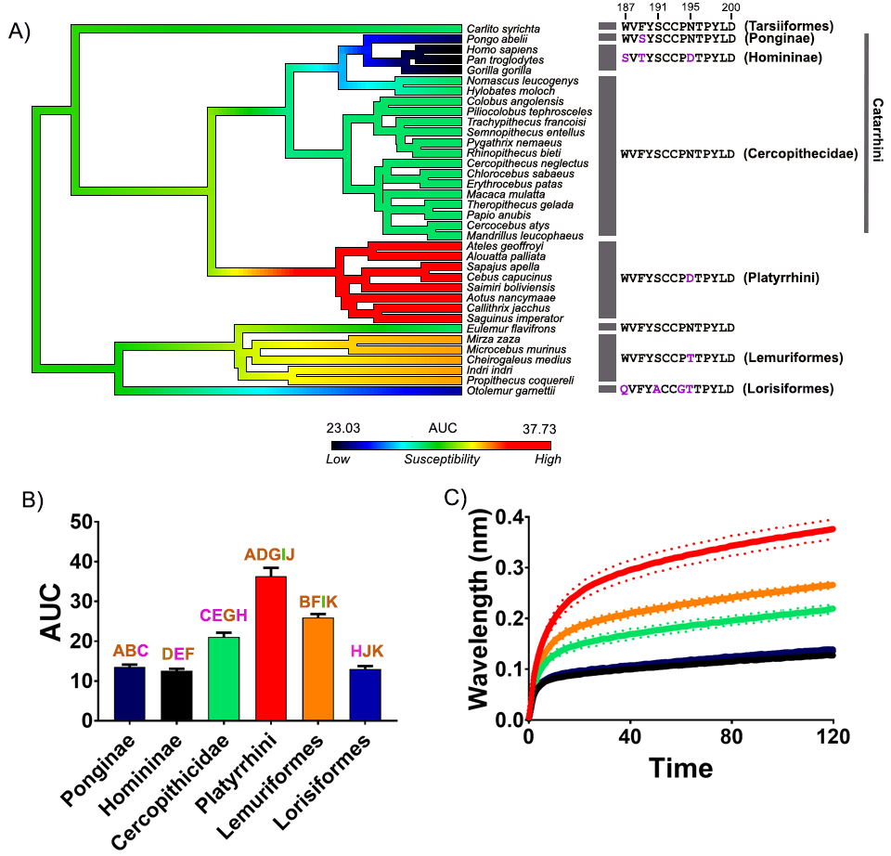
Fig. S3. The effects of venom from an additional Asian cobra species (Naja kaouthia) against the nAChR orthosteric site mimotopes from seven clades of primates. A) Ancestral state reconstruction of the area under the curve (AUC) values of the binding of N. kaouthia against the primate mimotopes. B) Bar graphs represent the mean AUC values of the adjacent curve graphs. C) Curve graphs show the mean wavelength shift (nm) in light with binding of venoms over a 120 second association phase. The venom was tested in triplicate (n=3). Error bars on all graphs represent the SEM. AUC values were statistically analysed using a one-way ANOVA with a Tukey’s comparisons multiple comparisons test comparing to the native mimotope. A statistical significance is indicated by matching letters with the colours of letter indicating the level of significance; brown p<0.0001, green p<0.001, pink p<0.05. All raw data and statistical analyses outputs can be found in Additional file 2.

Table S1. Orthosteric site sequences for each species and public database accessions codes.
Species | Common name | Sequence | Lineage | Accession code
Otolemur garnettii | Small-eared galago | QVFYACCGTTPYLD | Lorisiformes | H0WHF2
Propithecus coquereli | Coquerel's sifaka | WVFYSCCPTTPYLD | Lemuriformes | A0A2K6FUM4
Indri Indri | Indri | WVFYSCCPTTPYLD | Lemuriformes | RJWJ000000000.1
Cheirogaleus medius | Lesser dwarf lemur | WVFYSCCPTTPYLD | Lemuriformes | GCA_004024725.1
Microcebus murinus | Grey mouse lemur | WVFYSCCPTTPYLD | Lemuriformes | ENSMICT00000067396.1
Mirza zaza | Northern giant mouse lemur | WVFYSCCPTTPYLD | Lemuriformes | VSMD00000000.1
Eulemur flavifrons | Blue-eyed black lemur (Sclater's lemur) | WVFYSCCPNTPYLD | Lemuriformes | LGHW00000000.1
Saguinus imperator | Emperor tamarin | WVFYSCCPDTPYLD | Platyrrhini | PVHO000000000.1
Callithrix jacchus | White-tufted-ear marmoset | WVFYSCCPDTPYLD | Platyrrhini | U3E8V3
Aotus nancymaae | Ma's night monkey | WVFYSCCPDTPYLD | Platyrrhini | A0A2K5CH45
Saimiri boliviensis | Bolivian squirrel monkey | WVFYSCCPDTPYLD | Platyrrhini | A0A2K6V5P4
Cebus capucinus | Colombian white-faced capuchin | WVFYSCCPDTPYLD | Platyrrhini | A0A2K5RK82
Sapajus apella | Tufted capuchin | WVFYSCCPDTPYLD | Platyrrhini | WRPQ00000000.1
Alouatta palliata | Mantled howler monkey | WVFYSCCPDTPYLD | Platyrrhini | PVKV000000000.1
Ateles geoffroyi | Black-headed spider monkey | WVFYSCCPDTPYLD | Platyrrhini | PVHS00000000.1
Mandrillus leucophaeus | Mandrill | WVFYSCCPNTPYLD | Cercopithecidae | A0A2K6AD85
Cercocebus atys | Sooty mangabey | WVFYSCCPNTPYLD | Cercopithecidae | A0A2K5LJ67
Papio anubis | Olive baboon | WVFYSCCPNTPYLD | Cercopithecidae | A0A096MY80
Theropithecus gelada | Gelada | WVFYSCCPNTPYLD | Cercopithecidae | QGDE00000000.1
Macaca mulatta | Rhesus monkey | WVFYSCCPNTPYLD | Cercopithecidae | F7ET74
Erythrocebus patas | Patas monkey | WVFYSCCPNTPYLD | Cercopithecidae | PVJV000000000.1
Chlorocebus sabaeus | Green monkey | WVFYSCCPNTPYLD | Cercopithecidae | AQIB00000000.1
Cercopithecus neglectus | De Brazza's monkey | WVFYSCCPNTPYLD | Cercopithecidae | PVKI000000000.1
Rhinopithecus bieti | Black snub-nosed monkey | WVFYSCCPNTPYLD | Cercopithecidae | A0A2K6K3B8
Pygathrix nemaeus | Red-shanked douc | WVFYSCCPNTPYLD | Cercopithecidae | PVHW000000000.1
Semnopithecus entellus | Northern plains grey langur | WVFYSCCPNTPYLD | Cercopithecidae | PVII000000000.1
Trachypithecus francoisi | Francois' langur | WVFYSCCPNTPYLD | Cercopithecidae | GCA_009764315.1 & GCA_009764325.1
Piliocolobus tephrosceles | Ugandan red colobus | WVFYSCCPNTPYLD | Cercopithecidae | PDMG00000000.3
Colobus angolensis | Angolan colobus | WVFYSCCPNTPYLD | Cercopithecidae | A0A2K5HLD5
Hylobates moloch | Silvery gibbon | WVFYSCCPNTPYLD | Cercopithecidae | WKKJ00000000.2
Nomascus leucogenys | Northern white-cheeked gibbon | WVFYSCCPNTPYLD | Cercopithecidae | G1R1T5
Gorilla gorilla | Western gorilla | SVTYSCCPDTPYLD | Homininae | GCA_008122165.1
Pan troglodytes | Chimpanzee | SVTYSCCPDTPYLD | Homininae | H2QJ05
Homo sapiens | Human | SVTYSCCPDTPYLD | Homininae | G5E9G9
Pongo abelii | Sumatran orangutan | WVSYSCCPNTPYLD | Ponginae | H2P7W2
Carlito syrichta | Philippine tarsier | WVFYSCCPNTPYLD | Tarsiiformes | A0A1U7TLB3
Nycticebus coucang | Sunda slow loris | NVTYSCC-DTIYLD | Lorisiformes | PVIV010015948.1

