Epigenetic regulation of 5α reductase-1 underlies adaptive plasticity of reproductive function and pubertal timing

Ben Bar-Sadeh¹, Or E. Amichai¹, Lilach Pnueli¹, Kurshida Begum², Gregory Leeman³, Richard D. Emes⁴, Reinhard Stöger³, Gillian R. Bentley², Philippa Melamed¹

¹Faculty of Biology, Technion-Israel Institute of Technology, Haifa 32000 ISRAEL
²Department of Anthropology, Durham University, Durham, DH1 3LE UK
³School of Biological Sciences, University of Nottingham, Nottingham, LE12 5RD UK
⁴School of Veterinary Medicine and Sciences, University of Nottingham, Nottingham, LE12 5RD UK.

Corresponding Author: Philippa Melamed, Faculty of Biology, Technion-Israel Institute of Technology, Haifa 32000 ISRAEL. Tel: 972-4-8293760; philippa@tx.technion.ac.il

Supplementary Information
Table S1: Genes associated with differentially methylated CpGs in the women’s DNA which correlated at one or more CpG with the differential expression of the orthologous gene in the mouse ovaries

gene | expression in DSS- treated mice vs controls | 5mC in Bangladeshi women after growing up in Bangladesh rather than the UK
gene | expression in DSS- treated mice vs controls | position 1 | position 2 | position 3 | position 4
PKIB | up | down | up
REV3L | up | down
CMAH | up | down
GIGYF2 | up | down
UBR5 | up | down | up
ZBTB38 | up | down | up | up
BOD1L1 | up | down | down
SCLT1 | up | down | down | down
FYB | up | down | down | down | down
CEP44 | up | down
KDM1A | up | up | down
SRD5A1 | down | up | up
SND1 | down | up | up | up
Table S2: Primers for mice gene and DNA analysis
Gene ID | F sequence (5' -> 3') | R sequence (5' -> 3')
Rplp0 | GCGACCTGGAAGTCCAACTA | ATCTGCTTGGAGCCCACAT
Srd5a1 | GAATATGTATCTTCAGCCAAC | GGTAATCTTCAAACTTCTCG
Cyp19a1 | CAGTGGAGAGGAGACACTC | CTTCCACCATTCGAACAAGAC
Rasd1 | CTACCATCGAGGACTTCCAC | GACAGGACTTGGTGTCTAGG
Srd5a1 BS outer | AAGGAGTTTTTAGTTAATGTGTGTAG | AAACACAAACTAACACCACCAAAA
Srd5a1 BS inner | GGAGGTGTTATGTGAAAAATGTTT | CCAAATATCACAAAACTCAACTTC
Gnrh | GATCCTCAAACTGATGGCCG | CTCCTCGCAGATCCCTGAG
Kiss1 | AGCTGCTGCTTCTCCTCTGT | AGGCTTGCTCTCTGCATACC
Kiss1r | GGTCATCTACGTTATCTGCC | GCACATGAAGTCTCCCAGC
Esr1 | CTGTGCCGTGTGCAATGACT | CATGCCCACTTCGTAACACT
Tac2 | GTCTCTCTGGAAGGATTGCTG | GGTGTTCTCTTCAACCACGTC
Fkbp5 | GAGTCCAAAGCCTCAGAGTC | GCCAACACCTTCTCGAAGTC

Table S3: Primers for human DNA analysis
Island / shore | Gene_Name | Strand | forward primer |  | reverse primer
chr5:6632740-6634162 | SRD5A1 | Upper | AAGGGTTAGAGTTATTTTGAATGATAG | TTTCATCCCAACAACTCCTTATCCAA
 | AKAP10 | Lower | TGGTGAAATTTTGGTTAGAGGT | CCAAAATCCTCCAATCTCTTATCAA
 | PKIB | Upper | ATGATTTGTTTTTGTTGGTATATAA | CCCTTATACTACATATTTTCAATTCTCTAC
chr7:90893567-90896683 | FZD1 | Lower | TGGTATTAGAGTGTGAGGGTAAGAG | CCTTTAAACAACTCAACTCCTACAA
chr6:170686006-170687003 | FAM120B | Lower | ATTGTTTTGTTTTAAGGGTTTTTTTGTTA | CCTCCCTAATCCCAAATACCTAAA
chr2:26401695-26402099 | FAM59B | Upper | GGTTTTGGAGGGGTGGTG | ACCTTCCCCCTCCTAAAAACCTCTA
chr17:43318429-43319243 | FMNL1 | Upper | AAGGAGTTTGTTGGTGGGTATT | TCCAACTCCTCCACCTTCAAC
chr17:40274523-40275360 | KAT2A HSPB9 | Upper | GTTGGGGGATTAATTTGTTGTT | AACTACTCTCCTCCCAAACTCC
chr19:15568027-15569227 | RASAL3 | Upper | TGGGGGTTTTAGGGTATATAAGAGTAG | CAAAACTCCCCTTCCATCTATTACCA
chr1:25255527-25259005 | RUNX3 | Lower | TTTTAGAGTTTAGGGAGGTGTTT | CTTCCTCTCCCCCCTCCTAAATCTAT

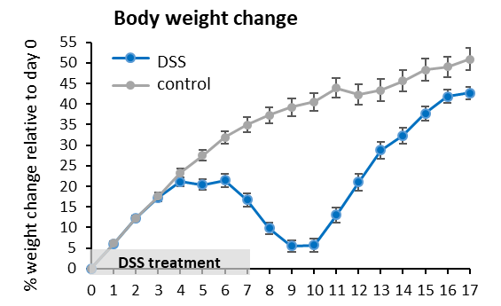

Fig S1: Changes in body weight in mice after transient pre-pubertal colitis. Change in body weight relative to their initial weight are shown for control (n=14-43) and DSS-treated (n=15-48) mice; mean±SEM.

D
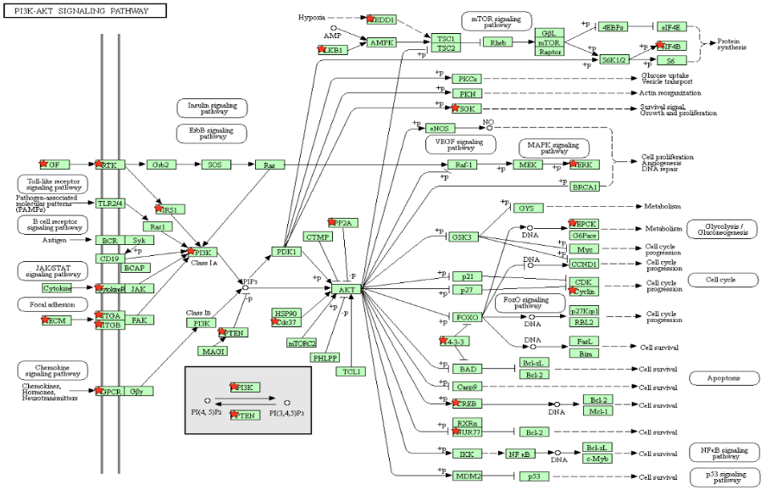
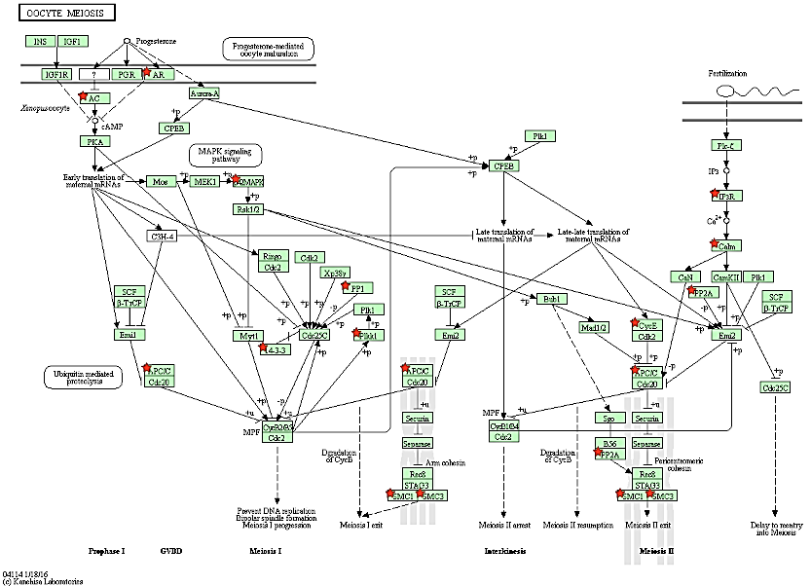
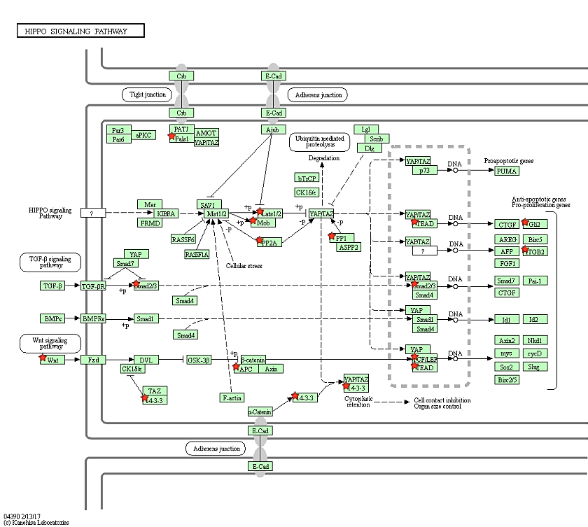
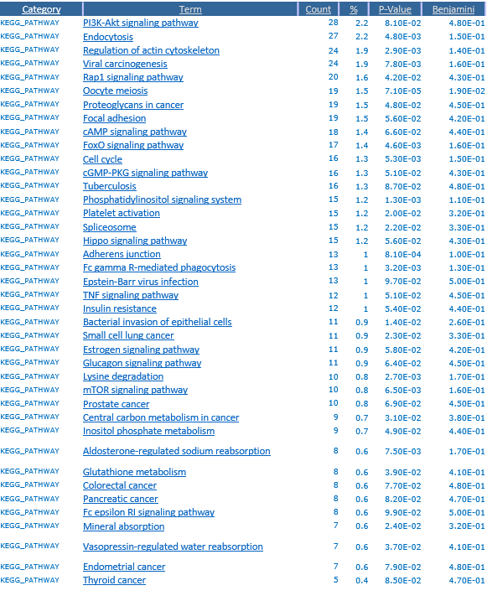
B
C
A
D

Fig S2: Pathway analysis of differentially expressed genes in mice ovaries. (A) Analysis was performed, using the Database for Annotation, Visualization and Integrated Discovery (DAVID), to determine the enriched pathways in the differentially expressed genes (DEGs) in the DSS-treated vs control mice, and the Kyoto Encyclopedia of Genes and Genomes (KEGG) pathways are listed. (B-D) Three of the most enriched pathways (B: PI3K-AKT; C: HIPPO; D: oocyte meiosis) are shown with the DEGs noted by red stars.
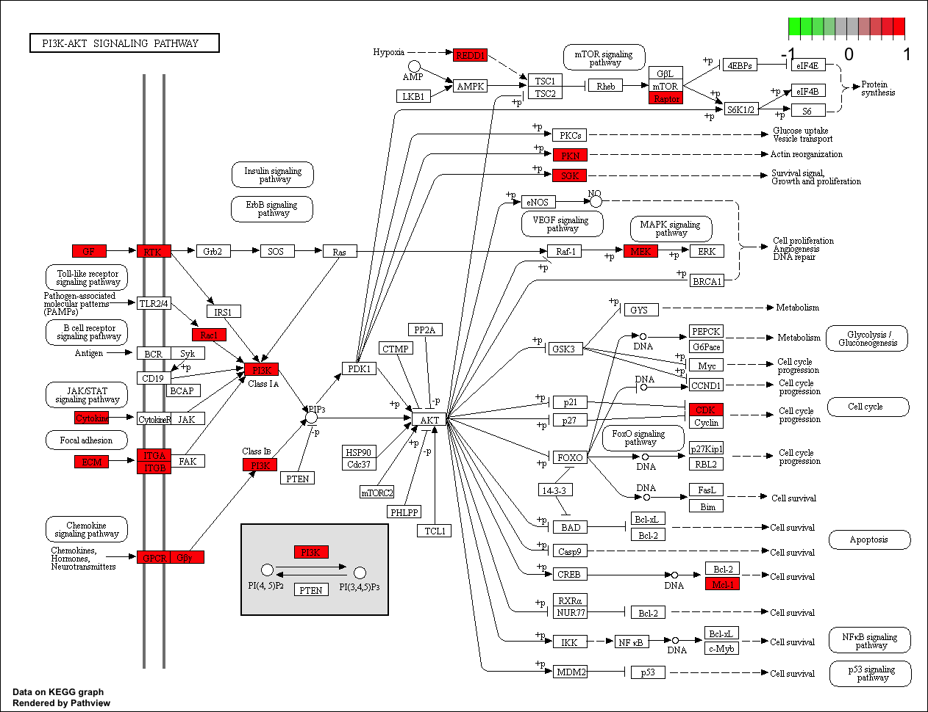
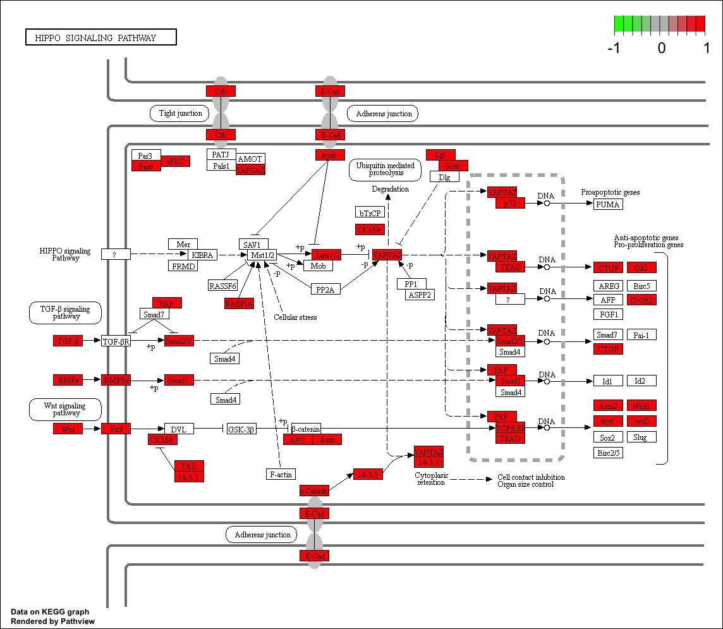
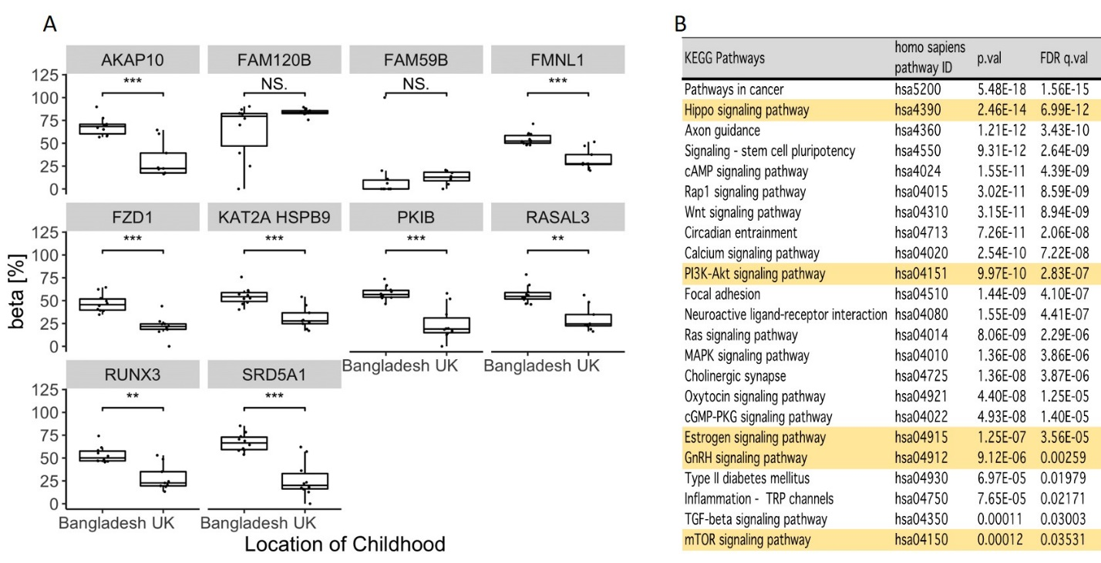
A B C D
Fig S3: Human Methylation analysis. (A) KEGG pathway and gene set enrichment analysis of genes associated with differentially methylated probes (FDR <0.05) within islands, shores and shelves. Pathways of particular relevance for our study are highlighted in yellow. (B,C) Genes in the (B) PI3K-Akt (hsa04151) and (C) Hippo (hsa04390) signalling pathways associated with differentially methylated CpGs in islands, shores or shelves are highlighted in red. (D) Targeted bisulfite sequencing confirmation of MethylationEPIC BeadChip data. Beta values: M/(M+U), where M is number of methylated and U un-methylated reads. Bangladesh-childhood (n=10) and UK-childhood (n=9). Mann-Whitney-U test: *** p<0.001; ** p<0.01; * p<0.05; N.S. p>0.05.
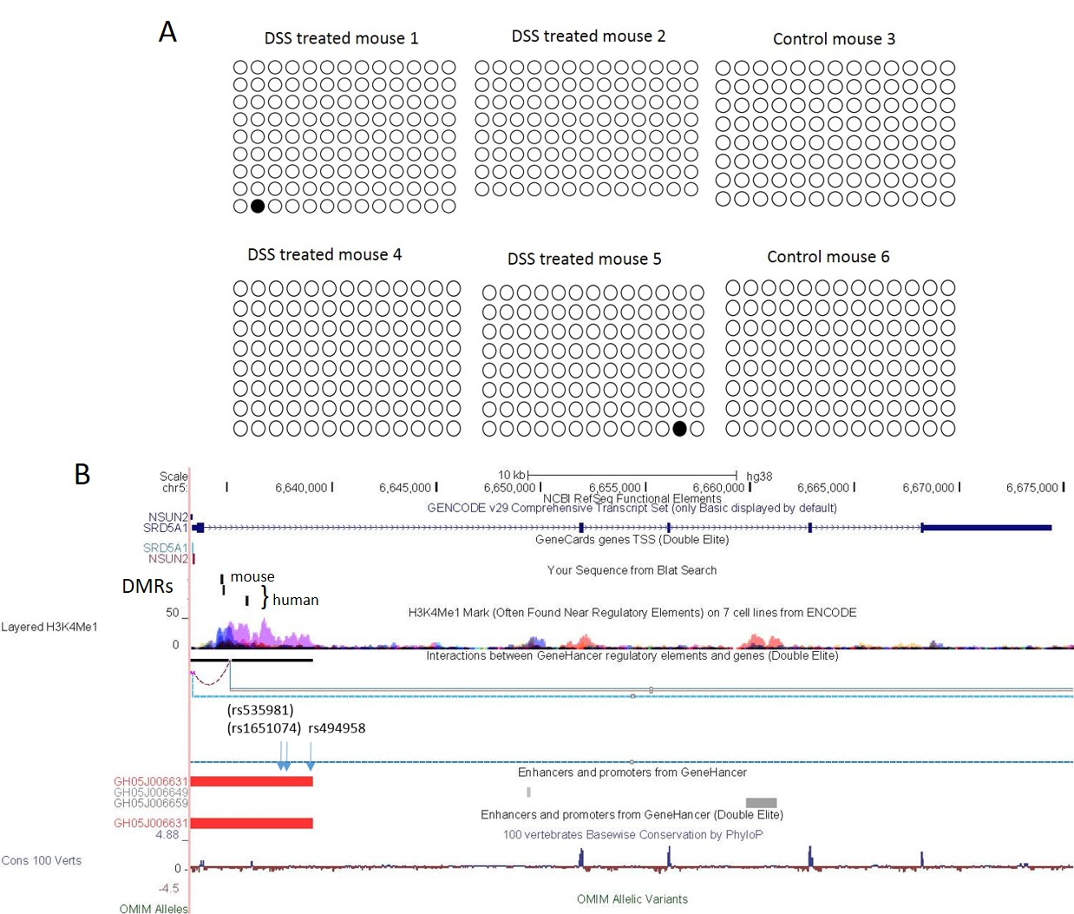

Fig S4: Differential SRD5A1 methylation at a putative enhancer. (A) After bisulfite conversion of ovarian DNA from DSS-treated (n=4) and control (n=2) mice, the Srd5a1 proximal promoter was sequenced in multiple clones (rows). Each column represents one CpG (-123 to +62 relative to the TSS); white circles represent unmethylated CpGs and black ones are methylated. (B) The human SRD5A1 genomic locus in the UCSC genome browser (GRC38/hg38) with observed differentially methylated regions (DMRs) marked, and homologous location of the DMR in the mice ovaries. Also shown are H3K4me1, GENEHancer elements, and an SNP (rs494958) associated with early menopause, and two others in high linkage disequilibrium.

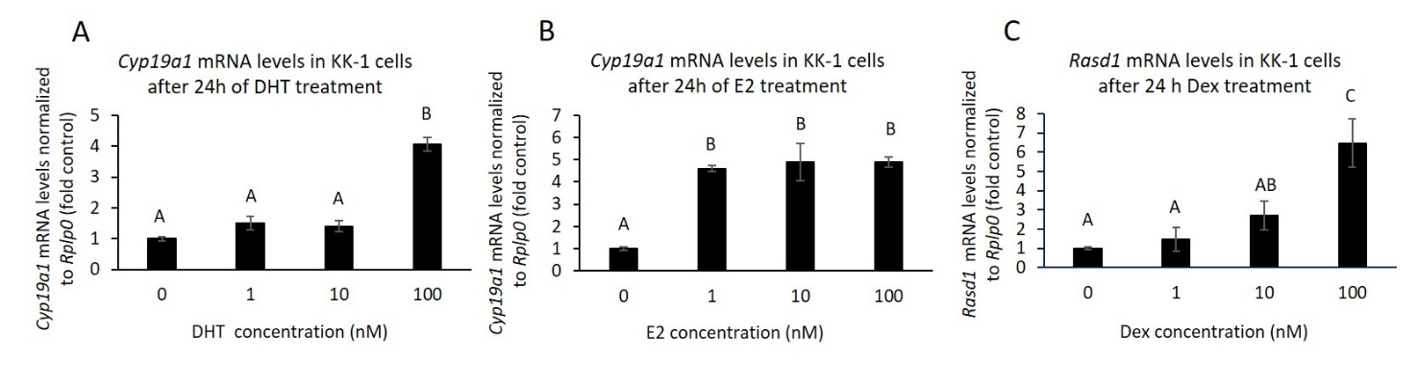
Fig S5: Positive controls for steroid treatments in KK-1 murine ovarian cells. (A-C) The mRNA from the experiments shown in Fig 4 of the main text was used to measure effects of the treatments on positive control genes (A,B) Cyp19A1 and (C) Rasd1. Mean ± SEM is shown, with ANOVA followed by Tukey-Kramer t-test; means sharing the same letter are statistically similar (P>0.05).

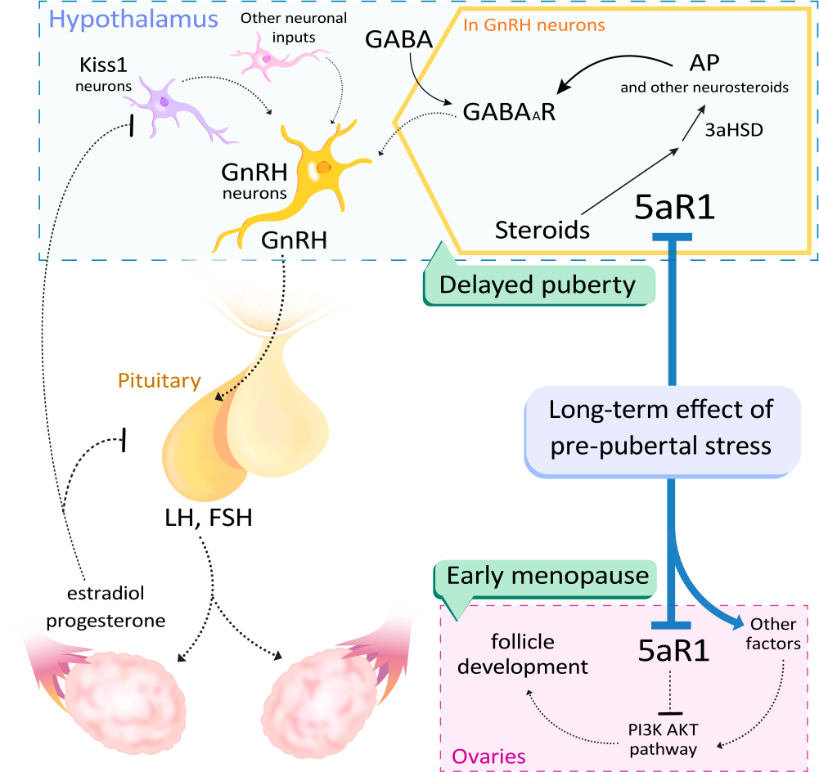

Fig S6: Schematic illustration of the core biological pathways by which early-life stress affects the reproductive axis. Early-life stress reduces Srd5a1 expression in the hypothalamus and ovaries. In the hypothalamus, the reduction in 5α reductase-1 (5aR1) lowers neurosteroid levels which could hamper GnRH secretion via GABA_{A}R, thereby delaying puberty onset. In the ovaries, 5aRa1 reduction would be expected to increase follicle recruitment by altering the PI3K AKT signaling pathway, resulting in faster depletion of the ovarian reserve and earlier menopause in women. Straight black arrows represent enzymatic reactions, curved arrows represent interaction with GABA_{A}R, and dashed arrows or lines represent effects on hormone synthesis or secretion.

