The Musa troglodytarum L. genome provides insights into the mechanism of non-climacteric behaviour and enrichment of carotenoids
Zhiying Li^{1,2,3,4, †}, Jiabin Wang^{1,2,3,4, †}, Yunliu Fu^{1,2,3,4}, Yonglin Jing^{1,2,3,4}, Bilan huang^{1,2,3,4}, Ying Chen⁵, Qinglong Wang¹, , XiaoBing Wang^{1,2,3,4}, Chunyang Meng^{1,2,3,4}, Qingquan Yang^{1,2,3,4} & Li Xu^{1,2,3,4, *}

†These authors contributed equally to this work.
*Corresponding author

Email: xllzy@263.net

1 Institute of Tropical Crop Genetic Resources, Chinese Academy of Tropical Agricultural Sciences, Danzhou 571737, Hainan, China.
2 Ministry of Agriculture Key Laboratory of Crop Gene Resources and Germplasm Enhancement in Southern China, Danzhou, 571737, Hainan, China.
3 Hainan Province Key Laboratory of Tropical Crops Germplasm Resources Genetic Improvement and Innovation, Danzhou 571737, Hainan, China.
4 National Gene Bank of Tropical Crops, Danzhou, 571700, Hainan, China.
5 College of Horticulture and Landscape Architecture, Hainan University, Haikou, 570228, China.

Table S1 Summary of GenomeScope profile on Tongkat with a k-mer of 19.
property | min | max
Homozygous (aa) | 98.4728% | 98.7589%
Heterozygous (ab) | 1.24111% | 1.52722%
aab | 1.24111% | 1.40428%
abc | 0% | 0.122935%
Genome Haploid Length | 651,288,318 bp | 655,194,593 bp
Genome Repeat Length | 374,597,237 bp | 376,843,983 bp
Genome Unique Length | 276,691,081 bp | 278,350,609 bp
Model Fit | 46.0232% | 97.8743%
Read Error Rate | 0.217203% | 0.217203%

Table S2 Summary of GenomeScope profile on karat with a k-mer of 19.
property | min | max
Homozygous (aa) | 98.7271% | 99.0177%
Heterozygous (ab) | 0.982281% | 1.27292%
Genome Haploid Length | 597,280,676 bp | 606,906,342 bp
Genome Repeat Length | 335,016,792 bp | 340,415,861 bp
Genome Unique Length | 262,263,885 bp | 266,490,482 bp
Model Fit | 48.3717% | 98.5423%
Read Error Rate | 0.523735% | 0.523735%

Table S3 summary of short reads of genome sequencing.
Library strategy | Hi-C | WGS
Library layout | PAIRED | PAIRED
Platform | ILLUMINA | ILLUMINA
Instrument | HiSeq X Ten | HiSeq X Ten
Total number of spots | 367575880 | 140,718,186
Total number of bases(bp) | 110,272,764,000 | 42,215,455,800
GC percentage | 41.7% | 40.07%
Insert size peak(bp) | 269 | 269
Read length(bp) | 150 | 150
Depth | 182.6 | 69.9

Table S4 summary of Pacbio reads of genome sequencing.
Library strategy | WGC
Library layout | SINGLE
Platform | PACBIO SMRT
Instrument | PacBio RS II
Total number of spots | 749,340
Total number of bases(bp) | 6,961,206,933
GC percentage | 40.69%
Average length(bp) | 9289.8
Max length(bp) | 213,087
Depth(x) | 11.5

Table S5 summary of Nanopore reads of genome sequencing.
Library strategy | WGC
Library layout | SINGLE
Platform | OXFORD NANOPORE
Instrument | PromethION
Total number of spots | 1,946,752
Total number of bases(bp) | 42,304,446,276
GC percentage | 39.20%
Average length(bp) | 21,730.8
Max length(bp) | 203,887
Base calling | Guppy v3.2.2
N50(bp) | 28,726
Depth(x) | 70.0

Table S6 Summary of BUSCO analysis of contigs before Purge Haplotigs processing (C:98.4%).

418 | Complete BUSCOs (C)
249 | Complete and single-copy BUSCOs (S)
169 | Complete and duplicated BUSCOs (D)
4 | Fragmented BUSCOs (F)
3 | Missing BUSCOs (M)
425 | Total BUSCO groups searched

Table S7 summary contigs after Purge Haplotigs processing and correction of chimeric contigs using ALLHIC_correcter.
contigs (>= 0 bp) | 1150
contigs (>= 1000 bp) | 1150
contigs (>= 5000 bp) | 712
contigs (>= 10000 bp) | 661
contigs (>= 25000 bp) | 596
contigs (>= 50000 bp) | 553
Largest contig | 43024999
Total length | 603485406
Total length (>= 0 bp) | 603485406
Total length (>= 1000 bp) | 603485406
Total length (>= 5000 bp) | 602813406
Total length (>= 10000 bp) | 602483406
Total length (>= 25000 bp) | 601517406
Total length (>= 50000 bp) | 600056406
N50 | 6002247
N75 | 1817000
L50 | 24
L75 | 68
GC (%) | 39.58

Table S8 Summary of BUSCO analysis of genome (C:97.7%).
415 | Complete BUSCOs (C)
393 | Complete and single-copy BUSCOs (S)
22 | Complete and duplicated BUSCOs (D)
5 | Fragmented BUSCOs (F)
5 | Missing BUSCOs (M)
425 | Total BUSCO groups searched

Table S9 summary of protein-coding genes of M. troglodytarum.
Protein coding gene number | 37,577
Total length of protein coding gene (bp) | 192,766,275
Average length of protein coding gene (bp) | 5,129
Total exon length (bp) | 64,862,008
Average length of exon (bp) | 316
Total intron length (bp) | 127,904,267
Average length of intron (bp) | 818
Genes with alternative splice transcripts | 13,357
Genes with one more exon | 31,360

Table S10 Summary of BUSCO analysis of predicted gene (C:92.5%).
393 | Complete BUSCOs (C)
203 | Complete and single-copy BUSCOs (S)
190 | Complete and duplicated BUSCOs (D)
24 | Fragmented BUSCOs (F)
8 | Missing BUSCOs (M)
425 | Total BUSCO groups searched

Table S11 Summary of Repeat content of genome.
 |  | Number | length | % of repeats | % of geneome
 | Repeats total | 201646 | 367133459 | 100 | 60.8338
LTR Retrotransposon | Gypsy | 11839 | 90963345 | 24.77664 | 15.07257
LTR Retrotransposon | Copia | 22314 | 219749689 | 59.85553 | 36.4124
LTR Retrotransposon | unknown | 2628 | 10755024 | 2.929459 | 1.782101
Retrotransposon | LINE | 4984 | 3343741 | 0.9107699 | 0.554056
Retrotransposon | SINE | 1 | 59 | 1.607045e-05 | 9.776266e-06
Unclassified retroelement | Unknown | 54756 | 32663669 | 8.896947 | 5.412351
DNA | hAT-Ac | 529 | 301732 | 0.08218592 | 0.04999682
DNA | hAT-Tag1 | 1573 | 2047178 | 0.5576114 | 0.3392162
DNA | MuLE-MuDR | 502 | 304752 | 0.08300851 | 0.05049723
TE total |  | 99126 | 359824437 | 98.00916 | 59.6227
 | Simple_repeat | 102520 | 7309022 | 1.990835 | 1.211101

Table S12 Summary of SNP and Indel sites of Karat and Tongka
Tongka INDEL sites | 459,137
karat INDEL sites | 516,884
Tongka and karat sharing INDEL sites | 237,581
Tongka SNP sites | 7,716,375
karat SNP sites | 7,125,857
Tongka and karat sharing SNP sites | 4,519,827

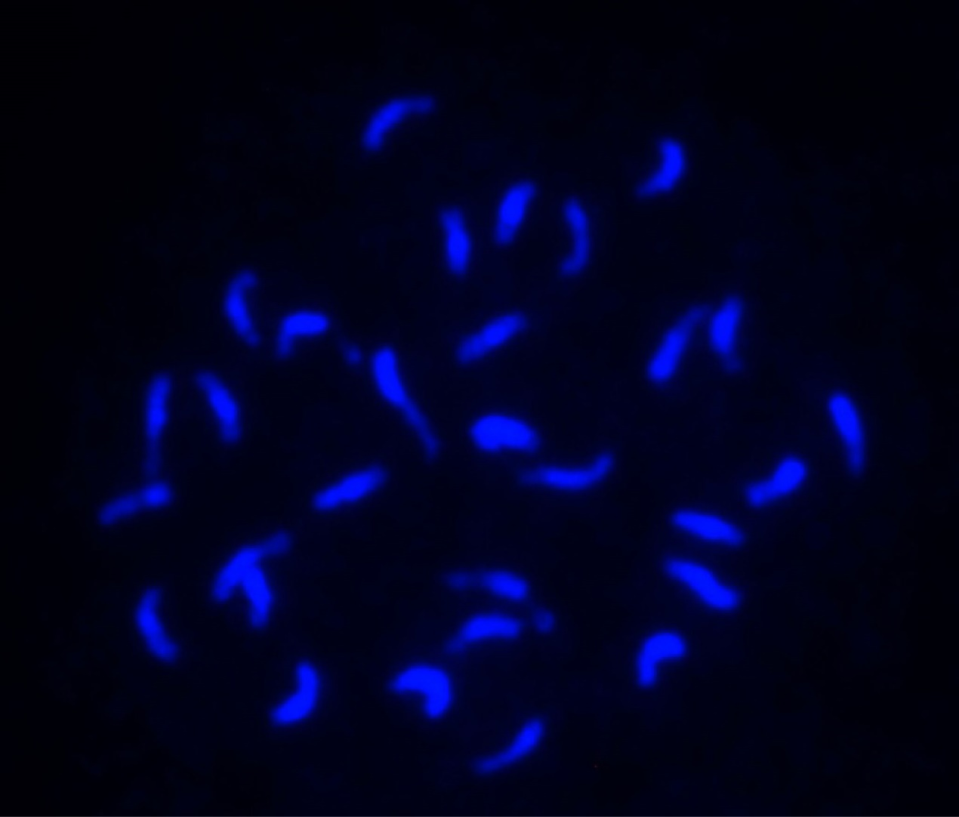
Figure S1 Fluorescent staining of chromosomes of Musa troglodytarum L. karat. The root tip of. karat plants staining with DPAI and screened under ultraviolet and fluorescence microscopy.

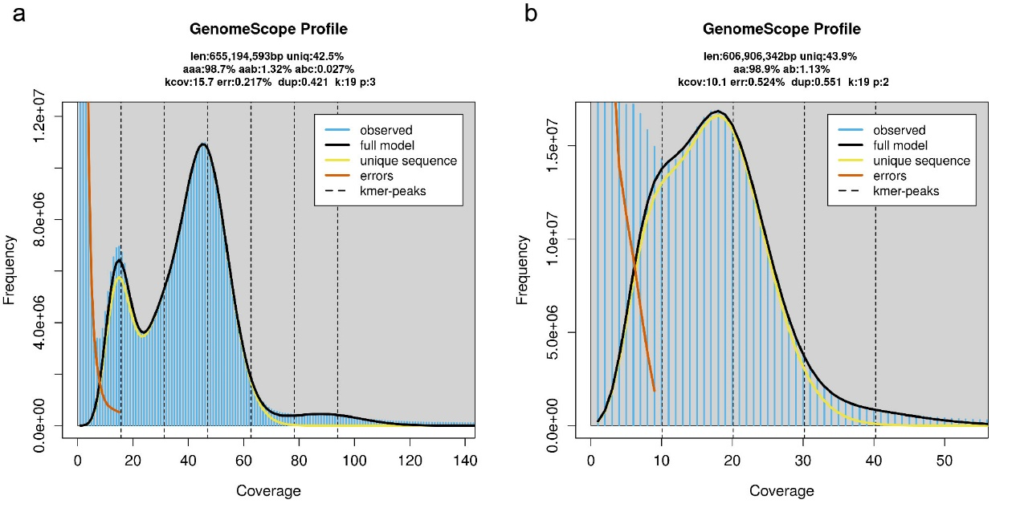
Figure S2 GenomeScope profile of karat and tongkat.

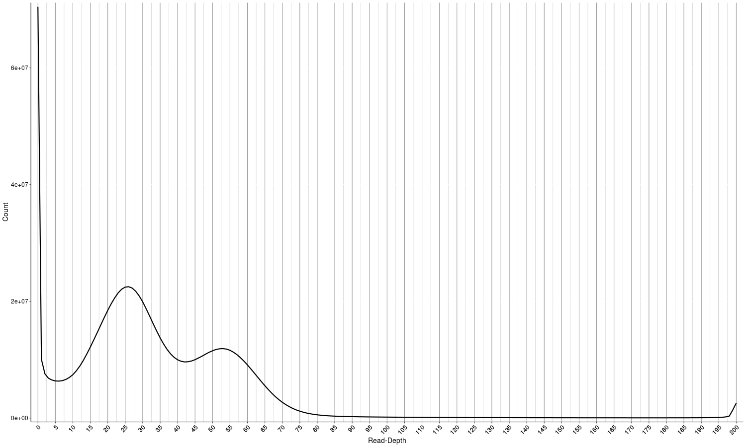
Figure S3 Bimodal histogram for Purge Haplotigs processing. The cutoff values for low, mid, and high points were 6,42 and 105, respectively.
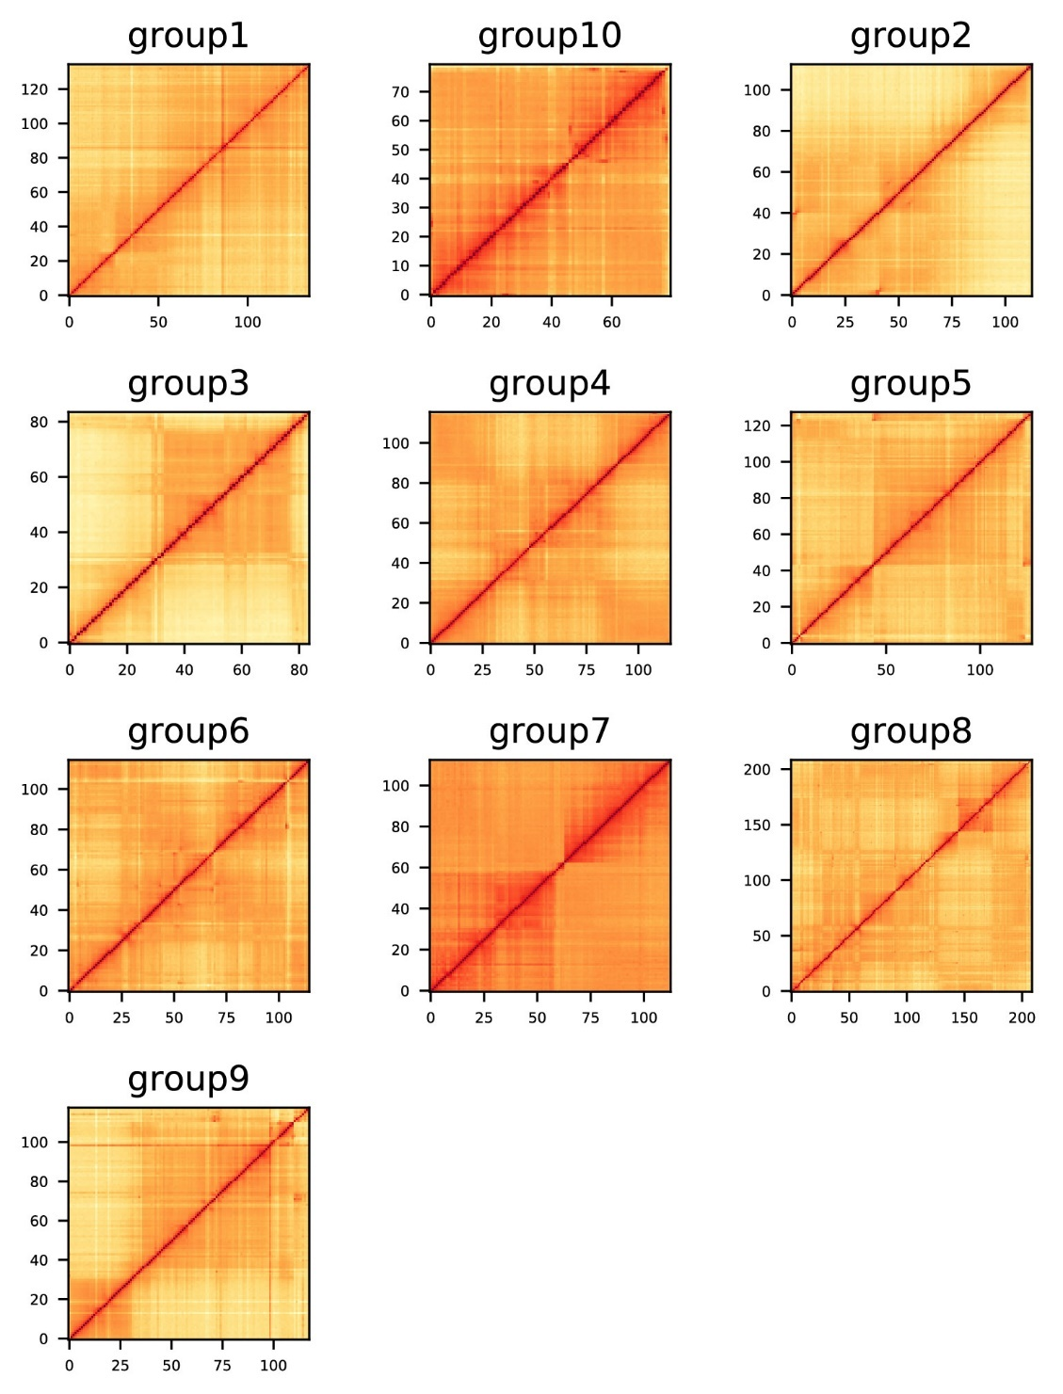
Figure S4 Hi-C mapping of chromosomes of the T genome.

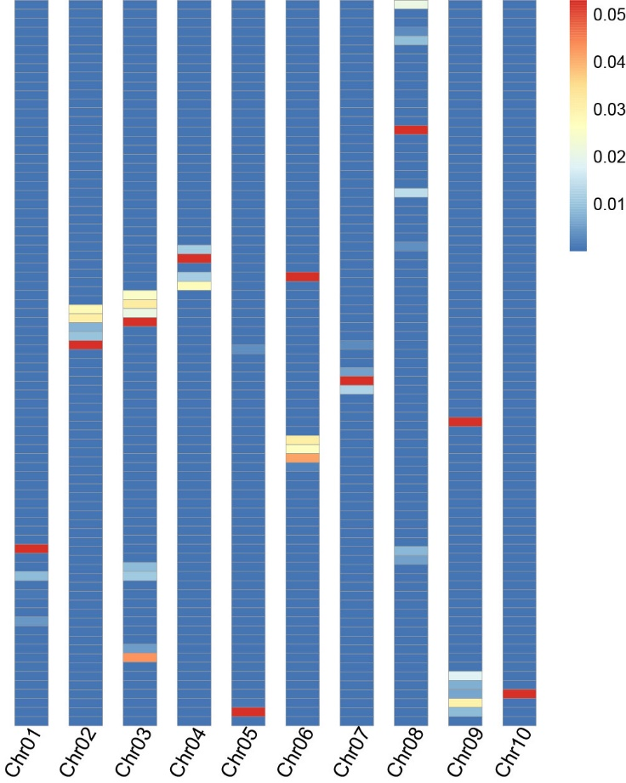
Figure S5 Heatmap of density of Nanica LINE.

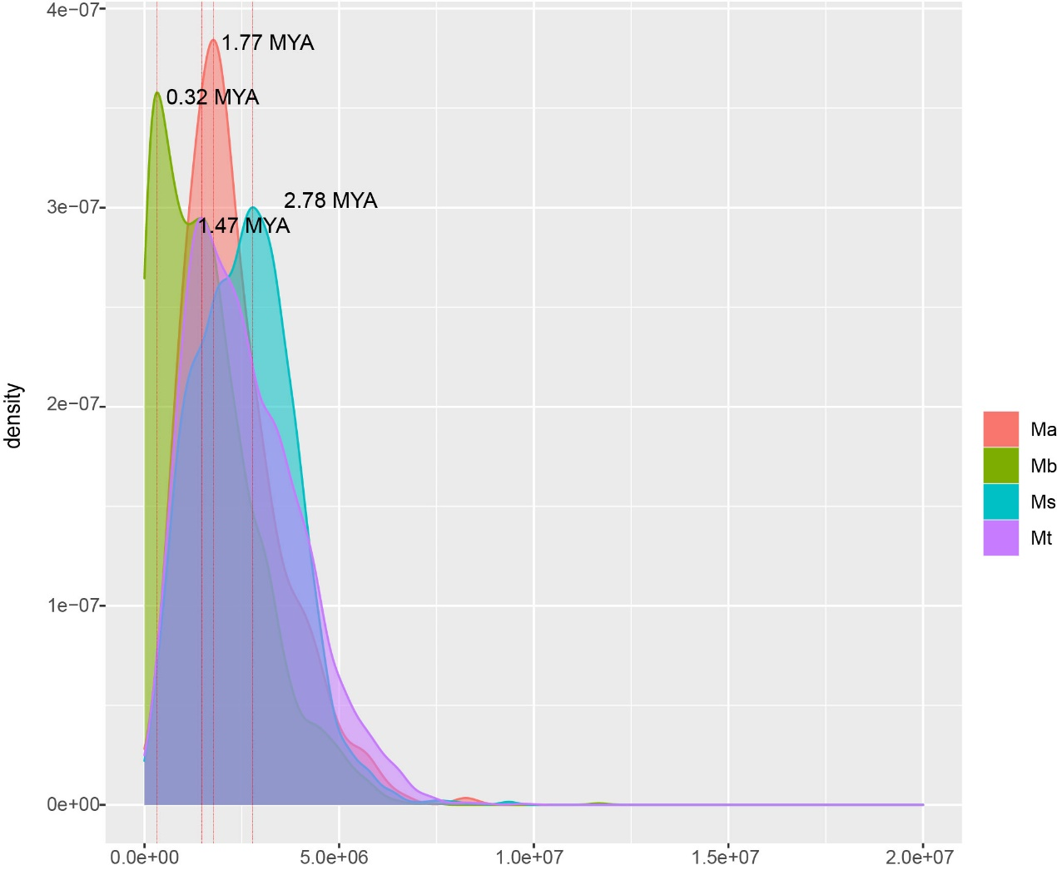
Figure S6 Analysis of LTR insertion times of the A, B, S and T genomes. Ma, Musa acuminata; Mb, Musa balbisiana; Ms, Musa schizocarpa; and Mt, Musa troglodytarum.

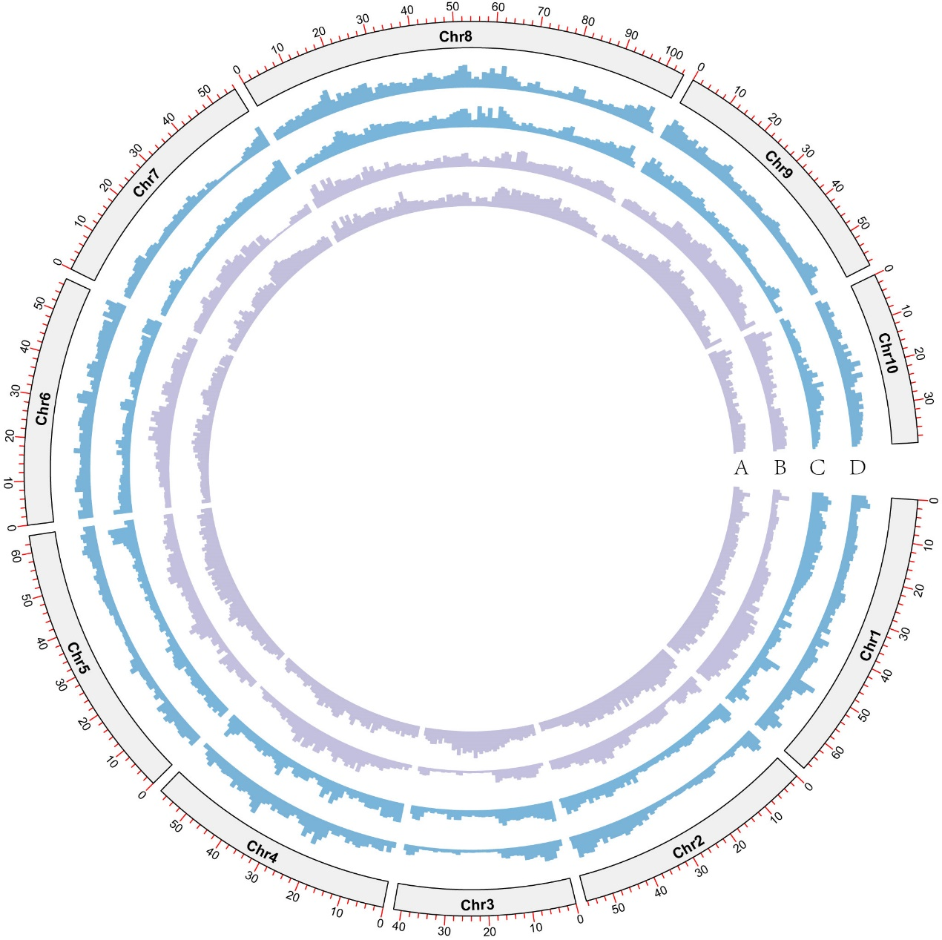
Figure S7 Distribution of SNP and indel sites in karat and tongkat. Indel sites in tongkat (A) and karat (B) and SNP sites in tongkat (C) and karat (D).
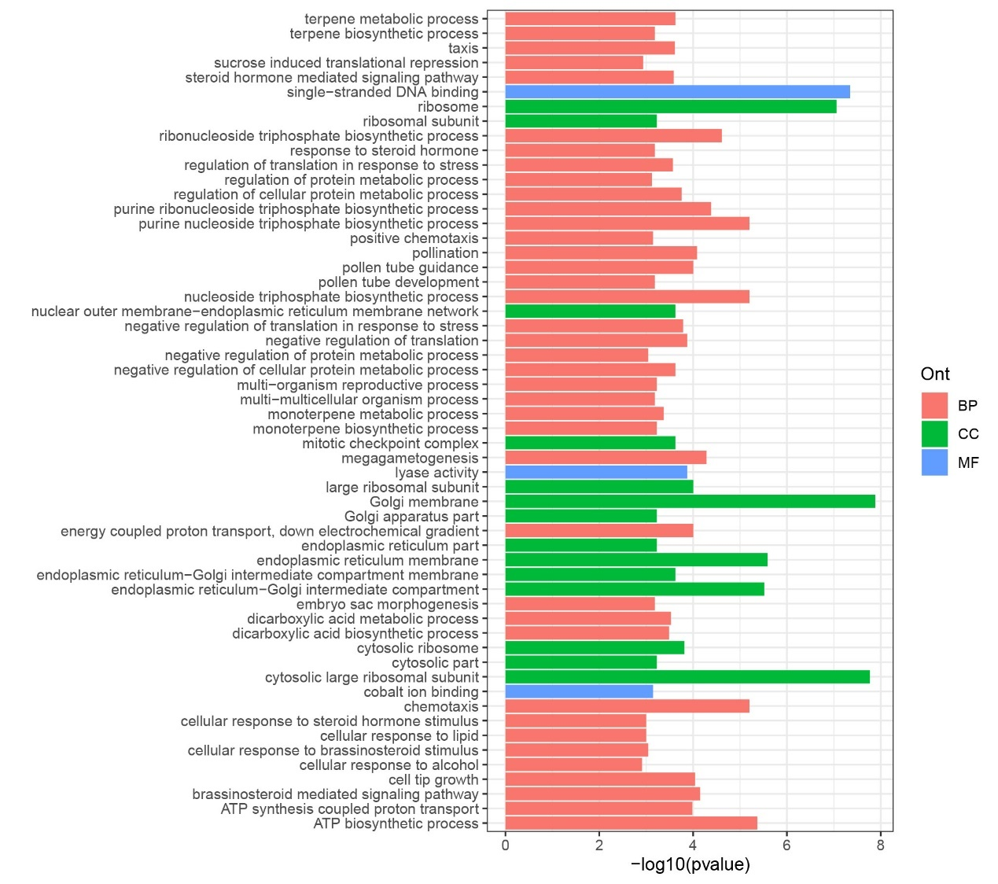
Figure S8 GO enrichment analysis of T genome specific genes.
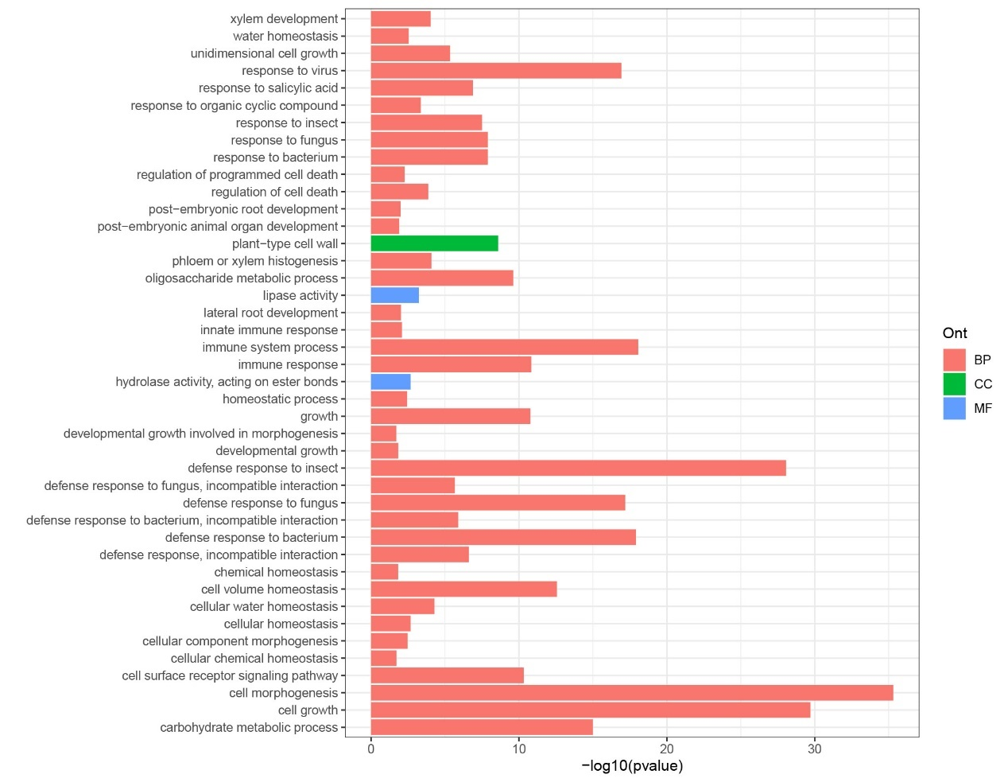
Figure S9 GO enrichment analysis rapidly evolving gene families in T genome.

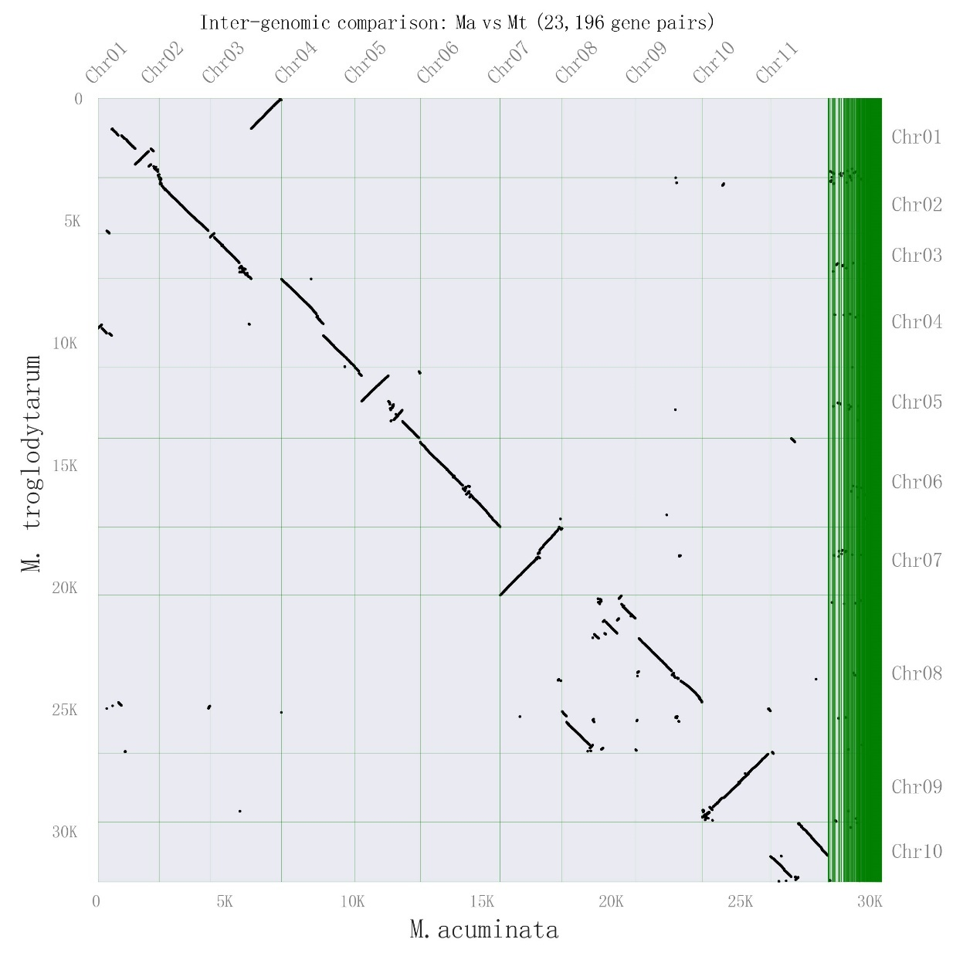
Figure S10 Dot plot of syntenic bocks between M. troglodytarum and M. acuminata.

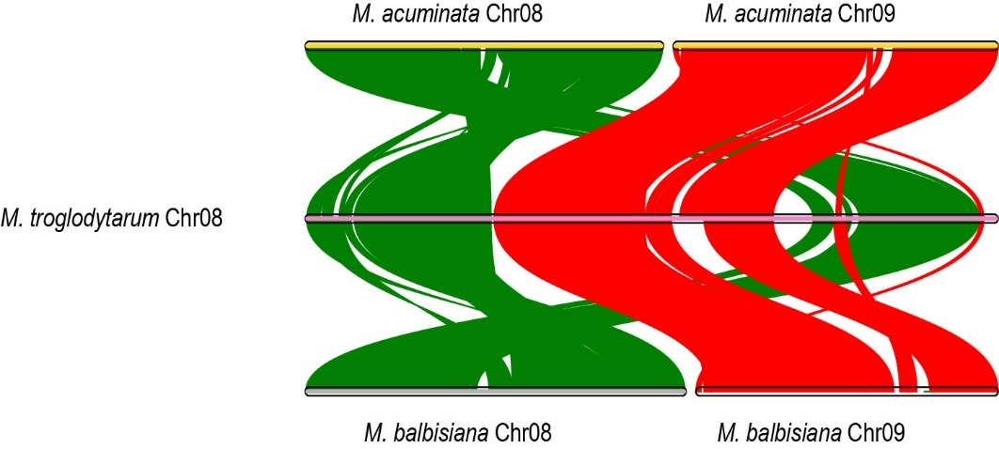
Figure S11 Synteny map of chromosome 8 and 9 among M. troglodytarum, M. acuminata and M. balbisiana.

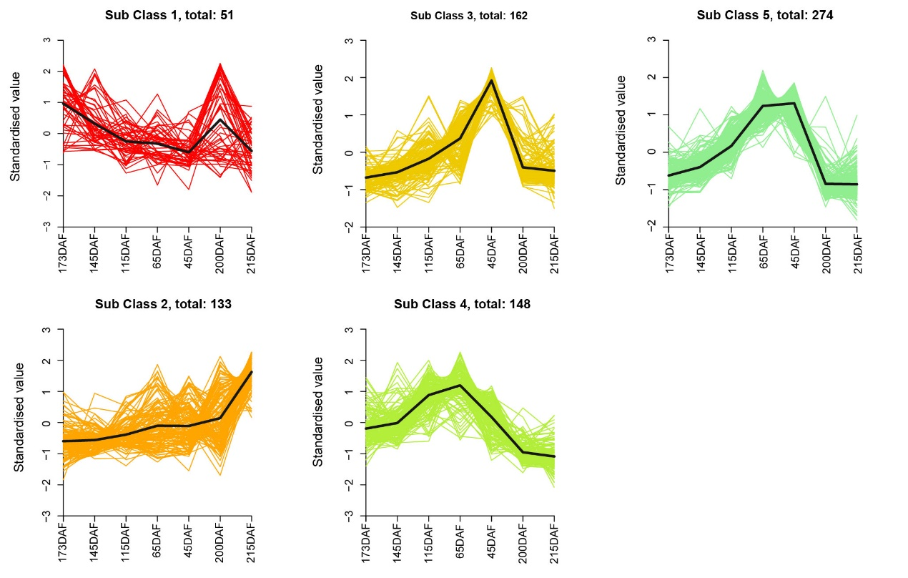
Figure S12 Clusters of metabolites in karat fruit pulp. DAF, days after flowering.

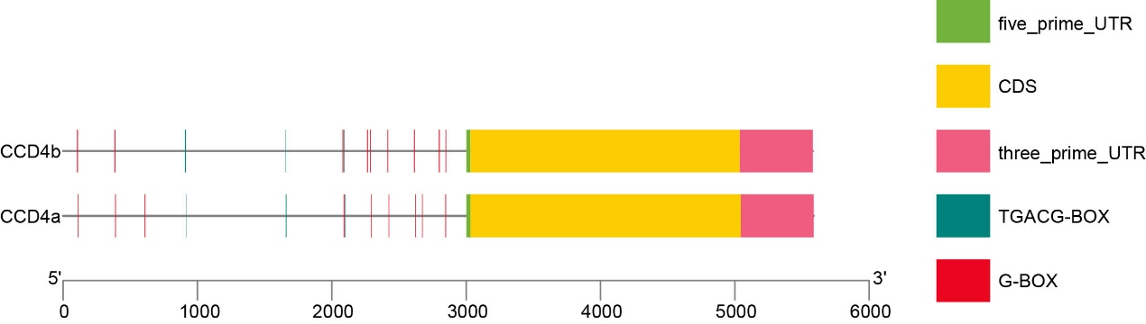
Figure S13 The distribution of JA response element G-box and TGACG-box motifs in the promoters of MtCCD4s.

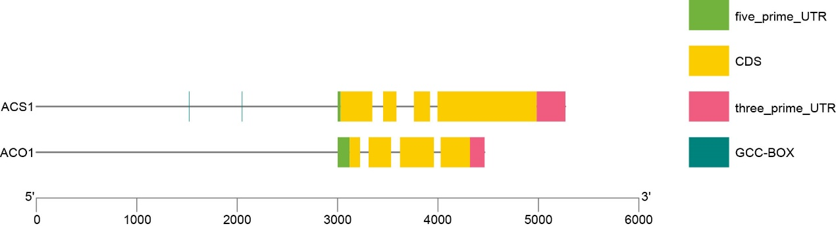
Figure S14 The distribution of GCC-boxes in the promoters of MtACO1 and MtACS1.

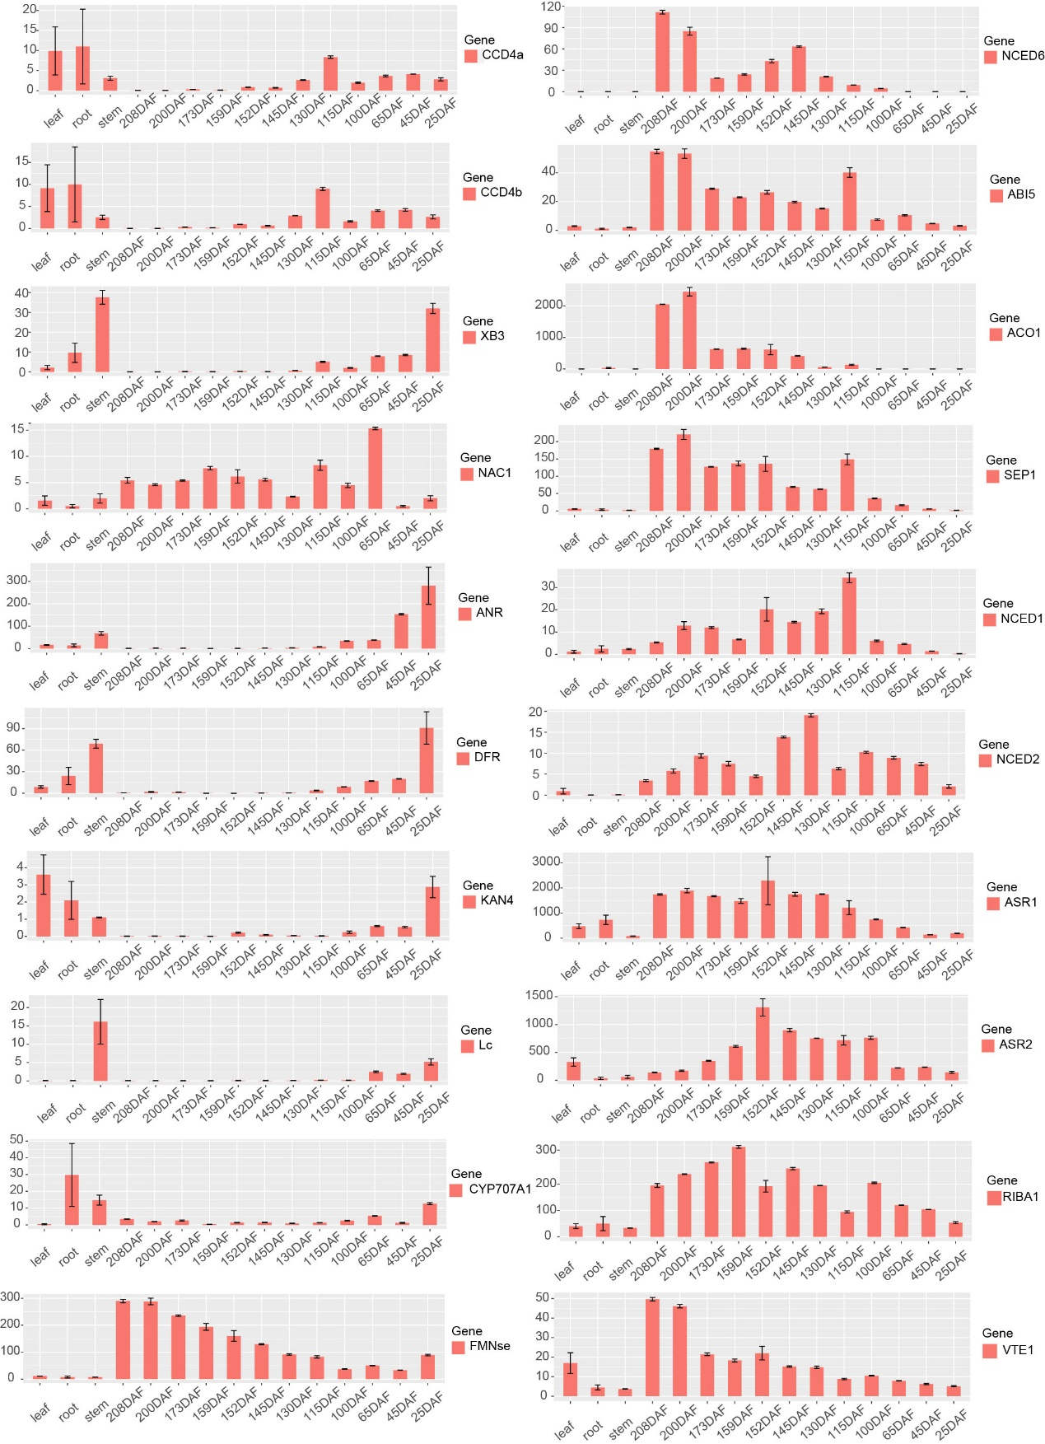
Figure S15 Expression patterns of genes involved in karat fruit ripening. Gene expression was normalized to FPKM (fragments per kilobase of transcript per million read pairs). DAF, days after flowering.

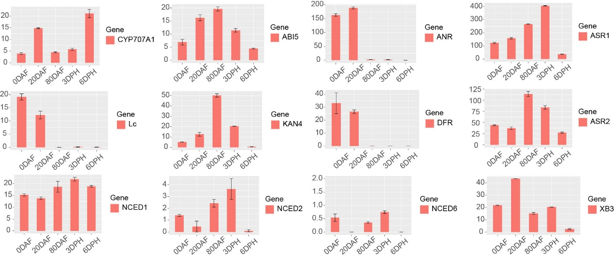
Figure S16 Expression patterns of genes involved in FJ fruit ripening. Gene expression was normalized to FPKM (fragments per kilobase of transcript per million read pairs). FJ (Fen jiao), dwarf banana. DAF, days after flowering. DPH, days post-harvest.

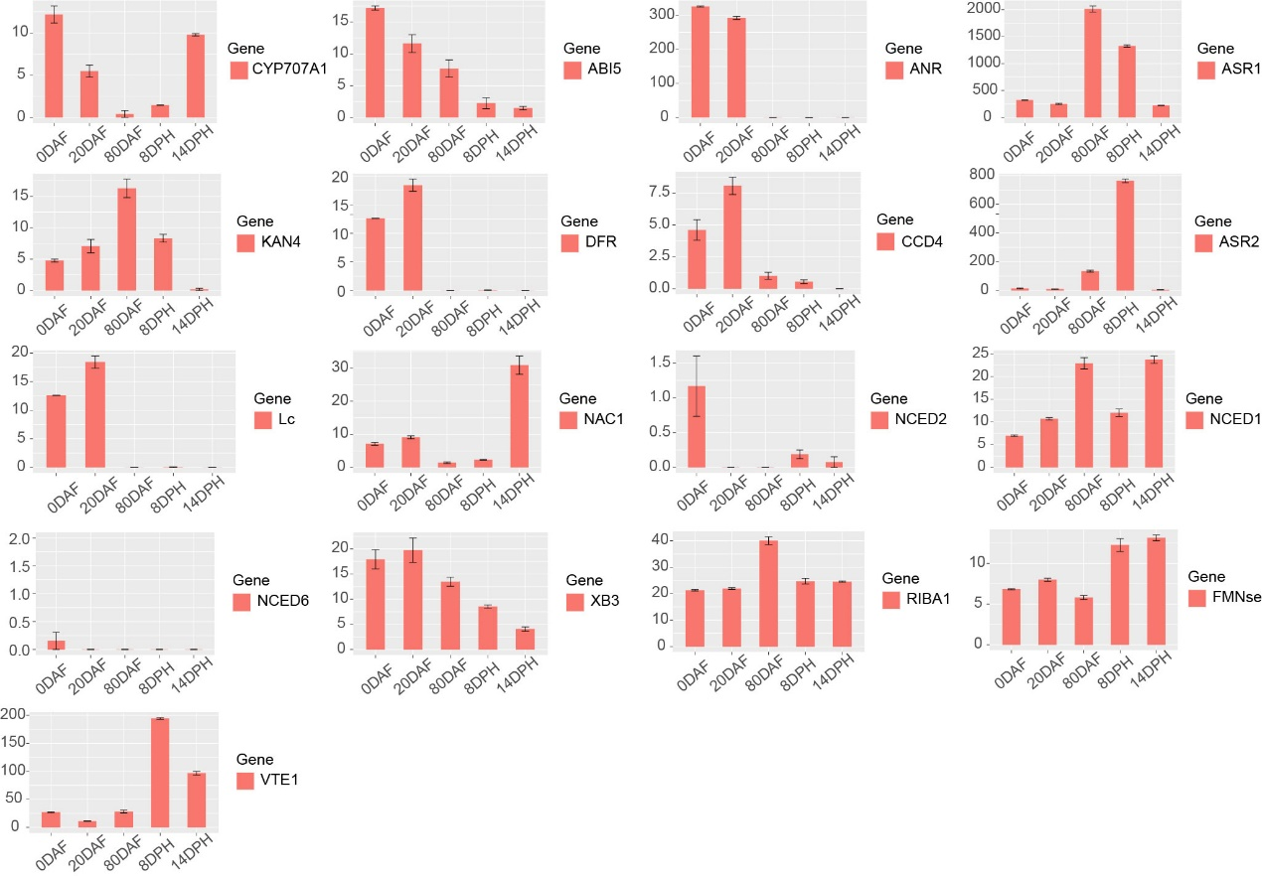
Figure S17 Expression patterns of genes involved in BXJ fruit ripening. Gene expression was normalized to FPKM (fragments per kilobase of transcript per million read pairs). BXJ (BaXi Jiao), Cavendish banana.

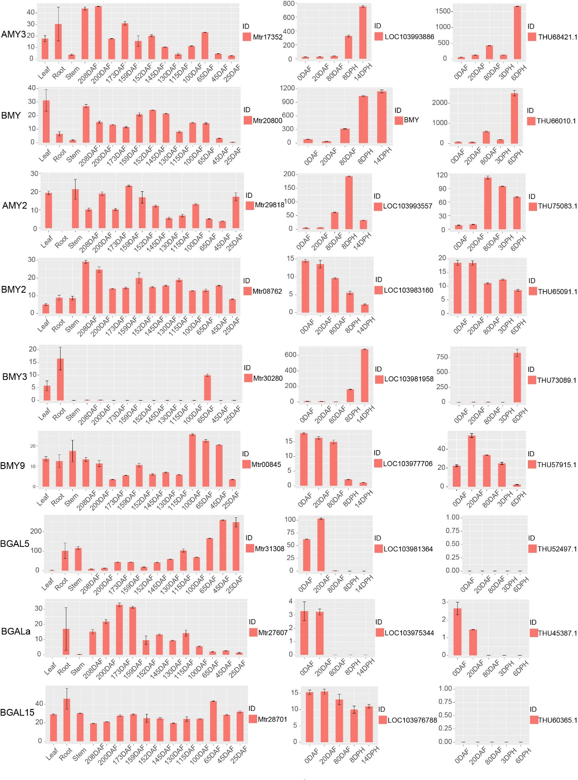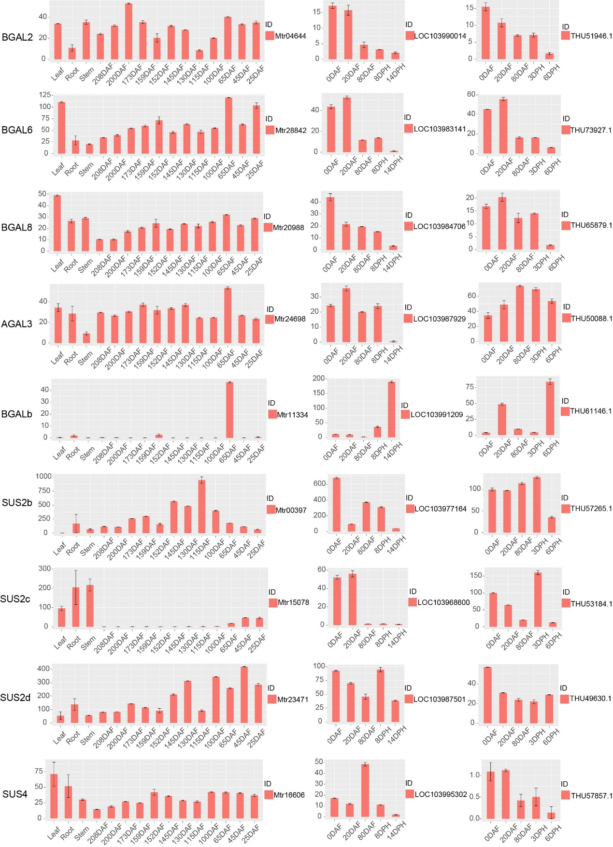
Figure S18 Expression patterns of genes involved in starch degradation and galactose accumulation. The gene IDs of M. troglodytarum, M. acuminata and M. balbisiana start with ‘Mt’, ‘LOC’ and ‘THU’, respectively. Gene expression was normalized to FPKM (fragments per kilobase of transcript per million read pairs).

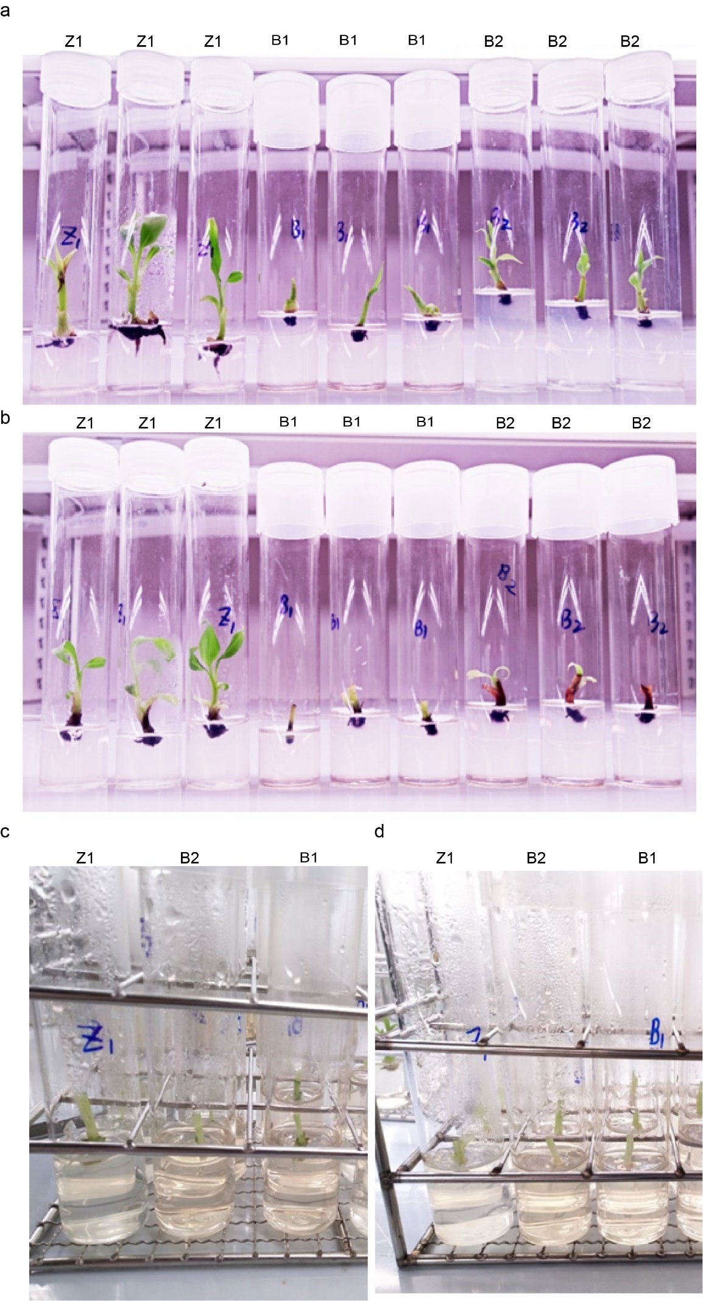
Figure S19 The effect of exogenous application free galactose on shoot buds of karat and BXJ. The shoot buds of karat (a) and BXJ (b) grown 20 days under a controlled environment (10 h light, 35% relative humidity and 25 °C). The karat (c)and BXJ (d) shoot buds (2-3 cm) were transferred into half-strength MS supplemented with Gal (10 mM, B2; and 100 mM, B1) and sucrose (10 mM, Z1), respectively. BXJ (BaXi Jiao), Cavendish banana.

