Fig. S1
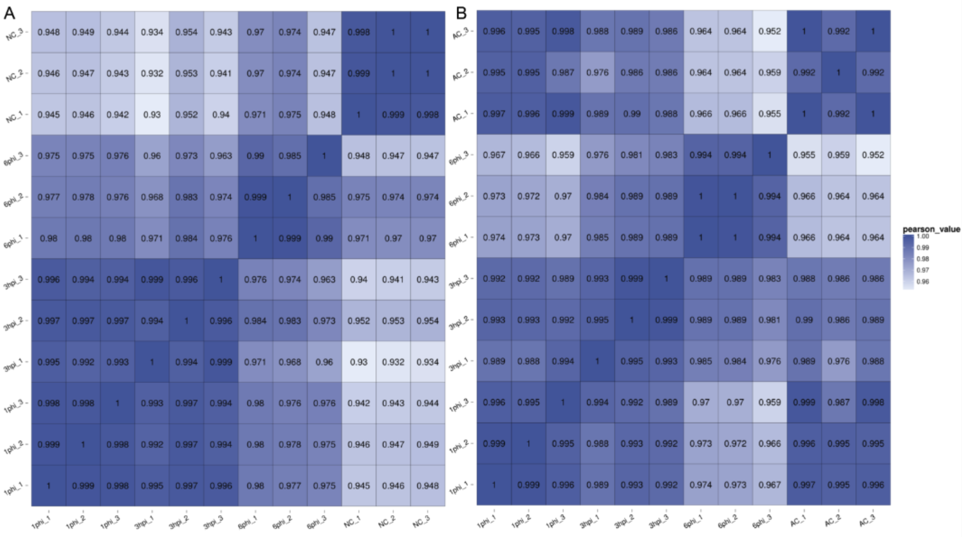

Fig. S2

Fig. S3

Fig. S4

Fig. S5
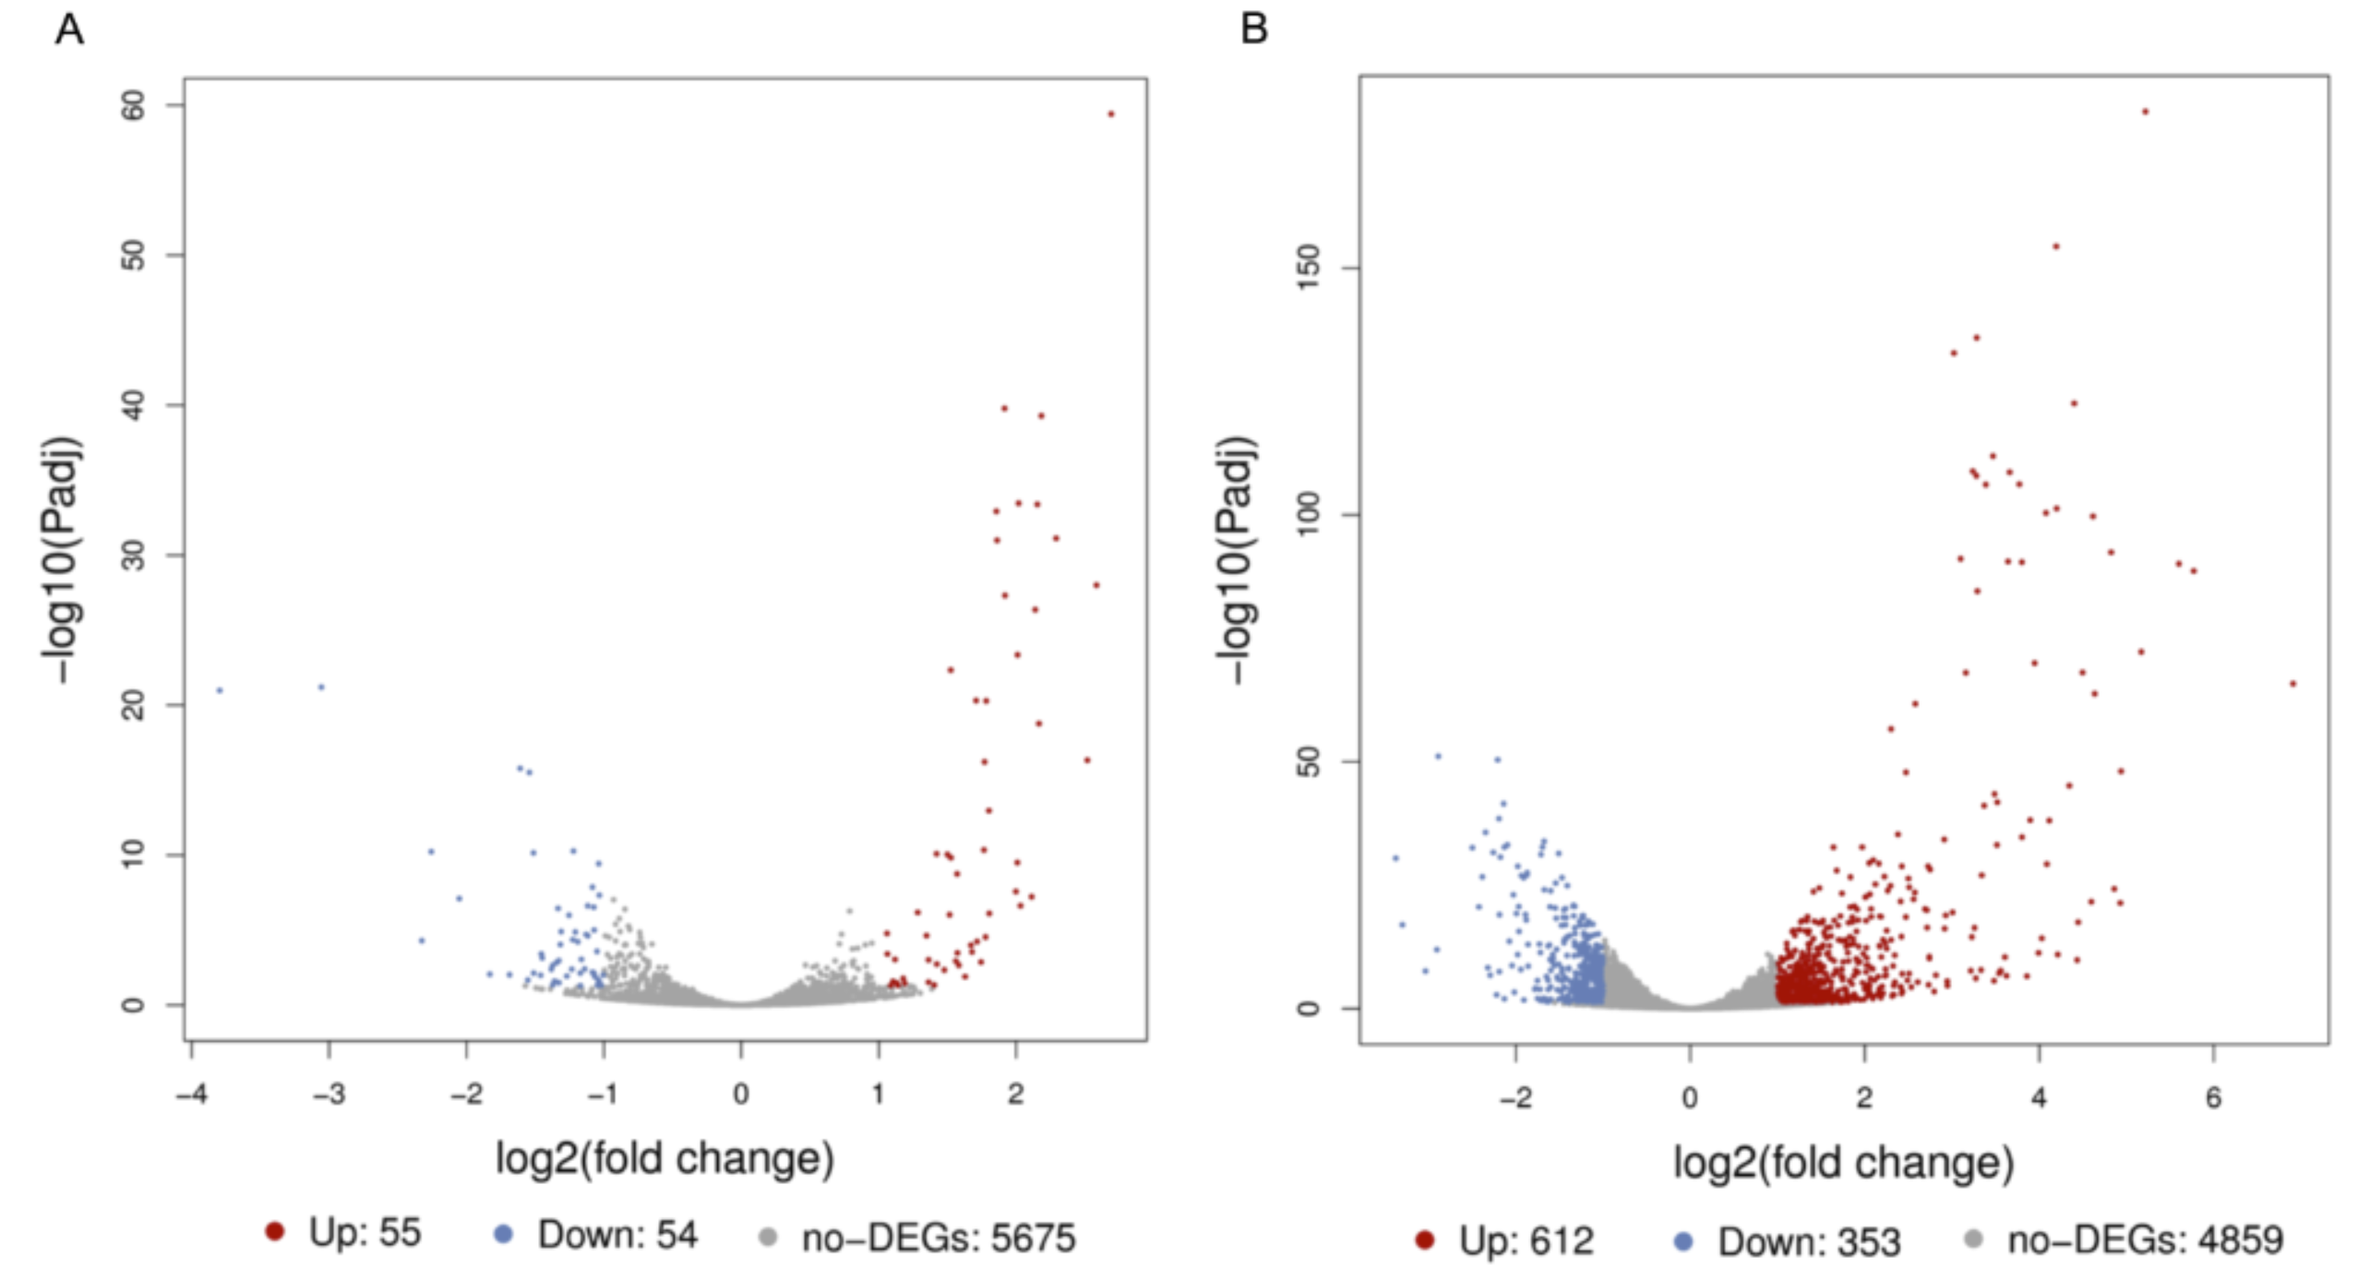

Fig. S6

Fig. S7

Fig. S8
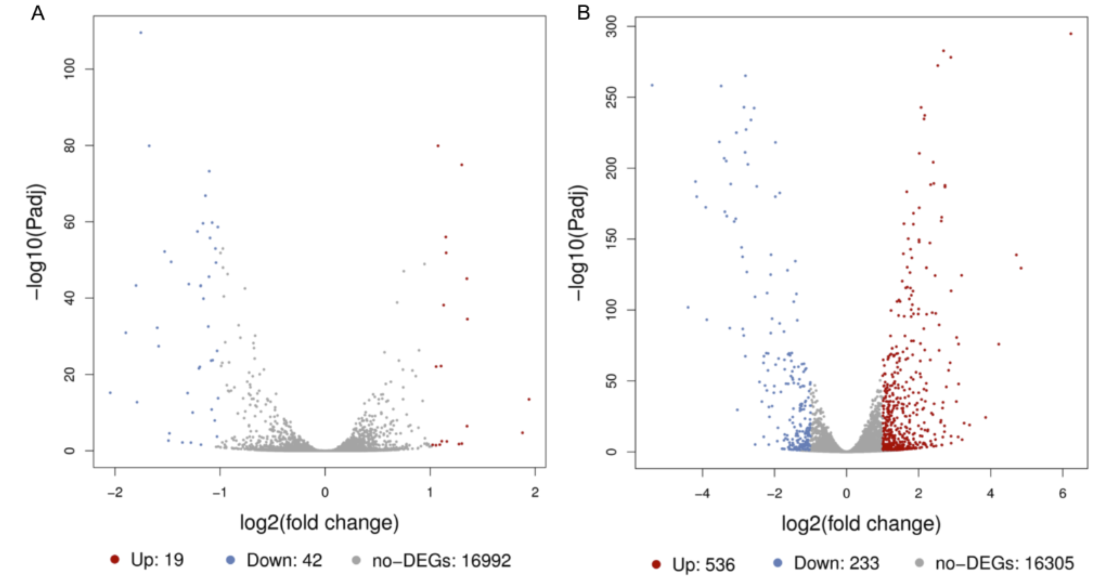

Fig. S9
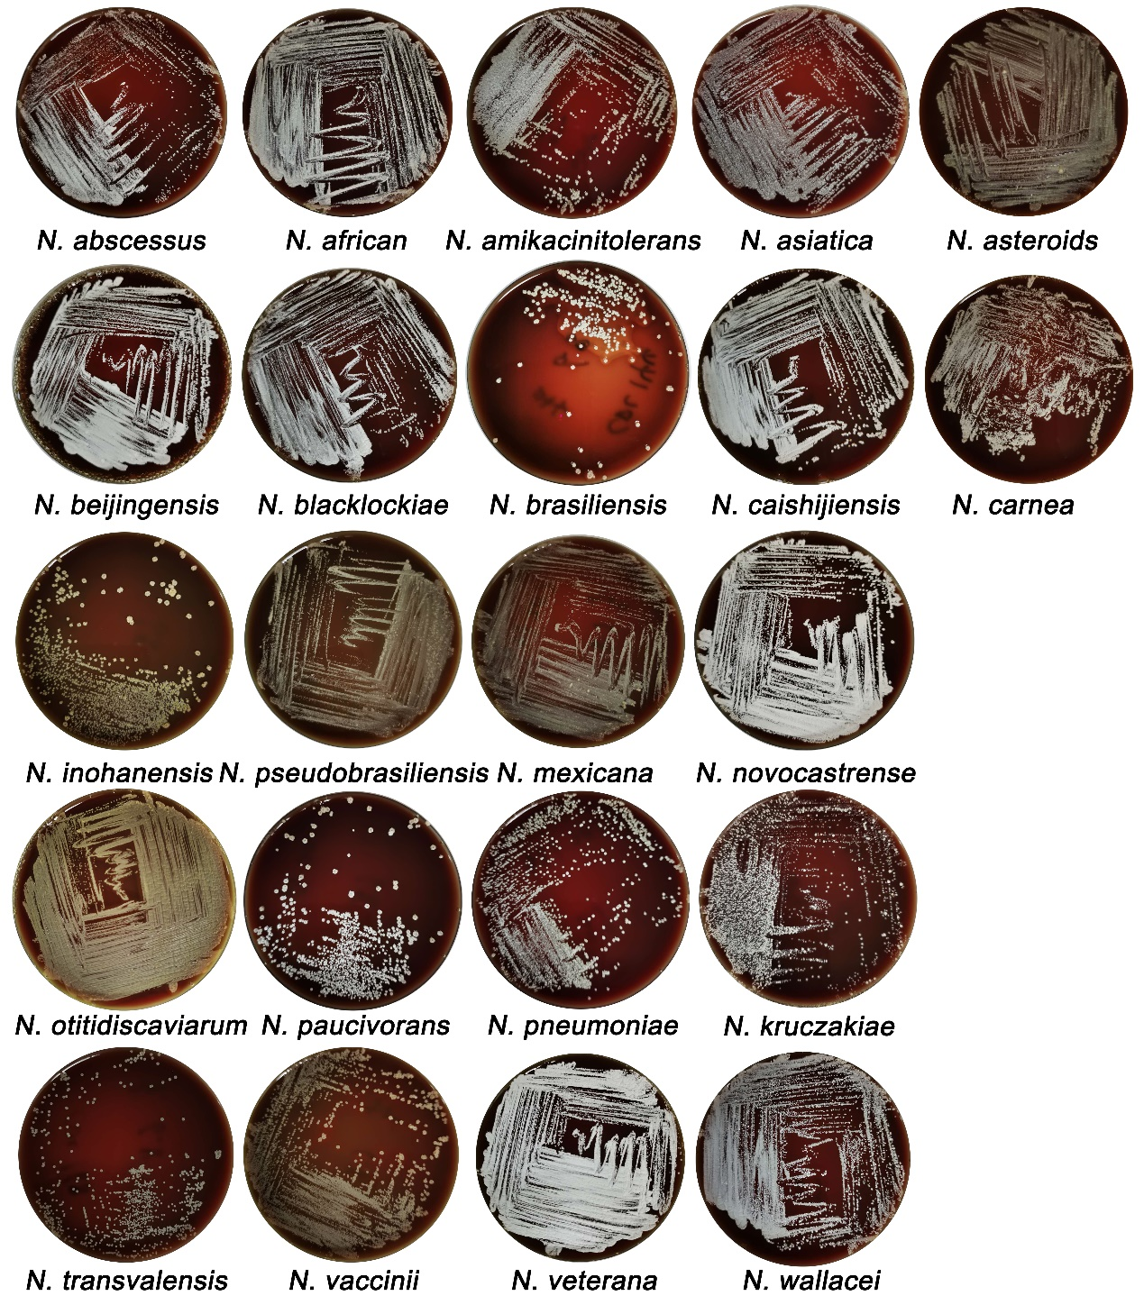

Fig. S10

Fig. S11

Additional file 1: Figure legends
Fig. S1 Heat map of the Pearson correlation of gene expression between samples for RNA-seq data. A: Nocardia farcinica; B: A549 cells.
Fig. S2 KEGG pathway analysis of DEGs for N. farcinica (A) and A549 cells (B).
Fig. S3 KEGG pathway analysis. A: A549 cells; B: Nocardia farcinica
Fig. S4 Validation of RNA-seq via qRT–PCR. a RNA-seq gene expression was verified by qRT–PCR. RNA-seq, the data for dual RNA-seq. qRT–PCR, RNA sample used for sequencing. R-qRT–PCR, RNA sample from the repeated experiment. b Correlation analysis of data obtained by RNA-seq and qRT–PCR.
Fig. S5 Volcano plot obtained from DESeq2 analysis of DEGs from Nocardia farcinica. A: The DEGs of 3 hpi compared to 1hpi; B: The DEGs of 6 hpi compared to 1hpi.
Fig. S6 KEGG pathway analysis of Nocardia at 3 hpi and 6 hpi.
Fig. S7 Analysis of the N. farcinica mutant strains. A: The deletion of genes was verified using PCR. The genomes from wild-type and mutant strains were extracted and amplified using primers. The size of the amplified fragment was detected by electrophoresis. B: The bacteria load in BV2 cells 18 h post infection (Student’s two-tailed T-test, ns: p>0.05, mean and SD).
Fig. S8 Volcano plot obtained from DESeq2 analysis of DEGs from A549 cells. A: The DEGs of 3 hpi compared to 1hpi; B: The DEGs of 6 hpi compared to 1hpi.
Fig. S9 The colony status of the Nocardia strains on the blood plate.
Fig. S10 Analysis of inflammatory factors in serum and brain. The brains of mice were isolated and ground post-infection with N. farcinica, and inflammatory factors were analyzed at different times (Student’s two-tailed T-test, ***p＜0.01, error bars represent SD).
Fig. S11 Original gel images with indicated figures.

Table S1 Primers used for qRT-PCR amplification
Genes | Primer | Sequence (5′ to 3′)
DDIT4 | F | GGTTTGACCGCTCCACGAG
DDIT4 | R | GGTAAGCCGTGTCTTCCTCC
CTGF | F | GGAGTGGGTGTGTGACGAG
CTGF | R | CTTCCAGTCGGTAAGCCGC
EGLN3 | F | ATCGTTCCCTCTCTGGTTGC
EGLN3 | R | CCATTGCCTCGTGCAGACA
ARRDC3 | F | CCGACACCACCTAAATGCGG
ARRDC3 | R | TGAGGTAGCGAGTGGTGTCT
PDK1 | F | CTCAGGACACCATCCGTTCA
PDK1 | R | ACCATGTTCTTCTAGGCCTTTCAT
ANGPTL4 | F | CCTCTCCGTACCCTTCTCCA
ANGPTL4 | R | AAACCACCAGCCTCCAGAGA
EFNA3 | F | ACAGCCCCATCAAGTTCTCG
EFNA3 | R | GAGTGGGCGTGGAGATGTAG
ENO2 | F | TGCACAGGCCAGATCAAGAC
ENO2 | R | ACAGCACACTGGGATTACGG
FOS | F | GGGGCAAGGTGGAACAGTTA
FOS | R | AGTTGGTCTGTCTCCGCTTG
GYS1 | F | CGAATGGGGCGACAACTACT
GYS1 | R | TCTGTGCCAGGAACTTGCAG
ITGB3 | F | TTGGAGACACGGTGAGCTTC
ITGB3 | R | GCCCACGGGCTTTATGGTAA
MDM2 | F | AGGAGATTTGTTTGGCGTGC
MDM2 | R | TGAGTCCGATGATTCCTGCTG
PDGFA | F | ACTCCTGGAGATAGACTCCGT
PDGFA | R | GGACAGCTTCCTCGATGCTT
HIF1A | F | AAATGAGCTCCCAATGTCGG
HIF1A | R | CGACGTTCAGAACTTATCCTACCAT
VGLL3 | F | TCCAGGGAGACATTGGGTCA
VGLL3 | R | CTGAGCTGTCTCGCCATAGG
CACNA1B | F | CCCACAGGGCAGTGGTTC
CACNA1B | R | GTTGGCCGTCTTGTAGGTGA
PPP2R5B | F | TAGGTTTTCGAGAAAGCCAGGG
PPP2R5B | R | GGGTAGAAAGGAGGATGGCT
LRP1 | F | GGACCGCTCTGATGAGTCTG
LRP1 | R | CAGTCATTGTCATTGTCGCATCT
APAF1 | F | CTTCTTCCAGTGTAAGGACAGT
APAF1 | R | GACCCATCCTGGTTCACCTT
DNAH11 | F | TTGGAAAGCGAGGACAACCG
DNAH11 | R | GCATCTCTTGGAATCTCCTGG
LOC101928841 | F | TTTCAGGAGGCTTTGAGGGG
LOC101928841 | R | CTTGCTGCTCTTCCGGCTTG
NFA_RS22680 | F | GACCGCCGAACTGGACACGA
NFA_RS22680 | R | GCCGAAACCGAAGGTCTTGC
NFA_RS10860 | F | GGGCTACCGCAAGACCCTCA
NFA_RS10860 | R | GGGTGATCCAGTTGCCCTCC
NFA_RS14450 | F | GGACTGGGCCGACGACTACG
NFA_RS14450 | R | CCACAGCAGGCGAACCGA
NFA_RS04505 | F | CGCCCAGAGCTTCGACTACC
NFA_RS04505 | R | CGATGGAGGATGCGACCAGAT
NFA_RS22305 | F | GCGGCTGCACTTCTACGCG
NFA_RS22305 | R | CGACCTGTTCGAGGGTGGG
NFA_RS21680 | F | ATGACCACCGTGGAAACCC
NFA_RS21680 | R | CCCGCAACGACTCGATGTAC
NFA_RS22680 | F | GACCGCCGAACTGGACACGA
NFA_RS22680 | R | GCCGAAACCGAAGGTCTTGC
NFA_RS10860 | F | GGGCTACCGCAAGACCCTCA
NFA_RS10860 | R | GGGTGATCCAGTTGCCCTCC
NFA_RS14450 | F | GGACTGGGCCGACGACTACG
NFA_RS14450 | R | CCACAGCAGGCGAACCGA
NFA_RS25335 | F | ACGCCTACACCCTCACCTTCG
NFA_RS25335 | R | TGGTCATCGAGTCCGACAAGG

Table S2 Primers used for construction of N. farcinica deletion mutants
Genes | Primer | Sequence (5′ to 3′)
NFA_RS03935 up | F | CAGAGAATTCCAGGGGACGGCCGATCCAG
NFA_RS03935 up | R | AACTCGATGACTGCGCTGGCGTGTGCACCCTCCTTCAT
NFA_RS03935 down | F | ATGAAGGAGGGTGCACACGCCAGCGCAGTCATCGAGTT
NFA_RS03935 down | R | TACCAAGCTTCACATTGCGCACCACCGGA
NFA_RS03935 | F | TTGATCGGGATCGGCACGTTGG
NFA_RS03935 | R | AAGGCGATGCCCAACCATTTCA
NFA_RS11335 up | F | ATGAGGATCCAGATCCAGCCCGGCCTCGCCCGC
NFA_RS11335 up | R | GTCCATGAGGTTGCCTCTCCTGTCCGGCGAACGCGATCTGTCTTTCCC
NFA_RS11335 down | F | AGCCGGGCTCGCGGGAAAGACAGATCGCGTTCGCCGGACAGGAGAGGC
NFA_RS11335 down | R | CATGAAGCTTTGGTGGTCTTGCCACAGCCGCTGGG
NFA_RS11335 | F | GCTCACGGTGAAGTCGTCCACCAGC
NFA_RS11335 | R | TGGTGAGCCCGGAAACGGTGAATT
NFA_RS18205 up | F | AGTCGAATTCATCCTGGCCAGGTAGTGCAGGGCGG
NFA_RS18205 up | R | ATGCTGGAGGAACGCTGGGCCGAGTGAGGCCCCAGCCGATGCCGTCCG
NFA_RS18205 down | F | GATTTGCGAGCGCGGACGGCATCGGCTGGGGCCTCACTCGGCCCAGCG
NFA_RS18205 down | R | ACTGAAGCTTCAGTGTCGACTCGGCGTTCCTGCGC
NFA_RS18205 | F | TGACCGACCACCTCCTCCAACGACC
NFA_RS18205 | R | CGAAGCGGTCTCCTACCAGTTCACCA
NFA_RS22575 up | F | GACTGGATCCGATGACCGCCTTCGACCAGATG
NFA_RS22575 up | R | GGGGCCCACCGATGGTTCATCGGCGGCCTTCCGAG
NFA_RS22575 down | F | AGGCCGCCGATGAACCATCGGTGGGCCCCGTCGAA
NFA_RS22575 down | R | GATCAAGCTTACTGATAGAGGGGCCAGCCGGC
NFA_RS22575 | F | GCGCCAGCCTGCACCTGACCTTCTA
NFA_RS22575 | R | GGCTCCGAAAGCAGATCCCACA
NFA_RS03870 up | F | GACTGAATTCAGTTGCCGCCGACCGCGTGT
NFA_RS03870 up | R | TCGCCGATCGCGGGGCGCGACTAAGGTTAGCCTAAC
NFA_RS03870 down | F | GGCTAACCTTAGTCGCGCCCCGCGATCGGCGAGGCT
NFA_RS03870 down | R | GATCAAGCTTAGTGGGCCGAGGAGGTCCGGT
NFA_RS03870 | F | GAGCGGCGAAGATCAGGGTGAGGA
NFA_RS03870 | R | CCACCCACGAAAGATTGGATGGAACA
NFA_RS24110 up | F | CAGAGAATTCCTGCAACGGTCCGACCGC
NFA_RS24110 up | R | AGCGGCGTGCTCCGGTAGAAGGGAATCCCTGG
NFA_RS24110 down | F | CCAGGGATTCCCTTCTACCGGAGCACGCCGCT
NFA_RS24110 down | R | GATCAAGCTTGGCAGGCGCTCGGACG
NFA_RS24110 | F | GGGATACCGAGCGTGCCAAACTG
NFA_RS24110 | R | GGTGTCGTCGTAGAGCGTGATGGTGG
NFA_RS12630 up | F | CAGAGAATTCCGCACAGCAGCAC
NFA_RS12630 up | R | CCGGCGTCCGCCCCGCTCGGAGCCGACCCGAGGAGGTTCGAT
NFA_RS12630 down | F | CCTCCTCGGGTCGGCTCCGAGCGGGGCGGACGCCGGGATTCG
NFA_RS12630 down | R | GATCAAGCTTAATGACCGTCACCCGTCC
NFA_RS12630 | F | AGGCCCGCGACGAGTGCCAG
NFA_RS12630 | R | TGGTCAGTCCCGCTTGGGCAGGTT
NFA_RS00660 up | F | CAGAGAATTCAGGTAGGCCACCGCGTC
NFA_RS00660 up | R | CGCATCCTTCCGGAGGTCCGCCGTGTGCCCGGTGCGATGGT
NFA_RS00660 down | F | ACCATCGCACCGGGCACACGGCGGACCTCCGGAAGGATGCG
NFA_RS00660 down | R | GATCAAGCTTGCCGTCGAGGGCGCCGT
NFA_RS00660 | F | ACGCTGACCCCCATCGCGTG
NFA_RS00660 | R | GGTGGGTCCGAAGTAGGCGATACGC
NFA_RS03155 up | F | CAGAGGATCCGTCGGTGTCGACTTTCCAG
NFA_RS03155 up | R | TGTGGTTTCGCCGGTGTCGTCTCGGGTGTCCGATCCTCCAAAGGTTAAG
NFA_RS03155 down | F | AGTTAGGTCAGCTTAACCTTTGGAGGATCGGACACCCGAGACGACACCG
NFA_RS03155 down | R | TACCAAGCTTTTCGTCACCGATCCCAGCC
NFA_RS03155 | F | CCCGTGCAACACCGAGGTAATGCTAA
NFA_RS03155 | R | ATGCCGAGTCTGGCGGAGGTCAAG
NFA_RS24125 up | F | CAGAGGATCCGGCCGTCCTGGTC
NFA_RS24125 up | R | CGGGGCGATACGGCGGGGTGATACCCGAGGAGACCACCC
NFA_RS24125 down | F | GGGTGGTCTCCTCGGGTATCACCCCGCCGTATCGCCCCG
NFA_RS24125 down | R | TACCAAGCTTGCTCCGAGGCCGGG
NFA_RS24125 | F | AGCAGTGGTTCGCCAGCGAATTCC
NFA_RS24125 | R | GAACAGCACCAGTGCCAGTCCGCC
NFA_RS03895 up | F | GACTGGATCCTCCGACCGTCGATGCGAT
NFA_RS03895 up | R | GTCCCGTCGGGGAGCAGGTAAAAAAGAGCTCGGTCGCGTGA
NFA_RS03895 down | F | TCACGCGACCGAGCTCTTTTTTACCTGCTCCCCGACGGGAC
NFA_RS03895 down | R | ACTGAAGCTTTCAACGCCCCGCACATCCT
NFA_RS03895 | F | AGGAACTCCTCGACCACATGACCG
NFA_RS03895 | R | TGTCCTGGTACCTGCCCTCGTCAC

