Figure. S1 Expression analysis of BZR1 and ERF49 in different tissues
Absolute expression of BZR1 (At1g75080) (a) and ERF49 (At1g75490) (b) in the Arabidopsis developmental map from Arabidopsis eFP Browser (http://bar.utoronto.ca/)^{[65]}.

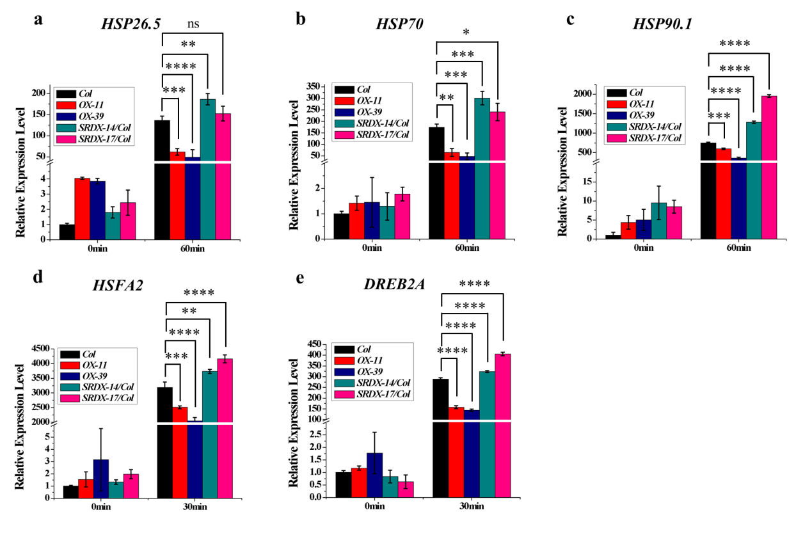
Figure. S2 Relative expression level of HSPs, HSFs and DREB2A in ERF49 transgenic lines
Relative expression levels of HSP26.5 (a), HSP70 (b), HSP90.1 (c), HSFA2 (d), and DREB2A (e) in ERF49 transgenic lines after heat stress treatment for 0 min and 60 min. Asterisks represent statistical significance (ns, no significant, P > 0.05; *, P < 0.05; **, P < 0.01; ***, P < 0.001; ****, P < 0.0001; one-way ANOVA followed by post hoc Tukey’s multiple comparison test). UBC30 was used as a reference gene. Numerical data is provided in Additional file 6. The experiments were repeated three times, error bars indicate standard deviation.

Figure. S3 Bioinformatics analysis for binding of BZR1 to the ERF49 promoter
a. Analysis of BZR1’s direct target genes in group IV of the ERF family. Three of the nine genes in this group are direct targets of BZR1 and are marked with stars. b. Diagram depicting the putative promoter (open box) and the exon (black box) of the ERF49 gene. Black and red asterisks indicate the positions of putative E-box and BRRE motifs, respectively.

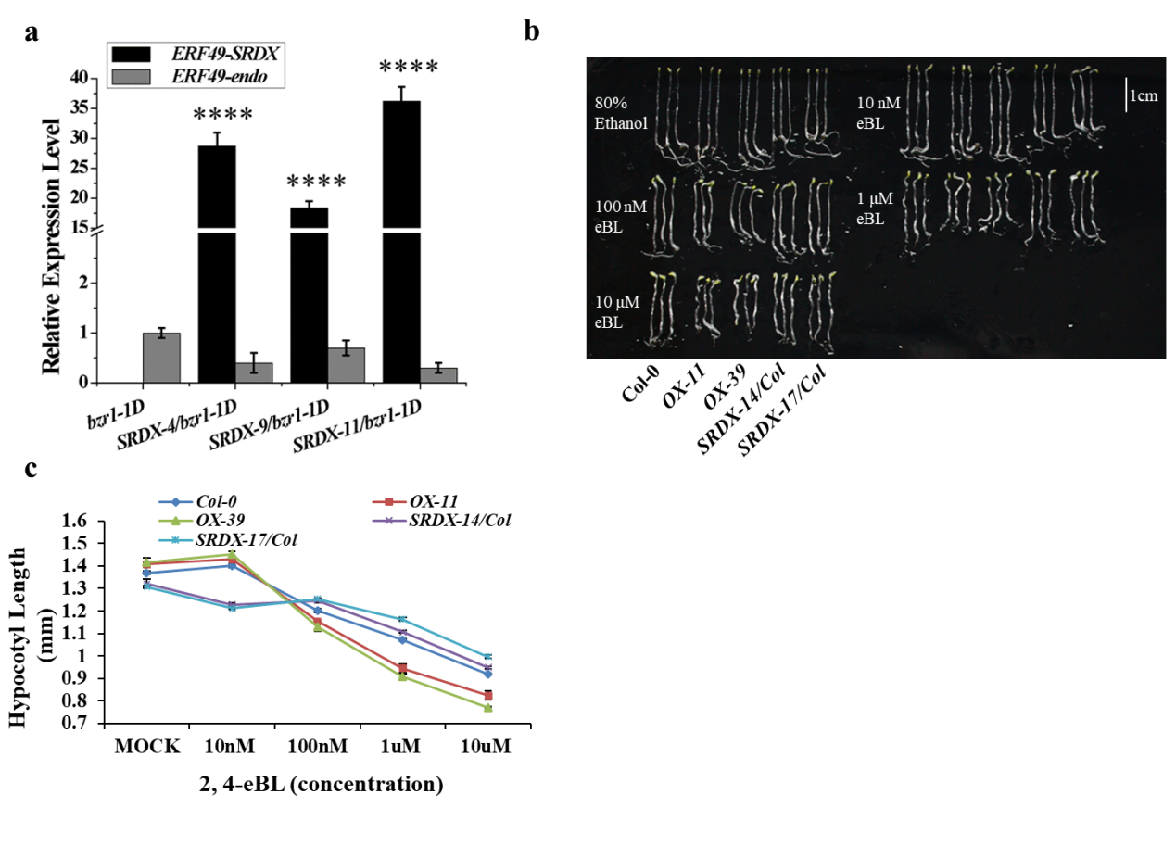
Figure. S4 The analysis of hypocotyl elongation in the ERF49 transgenic plants with 2, 4-eBL treatment
a. The relative expression level of ERF49 in three ERF49 dominant-negative transgenic lines under bzr1-1D background (SRDX-4/bzr1-1D, SRDX-9/bzr1-1D, and SRDX-11/bzr1-1D). Asterisks represent statistical significance (****, P < 0.0001; one-way ANOVA followed by post hoc Tukey’s multiple comparison test). UBC30 was used as a reference gene. Numerical data is provided in Additional file 6. The experiments were repeated three times, error bars indicate standard deviation. b. The hypocotyl elongation in the ERF49 transgenic plants with 2, 4-eBL or 80 % ethanol (as control) treatment. Seedlings were grown on 1/2 MS medium containing 80% ethanol and 10 nM, 100 nM, 1 μM, or 10 μM 2, 4-eBL in the dark for 7 days. Scale bar was 1 cm. c. Quantitative statistics of hypocotyl lengths from B, the hypocotyl lengths of over 30 seedlings were measured by Image J for each independent line, error bars represent standard deviation.

Figure. S5 Dominant-negative ERF49 increases thermotolerance in bzr1-1D
a. The phenotype of ERF49 dominant-negative transgenic lines in bzr1-1D after heat stress treatment at 42 °C for 3 hours and recovery for 5 days. bzr1-1D was the control. b. The survival rates of ERF49 dominant-negative transgenic lines in bzr1-1D after heat stress treatment at 42 °C for 3 hours and recovery for 5 days. 60-80 seedlings of each genotype from three biological replicates were counted. bzr1-1D was the control. Asterisks represent statistical significance (***, P < 0.001; ****, P < 0.0001; one-way ANOVA followed by post hoc Tukey’s multiple comparison test). Numerical data is provided in Additional file 6. The experiments were repeated three times, error bars indicate standard deviation.

Figure. S6 Thermotolerance analysis of ERF49 transgenic lines in the presence of 2, 4-eBL and BRZ
a. The survival rate of ERF49 transgenic lines in presence of 100 nM 2, 4-eBL after heat stress treatment at 42°C for 3 hours and recovery for 5 days. b. The survival rate of ERF49 transgenic lines in presence of 0.5 μM BRZ after heat stress treatment at 42°C for 3 hours and recovery for 5 days. 60-80 seedlings of each genotype were counted with three biological replicates. Error bars indicate standard deviation. Asterisks represent statistical significance (*, P < 0.05; **, P < 0.01; ***, P < 0.001; one-way ANOVA followed by post hoc Tukey’s multiple comparison test). Numerical data is provided in Additional file 6.

Table. S1 Primers used in this study
Primer name | Sequence (5’- 3’) | Usage
ERF49-SRDX-F | CGGGATCCGTCTTTGCCTTATCACTCACCA | Primers used for constructs
ERF49-SRDX-R | GGACTAGTAAGTGGGGAATGAAAGGAATC | Primers used for constructs
ERF49-OX-F | CACCTAACCATTACCTCATGTC | Primers used for constructs
ERF49-OX-R | AAGTGGGGAATGAAAGGAATC | Primers used for constructs
ERF49pro-F | CACCTGGTAACCAATCTCAAAAGTCA | Primers used for constructs
ERF49pro-R | CATGTACGGATGTTGATAACTCG | Primers used for constructs
ERF49pro-LUC-F | ACGCGTCGACTGCAAAGACTGTCCTTAGTG | Primers used for constructs
ERF49pro-LUC-R | CGCGGATCCCGAAAGTGATATTATGTGACG | Primers used for constructs
BZR1-PUC-F | GAACCAATTGATGACTTCGGATGGAGCTACGTC | Primers used for constructs
BZR1-PUC-R | CGGGGTACCTCAACCACGAGCCTTCCCAT | Primers used for constructs
ERF49pro-LUC-F | CCGGAATTCCAAACTGAACTAAGTATCACGTC | Primers used for constructs
ERF49pro-LUC-R | CGGGGTACCCGTTGTTTCTTATTAGCACC | Primers used for constructs
ERF49pro-1-LUC-F | CCGGAATTCTGCAAAGACTGTCCTTAGTGG | Primers used for constructs
ERF49pro-1-LUC-R | CGGGGTACCGTTATGATGGATTTGACTCCG | Primers used for constructs
ERF49pro-2-LUC-F | CCGGAATTCAGATAAATTGGAACCGGAGC | Primers used for constructs
ERF49pro-2-LUC-R | CGGGGTACCGTTCACTGAATCTTACTTCTCTGTC | Primers used for constructs
ERF49pro-3-LUC-F | CCGGAATTCAGCCATAGCTTGATTTTGTT | Primers used for constructs
ERF49pro-3-LUC-R | CGGGGTACCCGTTGTTTCTTATTAGCACC | Primers used for constructs
AtBZR1-AD-F | CCGGAATTCATGACTTCGGATGGAGCTACGTC | Primers used for constructs
AtBZR1-AD-R | CCGGCTCGAGCTCAACCACGAGCCTTCCCAT | Primers used for constructs
ERF49pro-F (with BRRE motif): | AGATAAATTGGAACCGGAGCTTTGTAGTTATCGGTTAAAAAGGCCGCCTTTTCACGTGTGTCTCGGCCACAAATGTTCTAAGACAGAGAAGTAAGATTCAGTGAAC
ERF49pro-m (with mutant BRRE motif): | AGATAAATTGGAACCGGAGCTTTGTAGTTATCGGTTAAAAAGGCCGCCTTTTCATTTTTTTCTCGGCCACAAATGTTCTAAGACAGAGAAGTAAGATTCAGTGAAC
AtBZR1-JG45-F | GATTATGCCTCTCCCGAATTCATGACTTCGGATGGAGCTACG
AtBZR1-JG45-R | AGAAGTCCAAAGCTTCTCGAGACCACGAGCCTTCCCATTT
ERF49pro-LacZi-F | GGAATTCCACCTGGTAACCAATCTCAAAAGTCA
ERF49pro-LacZi-R | CCGCTCGAGCATGTACGGATGTTGATAACTCG
ERF49pro-F/m-LacZi-F | GGAATTCAGATAAATTGGAACCGGAGCTTT
ERF49pro-F/m-LacZi-R | CCGCTCGAGGTTCACTGAATCTTACTTCTCTGTCTTA
AtBZR1-62SK-F | CGCTCTAGAACTAGTGGATCCATGACTTCGGATGGAGCTACGT
AtBZR1-62SK-R | TCAGCGTACCGAATTGGTACCACCACGAGCCTTCCCATTTC
ERF49pro-0800-F | GGGGTACCCACCTGGTAACCAATCTCAAAAGTCA
ERF49pro-0800-R | CGGGATCCCATGTACGGATGTTGATAACTCG
ERF49pro-F/m-0800-F | GGGGTACCAGATAAATTGGAACCGGAGCTTTGT
ERF49pro-F/m-0800-R | CGGGATCCGTTCACTGAATCTTACTTCTCTGTCTTA
ERF49-qF  ERF49-qR  ERF49-SRDX-qF  ERF49-SRDX-qR  ERF49-endo-qF  ERF49-endo-qR  UBC30-qF  UBC30-qR  SAUR_AC1-qF  SAUR_AC1-qR  CPD-qF  CPD-qR  XTR6-qF  XTR6-qR  RAB18-qF  RAB18-qR  RD29A-qF  RD29A-qR | AGACTACACCAAGCAGCAACACC  TTGGATGAACACGGCGACTCAG  TGTCATCATGTGGAAGAGTGACA  CGAAACCCAAACGGAGTTCTAG  TCGCGGATGACCTTATCCATA  CGTGTCGAGAGGAGGAAGC  TCACTTCCCACCAGATTACCC  TCGACAGAAGAACCTTGGATACG  CGGTCTATGTAGGAGAGAATG  GTATCTGAGATGTGACTGTG  TTGCTCAACTCAAGGAAGAG  TGATGTTAGCCACTCGTAGC  TTACTCTATCCTCTGGAACC  GTAGGAAGCAGTGAAGGGAG  TCCAGCTCTAGCTCGGAGGATGA  GGATCCCATGCCGCCCATCG  GCCGGAATCTGACGGCGGTT  CCCGTCGGCACATCCTTGTCG | Primers used for Real-time PCR
UBC30-F  UBC30-R  PP2A-F  PP2A-R  DWF4-F  DWF4-R  CPD-F  CPD-R  ERF49-F  ERF49-R | CAAATCCAAAACCCTAGAAACCGA  AACGACGAAGATCAAGAACTGGGAA  AGCAGCACAACCCTCAACAG  CCAGATGTGCTAAAGACGGAG  GGGTTTGACTGTCCAGTTCGGTAAT  ACCCTTAGGATATGGGAAAAGGGTG  CCCCCCGTGTGCCCACTC  CCATTGAAGAAGAAGATGATGATGA  GAGCTTTGTAGTTATCGGTT  CACTGAATCTTACTTCTCTGTC | Primers used for ChIP-qPCR

