Additional file 2: Figure S1. Elimination of estrous cycle in female mice did not affect defensive behavior following exposure to looming stimuli.
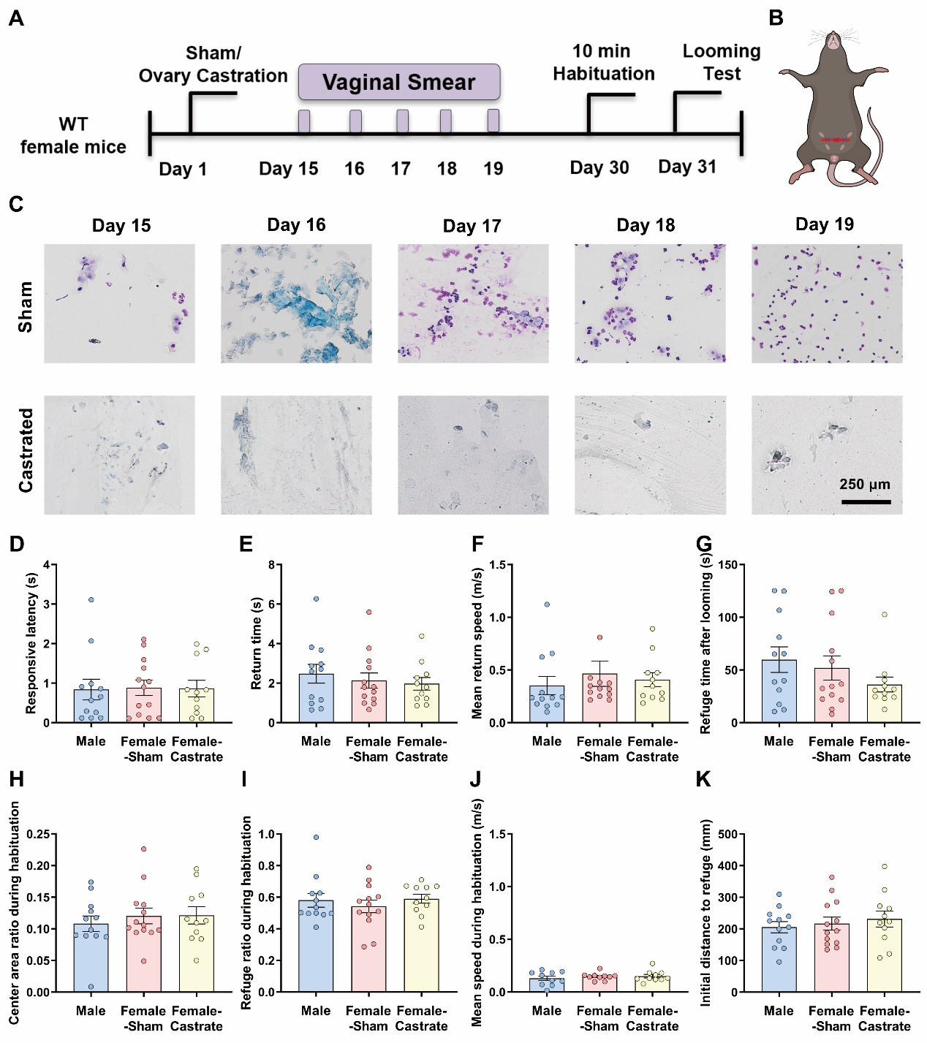
A, Experimental flow chart. B, Schematic diagram of the ovariectomy. C, Vaginal cytology identifying estrous cycle elimination in the castrated group compared to the sham group. D, Latency of mice to initiate flight behavior following looming stimuli onset. E, Latency of mice to return to the refuge following looming stimuli onset. F, Mean speed of return to the refuge following looming stimuli onset. G, Time spent in the refuge following looming stimuli onset. H, The ratio of time spent in the center area during the 5 min acclimation period. I, The ratio of time spent in the refuge during the 5-min acclimation period. J, Mean speed during the 5-min acclimation period to the arena. K, The initial location distance at stimuli onset to refuge following looming stimuli onset. Scale bar, 250 μm. Data are expressed as mean ± SEM.

