Additional file 3: Figure S2. There were no sex and estrus-phase differences in the auditory-induced defensive behavior.
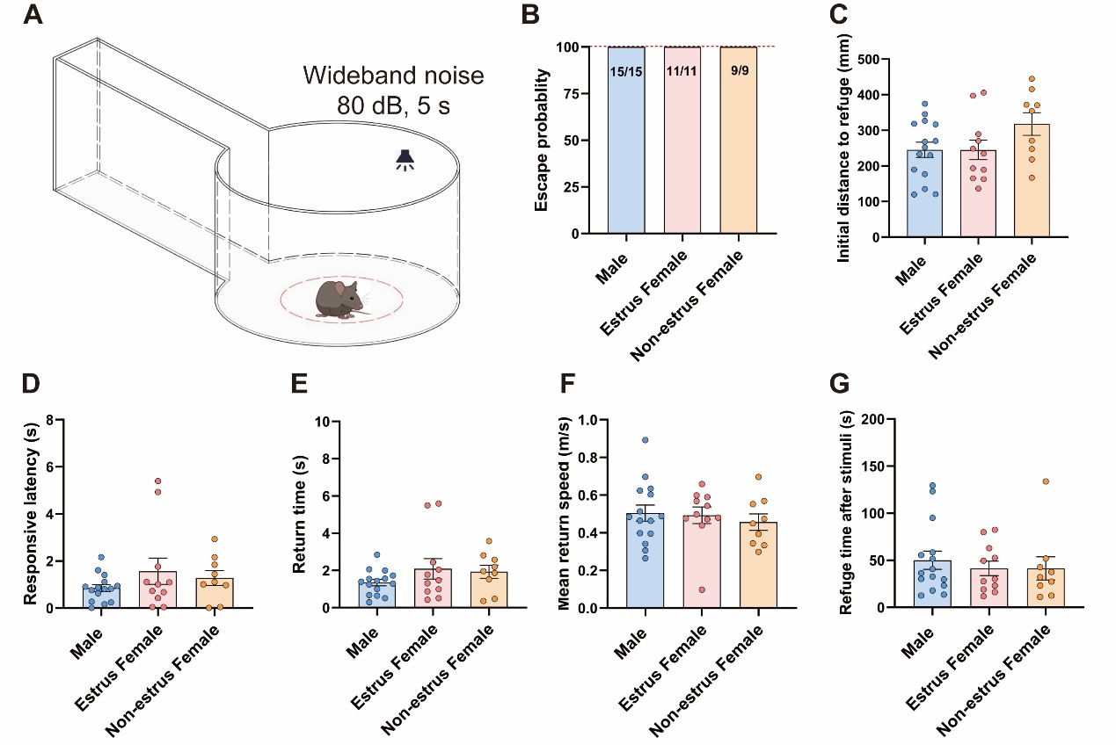
A, Schematic diagram of auditory-induced defensive behavior: a cylindrical open field, a rectangular refuge, and an infrared touchscreen frame below. Auditory stimuli were presented automatically in the floor of the setup. B, Escape probability after auditory stimuli. C, The initial location distance at stimuli onset to refuge following auditory stimuli onset. D, Latency of mice to initiate flight behavior following auditory stimuli onset. E, Latency of mice to return to the refuge following auditory stimuli onset. F, Mean speed of return to the refuge following auditory stimuli onset. G, Time spent in the refuge following auditory stimuli onset. Data are expressed as mean ± SEM.

