Additional file 7: Figure S3. Workflow of data acquisition and analysis of 3D motion multi-layered framework.
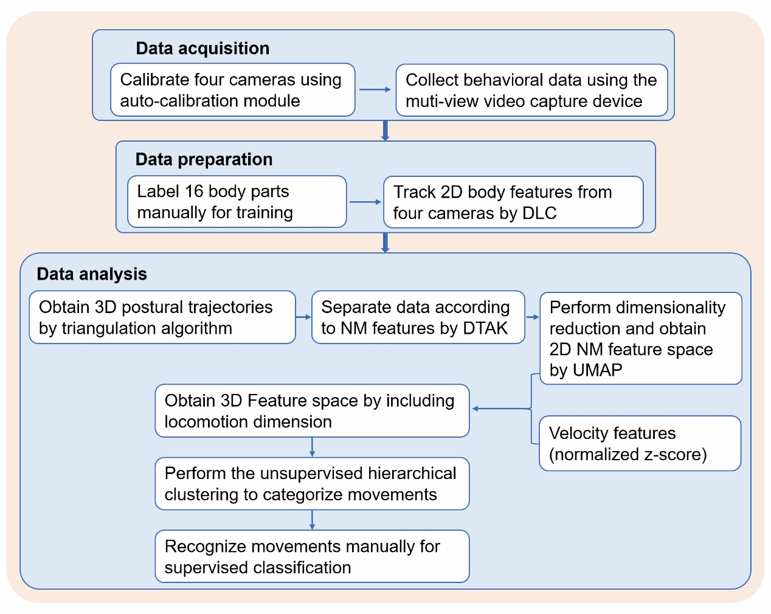
2D, two-dimensional; 3D, three-dimensional; DLC, DeepLabCut; DTAK, dynamic time alignment kernel; NM, non-locomotor movement; UMAP, uniform manifold approximation and projection.

