Additional file 9: Figure S4. There were no sex differences in flight response and behavior state transition following looming stimuli.
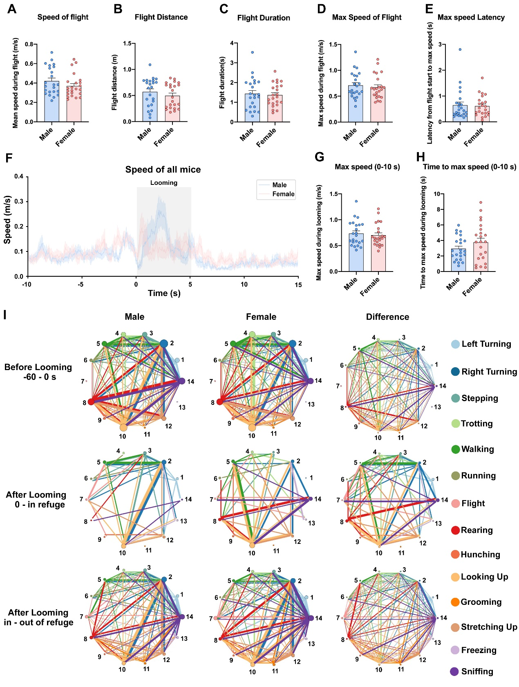
A, Mean speed during flight. B, Total flight distance. C, Total duration of flight. D, Maximum speed during flight. E, Duration from onset of flight to maximum speed. F, Real-time flight speed. G, Maximum speed during looming stimuli. H, Latency to maximum speed during looming. Data are expressed as mean ± SEM. I, State transitions of the movement modules from -60 s before looming to timepoint at which mouse went out of refuge and differences in the state transitions between male and female mice. Data are expressed as mean ± SEM.

