Figure S1 The heatmap shows the accuracy values of the model constructed with different k (length of k-mer) and w (window size) values

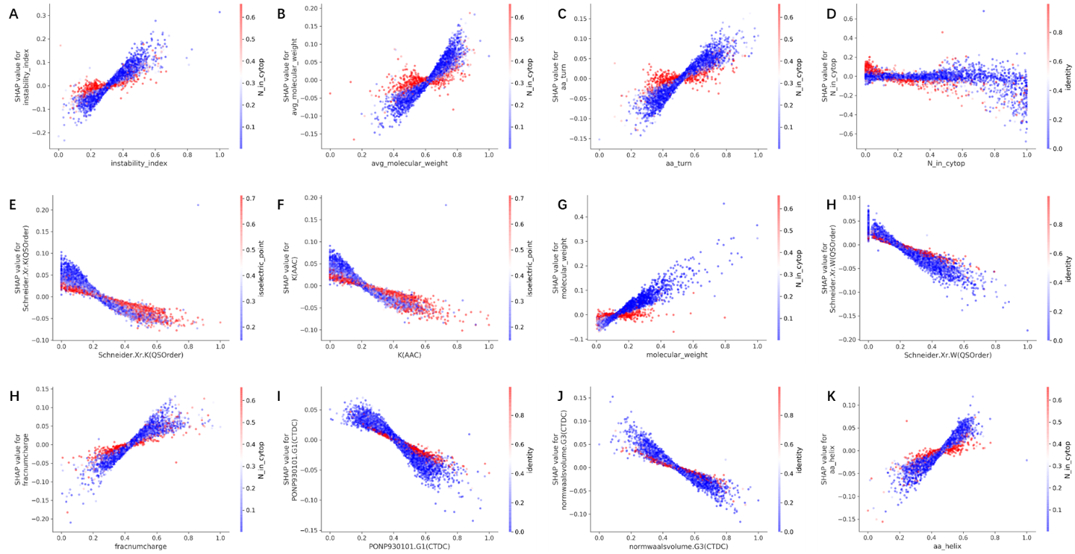
Figure S2 The SHAP dependence plots. These plots show the effect that a single feature has on the models predictions and the interaction effects across features. Each point corresponds to an individual sample, the value along the x axis corresponds to feature value, the color represents the value of the interacting feature.

