Additional file 6
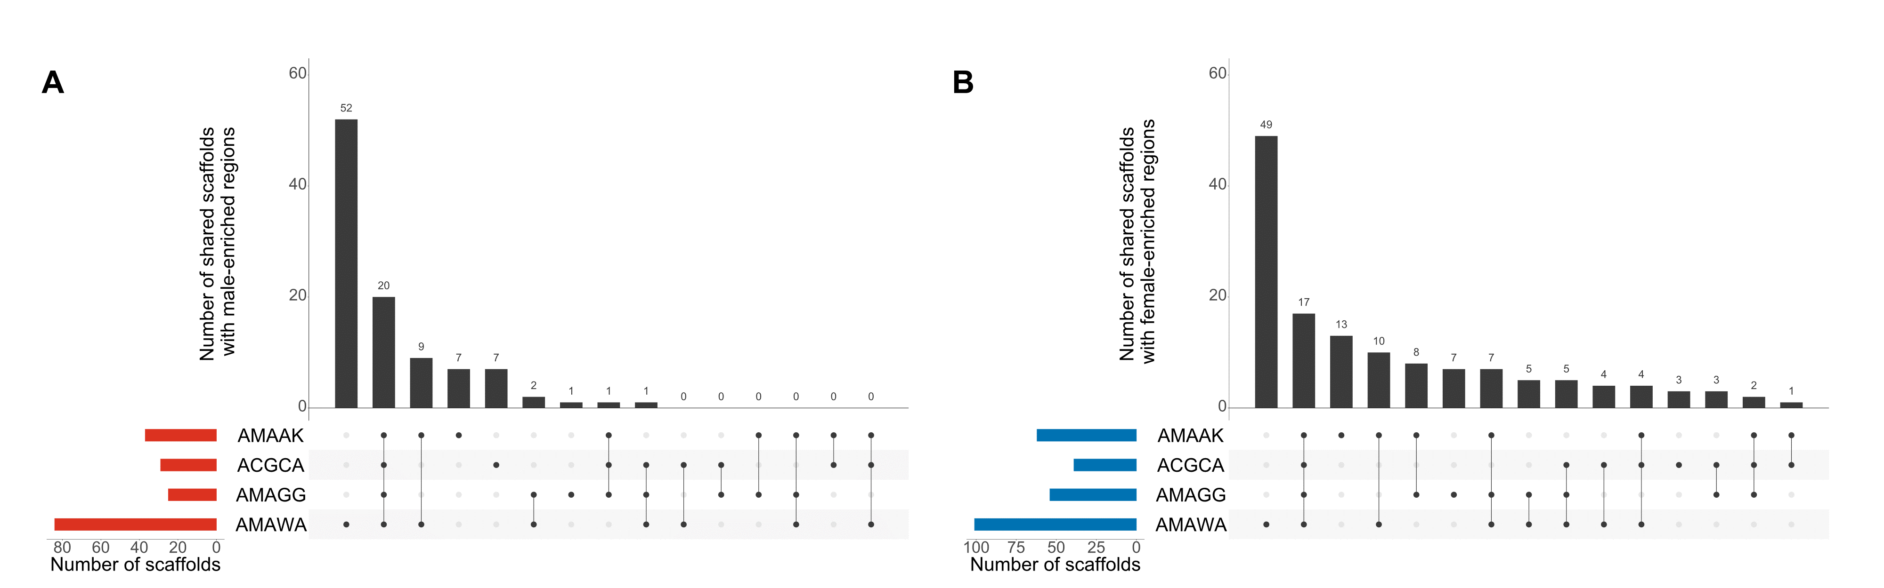
Figure S1. Upset plots delineating the number of shared scaffolds with male or female-enriched coverages. A Shared scaffold with regions enriched for male-specific coverages. B Shared scaffold with regions enriched for female-specific coverages. Species code represents the EPPO code for the four dioecious species: AMAAK (Amaranthus acanthochiton) ACGCA (Amaranthus cannabinus), AMAGG (Amaranthus greggii) and AMAWA (Amaranthus watsonii).

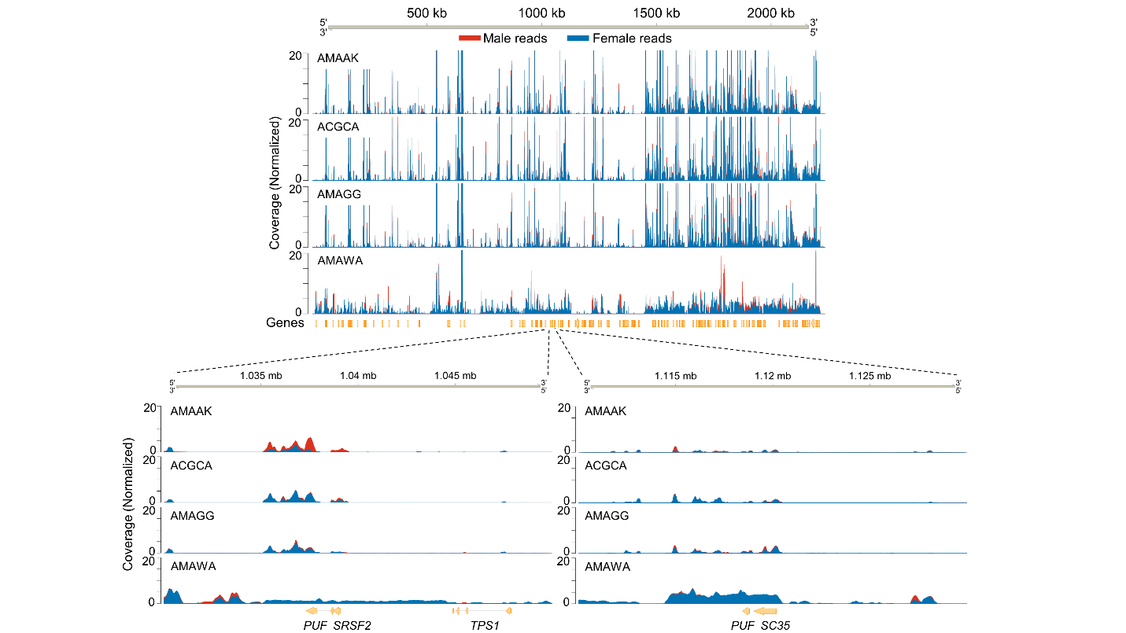
Figure S2. Reads alignment coverage of male-to-female individuals for four dioecious Amaranthus species across A. palmeri scaffold 19. Genes visualized within a 20-kb window.

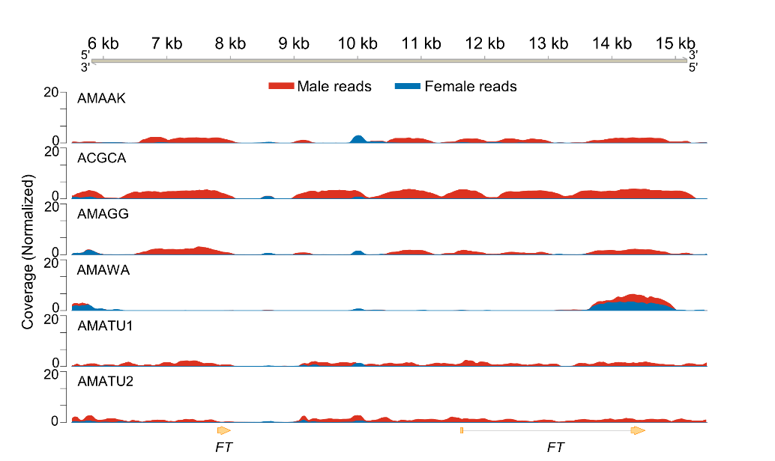
Figure S3. Reads alignment coverage of male-to-female individuals for five dioecious Amaranthus species across A. tuberculatus FLOWERING LOCUS T (FT) on contig 00000542. Species code AMATU1 (SRA numbers ERR3220246/ERR3220227) and AMATU2 (SRA numbers ERR3220310/ERR3220231) represent male/female individuals of A. tuberculatus from Kreiner et al. (2019). Genes visualized within a 10-kb window.

