Figure S1. The structure of the deep neural network framework, including the input layer, convolutional layers, merger layers, recurrent layers, fully connected layers, and output layer. A and B represent DL1 and DL2 in the main text, respectively.

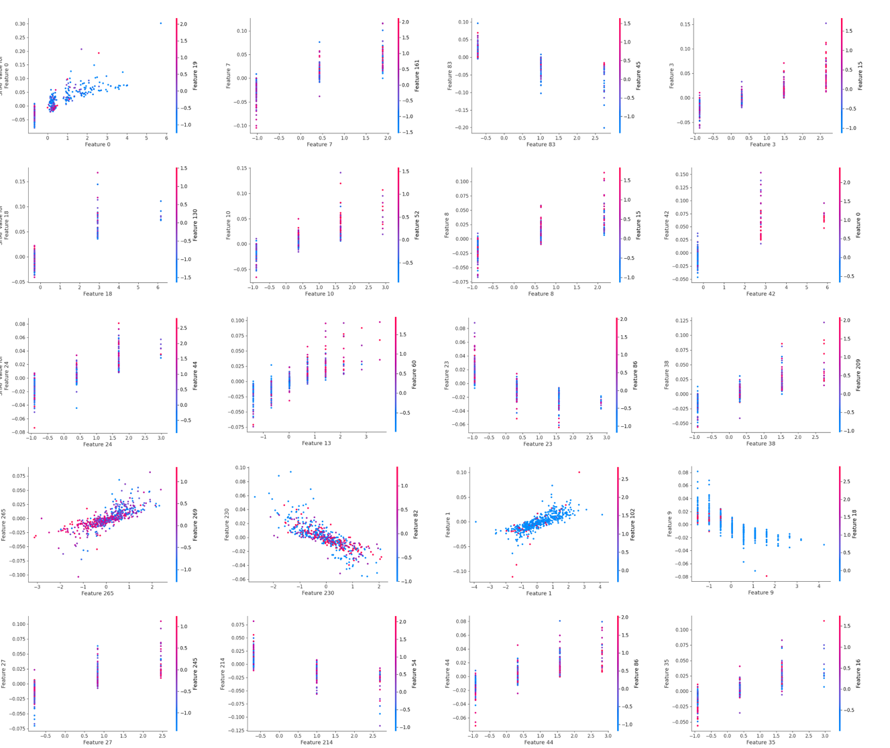
Figure S2. The SHAP dependence plots for full transcript mode m5U sites. These plots illustrate the effect that a single feature has on the models predictions and the interaction effects across features. Each point represents an individual sample, with the value on the x-axis representing the value of the feature in question and the color indicating the value of the interacting feature.

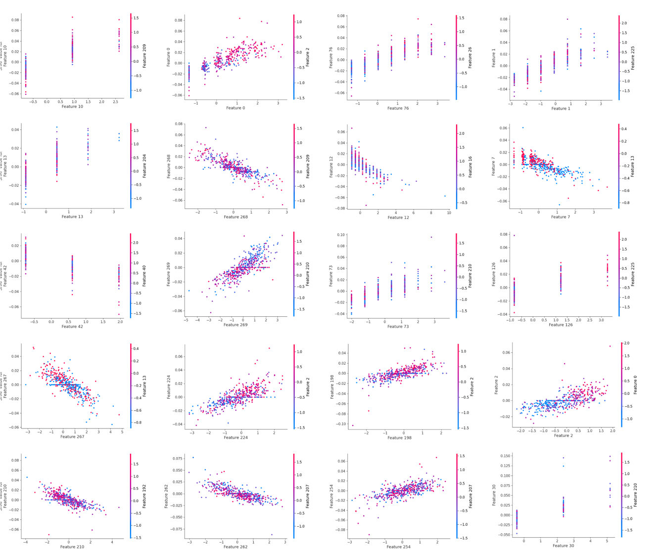
Figure S3. The SHAP dependence plots for mature mRNA mode m5U sites. These plots illustrate the effect that a single feature has on the models predictions and the interaction effects across features. Each point represents an individual sample, with the value on the x-axis representing the value of the feature in question and the color indicating the value of the interacting feature.

