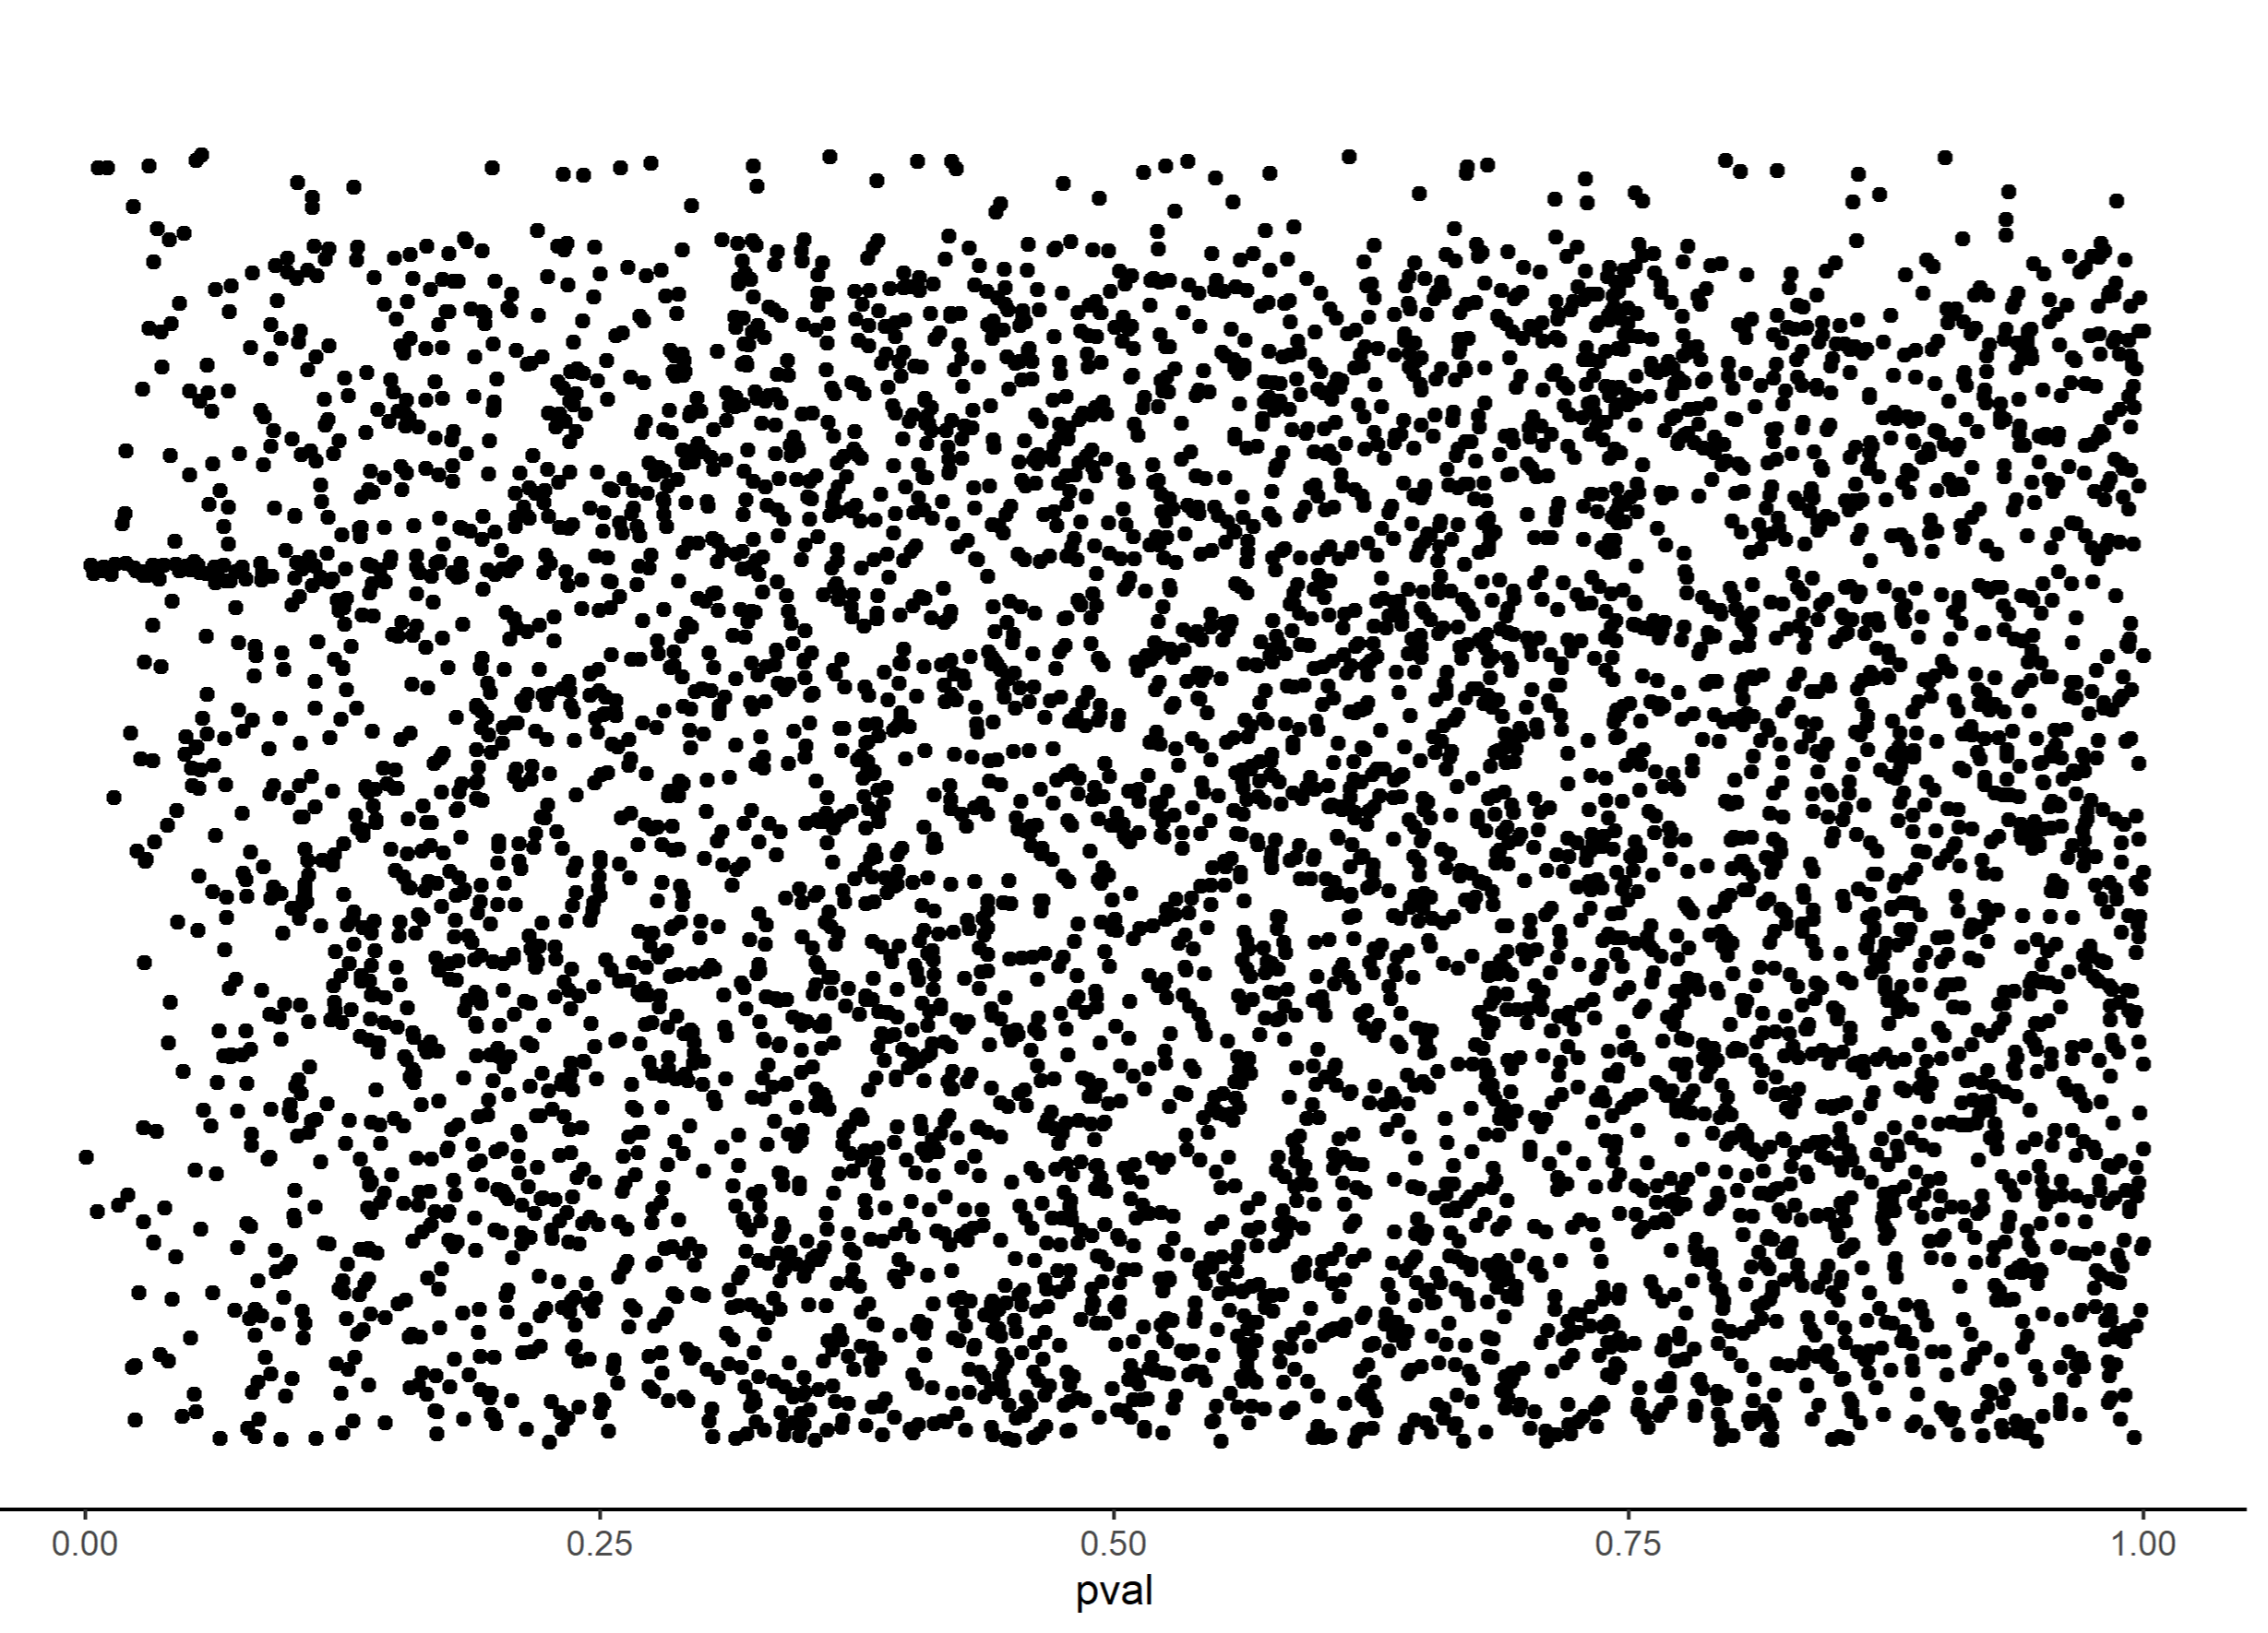
Figure S1. Distribution of p-values from the phylogenetically corrected linear mixed model (pglmm) investigating the correlation between viviparity and protein family size. Each dot corresponds to the p-value from a unique protein family.

