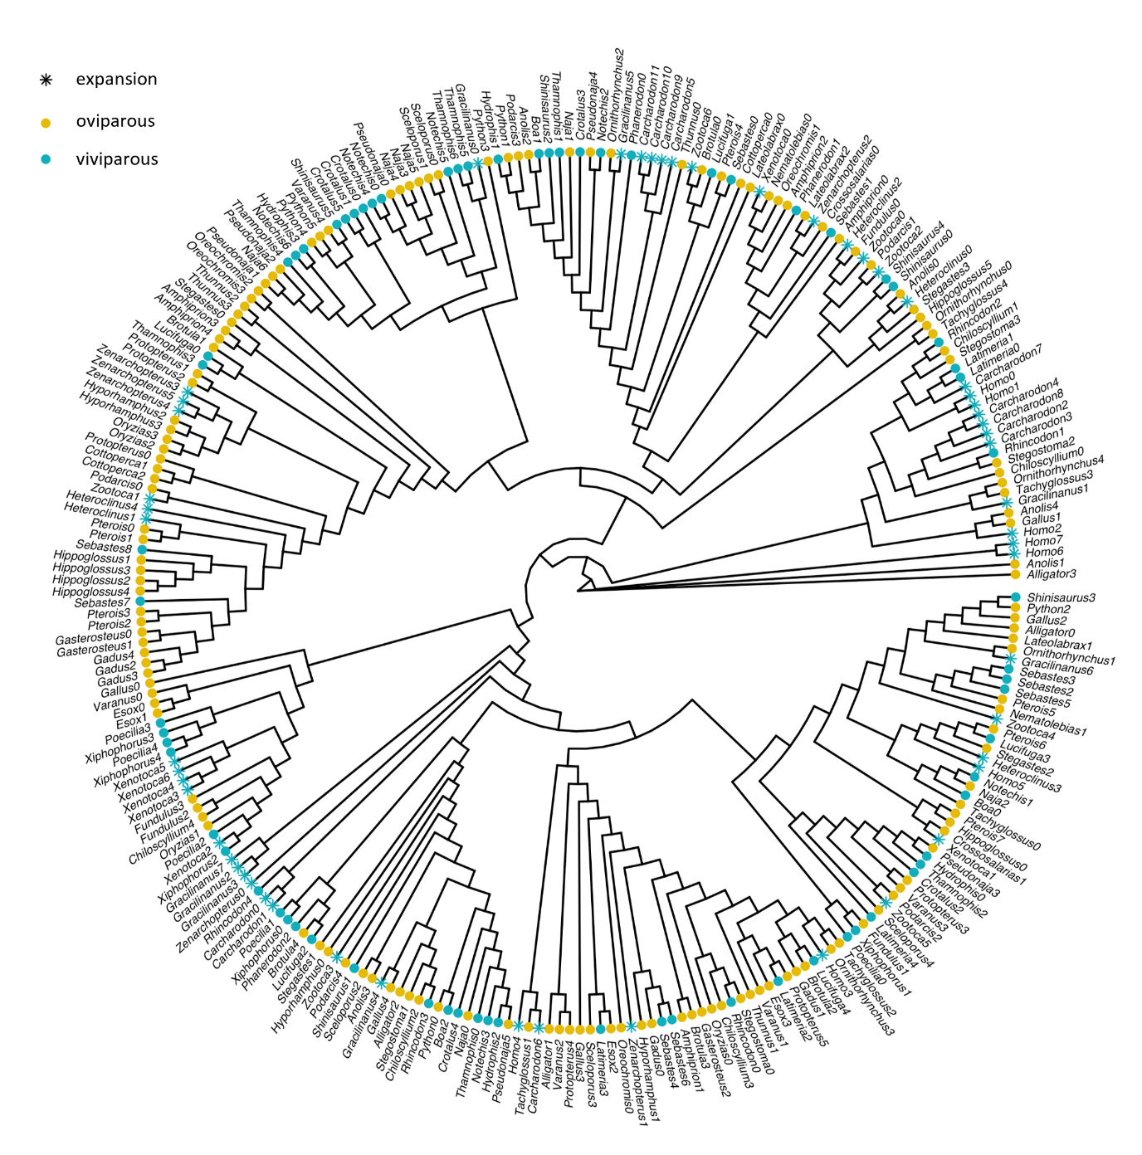
Figure S3. Tree topology for Ubi-N-Sde2. Phylogenetic tree generated using sequences corresponding to Ubi-N-Sde2. Tips are colored according to reproductive mode. Those with an asterisk outline viviparous species showing expansion for Ubi-N-Sde2.

