Table S1. Differential Gene Statistics of Orthogroups in Haptoria, Trichostomatia and Spirotrichea
Orthogroup id | Description | Did.sp. | Dilep.sp. | Lacry.sp.1 | Lacry.sp.2 | Mono.sp. | Trach.spp. | Ostra.dentatum | Dip.dentatum | Ento.caudatum | Epi.cattanei | Oxy.trifallax | Sty.lemnae | Total
OG0000604 | Ketoacyl-synt_C | 7 | 1 | 7 | 2 | 2 | 12 | 0 | 1 | 0 | 0 | 1 | 1 | 34
OG0000690 | Thiolase_C | 4 | 2 | 3 | 1 | 5 | 14 | 0 | 1 | 0 | 0 | 1 | 1 | 32
OG0003360 | DUF3050 | 1 | 0 | 3 | 4 | 1 | 1 | 0 | 0 | 0 | 0 | 0 | 1 | 11
OG0000345 | LCCL | 8 | 11 | 10 | 10 | 3 | 4 | 0 | 0 | 0 | 0 | 0 | 0 | 46
OG0001149 | LCCL | 4 | 8 | 6 | 5 | 0 | 0 | 0 | 0 | 0 | 0 | 0 | 0 | 23
OG0001713 | LCCL | 4 | 6 | 5 | 2 | 1 | 0 | 0 | 0 | 0 | 0 | 0 | 0 | 18
OG0004716 | LCCL | 3 | 0 | 1 | 1 | 1 | 2 | 0 | 0 | 0 | 0 | 0 | 0 | 8
OG0000252 | TSP_1 | 14 | 1 | 14 | 10 | 6 | 8 | 0 | 0 | 0 | 0 | 0 | 0 | 53
OG0003617 | TSP_1 | 4 | 3 | 0 | 1 | 1 | 1 | 0 | 0 | 0 | 0 | 0 | 0 | 10
OG0005710 | TSP_1 | 1 | 2 | 1 | 1 | 1 | 1 | 0 | 0 | 0 | 0 | 0 | 0 | 7
OG0006829 | COX1 | 0 | 1 | 3 | 2 | 0 | 0 | 0 | 0 | 0 | 0 | 0 | 0 | 6
OG0009227 | COX1 | 1 | 0 | 1 | 1 | 0 | 0 | 0 | 0 | 0 | 0 | 0 | 1 | 4
OG0002467 | DUF2451 | 2 | 1 | 2 | 5 | 3 | 1 | 0 | 0 | 0 | 0 | 0 | 0 | 14
OG0001849 | Fibrinogen_C | 2 | 2 | 6 | 6 | 0 | 1 | 0 | 0 | 0 | 0 | 0 | 0 | 17
OG0002220 | Proton_antipo_M | 4 | 3 | 3 | 3 | 1 | 1 | 0 | 0 | 0 | 0 | 0 | 0 | 15

Table S2. DE genes associated with TCDB, PHI, VFDB in Haptoria, Trichostomatia and three Outgroup species
 | Lit.sp. | Dil.mucronatus |  | Mon.sp. | Did.sp. | Tra.ovum | Phi.sp. | Dip.dentatum | Ento.furca | Tri.finlayi | Bal.ctenopharyngodoni | Iso.intestinalis | Fab. salina | Tetra.thermophila | Param.bursaria | P value | FoldChange
TCDB-id
1.A.105.1.2 | 43.86 | 0 |  | 15.74 | 8.99 | 47.33 | 63.24 | 0 | 0 | 0 | 2.52 | 0 | 3.18 | 28.94 | 4.01 | 0.037 | 4.830
1.A.17.3.8 | 0 | 24.89 |  | 17.18 | 44.08 | 30.38 | 18.21 | 0 | 0 | 0 | 0 | 0 | 0 | 0 | 50.33 | 0.014 | 7.811
1.A.3.2.3 | 45.73 |  | 61.1 | 26.25 | 28.48 | 89.51 | 86.72 | 7.31 | 1.89 | 0 | 49.25 | 20.77 | 0 | 14.19 | 1.05 | 0.012 | 2.081
1.A.77.1.13 | 51.77 |  | 491.38 | 234.12 | 184.94 | 194.56 | 649.24 | 11.83 | 6.84 | 6.78 | 122.97 | 62.49 | 2.09 | 6.39 | 82.41 | 0.032 | 3.080
2.A.1.53.4 | 3.23 |  | 42.96 | 27.1 | 10.47 | 8.27 | 34.17 | 2.09 | 0 | 0 | 0 | 0 | 0 | 0 | 39.95 | 0.025 | 5.552
2.A.29.8.12 | 22.27 |  | 27.38 | 41.06 | 24.35 | 89.07 | 52.87 | 0 | 0 | 0 | 0 | 0 | 23.13 | 8.49 | 5.59 | 0.011 | 3.437
2.A.53.3.8 | 106.83 |  | 39.73 | 29.34 | 30.28 | 0 | 87.18 | 0 | 0 | 0 | 0 | 1.46 | 0 | 26.96 | 54.42 | 0.031 | 7.154
2.A.71.2.2 | 33.1 |  | 13.13 | 34.08 | 67.47 | 99.28 | 95.2 | 5.31 | 9.8 | 0 | 6.42 | 13.6 | 0 | 0 | 52.21 | 0.017 | 3.260
3.A.1.204.6 | 0 |  | 29.21 | 37.51 | 59.48 | 27.25 | 55.56 | 0 | 0 | 0 | 4.09 | 0 | 0 | 63.11 | 575.93 | 0.012 | 5.478
3.A.10.1.18 | 25.7 |  | 298.67 | 737 | 605.93 | 236.63 | 456.26 | 0 | 0 | 0 | 0 | 55.15 | 10.74 | 208.91 | 498.51 | 0.015 | 5.150
3.D.3.1.2 | 0 |  | 6.27 | 148.88 | 63.95 | 131.44 | 86.57 | 0 | 6.68 | 0 | 0 | 0 | 0 | 0 | 0 | 0.036 | 5.908
3.D.3.3.1 | 58.4 |  | 60.38 | 137.53 | 54.34 | 152.01 | 365.06 | 0.94 | 0 | 0 | 0 | 69.1 | 0 | 61.89 | 266.82 | 0.048 | 3.551
8.A.114.1.6 | 384.7 |  | 229.51 | 19.05 | 157.74 | 364.97 | 97.98 | 6.03 | 6.94 | 0 | 18.16 | 55.35 | 47.91 | 31.51 | 69.23 | 0.025 | 3.216
8.A.151.1.1 | 271.13 |  | 466.74 | 1069.4 | 664.55 | 1399.81 | 1904.12 | 28.13 | 3.74 | 64 | 103.93 | 10.44 | 331.22 | 92.97 | 176.2 | 0.017 | 3.413
PHI-id
B2SI02 | 4966.73 |  | 10762.2 | 0 | 4326.9 | 1102.42 | 7587.8 | 69.91 | 1333.09 | 918.8 | 45.65 | 7.19 | 0 | 1398.99 | 13827.9 | 0.043 | 3.597
VFDB-id
VFG001404 | 318.66 |  | 227.97 | 258.09 | 156.68 | 412 | 0 | 20.89 | 0 | 0 | 2.52 | 0 | 0 | 56.16 | 17.73 | 0.011 | 5.838
VFG005373 | 0 |  | 25.71 | 12.72 | 110.27 | 74.67 | 67.55 | 0 | 0 | 0 | 0 | 0 | 0 | 34.85 | 0 | 0.038 | 8.921
VFG016506 | 33.13 |  | 6.38 | 72.63 | 24.27 | 54.84 | 0 | 0 | 0 | 0 | 0 | 2.98 | 0 | 60.71 | 63.42 | 0.040 | 5.739
VFG044254 | 33.27 |  | 56.82 | 191.12 | 36.49 | 114.27 | 60.58 | 25.03 | 0 | 0 | 5.22 | 13.48 | 12.2 | 34.14 | 13.02 | 0.032 | 3.123

Table S3. The source of ciliates genome and transcriptome data
Species | Genome | Transcriptome | Website
Lacrymaria sp.1 | PRJCA019558 |  | https://ngdc.cncb.ac.cn/
Lacrymaria sp.2 | PRJCA019558 |  | https://ngdc.cncb.ac.cn/
Trachelophyllidae spp. | PRJCA019558 |  | https://ngdc.cncb.ac.cn/
Didinium sp.1 | PRJCA019558 |  | https://ngdc.cncb.ac.cn/
Litonotus sp.1 | PRJCA019558 |  | https://ngdc.cncb.ac.cn/
Dileptus sp. | PRJCA019558 |  | https://ngdc.cncb.ac.cn/
Monodinium sp. | PRJCA019558 | PRJNA1012847 | https://ngdc.cncb.ac.cn/  https://www.ncbi.nlm.nih.gov/
Didinium sp.2 |  | PRJNA1012847 | https://www.ncbi.nlm.nih.gov/
Trachelius ovum |  | PRJNA1012847 | https://www.ncbi.nlm.nih.gov/
Phialina sp. |  | PRJNA1012847 | https://www.ncbi.nlm.nih.gov/
Litonotus sp.2 |  | SRR10512988 | https://www.ncbi.nlm.nih.gov/
Dileptus mucronatus |  | SRR10512990/SRR10512991 | https://www.ncbi.nlm.nih.gov/
Fabrea salina |  | PRJCA019558 | https://www.ncbi.nlm.nih.gov/
Epidinium cattanei | ASM2380562v1 |  | https://www.ncbi.nlm.nih.gov/
Epidinium caudatum | ASM2380722v1 |  | https://www.ncbi.nlm.nih.gov/
Ostracodinium gracile | ASM2380568v1 |  | https://www.ncbi.nlm.nih.gov/
Polyplastron multivesiculatum | ASM2378335v1 |  | https://www.ncbi.nlm.nih.gov/
Diplodinium dentatum | ASM2380716v1 | SRR8920957 | https://www.ncbi.nlm.nih.gov/
Diplodinium flabellum | ASM2380556v1 |  | https://www.ncbi.nlm.nih.gov/
Entodinium bursa | ASM2380734v1 |  | https://www.ncbi.nlm.nih.gov/
Entodinium caudatum | ASM208785v3 |  | https://www.ncbi.nlm.nih.gov/
Isotricha intestinalis | ASM2380706v1 | SRR8920958 | https://www.ncbi.nlm.nih.gov/
Isotricha sp. | ASM2380574v1 |  | https://www.ncbi.nlm.nih.gov/
Isotricha prostoma | ASM2380720v1 |  | https://www.ncbi.nlm.nih.gov/
Entodinium furca |  | SRR8920956 | https://www.ncbi.nlm.nih.gov/
Trimyema finlayi |  | SRR10356064 | https://www.ncbi.nlm.nih.gov/
Balantidium ctenopharyngodoni |  | SRR5896119 | https://www.ncbi.nlm.nih.gov/
Mesodinium chamaeleon |  | SRR9987803/SRR9987804 | https://www.ncbi.nlm.nih.gov/
Myrionecta rubra CCMP2563 |  | SRR1296700 | https://www.ncbi.nlm.nih.gov/
Mesodinium rubrum |  | SRR2060969 | https://www.ncbi.nlm.nih.gov/
Climacostomum sp. |  | SRR10512972 | https://www.ncbi.nlm.nih.gov/
Spirostomum sp. |  | SRR7141210 | https://www.ncbi.nlm.nih.gov/
Stentor coeruleus | GCA_001970955.1 |  | https://www.ncbi.nlm.nih.gov/
Climacostomum virens |  | SRR1300461 | https://www.ncbi.nlm.nih.gov/
Blepharisma japonicum | ERR6474356 | SRR1294460 | https://www.ncbi.nlm.nih.gov/
Loxodes striatus |  | SRR10512997/SRR10512998 | https://www.ncbi.nlm.nih.gov/
Parduczia sp. |  | SRR1300374 | https://www.ncbi.nlm.nih.gov/
Tetrahymena malaccensis | GCA_000231845.2 |  | https://www.ncbi.nlm.nih.gov/
Tetrahymena thermophila | GCA_016584475.1 |  | https://www.ncbi.nlm.nih.gov/
Ichthyophthirius multifiliis | GCA_000220395.1 |  | https://www.ncbi.nlm.nih.gov/
Miamiensis avidus | SRR15925892 |  | https://www.ncbi.nlm.nih.gov/
Pseudocohnilembus persalinus | GCA_001447515.1 |  | https://www.ncbi.nlm.nih.gov/
Paramecium biaurelia | GCA_000733385.1 |  | https://www.ncbi.nlm.nih.gov/
Paramecium tetraurelia | GCA_000165425.1 |  | https://www.ncbi.nlm.nih.gov/
Frontonia sp. |  | SRR19610302/SRR10512984 | https://www.ncbi.nlm.nih.gov/
Aristerostoma ATCC |  | SRR1296811 | https://www.ncbi.nlm.nih.gov/
Bursaria truncatella | SRR11061013 |  | https://www.ncbi.nlm.nih.gov/
Platyophrya macrostoma |  | SRR1296905 | https://www.ncbi.nlm.nih.gov/
Dysteria derouxi | SRR9841578 | SRR9841576 | https://www.ncbi.nlm.nih.gov/
Trochilia petrani | SRR9841580 |  | https://www.ncbi.nlm.nih.gov/
Chilodochona sp. | SRR9841583 |  | https://www.ncbi.nlm.nih.gov/
Favella ehrenbergii |  | SRR1296812 | https://www.ncbi.nlm.nih.gov/
Schmidingerella taraikaensis |  | SRR1296936/SRR1296899 | https://www.ncbi.nlm.nih.gov/
Strombidinopsis acuminatum |  | SRR1296813 | https://www.ncbi.nlm.nih.gov/
Strombidium stylifer | SRR8275879 |  | https://www.ncbi.nlm.nih.gov/
Oxytricha trifallax | GCA_001297925.1 |  | https://www.ncbi.nlm.nih.gov/
Stylonychia lemnae | GCA_000751175.1 |  | https://www.ncbi.nlm.nih.gov/
Halteria grandinella | GCA_006369765.1 |  | https://www.ncbi.nlm.nih.gov/
Euplotes vannus | Evan_data |  | https://evan.ciliate.org/index.php/home/downloads
Nyctotherus ovalis |  | SRR10355986 | https://www.ncbi.nlm.nih.gov/
Brachonella spiralis | SRR6033281 |  | https://www.ncbi.nlm.nih.gov/
Metopus sp. |  | SRR10513011 | https://www.ncbi.nlm.nih.gov/

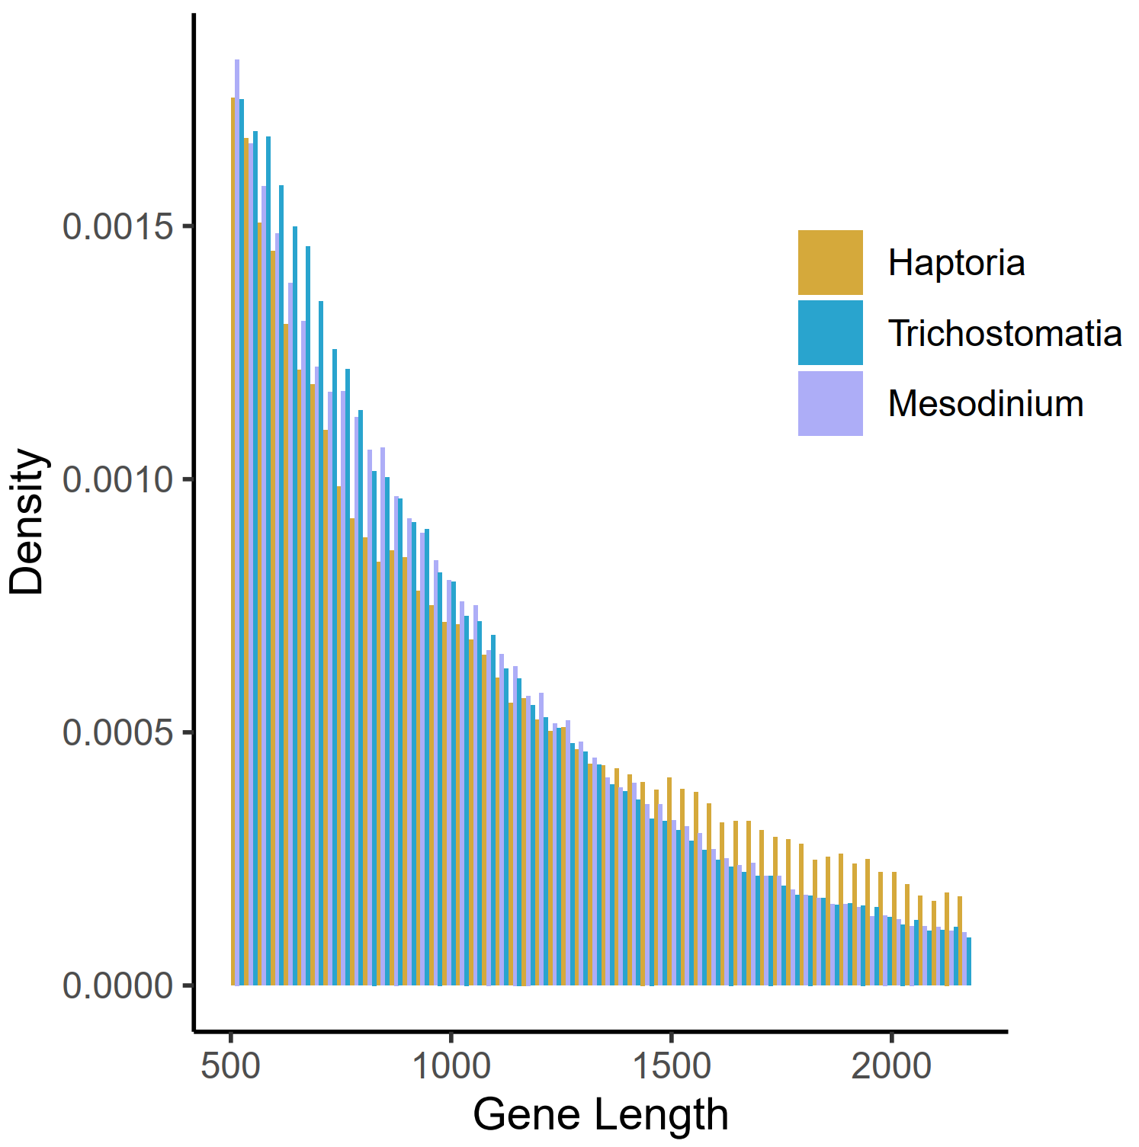
Fig. S1 the distribution of gene length in litostomatea (including Haptoria, Trichostomatia and Mesodinium)

