Table S1. Sampling details of the insect panel
Nest/Location | Analysis | Coordinates/City | Country | Ant species | Silverfish species
N1 | M | 36°56’07’’ N, 3°23’21’’ W | Spain | Cataglypis velox | Neoasterolepisma curtiseta
N2 | M | 36°56’07’’ N, 3°23’21’’ W | Spain | Messor barbarus | Neoasterolepisma spectabile
N3 | M | 36°56’07’’ N, 3°23’21’’ W | Spain | Messor barbarus | Neoasterolepisma spectabile
N4 | M | 37°09’20’’ N, 4°09’21’’ W | Spain | Iberoformica subrufa | Neoasterolepisma curtiseta
N5 | M | 37°09’20’’ N, 4°09’21’’ W | Spain | Messor barbarus | Neoasterolepisma foreli
N6 | M | 37°09’20’’ N, 4°09’21’’ W | Spain | Messor barbarus | Neoasterolepisma foreli
N7 | M | 37°09’20’’ N, 4°09’21’’ W | Spain | Messor barbarus | Neoasterolepisma spectabile
N8 | M | 37°09’20’’ N, 4°09’21’’ W | Spain | Messor sp. | Neoasterolepisma spectabile
N9 | M | Córdoba | Spain | Camponotus pilicornis | Neoasterolepisma curtiseta  Lepisma baetica  Proatelurina pseudolepisma
N10 | M | Córdoba | Spain | Aphaenogaster senilis | Neoasterolepisma curtiseta  Neoasterolepisma delator
N11 | M | Córdoba | Spain | Pheidole pallidula | Proatelurina pseudolepisma
N12 | M | Córdoba | Spain | Lasius niger | Proatelurina pseudolepisma
N13 | M | Córdoba | Spain | Aphaenogaster senilis | Neoasterolepisma delator
N14 | M | Córdoba | Spain | Aphaenogaster senilis | Neoasterolepisma delator
N15 | M | Córdoba | Spain | Tetramorium sp. | Lepisma baetica
N16 | M | Córdoba | Spain | Tetramorium sp. | Lepisma baetica
N17 | M | 41°29’34’’ N, 2°00’49’’ E | Spain | Messor barbarus | Neoasterolepisma balearicum  Tricholepisma aureum  Neoasterolepisma foreli
N18 | M | Córdoba | Spain | Aphaenogaster senilis | Neoasterolepisma delator
N19 | M | Córdoba | Spain | Messor barbarus | Neoasterolepisma lusitanum
N20 | M | Golyam Dervent | Bulgaria | Messor ibericus (structor s.l.) | Neoasterolepisma balcanicum
N21* | M | Córdoba | Spain | Messor barbarus | Neoasterolepisma spectabile
N22* | M | Córdoba | Spain | Messor barbarus | Neoasterolepisma spectabile  Neoasterolepisma lusitanum
N23 | M | 45°34’40.4” N, 10°46’37.0” E | Italy | Messor ibericus (structor s.l.) | Atelura formicaria
N24 | M | 45°34’41.0” N, 10°46’45.5” E | Italy | Lasius emarginatus | Atelura formicaria
N25 | M | 45°34’36.2” N, 10°46’51.8” E | Italy | Formica fusca | Atelura formicaria
N26* | M | 43°50'4.0"N, 3°44'29.6"E | France | Messor barbarus | Neoasterolepisma crassipes
N27 | M | 43°50'2.2"N, 3°44'30.2"E | France | Camponotus cruentatus | Proatelurina pseudolepisma
N28 | M | 43°50'12.3"N, 3°44'28.6"E | France | Messor sp. | Tricholepisma aureum
N29 | M/F | 51°10'33.3" N, 2°47'41.4" E | Belgium | Lasius flavus | Atelura formicaria
N30 | M | 51°10'32.7" N, 2°47'42.2" E | Belgium | Lasius niger | Atelura formicaria
M1 | SI | 37°56’32.2” N, 4°41’16.0” W | Spain | Messor barbarus | Neoasterolepisma spectabile  Neoasterolepisma lusitanum
M2 | SI | 37°56’33.5” N, 4°41’16.1” W | Spain | Messor barbarus | Neoasterolepisma spectabile  Neoasterolepisma lusitanum
M3 | SI | 37°56’33.3” N, 4°41’16.4” W | Spain | Messor barbarus | Neoasterolepisma spectabile
M4 | SI | 37°56’32.5” N, 4°41’15.8” W | Spain | Messor barbarus | Neoasterolepisma spectabile  Neoasterolepisma lusitanum
M5 | SI | 37°56’32.8” N, 4°41’16.3” W | Spain | Messor barbarus | Neoasterolepisma spectabile  Neoasterolepisma lusitanum
M6 | SI | 37°56’31.9” N, 4°41’19.2” W | Spain | Messor barbarus | Neoasterolepisma spectabile
M7 | SI | 37°56’31.3” N, 4°41’21.9” W | Spain | Messor barbarus | Neoasterolepisma spectabile  Neoasterolepisma lusitanum
M8 | SI | 37°56’31.6” N, 4°41’23” W | Spain | Messor barbarus | Neoasterolepisma spectabile  Neoasterolepisma lusitanum
M9 | SI | 37°56'31.4" N, 4°41'21.9" W | Spain | Messor barbarus | Neoasterolepisma spectabile  Neoasterolepisma lusitanum
M10 | SI | 37°56'31.7" N, 4°41'22.6" W | Spain | Messor barbarus | Neoasterolepisma spectabile  Neoasterolepisma lusitanum
M11 | SI | 37°56’31.9” N, 4°41’25.2” W | Spain | Messor barbarus | Neoasterolepisma spectabile  Neoasterolepisma lusitanum
M12 | SI | 37°56’31.2” N, 4°41’26.3” W | Spain | Messor barbarus | Neoasterolepisma spectabile
A1 | SI | 37°56’33.3” N, 4°41’16.6” W | Spain | Aphaenogaster senilis | Neoasterolepisma delator
A2 | SI | 37°56’43.6” N, 4°40’40.1” W | Spain | Aphaenogaster senilis | Neoasterolepisma delator
A3 | SI | 37°56’33.3” N, 4°41’15.9” W | Spain | Aphaenogaster gibbosa | Neoasterolepisma delator
A4 | SI | 37°56’33.2” N, 4°41’16.0” W | Spain | Aphaenogaster senilis | Neoasterolepisma delator
A7 | SI | 37°56’31.7” N, 4°41’28.1” W | Spain | Aphaenogaster senilis | Neoasterolepisma delator  Neoasterolepisma curtiseta
C1 | SI | 37°56’33.3” N, 4°41’16.7” W | Spain | Camponotus aethiops | Neoasterolepisma curtiseta
C2 | SI | 37°56’32.2” N, 4°41’20.4” W | Spain | Camponotus aethiops | Neoasterolepisma curtiseta
C3 | SI | 37°56’32.1” N, 4°41’20.8” W | Spain | Camponotus micans | Neoasterolepisma curtiseta  Ctenolepisma ciliatum
C4 | SI | 37°56’33.6” N, 4°41’16.2” W | Spain | Camponotus barbaricus | Neoasterolepisma curtiseta  Proatelurina pseudolepisma
C6 | SI | 37°56’30.3” N, 4°41’26.2” W | Spain | Camponotus barbaricus | Neoasterolepisma curtiseta
C7 | SI | 37°56’31.7” N, 4°41’25.4” W | Spain | Camponotus barbaricus | Neoasterolepisma curtiseta  Proatelurina pseudolepisma
T1 | SI | 37°56’31.8” N, 4°41’22.7” W | Spain | Tetramorium group semilaeve | Lepisma baetica
T2 | SI | 37°56’31.8” N, 4°41’22.7” W | Spain | Tetramorium group forte | Lepisma baetica
X1 | M |  | Spain | unasssociated | Allacrotelsa kraepelini
X2 | M |  | Spain | unasssociated | Ctenolepisma ciliate
X3 | SI | 37°56'31.7"N 4°41'20.1"W | Spain | unasssociated | Lepisma baetica
X4 | SI | 37°56'32.1"N 4°41'21.0"W | Spain | unasssociated | Ctenolepisma ciliate
F1 | F | 38°54'25.6"N 4°47'39.3"W | Spain | Messor barbarus | Neoasterolepisma lusitanum
F2 | F | 38º24'11'' N, 5º25'44'' W | Spain | Cataglyphis iberica | Neoasterolepisma curtiseta
F3 | F | 37º55'23'' N, 4º48'09'' W | Spain | Lasius niger | Proatelurina pseudolepisma
An asterisk indicates those Messor nests where organic plant material was sampled for microbiome analysis. For stable isotope profiling, organic plant material of each Messor nest was collected. The column ‘Analysis’ indicates whether individuals were collected for microbiome characterization (M), stable isotope profiling (SI), or feeding trials (F).

Table S2. PCR reaction conditions

Step | Temp [ºC] |  | Time [s] |  | Cycles
 | PCR1 | PCR2 | PCR1 | PCR2 | PCR1 | PCR2
Initial denaturation | 95 | 95 | 900 | 900 | 1 | 1
Denaturation | 94 | 94 | 30 | 30 | 25 | 7
Annealing | 50 | 50 | 90 | 90 | 25 | 7
Extension | 72 | 72 | 90 | 90 | 25 | 7
Final extension | 72 | 72 | 600 | 600 | 1 | 1
Store | 8 | 8 | ∞ | ∞

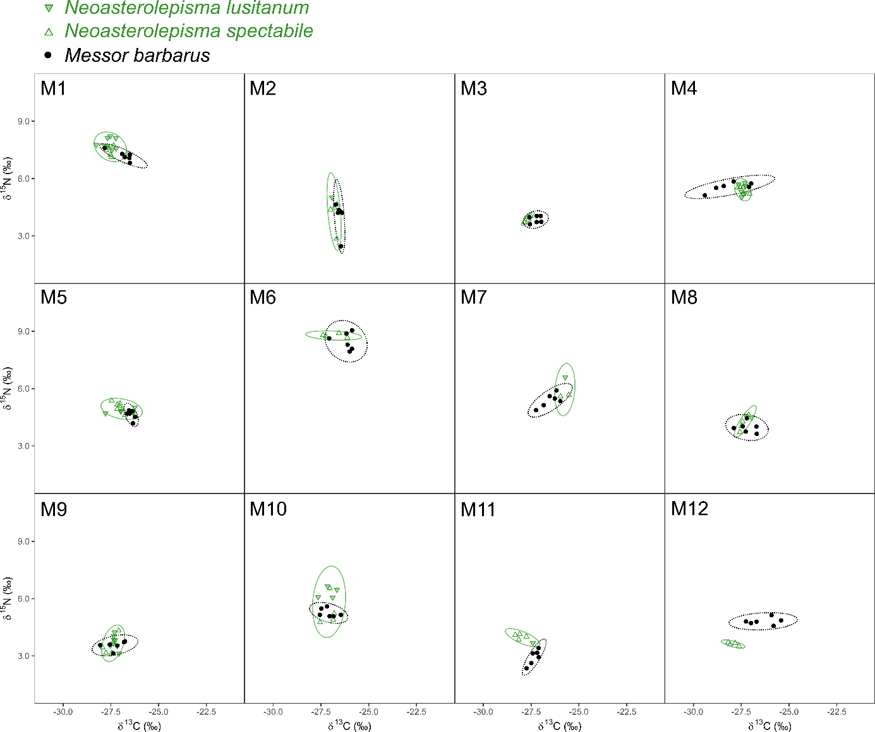
Figure S1. Nest-specific isotopic niche overlap between Messor host and Messor-specialized Neoasterolepisma. Each point represents the δ¹³C-δ¹⁵N signature of an individual M. barbarus worker (black dot) or Messor-specialized Neoasterolepisma (down-pointing green triangle N. lusitanum, up-pointing green triangle N. spectabile). The M. barbarus workers and silverfish are grouped per nest, with each of the twelve panels corresponding to one of the twelve sampled M. barbarus nests: M1 to M12. Note that both Messor-specialized species co-occurred in multiple nests. Ellipses comprise approx. 95% of the Messor worker samples (black ellipse) or Messor-specialized Neoasterolepisma (green ellipse).

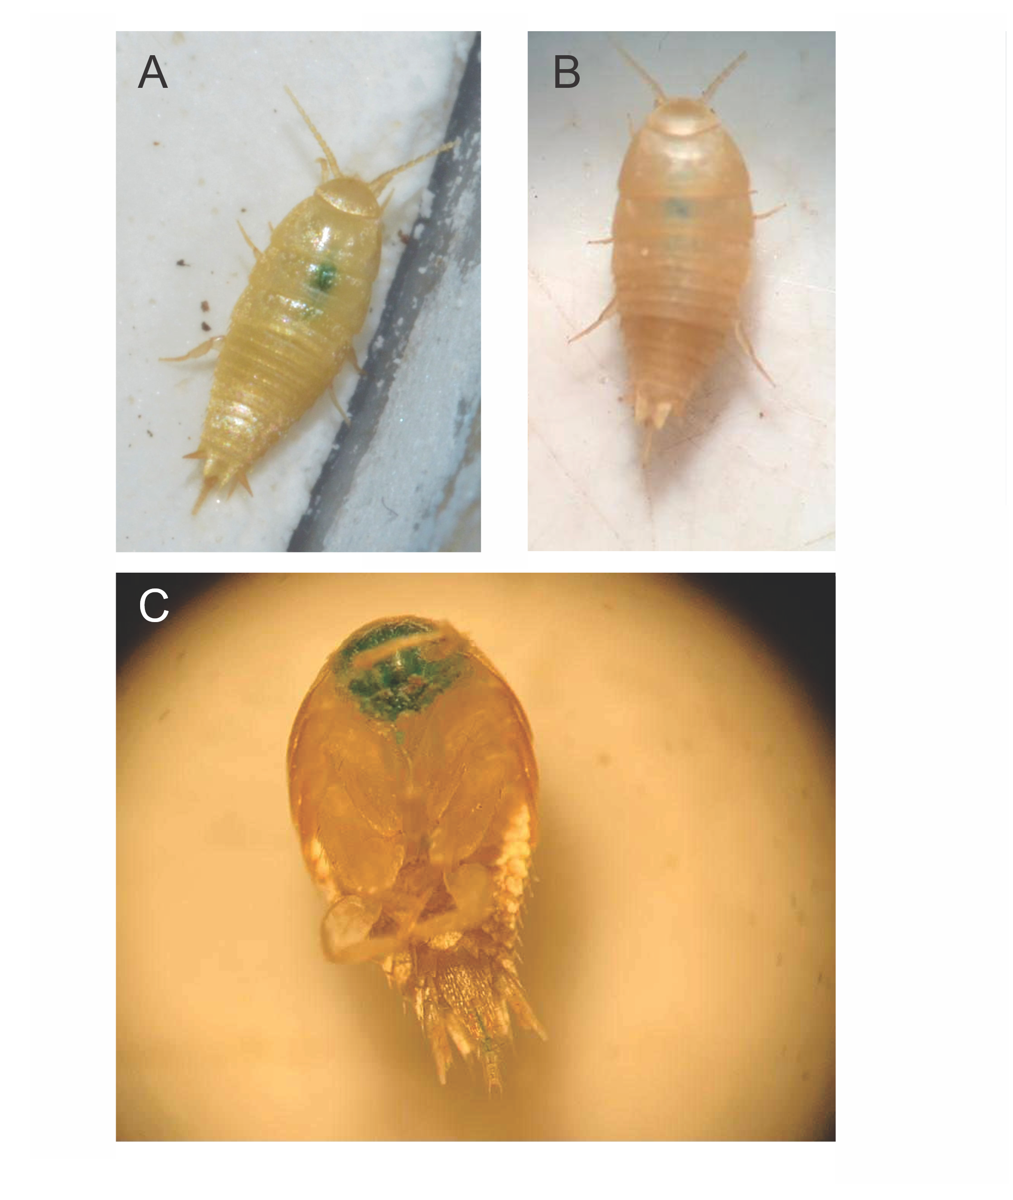
Figure S2. The obligate generalist nicoletiids P. pseudolepisma and A. formicaria steal food droplets from ant hosts. A: Our trophallaxis assays confirm previous observations of this behaviour in A. formicaria (Janet, 1897). B: Stealing of food droplets was also observed for the obligate generalist nicoletiid P. pseudolepisma. C: The mouth parts of a number of P. pseudolepisma individuals were stained.

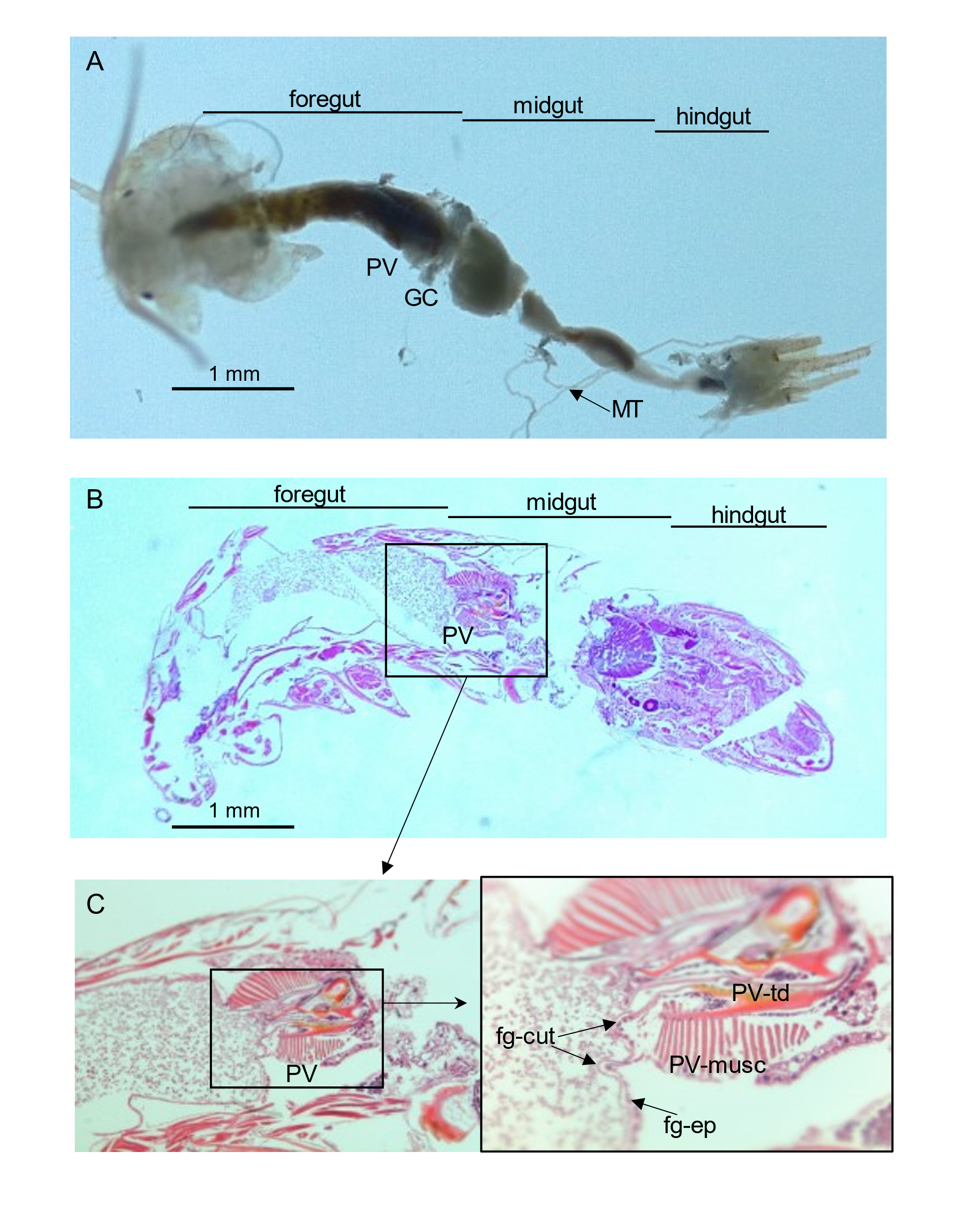
Figure S3. Neoasterolepisma silverfish display a differentiated proventriculus with sclerotized teeth-like structures. Throughout panels A to C, abbreviations are; fg-cut: foregut cuticle, fg-ep: foregut epithelium, GC: gastric caeca, MT: Malpighian tubules, PV: proventriculus, PV-musc: proventriculus musculature, and PV-td: proventriculus tooth-like denticles. A Masson trichromic stain was used.

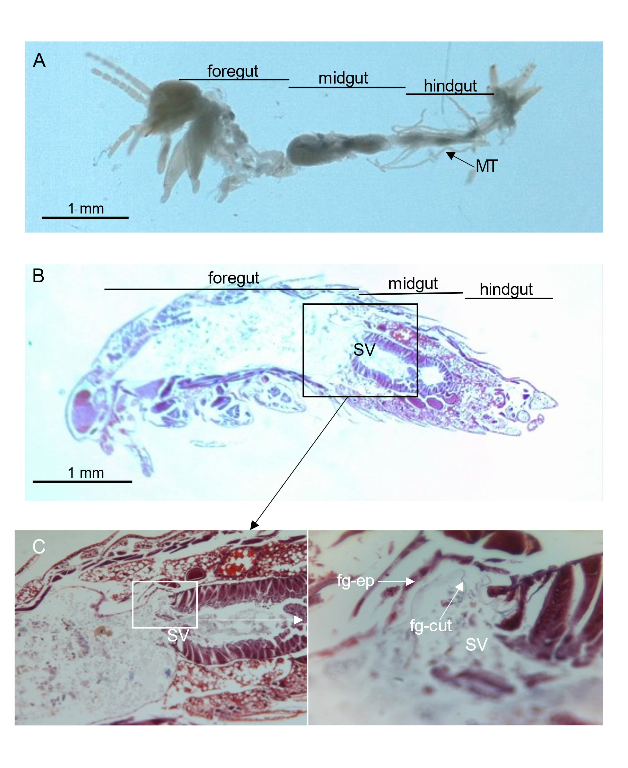
Figure S4. The nicoletiid P. pseudolepisma lacks sclerotized teeth-like structures in its digestive tract. Throughout panels A to C, abbreviations are; fg-cut: foregut cuticle, fg-ep: foregut epithelium, MT: Malpighian tubules, and SV: stomodeal valve. A hematoxylin eosin stain was used.

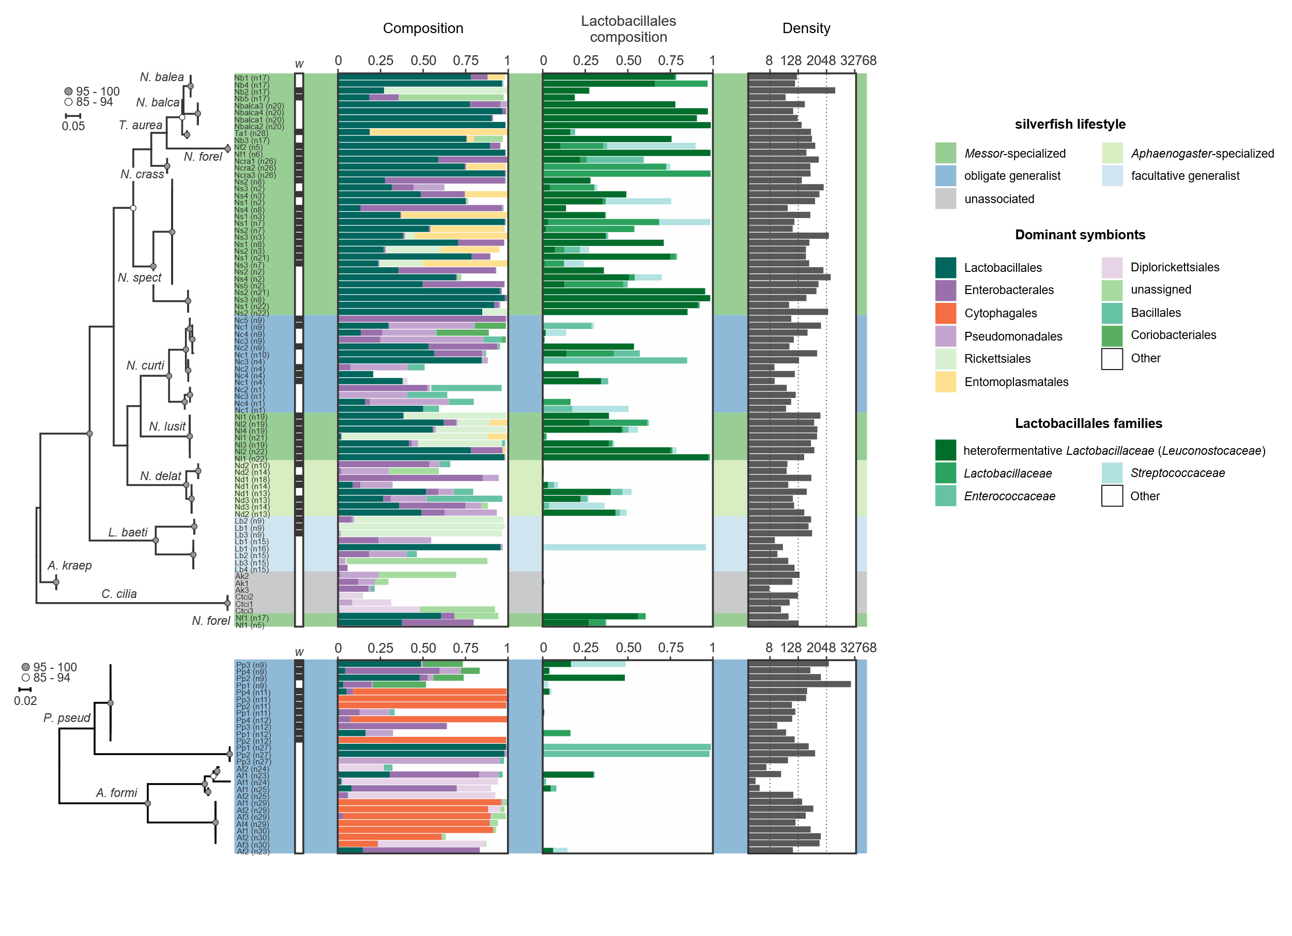
Figure S5. Myrmecophilous lifestyle shapes the silverfish microbiome. This supplementary figure replicates Figure 3 but adds the insect specimen ID to each microbiome. Specimens are indicated by their species name abbreviation and nest origin (latter between brackets). The Lepismatinae and Atelurinae phylogenies are shown. COI amplification was not successful for three silverfish samples and their symbiotic communities are depicted below their respective phylogenetic trees. Silverfish lifestyle is colour-coded (see right). Wolbachia infection is indicated by a black background within the row labelled with ‘w’. The unit for the microbiome density is the number of symbiotic rRNA copies per ng DNA. Leuconostocaceae is currently considered as a later synonym of Lactobacillaceae.

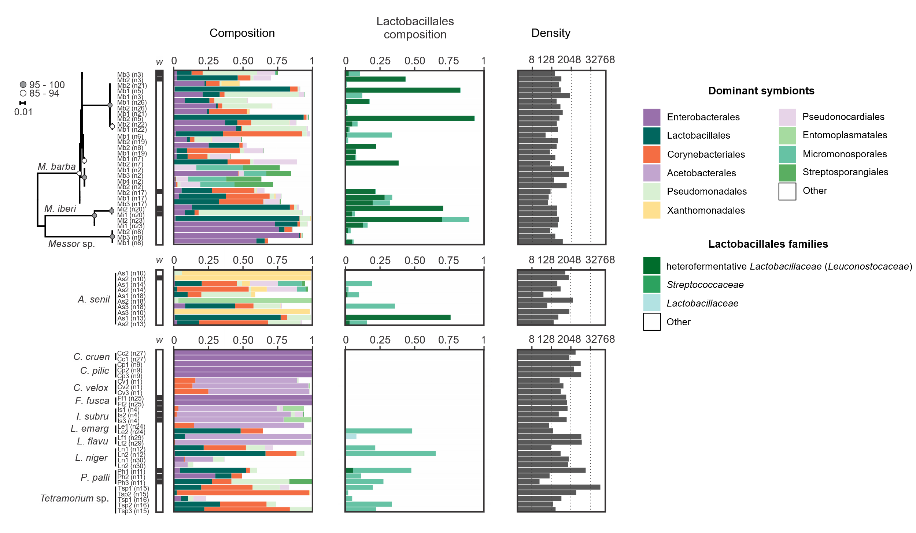
Figure S6. Heterofermentative Lactobacillaceae symbionts infect Messor ants. Specimens are indicated by their species name abbreviation and nest origin (latter between brackets). Messor ant samples are ordered according to phylogeny. Wolbachia infection is indicated by a black background within the row labelled with ‘w’. The unit for the microbiome density is the number of symbiotic rRNA copies per ng DNA. Leuconostocaceae is currently considered as a later synonym of Lactobacillaceae.

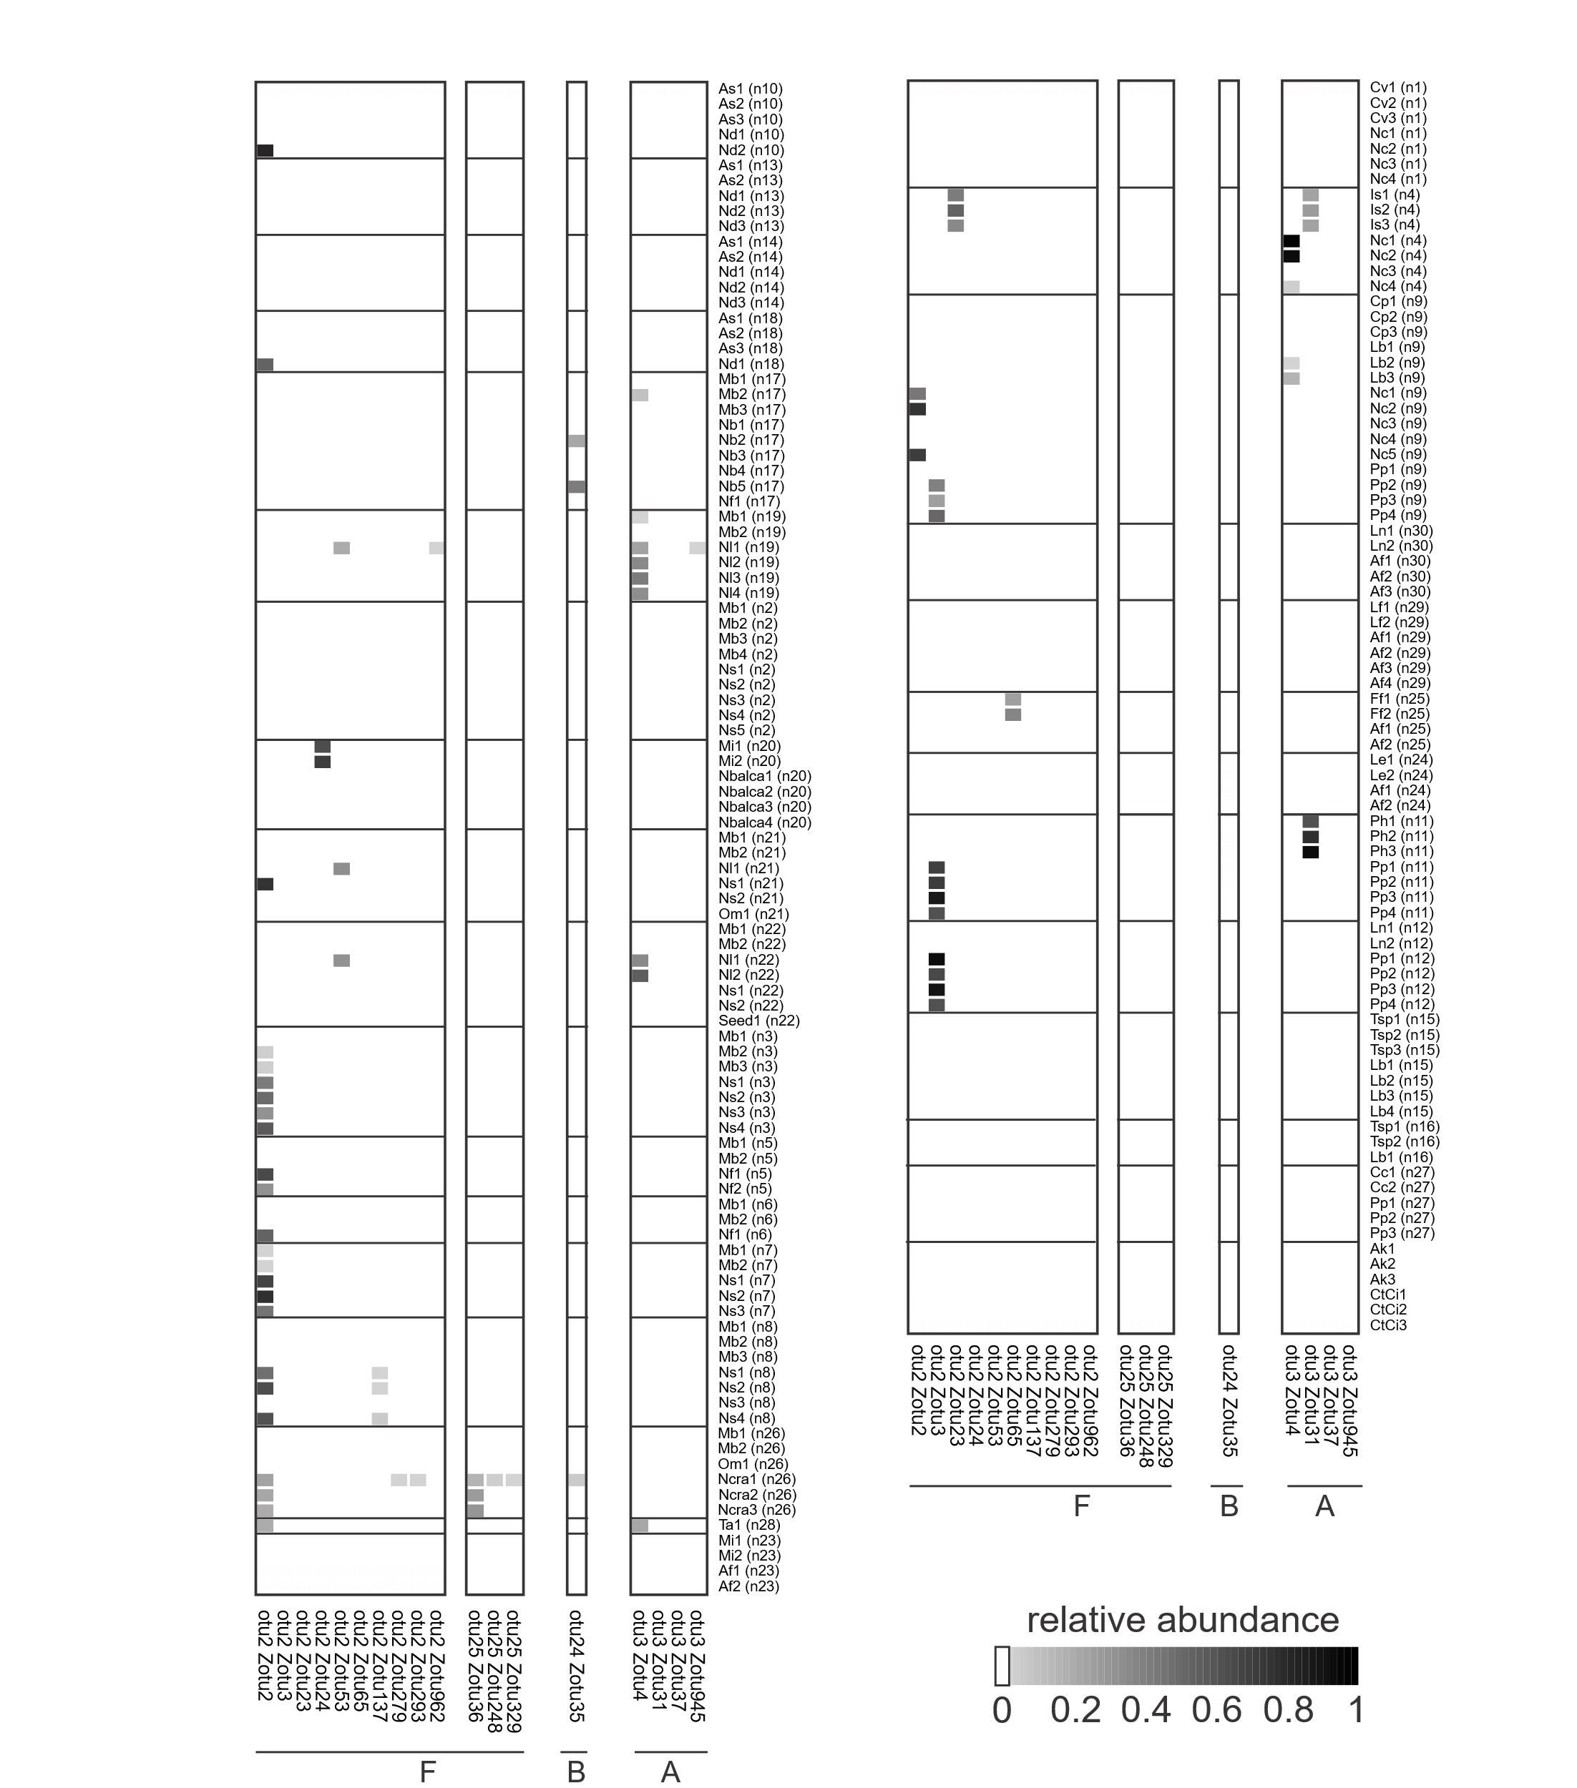
Figure S7. Maternally transmitted Wolbachia bacteria are pervasive in our insect panel. Ant and silverfish individuals are grouped according to nest origin. The relative abundances of Wolbachia bacteria are visualized (see bottom right). Wolbachia zOTU lineages are divided based on their apparent supergroup affiliation (A, B, or F). Insect specimens are indicated by their species name abbreviation and nest origin (latter between brackets).

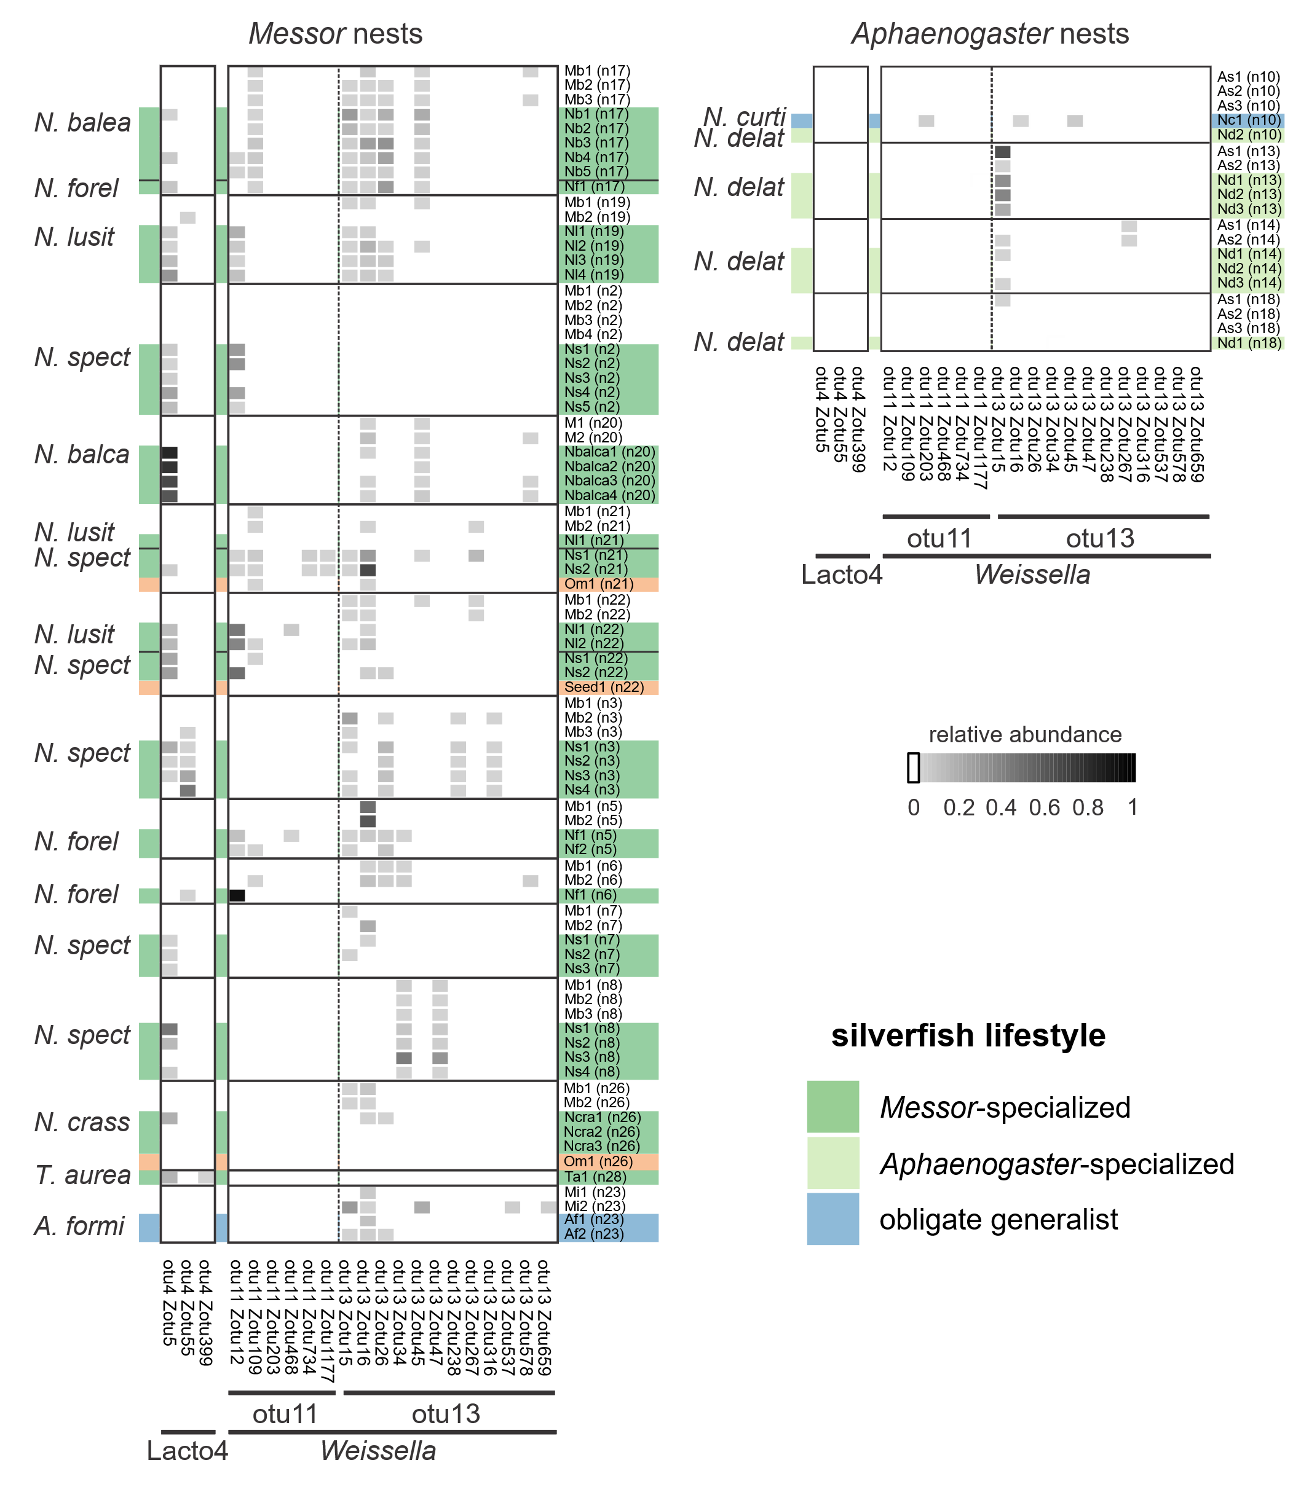
Figure S8. Ant nest determines the infection profile of Weissella bacteria in Messor-specialized silverfish. This supplementary figure largely duplicates Figure 4 but now also adds the insect specimen ID’s. Specimens are indicated by their species name abbreviation and nest origin (latter between brackets). Ant and silverfish individuals are grouped according to nest origin. The relative abundances of heterofermentative Lactobacillaceae symbionts are visualized (see middle right). Silverfish lifestyle is colour-coded (bottom right). Plant seed material is indicated with an orange background. Silverfish species are further identified by their abbreviated species name. Here, OTU26 (zOTU38) was removed as only a single C. pilicornis colony exhibited infection (Figure S9).

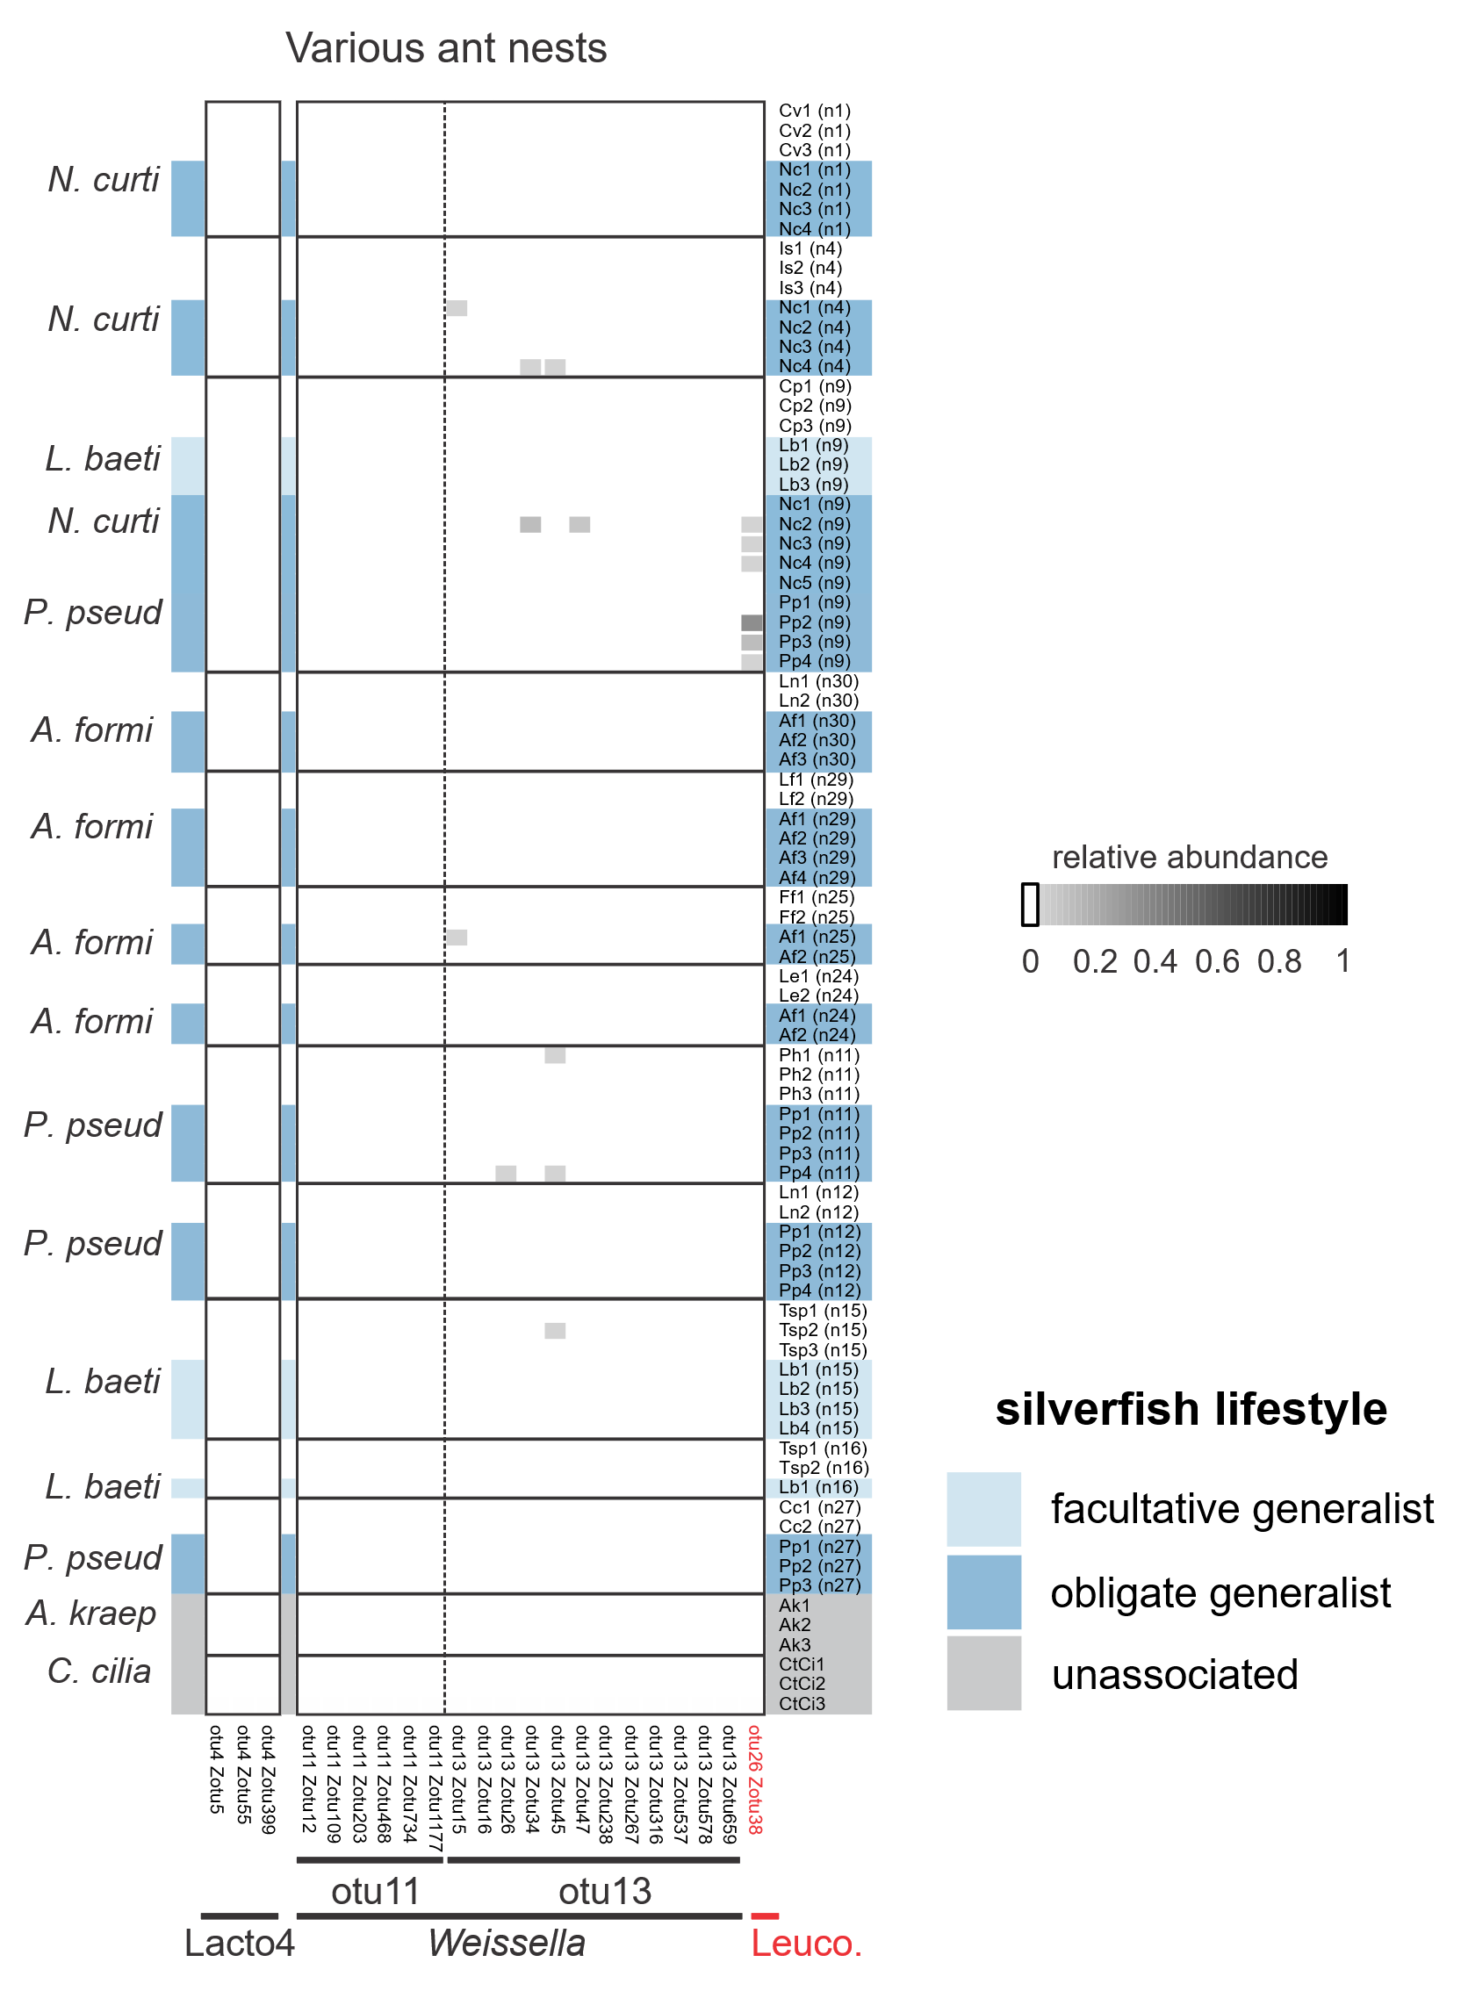
Figure S9. Heterofermentative Lactobacillaceae symbionts are generally restricted to host-specialized Neoasterolepisma within our silverfish panel. Ant and silverfish individuals are grouped according to nest origin. The relative abundances of heterofermentative Lactobacillaceae symbionts are visualized (see middle right). Silverfish lifestyle is colour-coded (bottom right). Silverfish species are further identified by their abbreviated species name. Here, OTU26 (zOTU38) was restricted to a single C. pilicornis colony (depicted here in red font).

