Supplementary Information for

Juvenile hormone signaling is indispensable for late embryogenesis in ametabolous and hemimetabolous insects

Ya-Nan Lv^{1, †}, Mei Zeng^{1, †}, Zi-Yu Yan^{1, †}, Pei-Yan Zhang¹, Ning Ban¹, Dong-Wei Yuan¹, Sheng Li^{1,2, *}, Yun-Xia Luan^{1,2, *}, and Yu Bai^{1,2 *}

¹ Guangdong Provincial Key Laboratory of Insect Development Biology and Applied Technology, Institute of Insect Science and Technology, School of Life Sciences, South China Normal University, Guangzhou, 510000, China
² Guangmeiyuan R&D Center, Guangdong Provincial Key Laboratory of Insect Developmental Biology and Applied Technology, South China Normal University, Meizhou, 514000, China

† Ya-Nan Lv, Mei Zeng, and Zi-Yu Yan contributed equally to this work.

* Corresponding authors:
S.L., lisheng@scnu.edu.cn
Y.-X.L., yxluan@scnu.edu.cn
Y.B., yubai@m.scnu.edu.cn

Table S1. List of significantly downregulated pathways enriched in KEGG analysis from the comparative transcriptome of KO-Td-JHAMT vs. Control.
KEGG pathway | GeneRatio | P-value adjust
Oxidative phosphorylation | 70/1613 | 4.23E-24
Proteasome | 36/1613 | 3.40E-13
DNA replication proteins | 50/1613 | 1.97E-09
Ribosome biogenesis | 94/1613 | 2.20E-09
DNA replication | 26/1613 | 3.83E-09
Citrate cycle (TCA cycle) | 23/1613 | 3.65E-08
Mitochondrial biogenesis | 104/1613 | 6.55E-08
Thermogenesis | 74/1613 | 2.10E-07
Proteasome | 41/1613 | 3.49E-07
Cardiac muscle contraction | 26/1613 | 3.49E-07
Ribosome | 57/1613 | 2.22E-06
Glycolysis / Gluconeogenesis | 28/1613 | 1.35E-05
Retrograde endocannabinoid signaling | 42/1613 | 4.63E-05
Carbon fixation in photosynthetic organisms | 12/1613 | 7.14E-05
Synaptic vesicle cycle | 32/1613 | 8.38E-05
Pyruvate metabolism | 27/1613 | 0.000106616
Cell cycle - yeast | 30/1613 | 0.00020844
Ribosome biogenesis in eukaryotes | 31/1613 | 0.00020844
Amino acid related enzymes | 27/1613 | 0.000230974
Nucleocytoplasmic transport | 32/1613 | 0.000245651
Propanoate metabolism | 18/1613 | 0.000398052
Arginine biosynthesis | 11/1613 | 0.000398052
Glyoxylate and dicarboxylate metabolism | 19/1613 | 0.000654387
Glucagon signaling pathway | 28/1613 | 0.000962715
Valine | 22/1613 | 0.00111689
Methane metabolism | 12/1613 | 0.00122151
Cysteine and methionine metabolism | 18/1613 | 0.00201766
Collecting duct acid secretion | 9/1613 | 0.002113637
Cell cycle | 34/1613 | 0.002237341
Messenger RNA biogenesis | 93/1613 | 0.002359844
Aminoacyl-tRNA biosynthesis | 19/1613 | 0.002593409
Tyrosine metabolism | 19/1613 | 0.00449891
Transfer RNA biogenesis | 49/1613 | 0.005540687
Nucleotide excision repair | 19/1613 | 0.005574699
Pyrimidine metabolism | 18/1613 | 0.00704757
Alanine | 18/1613 | 0.011570996
beta-Alanine metabolism | 14/1613 | 0.019203179
Butanoate metabolism | 11/1613 | 0.021046097
Mismatch repair | 11/1613 | 0.021046097
Tryptophan metabolism | 18/1613 | 0.021046097
Fatty acid degradation | 26/1613 | 0.021046097
Endocrine and other factor-regulated calcium reabsorption | 15/1613 | 0.028114931
Histidine metabolism | 12/1613 | 0.028114931
Translation factors | 27/1613 | 0.029100723

Table S2. List of significantly downregulated pathways enriched in KEGG analysis from the comparative transcriptome of KO-Td-CYP15A1 vs. Control.
KEGG pathway | GeneRatio | P-value adjust
Oxidative phosphorylation | 73/1537 | 2.79E-28
Ribosome | 72/1537 | 3.40E-14
Proteasome | 36/1537 | 4.68E-14
Ribosome biogenesis | 99/1537 | 8.18E-13
Mitochondrial biogenesis | 111/1537 | 1.14E-11
Cardiac muscle contraction | 30/1537 | 9.32E-11
Citrate cycle (TCA cycle) | 25/1537 | 1.21E-10
Thermogenesis | 79/1537 | 1.51E-10
Proteasome | 42/1537 | 2.21E-08
Glyoxylate and dicarboxylate metabolism | 24/1537 | 2.50E-07
Ribosome | 48/1537 | 5.38E-07
Glycolysis / Gluconeogenesis | 27/1537 | 1.91E-05
Valine | 25/1537 | 1.96E-05
DNA replication | 20/1537 | 3.38E-05
Nucleocytoplasmic transport | 33/1537 | 3.54E-05
Carbon fixation in photosynthetic organisms | 12/1537 | 3.54E-05
DNA replication proteins | 39/1537 | 3.54E-05
Pyruvate metabolism | 27/1537 | 3.54E-05
Messenger RNA biogenesis | 98/1537 | 3.54E-05
Translation factors | 34/1537 | 4.91E-05
Ribosome biogenesis in eukaryotes | 31/1537 | 6.45E-05
Amino acid related enzymes | 27/1537 | 7.92E-05
Aminoacyl-tRNA biosynthesis | 21/1537 | 0.000135941
Methane metabolism | 12/1537 | 0.000809898
Arginine biosynthesis | 10/1537 | 0.001623487
Tryptophan metabolism | 20/1537 | 0.002188781
Propanoate metabolism | 16/1537 | 0.002575543
One carbon pool by folate | 10/1537 | 0.002621919
Tyrosine metabolism | 19/1537 | 0.002624356
Cysteine and methionine metabolism | 17/1537 | 0.003355701
Carbon fixation pathways in prokaryotes | 9/1537 | 0.004626708
mRNA surveillance pathway | 25/1537 | 0.006753497
Histidine metabolism | 13/1537 | 0.006753497
Collecting duct acid secretion | 8/1537 | 0.008279736
Fatty acid degradation | 26/1537 | 0.012201587
Alanine | 17/1537 | 0.01827622
Chaperones and folding catalysts | 62/1537 | 0.018894099
Selenocompound metabolism | 8/1537 | 0.020722205
Retrograde endocannabinoid signaling | 32/1537 | 0.022147163
Synaptic vesicle cycle | 24/1537 | 0.026329711
Cell cycle - yeast | 23/1537 | 0.028778401
Transfer RNA biogenesis | 44/1537 | 0.028809108

Table S3. List of significantly downregulated pathways enriched in KEGG analysis from the comparative transcriptome of KO-Td-Met vs. Control.
KEGG pathway | GeneRatio | P-value adjust
Oxidative phosphorylation | 69/1489 | 2.36E-25
Proteasome | 35/1489 | 2.38E-13
Ribosome biogenesis | 90/1489 | 1.10E-09
Citrate cycle (TCA cycle) | 24/1489 | 1.10E-09
Cardiac muscle contraction | 27/1489 | 1.93E-08
Proteasome | 41/1489 | 4.17E-08
Thermogenesis | 72/1489 | 4.17E-08
DNA replication | 23/1489 | 1.74E-07
DNA replication proteins | 43/1489 | 3.37E-07
Ribosome | 56/1489 | 3.65E-07
Mitochondrial biogenesis | 95/1489 | 4.99E-07
Carbon fixation in photosynthetic organisms | 12/1489 | 3.45E-05
Glyoxylate and dicarboxylate metabolism | 20/1489 | 8.38E-05
Glycolysis / Gluconeogenesis | 25/1489 | 0.000122008
Ribosome biogenesis in eukaryotes | 30/1489 | 0.00014256
Pyruvate metabolism | 25/1489 | 0.000270283
Synaptic vesicle cycle | 29/1489 | 0.000373811
Cell cycle - yeast | 28/1489 | 0.000374762
Valine | 22/1489 | 0.000418061
Retrograde endocannabinoid signaling | 37/1489 | 0.00046578
Methane metabolism | 12/1489 | 0.000659228
Tyrosine metabolism | 20/1489 | 0.000659228
Collecting duct acid secretion | 9/1489 | 0.001350985
Propanoate metabolism | 16/1489 | 0.001981749
Nucleocytoplasmic transport | 28/1489 | 0.002163294
Cysteine and methionine metabolism | 17/1489 | 0.002622048
Pyrimidine metabolism | 18/1489 | 0.003366143
Carbon fixation pathways in prokaryotes | 9/1489 | 0.004009721
Cell cycle | 31/1489 | 0.005787938
Translation factors | 28/1489 | 0.005787938
Arginine biosynthesis | 9/1489 | 0.006090515
Messenger RNA biogenesis | 85/1489 | 0.006090515
Purine metabolism | 37/1489 | 0.007957449
Aminoacyl-tRNA biosynthesis | 17/1489 | 0.008291426
One carbon pool by folate | 9/1489 | 0.009078493
Tryptophan metabolism | 18/1489 | 0.009317709
Amino acid related enzymes | 21/1489 | 0.01567174
Caprolactam degradation | 10/1489 | 0.021388238
Meiosis - yeast | 22/1489 | 0.02278727
Drug metabolism - other enzymes | 41/1489 | 0.027354012
Ribosome | 33/1489 | 0.031536958
Isoquinoline alkaloid biosynthesis | 11/1489 | 0.034715153
Endocrine and other factor-regulated calcium reabsorption | 14/1489 | 0.034715153
Adrenergic signaling in cardiomyocytes | 25/1489 | 0.034715153
Mismatch repair | 10/1489 | 0.034715153
Histidine metabolism | 11/1489 | 0.043100724

Table S4. List of significantly downregulated pathways enriched in KEGG analysis from the comparative transcriptome of KO-Td-Kr-h1 vs. Control.
KEGG pathway | GeneRatio | P-value adjust
Oxidative phosphorylation | 71/1522 | 1.25E-26
Thermogenesis | 85/1522 | 4.21E-13
Cardiac muscle contraction | 31/1522 | 1.68E-11
Proteasome | 33/1522 | 1.68E-11
Citrate cycle (TCA cycle) | 24/1522 | 1.42E-09
Mitochondrial biogenesis | 102/1522 | 1.31E-08
Pyruvate metabolism | 30/1522 | 1.24E-06
Glycolysis / Gluconeogenesis | 29/1522 | 1.36E-06
Retrograde endocannabinoid signaling | 44/1522 | 1.55E-06
Ribosome | 55/1522 | 2.15E-06
DNA replication proteins | 41/1522 | 5.30E-06
DNA replication | 21/1522 | 6.25E-06
Proteasome | 37/1522 | 6.25E-06
Carbon fixation in photosynthetic organisms | 12/1522 | 3.77E-05
Synaptic vesicle cycle | 31/1522 | 7.35E-05
Glucagon signaling pathway | 29/1522 | 0.000164091
Tyrosine metabolism | 20/1522 | 0.001178735
Messenger RNA biogenesis | 90/1522 | 0.002089457
Ribosome biogenesis | 70/1522 | 0.00213839
Nucleocytoplasmic transport | 28/1522 | 0.003957005
Methane metabolism | 11/1522 | 0.004632432
Alanine | 18/1522 | 0.009420054
Glyoxylate and dicarboxylate metabolism | 16/1522 | 0.012653422
Fatty acid degradation | 26/1522 | 0.015001827
One carbon pool by folate | 9/1522 | 0.015001827
Adrenergic signaling in cardiomyocytes | 27/1522 | 0.017980447
Propanoate metabolism | 14/1522 | 0.026130986
Ribosome biogenesis in eukaryotes | 24/1522 | 0.033127206
Chloroalkane and chloroalkene degradation | 6/1522 | 0.036336356
Arginine biosynthesis | 8/1522 | 0.037143699
Tryptophan metabolism | 17/1522 | 0.037143699
Long-term potentiation | 18/1522 | 0.039864114

Table S5. List of significantly downregulated pathways enriched in KEGG analysis from the comparative transcriptome of KO-Gb-Kr-h1 vs. Control.
KEGG pathway | GeneRatio | P-value adjust
Oxidative phosphorylation | 64/1093 | 2.03E-21
Thermogenesis | 74/1093 | 3.32E-13
Cardiac muscle contraction | 39/1093 | 2.78E-11
Adrenergic signaling in cardiomyocytes | 45/1093 | 4.75E-09
cGMP-PKG signaling pathway | 46/1093 | 8.85E-08
Citrate cycle (TCA cycle) | 24/1093 | 7.06E-06
Gastric acid secretion | 25/1093 | 0.00010085
Focal adhesion | 45/1093 | 0.00010085
Retrograde endocannabinoid signaling | 33/1093 | 0.00010085
Collecting duct acid secretion | 11/1093 | 0.00011436
Platelet activation | 30/1093 | 0.00011436
Regulation of actin cytoskeleton | 38/1093 | 0.00057874
Glucagon signaling pathway | 28/1093 | 0.00057874
Calcium signaling pathway | 35/1093 | 0.000583239
Vascular smooth muscle contraction | 30/1093 | 0.000889816
Phagosome | 32/1093 | 0.000913037
Domain-containing proteins not elsewhere classified | 26/1093 | 0.00118806
Tight junction | 36/1093 | 0.00188691
Oxytocin signaling pathway | 29/1093 | 0.004550019
Apelin signaling pathway | 24/1093 | 0.005931876
Leukocyte transendothelial migration | 20/1093 | 0.006741979
ECM-receptor interaction | 13/1093 | 0.011474198
Glycolysis / Gluconeogenesis | 20/1093 | 0.011903313
Pyruvate metabolism | 18/1093 | 0.011903313
Mineral absorption | 16/1093 | 0.01278674
Pentose phosphate pathway | 13/1093 | 0.014180487
Salivary secretion | 21/1093 | 0.044100202

Table S6. List of primers utilized in gRNA synthesis.
Fragment | Forward (5’ to 3’) | Reverse (5’ to 3’)
Td-JHAMT gRNA1 | TAATACGACTCACTATAGGAAGTGGCAGGACAAG | TTCTAGCTCTAAAACGGTCCTTGTCCTGCCACTT
Td-JHAMT gRNA2 | TAATACGACTCACTATAGCTCGTTTCTCACGTTT | TTCTAGCTCTAAAACCACCAAACGTGAGAAACGA
Td-CYP15A1 gRNA1 | TAATACGACTCACTATAGGACGTGCATGGCAGGA | TTCTAGCTCTAAAACCTGTTCCTGCCATGCACGT
Td-CYP15A1 gRNA2 | TAATACGACTCACTATAGGTCTGTGGGCCATGAC | TTCTAGCTCTAAAACTGCAGTCATGGCCCAGAGA
Td-Met gRNA1 | TAATACGACTCACTATAGCCGCATTATGCGGAAT | TTCTAGCTCTAAAACCCAGATTCCGCATAATGCG
Td-Met gRNA2 | TAATACGACTCACTATAGGGCTTAGTGCCACGTT | TTCTAGCTCTAAAACGAGGAACGTGGCACTAAGC
Td-Kr-h1 gRNA1 | TAATACGACTCACTATAGCCGGAAGAGACTACAG | TTCTAGCTCTAAAACCCTGCTGTAGTCTCTTCCG
Td-Kr-h1 gRNA2 | TAATACGACTCACTATAGCTGCACCAAGTGGCCC | TTCTAGCTCTAAAACTAGTGGGCCACTTGGTGCA
Gb-Kr-h1 gRNA1 | TAATACGACTCACTATAGGTTCTGCGCAAAGAGC | TTCTAGCTCTAAAACAGAAGCTCTTTGCGCAGAA
Gb-Kr-h1 gRNA2 | TAATACGACTCACTATAGTCCAAGACCTTCATCC | TTCTAGCTCTAAAACCTCTGGATGAAGGTCTTGG

Table S7. List of primers used for genotyping.
Fragment | Forward (5’ to 3’) | Reverse (5’ to 3’)
Td-JHAMT | AGAGAGGTGTCTTCCTTCAAGA | AGCTTACCTGTGATCACTTATCC
Td-CYP15A1 | ACCTTCTCATCAGTGCAATCTC | ACGCATTCCAAATATTCTTCACG
Td-Met | TGTATCGTGTTCTGTTGTCTAATTG | GGGACATGTACAGATGTGAGG
Td-Kr-h1 | GTTGGCTACTTCGACATGGA | CACTCTCGATTTGAGGAGGC
Gb-Kr-h1 | CAAAACGTTCGCCGTTCC | CTTGCGTATTCCAAGCAAGG

Table S8. List of primers utilized in qPCR.
gene | Forward (5’ to 3’) | Reverse (5’ to 3’)
qTd-Kr-h1 | CATATGCGTATTCATACGGGG | TGTGTATCACCAGTTGTCCA
qTd-rps26 | ATGACTTGCAAGCGAAGAAA | CAGTTTGTACACCTCACTGG

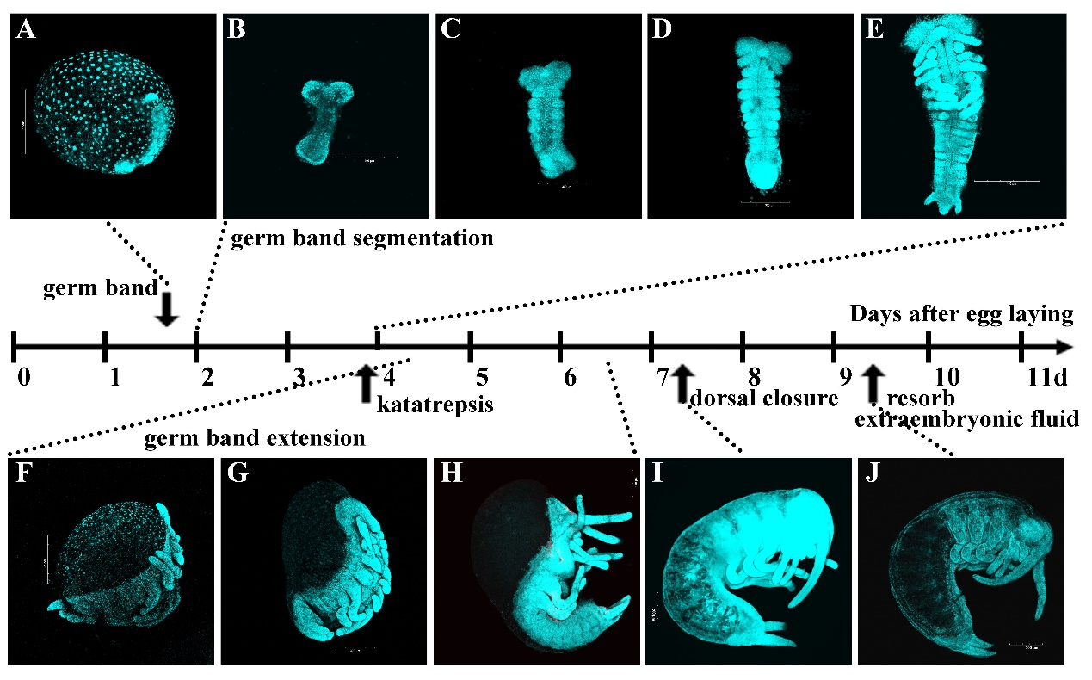
Figure S1. Timeline of Thermobia domestica embryogenesis, revealed by cellular dynamics, Related to Figure 1. DAPI-stained whole eggs or germ bands during the embryonic development of T. domestica. Days after egg deposition are displayed along the time axis. Photomicrographs illustrate embryo appearance at specified time points or intervals. At the onset of embryogenesis, energids proliferate and migrate to the ventral surface of the egg. Following this, energids located in the ventral region undergo proliferation, initiating the formation of the initial germ band (A, B). Subsequently, starting from day 2, the thoracic and abdominal segments progressively develop from the posterior growth zone, resulting in the formation of a fully segmented germ band by days 3–4 (B–E). During this process, the appendage primordia, including legs, are established. Upon the onset of katatrepsis, the extension of the lateral edges of the germ band progresses from posterior to anterior, gradually closing the dorsal thoracic midline until definitive dorsal closure is achieved by day 7 (F–I). During this process, the legs undergo morphogenetic growth and segmentation. Following dorsal closure, differentiation and maturation of tissues and organs, including the legs, occur. By day 9, there is a resorption of extraembryonic fluid, and the embryos rarely stained with DAPI at this time (J). Finally, the embryos hatch as first instar nymphs by day 11.
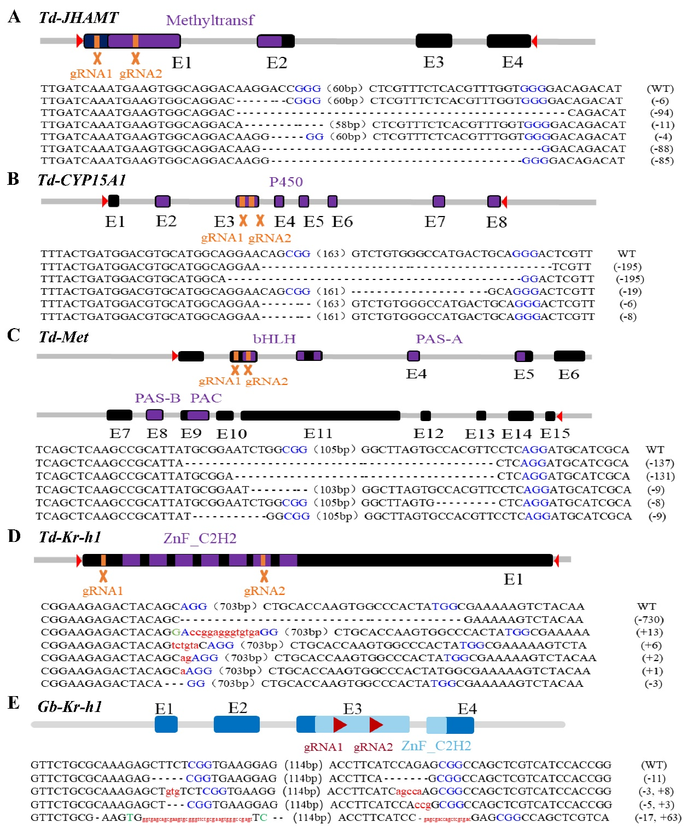
Figure S2. CRISPR/Cas9 mediated gene disruption. Diagram illustrating CRISPR/Cas9-mediated knockout of JHAMT, CYP15A1, Met, and Kr-h1 genes in T. domestica (A–D), as well as Kr-h1 gene knockout in G. bimaculatus (E). The genetic architecture, predicted functional domains, and locations of guide RNAs (gRNAs) are delineated within the schematic. Below each respective gene structure, clone sequencing outcomes of the mutant strains are presented. The protospacer adjacent motif (PAM) sites are denoted in blue; deleted bases are represented with “-”; inserted bases are highlighted in red; and replaced bases are depicted in green.
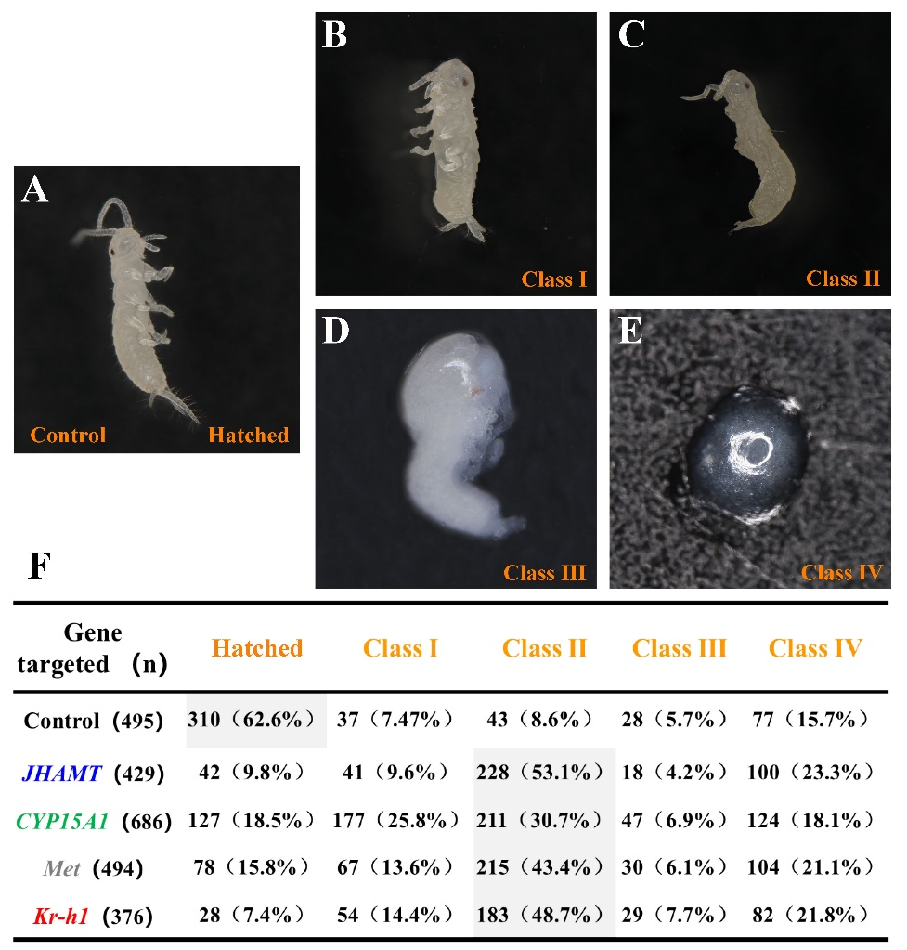
Figure S3. The classification criteria and distribution of unhatched embryos resulting from knockout of JHAMT, CYP15A1, Met, or Kr-h1 in T. domestica. (A–E) Images depicting typical phenotypes across various classes identified at ED14. (A) Normal freshly hatched first instar nymph. (B) Class Ⅰ. (C) Class Ⅱ. (D) Class Ⅲ. (E) Class Ⅳ. (F) Statistical analysis of unhatched embryos based on the aforementioned grading standards. Embryo dissections were conducted at ED14. Numbers in parentheses denote the total embryo count or the average percentage across four biological replicates.

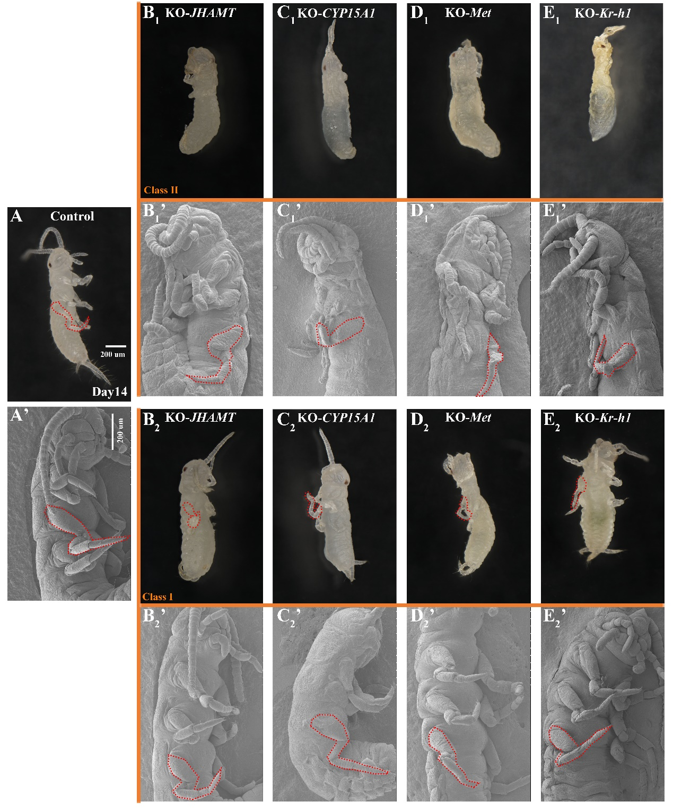
Figure S4. Embryonic phenotypes of Class Ⅱ and Class Ⅰ resulting from knockout of JHAMT, CYP15A1, Met, or Kr-h1 in T. domestica. (A, A’) Normal freshly emerged first instar nymph. Class Ⅱ (B1–E1’, displaying greater severity than depicted in Fig. 2) and Class Ⅰ (B2–E2’) embryos were examined using optical microscopy and scanning electron microscopy (SEM) (scale bar = 200 μm). Unhatched embryos were dissected at ED14, with legs outlined in red dashed lines.
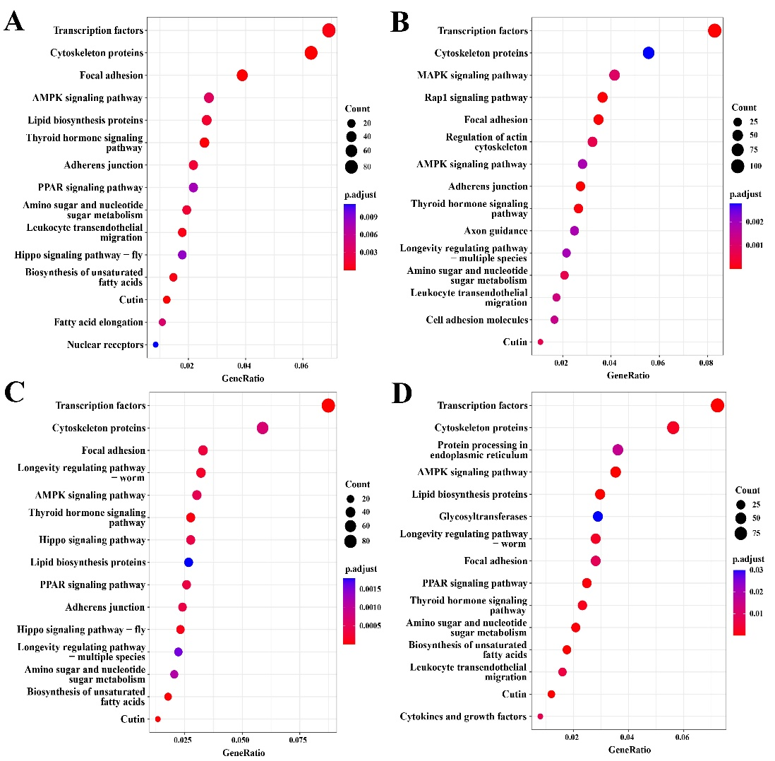
Figure S5. KEGG enrichment analysis of the upregulated genes resulting from knockout of JHAMT, CYP15A1, Met, or Kr-h1 in T. domestica. Bubble maps were generated (Top 15 upregulated pathways) from the comparative analysis of embryonic leg transcriptomes. (A) KO-JHAMT vs. Control; (B) KO-CYP15A1 vs. Control; (C) KO-Met vs. Control; (D) KO-Kr-h1 vs. Control. The results reveal significant consistency in the upregulated pathways across the comparative analysis of the aforementioned four groups. Embryonic legs were collected at ED10 and ED11 (mixed in a ratio of 6:4) from Control and G0 mutants for RNA-seq. Each group comprised three independent biological replicates, with at least 200 embryos classified as class Ⅰ or Ⅱ pooled to form one biological replicate.

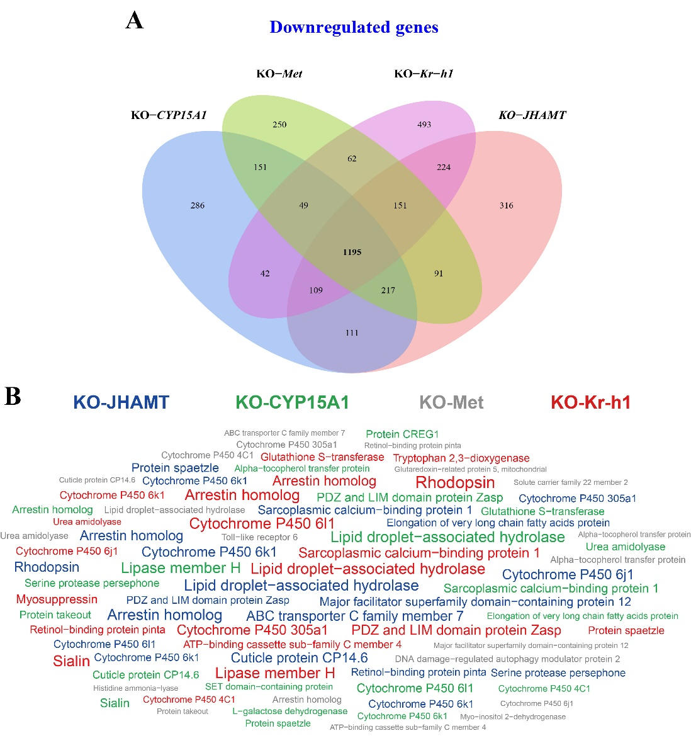
Figure S6. Venn analysis of the downregulated genes resulting from knockout of JHAMT, CYP15A1, Met, or Kr-h1 in T. domestica. (A) The Venn diagram derived from the sets (all downregulated genes) resulting from the comparative analysis of KO-JHAMT vs. Control, KO-CYP15A1 vs. Control, KO-Met vs. Control, and KO-Kr-h1 vs. Control, respectively. The analysis reveals 1198 genes that were commonly downregulated across the four groups of comparative transcriptomes. (B) The word cloud diagram, constructed from the commonly downregulated Top 20 annotated genes (displaying the highest fold change). The names of downregulated genes in each group are indicated on the diagram (blue for KO-JHAMT, green for KO-CYP15A1, grey for KO-Met, and red for KO-Kr-h1), with font sizes directly proportional to the fold changes.

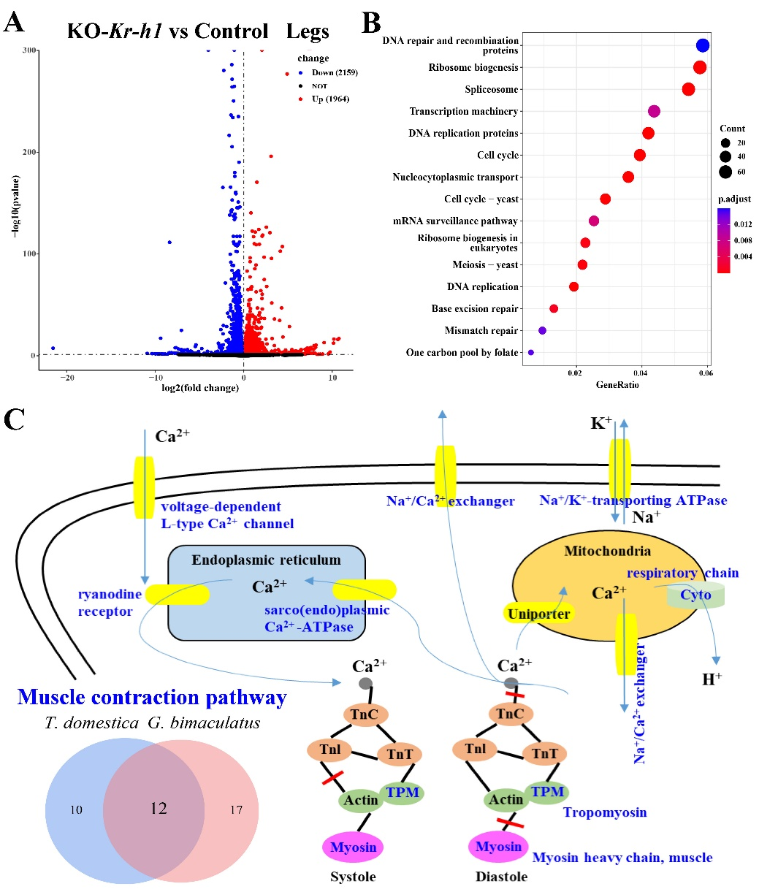
Figure S7. Comparative transcriptomes analysis of the embryonic legs in G. bimaculatus. (A) The volcano plot and (B) KEGG bubble map (Top 15 upregulated pathways) derived from comparative transcriptomes (KO-Kr-h1 vs. Control) of embryonic legs in G. bimaculatus. Embryonic legs were collected at ED10 and ED11 (mixed in a ratio of 6:4) from Control and G0 mutants for RNA-seq. Each group comprised three independent biological replicates, with at least 200 embryos classified as class Ⅰ pooled to form one biological replicate. (C) Diagrammatic representation of the muscle contraction pathway. Twelve genes involved in the muscle contraction pathway, commonly downregulated upon inhibition of JH signaling in the embryonic legs of T. domestica and G. bimaculatus, are depicted in blue font within the sketch.

