Supplementary Information
Uncovering Bacterial-Mammalian Cell Interactions via Single-Cell Tracking
Narendra K. Dewanganª, Sayed Golam Mohiuddinª, Shayne Sensenbach, Prashant Karki, and Mehmet A. Orman*
William A. Brookshire Department of Chemical and Biomolecular Engineering,
University of Houston, Houston, TX 77204-4004
*Corresponding author: morman@central.uh.edu
ªNarendra K. Dewangan and Sayed Golam Mohiuddin contributed equally.

Supplementary Figures
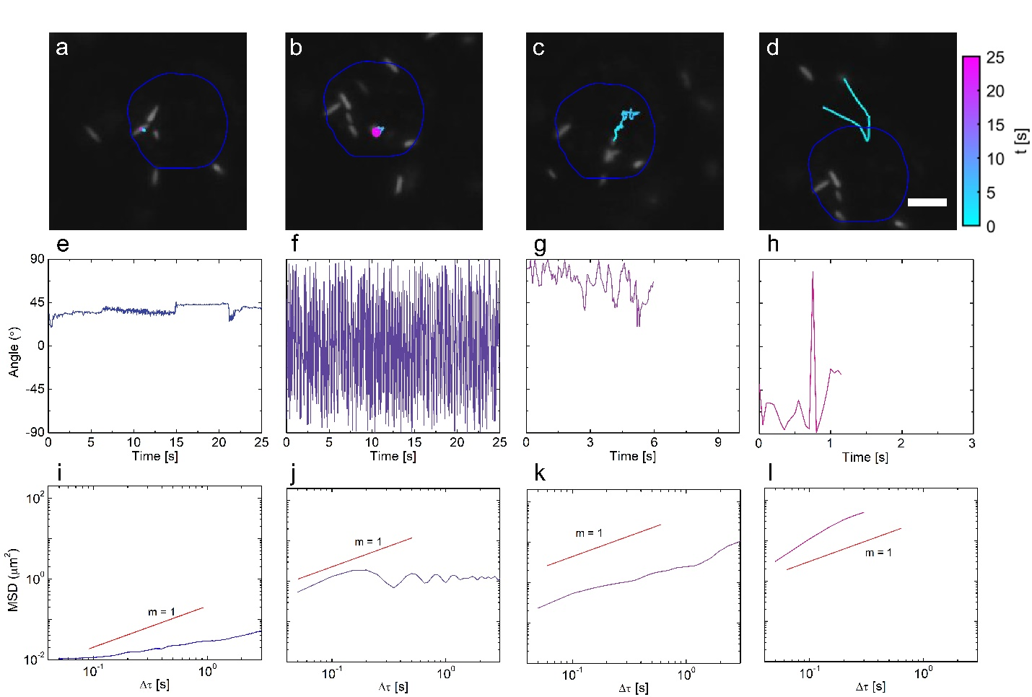Fig. S1: Bacterial cell trajectories. Trajectories of P. aeruginosa PAO1 near the lung H1975 cell for (a) an adhered bacterium, (b) a surface-bound bacterium rotating in the clockwise direction, (c) a bacterium moving on the mammalian cell surface, and (d) a bacterium approaching the H1975 cell. Scale bar is 5 μm. (e-h) Orientation angle of a bacterium as a function of time corresponding to the panels a, b, c, and d, respectively. Note that the bacterium's rotational motion in panel b resulted in an oscillatory angular behavior, as demonstrated in panel f. (i-l) Mean square displacements of a bacterium as a function of time corresponding to the panels a, b, c, and d, respectively. The blue circle in panels a, b, c, and d represents the same mammalian cell observed at various times and/or depicted from different angles.
Fig. S2: The changes in the density of bacteria on mammalian cell surfaces in relation to the initial concentration of bacterial cells and co-culturing time. (a, c) Micrographs of E. coli MG1655 on skin cells (A375) as a function of the number of bacterial cells (M: million) or co-culturing time, respectively. (b, d) Micrographs of P. aeruginosa PAO1 on A375 cell line as a function of the number of bacterial cells or co-culturing time, respectively. The scale bar is 30 μm. (e, f) The surface density (ρ) of bacteria as a function of the number of bacterial cells or co-culturing time, respectively. The surface density is defined as the number of bacterial cells per unit surface area. The F-statistics were used to perform a statistical comparison between two groups, where ***P < 0.001. The data for each time point is represented as the mean value ± standard deviation. N= 3.
Fig. S3: Individual MSDs of P. aeruginosa strains on lung-cell surfaces. At the population level, the individual MSD of each cell were analyzed for the specified mutants of P. aeruginosa. The data presented in each panel correspond to a minimum of three biological replicates, with multiple movies captured in each replicate, ensuring a sufficient number of cell trajectories were analyzed: ΔfliD=5,600; ΔcupC1=12,553; ΔcupC3¹=12,539; ΔcupC3²=22,005; ΔfimL¹=15,633; ΔfimL²=16,440; ΔcupA1¹=14,914; ΔcupA1²=12,751; ΔcupA5=16,040; ΔcupB6¹=12,937; ΔcupB6²=7375; ΔcupB1¹=7070; ΔcupB1²=13,414; ΔpilA¹=11,837; ΔpilA²=9,837; ΔfimT¹=13,607; ΔfimT²=15,749; ΔfimU¹=7,862; ΔfimU²=11,402 trajectories.
Fig. S4: The impact of membrane proteins on the adhesion and tolerance of P. aeruginosa. (a) Micrographs depicting wild-type P. aeruginosa as well as mutant strains on skin cells (A375), with a scale bar of 30 μm. (b) The surface density (ρ) of wild-type P. aeruginosa and the mutant strains on A375 cell line. One-way ANOVA with Dunnett's post-test was utilized for the statistical analysis, where *P < 0.05, ***P < 0.001, ****P < 0.0001. The data for each time point is represented as the mean value ± standard deviation. N=3.
Fig. S5: Clonogenic survival assays. (a-b) The colony forming unit (CFU) counts of wild-type P. aeruginosa and the mutant strains. Bacterial cells were cocultured with lung cells (H1975) for 2 h at 37 °C. In order to quantify the number of colony-forming units for cells pre- (t=0) and post-interaction (t=2 h) between H1975 and P. aeruginosa, both swimming and attached bacterial cells were collected and plated onto Mueller-Hinton agar plates. (c) Time dependent bimodal killing curve. Wild-type P. aeruginosa cells were exposed to ofloxacin (10x MIC) for 3 hours in the presence of lung cells. Clonogenic survival assays were conducted at designated time points to determine the cell survival fractions. One-way ANOVA with Dunnett's post-test was utilized for the statistical analysis. The data for each time point is represented as the mean value ± standard deviation. N=3.

Fig. S6: Clonogenic survival assays. The colony forming unit (CFU) counts of wild-type P. aeruginosa and the mutant strains. Bacterial cells were cultured in the presence and absence of the lung cells (H1975) for 2 h at 37 °C. Then wild-type P. aeruginosa cells were exposed to ofloxacin (10x MIC) for 3 hours. Clonogenic survival assays were conducted at designated time points (before the treatment, t=0 and after the treatment, t=3 h) to determine the cell survival fractions. A two-tailed student t-test with unequal variance was used to determine statistical significance where the threshold P-value is 0.05. The data for each time point is represented as the mean value ± standard deviation. N=3.

Supplementary Tables
Table S1: Bacterial strains, plasmids, mammalian cell lines, and oligonucleotides used in this study.
A. Bacterial strains |  |  |  | Source or reference
Escherichia coli K-12 MG1655 (wild type) |  |  |  | In house
Pseudomonas aeruginosa PAO1 (wild type) |  |  |  | Manoil Lab
Pseudomonas aeruginosa PAO1 ΔcupC1 |  |  |  | Manoil Lab
Pseudomonas aeruginosa PAO1 ΔcupC3¹ |  |  |  | Manoil Lab
Pseudomonas aeruginosa PAO1 ΔcupC3² |  |  |  | Manoil Lab
Pseudomonas aeruginosa PAO1 ΔfliD |  |  |  | Manoil Lab
Pseudomonas aeruginosa PAO1 ΔfimL¹ |  |  |  | Manoil Lab
Pseudomonas aeruginosa PAO1 ΔfimL² |  |  |  | Manoil Lab
Pseudomonas aeruginosa PAO1 ΔcupA1¹ |  |  |  | Manoil Lab
Pseudomonas aeruginosa PAO1 ΔcupA1² |  |  |  | Manoil Lab
Pseudomonas aeruginosa PAO1 ΔcupA5 |  |  |  | Manoil Lab
Pseudomonas aeruginosa PAO1 ΔcupB6¹ |  |  |  | Manoil Lab
Pseudomonas aeruginosa PAO1 ΔcupB6² |  |  |  | Manoil Lab
Pseudomonas aeruginosa PAO1 ΔcupB1¹ |  |  |  | Manoil Lab
Pseudomonas aeruginosa PAO1 ΔcupB1² |  |  |  | Manoil Lab
Pseudomonas aeruginosa PAO1 ΔpilA¹ |  |  |  | Manoil Lab
Pseudomonas aeruginosa PAO1 ΔpilA² |  |  |  | Manoil Lab
Pseudomonas aeruginosa PAO1 ΔfimT¹ |  |  |  | Manoil Lab
Pseudomonas aeruginosa PAO1 ΔfimT² |  |  |  | Manoil Lab
Pseudomonas aeruginosa PAO1 ΔfimU¹ |  |  |  | Manoil Lab
Pseudomonas aeruginosa PAO1 ΔfimU² |  |  |  | Manoil Lab
B. Plasmids |  |  |  | Source or reference
pMMB67EH-yfp |  |  |  | Addgene (Catalog# 90104)
pMMB67EH-mCherry |  |  |  | This study
C. Mammalian cell lines |  |  |  | Source or reference
Lung cancer cell (H1975) |  |  |  | ATCC
Melanoma cancer cell (A375) |  |  |  | ATCC
C. Plasmid construction
pMMB67EH-mCherry |  | The pMMB67EH-yfp plasmid was purchased from Addgene. The mCherry gene was amplified using forward and reverse primers with EcoRI and HindIII restriction enzyme cut sites, respectively. The pMMB67EH-yfp plasmid was double digested with HindIII and MluI to remove the yfp gene. Then, the digested mCherry gene and plasmid were ligated to generate pMMB67EH-mCherry.
D. Oligonucleotides to check mutant strains and plasmids construction
Plasmid/deletion | Forward primer (5’ to 3’) |  | Reverse primer (5’ to 3’) |  | Source
mCherry  (pMMB67EH-mCherry) | GCGCATGAATTCACT  TTAAGAAGGAGATA  TCATATGGTGAGCAA  GGGCGAGGAGGATA |  | GCGCCTAAGCTTAGT  CTACTTGTACAGCTC  GTCCATGCCG |  | Integrated DNA Technologies, Inc.
ΔcupC1 | AAGCTGCTCAGGTTT  CTCCA |  | ATAGATGCCAATACCG  ACGC |  | Integrated DNA Technologies, Inc.
ΔcupC3¹ | TTTCCAACTACCAG  GCCAAC |  | TCTTCTGCCGACTGGA  ACTT |  | Integrated DNA Technologies, Inc.
ΔcupC3² | TTGTATACCTCCGC  TCAGGG |  | TTGGCTTCATCCAGGT  ATCC |  | Integrated DNA Technologies, Inc.
ΔfliD | CCAGTTCAAGAGTG  CGATCA |  | TCGAGCTTCTTCTCGT  CGAT |  | Integrated DNA Technologies, Inc.
ΔfimL¹ | TGCCGTTGTATATT  CTTGCG |  | GCCACCAGGTAAAGC  AGTTC |  | Integrated DNA Technologies, Inc.
ΔfimL² | GATCCAGGGCTACT  GCCTG |  | GATAGAGGTTCTGTT  CGCGG |  | Integrated DNA Technologies, Inc.
ΔcupA1¹ | CTCGTTCGAGTCTT  TACCGC |  | AGAACAGCTTCAGGC  GATTG |  | Integrated DNA Technologies, Inc.
ΔcupA1² | TGGACGATTATTGC  CTCACA |  | GGTAGAACAGCTTCA  GGCGA |  | Integrated DNA Technologies, Inc.
ΔcupA5 | AGGTGGTTATCCGT  GTCCAG |  | AGGATCAGTTCCTGG  GTCG |  | Integrated DNA Technologies, Inc.
ΔcupB6¹ | GCTCTTCAAGCTGA  GGATCG |  | CTGAACTGCTCGTTC  GACAA |  | Integrated DNA Technologies, Inc.
ΔcupB6² | AAACGTATCCGCTG  CTGGT |  | CTGAACTGCTCGTTC  GACAA |  | Integrated DNA Technologies, Inc.
ΔcupB1¹ | CACTCTTCAACTGG  CTGGGT |  | GTCGATGGGATCGTC  AACTT |  | Integrated DNA Technologies, Inc.
ΔcupB1² | GAAACGTAGTAAGG  CGTCGG |  | GGAACCAACTCCACT  TTCCA |  | Integrated DNA Technologies, Inc.
ΔpilA¹ | ACTACATCTCCATCG  GCACC |  | ACCCAGTTTCCTTGA  TCGTG |  | Integrated DNA Technologies, Inc.
ΔpilA² | GGAATCAACGAGG  GCACC |  | ACCCAGTTTCCTTGA  TCGTG |  | Integrated DNA Technologies, Inc.
ΔfimT¹ | CTCGATCGGCACT  TCCTTC |  | AGGAGCCTTTCCTTC  TTTGC |  | Integrated DNA Technologies, Inc.
ΔfimT² | CGCCCACTACCAC  AACTCTT |  | TGTCAGCTGCTTGAA  GTTCG |  | Integrated DNA Technologies, Inc.
ΔfimU¹ | GAGAGGGCTGGCT  GCTTG |  | GCGGTGTACTGGATG  GTCTT |  | Integrated DNA Technologies, Inc.
ΔfimU² | CTGGCAACTGATCC  TCAACC |  | GCGGTGTACTGGATG  GTCTT |  | Integrated DNA Technologies, Inc.

Table S2: Comparing the distributions of average displacements between PA01 and mutant strains.
Strains | Kolmogorov-Smirnov test, P value
ΔcupC1 | <0.000001
ΔcupC3¹ | 0.174433
ΔcupC3² | <0.000001
ΔfliD | <0.000001
ΔfimL¹ | <0.000001
ΔfimL² | <0.000001
ΔcupA1¹ | <0.000001
ΔcupA1² | <0.000001
ΔcupA5 | <0.000001
ΔcupB6¹ | <0.000001
ΔcupB6² | <0.000001
ΔcupB1¹ | <0.000001
ΔcupB1² | <0.000001
ΔpilA¹ | 0.008441
ΔpilA² | <0.000001
ΔfimT¹ | <0.000001
ΔfimT² | <0.000001
ΔfimU¹ | <0.000001
ΔfimU² | <0.000001
E. coli MG1655 | <0.000001

Table S3: Percentage of attached and unattached/motile cells in P. aeruginosa strains.
Strain | % attached | % unattached/motile
P. aeruginosa PA01 | 2.54 | 97.46
P. aeruginosa ΔcupC1 | 6.10 | 93.90
P. aeruginosa ΔcupC3¹ | 2.80 | 97.20
P. aeruginosa ΔcupC3² | 3.62 | 96.38
P. aeruginosa ΔfliD | 0.86 | 99.14
P. aeruginosa ΔfimL¹ | 2.51 | 97.49
P. aeruginosa ΔfimL² | 4.64 | 95.36
P. aeruginosa ΔcupA1¹ | 3.76 | 96.24
P. aeruginosa ΔcupA1² | 2.64 | 97.36
P. aeruginosa ΔcupA5 | 3.45 | 96.55
P. aeruginosa ΔcupB6¹ | 3.25 | 96.75
P. aeruginosa ΔcupB6² | 5.69 | 94.31
P. aeruginosa ΔcupB1¹ | 4.55 | 95.45
P. aeruginosa ΔcupB1² | 3.47 | 96.53
P. aeruginosa ΔpilA¹ | 2.54 | 97.46
P. aeruginosa ΔpilA² | 2.27 | 97.73
P. aeruginosa ΔfimT¹ | 2.12 | 97.88
P. aeruginosa ΔfimT² | 3.89 | 96.11
P. aeruginosa ΔfimU¹ | 2.85 | 97.15
P. aeruginosa ΔfimU² | 3.28 | 96.72

Table S4: MIC levels of ofloxacin for the strains used in this study.
Bacterial strain | Bactericidal antibiotics | MIC Range (µg/ml) | Clonogenic survival assay concentration (µg/ml)
Pseudomonas aeruginosa PAO1 (wild type) | Ofloxacin | 0.75-1.0 | 10
Pseudomonas aeruginosa PAO1 ΔcupC1 | Ofloxacin | 0.75-1.0 | 10
Pseudomonas aeruginosa PAO1 ΔcupC3¹ | Ofloxacin | 1.5-2.0 | 10
Pseudomonas aeruginosa PAO1 ΔcupC3² | Ofloxacin | 0.75-1.0 | 10
Pseudomonas aeruginosa PAO1 ΔfliD | Ofloxacin | 0.75-1.0 | 10
Pseudomonas aeruginosa PAO1 ΔfimL¹ | Ofloxacin | 0.75-1.0 | 10
Pseudomonas aeruginosa PAO1 ΔfimL² | Ofloxacin | 0.75-1.0 | 10
Pseudomonas aeruginosa PAO1 ΔcupA1¹ | Ofloxacin | 0.75-1.0 | 10
Pseudomonas aeruginosa PAO1 ΔcupA1² | Ofloxacin | 0.75-1.0 | 10
Pseudomonas aeruginosa PAO1 ΔcupA5 | Ofloxacin | 0.75-1.0 | 10
Pseudomonas aeruginosa PAO1 ΔcupB6¹ | Ofloxacin | 0.75-1.0 | 10
Pseudomonas aeruginosa PAO1 ΔcupB6² | Ofloxacin | 0.75-1.0 | 10
Pseudomonas aeruginosa PAO1 ΔcupB1¹ | Ofloxacin | 0.75-1.0 | 10
Pseudomonas aeruginosa PAO1 ΔcupB1² | Ofloxacin | 0.75-1.0 | 10
Pseudomonas aeruginosa PAO1 ΔpilA¹ | Ofloxacin | 0.75-1.0 | 10
Pseudomonas aeruginosa PAO1 ΔpilA² | Ofloxacin | 0.75-1.0 | 10
Pseudomonas aeruginosa PAO1 ΔfimT¹ | Ofloxacin | 0.75-1.0 | 10
Pseudomonas aeruginosa PAO1 ΔfimT² | Ofloxacin | 0.75-1.0 | 10
Pseudomonas aeruginosa PAO1 ΔfimU¹ | Ofloxacin | 0.75-1.0 | 10
Pseudomonas aeruginosa PAO1 ΔfimU² | Ofloxacin | 0.75-1.0 | 10

Table S5: Chemicals used in this study.
Chemicals | Purity (%) | Source | Catalog number
Isopropyl ß-D-1 thiogalactopyranoside | >99 | Fisher Scientific | BP1755-10
Gentamicin sulfate | >99 | VWR | 0304-100G
Ofloxacin | 98 | Fisher Scientific | AC455670050
HEPES hemisodium salt | 98 | ThermoFisher Scientific | J61830.36

