Additional File 1
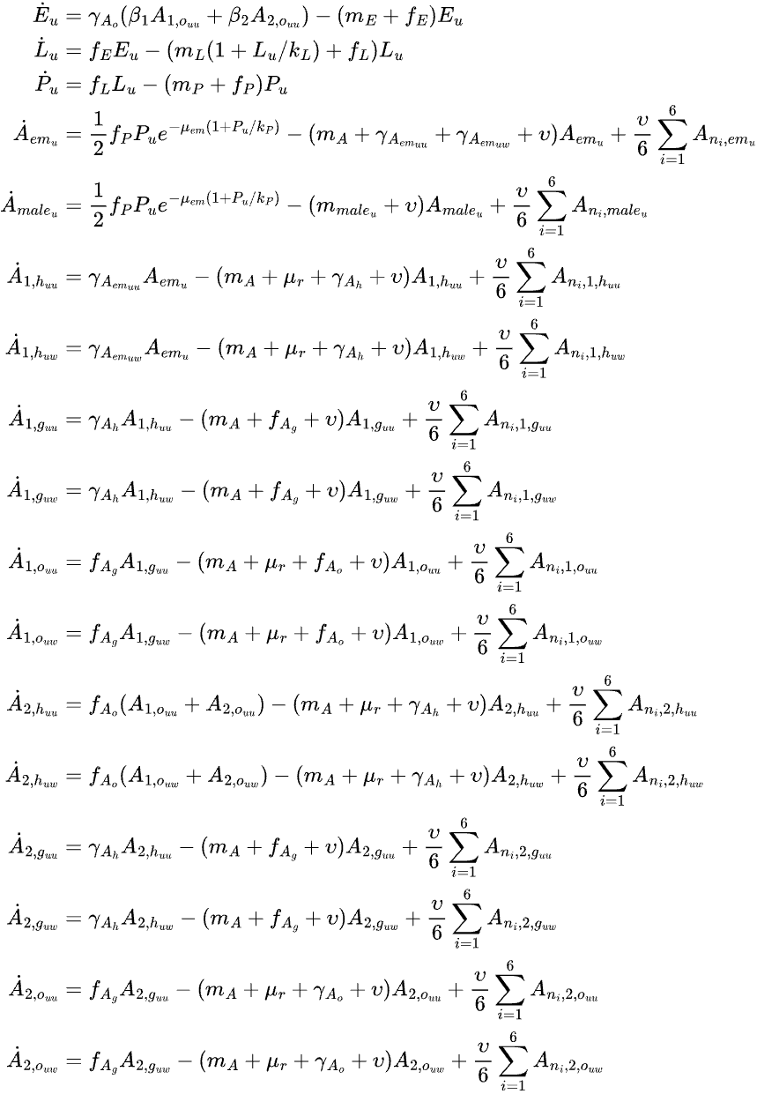

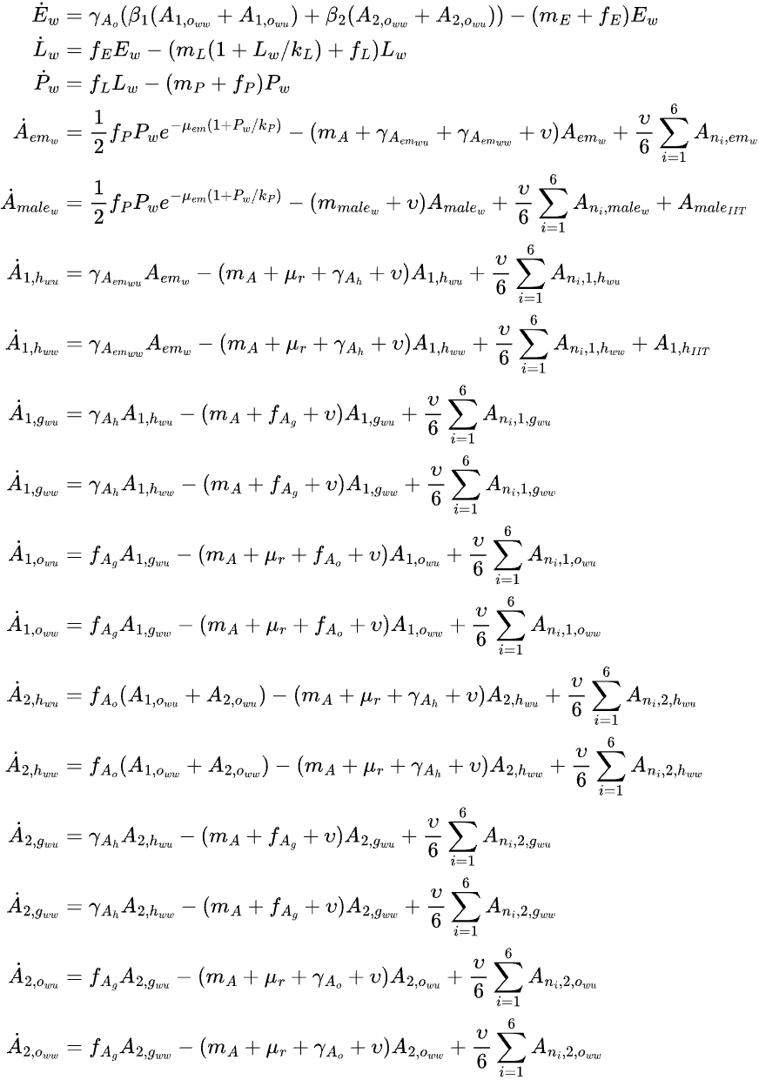

where
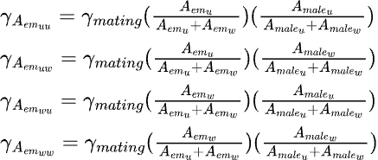
Figure S1. Equations for the process-based model.

Table S1. Process-based model parameters.
Notation | Definition | Value | Reference
β₁ | Number of eggs laid per ovipositing nulliparous female | 60.0 | (42)
β₂ | Number of eggs laid per ovipositing parous female | 80.0 | (42)
𝛾_{mating} | Transition rate from emergent to host-seeking adults per day | 0.4 | (42)
𝛾_{Ah} | Transition rate from host-seeking to engorged adults per day | 0.2 | (42)
𝛾_{Ao} | Minimum transition rate from ovipositing to host-seeking adults per day | 0.2 | (42)
µ_{E} | Minimum egg mortality rate per day | 0.01 | (42)
µ_{em} | Mortality rate during emergence per day | 0.1 | (42)
µ_{r} | Mortality rate related to seeking behavior per day | 0.08 | (42)
k_{Lfix} | Maximum human-dependent larval carrying capacity index in a specific hexagon | 100 | Reference index
k_{Pfix} | Maximum human-dependent larval carrying capacity index in a specific hexagon | 100 | Reference index
k_{Lvar} | Maximum rainfall-dependent larval carrying capacity index in a specific hexagon | 50 | Derived¹
k_{Pvar} | Maximum rainfall-dependent pupal carrying capacity index in a specific hexagon | 50 | Derived¹
𝜐 | Migration rate of adult mosquitoes out of a hexagon per day | 0.0663 | Derived²
𝜂_{maleu} | Adult male mortality factor (relative to adult female mosquitoes) | 2 | Derived³
𝜂_{malew} | Additional male Wolbachia-infected mortality factor (relative to adult male mosquitoes) | 0.3 | Derived⁴
Details can be found in the following sub-sections of Additional File 2:
¹Derivation of the relative ratio between fixed and variable carrying capacities
²Derivation of the migration rate
³Derivation of the adult male mortality factor
⁴Derivation of the additional adult Wolbachia-infected male mortality factor

Table S2. Process-based model functions.
Notation | Definition | Expression | Reference
f_{E} | Transition function from egg to larva | _{A}R(1298-1TK)1 + e_{HH}R(1T1/2H-1TK)  $$\frac{24ρ\frac{T^{K}}{298}e^{\frac{∆H_{A}}{R}\left(\frac{1}{298}-\frac{1}{T^{K}}\right)}}{1+e^{\frac{ΔH_{H}}{R}\left(\frac{1}{T_{1/2H}}-\frac{1}{T^{K}}\right)}}$$  Where $ρ$= 0.01066; ΔH_{A} = 10,798.18; ΔH_{H} = 100,000; T_{1/2H} = 14,184.5 | (42)
f_{L} | Transition function from larva to pupa | $\frac{24ρ\frac{T^{K}}{298}e^{\frac{∆H_{A}}{R}\left(\frac{1}{298}-\frac{1}{T^{K}}\right)}}{1+e^{\frac{ΔH_{H}}{R}\left(\frac{1}{T_{1/2H}}-\frac{1}{T^{K}}\right)}}$  Where $ρ$= 0.00873; ΔH_{A} = 26,018.51; ΔH_{H} = 55,990; T_{1/2H} = 304.58 | (42)
f_{P} | Transition function from pupa to emergent adult | $$\frac{24ρ\frac{T^{K}}{298}e^{\frac{∆H_{A}}{R}\left(\frac{1}{298}-\frac{1}{T^{K}}\right)}}{1+e^{\frac{ΔH_{H}}{R}\left(\frac{1}{T_{1/2H}}-\frac{1}{T^{K}}\right)}}$$  Where $ρ$= 0.0161; ΔH_{A} = 14,931.94; ΔH_{H} = -472,379; T_{1/2H} = 148.45 | (42)
f_{Ag} | Transition function from engorged adult to ovipositing site-seeking female adult | $$\frac{24ρ\frac{T^{K}}{298}e^{\frac{∆H_{A}}{R}\left(\frac{1}{298}-\frac{1}{T^{K}}\right)}}{1+e^{\frac{ΔH_{H}}{R}\left(\frac{1}{T_{1/2H}}-\frac{1}{T^{K}}\right)}}$$  Where $ρ$= 0.00898; ΔH_{A} = 15,725.23; ΔH_{H} =1,756,481.07; T_{1/2H} = 447.17 | (42)
f_{Ao} | Transition function from ovipositing adult to host-seeking female adult | 𝛾_{Ao} × (1+P_{norm}) | (42)
m_{E} | Egg mortality rate | µ_{E} +0.1 if P > 80,  µ_{E} otherwise | (42)
m_{L} | Larval mortality rate | 0.52 + 0.0007e^{0.1838(T-10)} if P > 80,  0.02 + 0.0007e^{0.1838(T-10)} otherwise | (42)
m_{P} | Pupal mortality rate | 0.52 + 0.0003e^{0.2228(T-10)} if P > 80,  0.02 + 0.0003e^{0.2228(T-10)} otherwise | (42)
m_{A} | Adult female mortality rate | 0.025 + 0.0003e^{0.1745(T-10)} | (42)
m_{maleu} | Adult uninfected male mortality rate | 𝜂_{maleu} × m_{A} | Derived¹
m_{malew} | Adult Wolbachia-infected male mortality rate | (1+ 𝜂_{malew}) × m_{maleu} | Derived²
k_{L} | Total larval carrying capacity index per hexagon | k_{L} = H_{norm} k_{Lfix} + P_{norm} k_{Lvar} | Derived³
k_{P} | Total pupal carrying capacity index per hexagon | k_{P} = H_{norm} k_{Pfix} + P_{norm} k_{Pvar} | Derived³
Details can be found in the following sub-sections of Additional File 2:
¹Derivation of the adult male mortality factor
²Derivation of the additional adult Wolbachia-infected male mortality factor
³Derivation of the carrying capacity index functions

