Additional File 3
Figure S1. Full membrane images of ORP7 to make Figure 12

Figure S2. Full membrane image of AKT1 used to make Figure 12
Figure S3. Full membrane images used to make Figure 12
Figure S4. Full membrane image of ORP7 in oex samples used to make Figure S11B
Figure S5. Full membrane image of pFAK in oex samples used to make Figure S11B
Figure S6. Full membrane image of pAKT in oex samples used to make Figure S11B
Figure S7. Full membrane image of ACTB in phosphorylate proteins from oex samples used to make Figure S11B
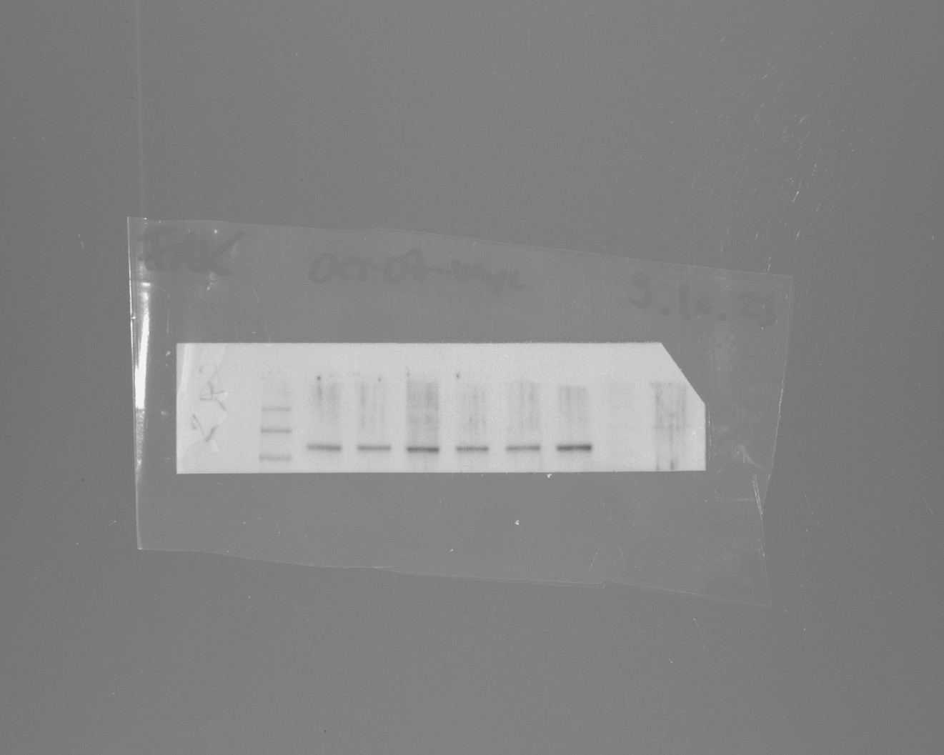
Figure S8. Full membrane image of FAK in oex samples used to make Figure S11B
Figure S9. Full membrane image of ACTB in oex samples used to make Figure S11B

Figure S10. Full membrane image of AKT in oex samples used to make Figure S11B
Figure S11. Full membrane image of ACTB in oex samples used to make Figure S11B
Figure S12. Full membrane image of ORP7 in treated samples used to make Figure S11B
Figure S13. Full membrane image of pFAK in treated samples used to make Figure S11B
Figure S14. Full membrane image of pAKT1 in treated samples used to make Figure S11B
Figure S15. Full membrane image of FAK in treated samples used to make Figure S11B
Figure S16. Full membrane image of ACTB in treated samples used to make Figure S11B
Figure S17. Full membrane image of ORP7 in treated samples used to make Figure S11B

Figure S18. Full membrane image of AKT1 in treated samples used to make Figure S11B
Figure S19. Full membrane image of ACTB in treated samples used to make Figure S11B
Figure S20. Full membrane image of ORP7 in oex samples used to make Figure 12
Figure S21. Full membrane image of AKT1 in oex samples used to make Figure 12
Figure S22. Full membrane image of ORP7 loadings in oex samples used to make Figure 12
Figure S23. Full membrane image of AKT1 loadings in oex samples used to make Figure 12
Figure S24. Full membrane image of ORP7 in treated samples used to make Figure S13
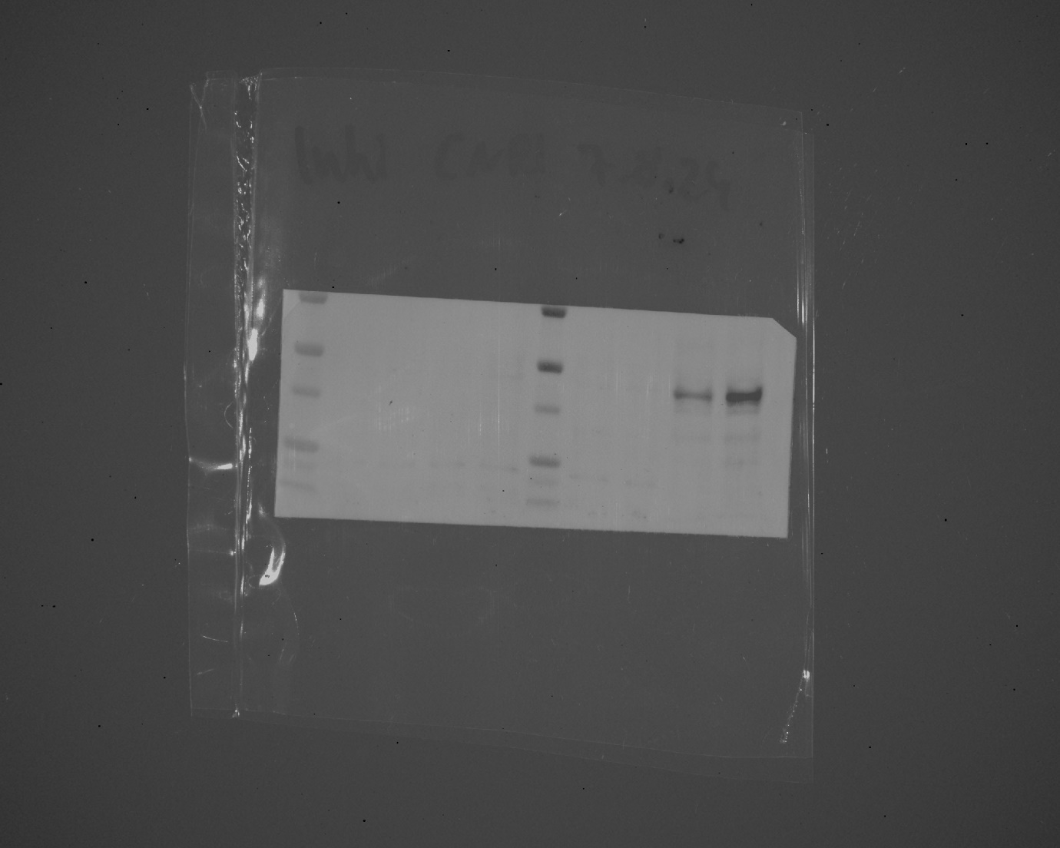
Figure S25. Full membrane image of CNR1 in treated samples used to make Figure S13
Figure S26. Full membrane image of ACTB in treated samples used to make Figure S13

