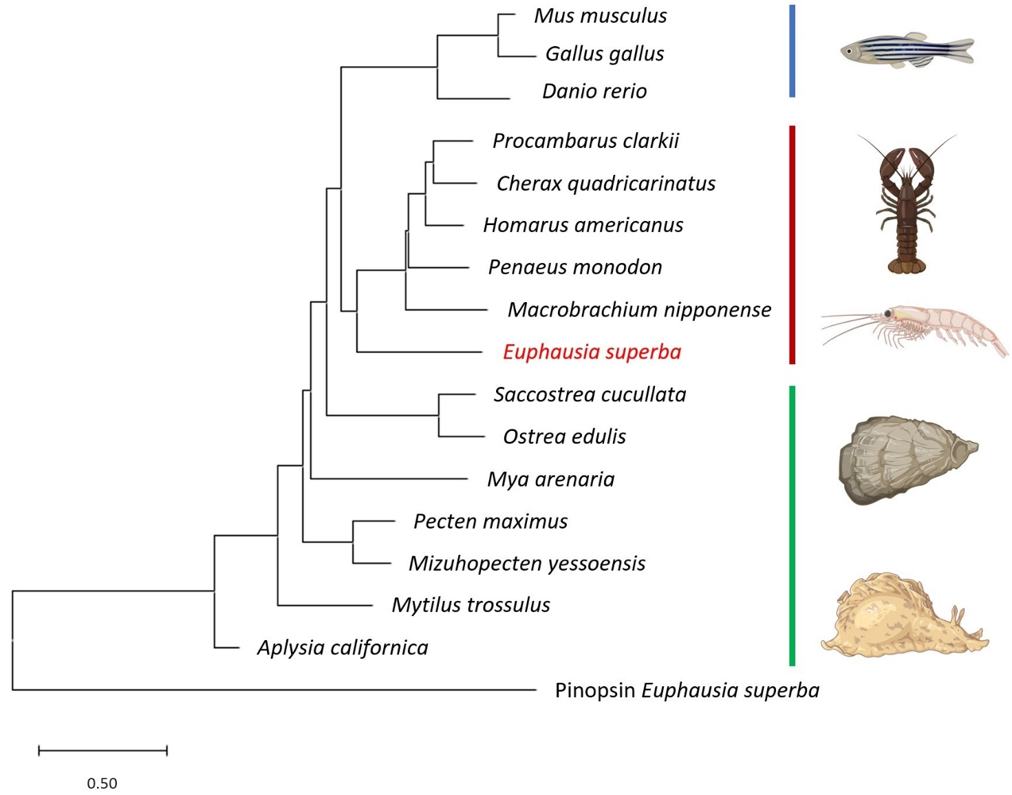
Additional file 3: Fig. S1 Phylogenetic analysis of selected PDP1/TEF proteins shows that EsPDP1 clusterizes with other Crustacean orthologs. Scale bars indicate amino acid substitutions per site. The E. superba Pinopsin has been used as outgroup. Accession numbers: XP_037778882.1: Penaeus monodon, XP_064117072.1: Macrobrachium nipponense, XP_045612923.1: Procambarus clarkii, XP_053647350.1: Cherax quadricarinatus, XP_042211659.1: Homarus americanus, XP_033742026.1: Pecten maximus, XP_021364925.1: Mizuhopecten yessoensis, XP_063414312.1: Mytilus trossulus, XP_062612114.1: Saccostrea cucullata, XP_048778877.1: Ostrea edulis, XP_005104321.1: Aplysia californica, XP_052794455.1: Mya arenaria, Q92172: Gallus gallus, Q9JLC6: Mus musculus, Q9W722: Danio rerio, A0A142BLT2: Euphausia superba Peropsin. Parts of the figure were created with BioRender.com.

