Attraction and aversion of noctuid moths to fermented food sources coordinated by olfactory receptors from distinct gene families
Xiao-Qing Hou1,4, Dan-Dan Zhang3, Hanbo Zhao1, Yang Liu2, Christer Löfstedt3,4, Guirong Wang1,2*
1Shenzhen Branch, Guangdong Laboratory for Lingnan Modern Agriculture, Synthetic Biology Laboratory of the Ministry of Agriculture and Rural Affairs, Agricultural Genomics Institute at Shenzhen, Chinese Academy of Agricultural Sciences, Shenzhen, China; 2 State Key Laboratory for Biology of Plant Diseases and Insect Pests, Institute of Plant Protection, Chinese Academy of Agricultural Sciences, Beijing, China; 3 Department of Biology, Lund University, Lund, Sweden; 4 Xianghu Laboratory, Hangzhou, Zhejiang, China.

Xiao-Qing Hou: houxiaoqing@caas.cn
Dan-Dan Zhang: dan-dan.zhang@biol.lu.se
Hanbo Zhao: zhaohanbo@caas.cn
Yang Liu: yangliu@ippcaas.cn
Christer Löfstedt: christer.lofstedt@biol.lu.se
Guirong Wang: wangguirong@caas.cn

*Corresponding author: Guirong Wang
Shenzhen Branch, Guangdong Laboratory for Lingnan Modern Agriculture, Synthetic Biology Laboratory of the Ministry of Agriculture and Rural Affairs, Agricultural Genomics Institute at Shenzhen, Chinese Academy of Agricultural Sciences, Shenzhen, China.
Email: wangguirong@caas.cn
Phone: +86-0755-23250152

Supplemental Information

Table S1. Amounts of isoamyl alcohol and octanoic acid emitted from 12h and 48h fermented honey solution, apple juice and watermelon juice.
 |  | ng of compound emitted
 |  | 12 h fermentation broths |  | 48 h fermentation broths
 |  | Isoamyl alcohol | Octanoic acid | Isoamyl alcohol | Octanoic acid
Honey solution | Sample 1 | 75.1452851 | 0 | 139.3120666 | 45.84044908
Honey solution | Sample 2 | 64.71297383 | 0 | 179.9080243 | 40.99837961
Honey solution | Sample 3 | 51.10032588 | 0 | 143.6652682 | 51.0037134
Apple juice | Sample 1 | 122.46889 | 34.57016884 | 88.34603783 | 78.92619251
Apple juice | Sample 2 | 117.3207551 | 24.97855389 | 115.4557438 | 49.9811798
 | Sample 3 | 131.141052 | 25.99852187 | 82.52667742 | 67.88401645
Watermelon juice | Sample 1 | 51.127363 | 0 | 126.6976593 | 57.57857704
Watermelon juice | Sample 2 | 45.21519895 | 0 | 149.2685664 | 40.919518
 | Sample 3 | 54.50627904 | 0 | 123.7006656 | 41.3533037

Table S2. Pairwise amino acid identity (%) of receptors from HarmOR52 clade.
 | SfruOR36 | HarmOR52 | MsepOR8
SfruOR36
HarmOR52 | 74.224
MsepOR8 | 85.203 | 72.792
AsegOR17 | 87.112 | 73.747 | 89.260

Table S3. Pairwise amino acid identity (%) of IR75q.1 clade. Red color highlights the pairwise amino acid identity of IR75q.1 between noctuid moths.

 | CpomIR75q.1 | BmorIR75q.1 | OfurIR75 | SfruIR75q.1 | HarmIR75q.1 | MsepIR75q.1
CpomIR75q.1
BmorIR75q.1 | 45.933
OfurIR75 | 46.635 | 49.285
SfruIR75q.1 | 43.810 | 47.717 | 48.265
HarmIR75q.1 | 45.223 | 49.211 | 49.842 | 64.882
MsepIR75q.1 | 44.427 | 51.266 | 49.287 | 68.189 | 73.534
AsegIR75q.1 | 45.774 | 50.475 | 50.952 | 67.402 | 72.900 | 78.889

Table S4. List of compounds used in this study, with CAS number, purity and source.
 | Compound | CAS number | Purity (%) | Source*
For oocyte recording of ORs | Butanol | 71-36-3 | ≥ 99 | Sigma
For oocyte recording of ORs | Pentanol | 71-41-0 | ≥ 99.5 | J&K Scientific
For oocyte recording of ORs | Hexanol | 111-27-3 | 98 | Sigma-Aldrich
For oocyte recording of ORs | Isobutanol | 78-83-1 | ≥ 98.5 | Sigma
For oocyte recording of ORs | Isoamyl alcohol | 123-51-3 | ≥ 98.5 | Sigma
For oocyte recording of ORs | 2-Methyl-butanol | 137-32-6 | 98 | J&K Scientific
 | Benzyl alcohol | 100-51-6 | ≥ 99 | Sigma
For oocyte recording of IRs | Pentanoic acid | 109-52-4 | ≥ 99 | J&K Scientific
For oocyte recording of IRs | Hexanoic acid | 142-62-1 | 98 | Sigma-Aldrich
For oocyte recording of IRs | Heptanoic acid | 111-14-8 | 98 | J&K Scientific
For oocyte recording of IRs | Octanoic acid | 124-07-2 | 98 | Aldrich
For oocyte recording of IRs | Nonanoic acid | 112-05-0 | 96 | Sigma-Aldrich
For oocyte recording of IRs | Decanoic acid | 334-48-5 | ≥ 99.5 | Sigma-Aldrich
For oocyte recording of IRs | Undecanoic acid | 112-37-8 | 98 | J&K Scientific
 | Dodecanoic acid | 143-07-7 | ≥ 99 | Sigma-Aldrich
For Y-tube experiments | Isoamyl alcohol | 123-51-3 | ≥ 98.5 | Sigma
For Y-tube experiments | Hexanoic acid | 142-62-1 | 98 | Sigma-Aldrich
For Y-tube experiments | Phenylethyl alcohol | 60-12-8 | 99 | Aldrich
For Y-tube experiments | Ethyl caprylate | 106-32-1 | 99 | J&K Scientific
For Y-tube experiments | Octanoic acid | 124-07-2 | 98 | Aldrich
For Y-tube experiments | Ethyl caprate | 110-38-3 | 99 | J&K Scientific
 | Decanoic acid | 334-48-5 | ≥ 99.5 | Sigma-Aldrich
 | Ethyl laurate | 106-33-2 | 99 | Sigma-Aldrich

Table S5. Primers used in this study.
Genes | Primer sequence (5’-3’)
AsegOR17_F | TTGCAGGATCCCATCGATTCGAATTCGCCACCATGATAACCTTACGAGAAATTGAACATGACTCACT
AsegOR17_R | ATAGTTCTAGAGGCTCGAGCTACTTCATAGTAGACCGAAGAGC
HarmOR52_F | TTGCAGGATCCCATCGATTCGAATTCGCCACCATGCGGACGTTACGAGAAAT
HarmOR52_R | GACTCACTATAGTTCTAGAGGCTCGAGCTACTTCACAGTAGACCGAAGC
HarmIR75q.1_F | TTGCAGGATCCCATCGATTCGAATTCGCCACCATGAAATATTTCACATTGTTTTTGAATATATTGTGC
HarmIR75q.1_R | GACTCACTATAGTTCTAGAGGCTCGAGTTATTGAAGCTGCGTAACATCTGG
MsepOR8_F | TTGCAGGATCCCATCGATTCGAATTCGCCACCATGCTGACCCTACGTGAGAT
MsepOR8_R | GACTCACTATAGTTCTAGAGGCTCGAGCTACTTCATCGTGGTCCTAAGAG
MsepIR75q.1_F | TTGCAGGATCCCATCGATTCGAATTCGCCACCATGAAAATTTTGTCGATATTCATAAATATATTTTGT
MsepIR75q.1_R | GACTCACTATAGTTCTAGAGGCTCGAGCTAAATCTCAATTTCATTGCTTCTTCTCT
SfruOR36_F | TTGCAGGATCCCATCGATTCGAATTCGCCACCATGCTGTCTTTTAAAGAAATAATTCAT
SfruOR36_R | GACTCACTATAGTTCTAGAGGCTCGAGCTACTTCATAGTAGACCTAAGAGC
SfruIR75q.1_F | TTGCAGGATCCCATCGATTCGAATTCGCCACCATGAAGTATCTAACATTCTTCTTAAATATAATTTGT
SfruIR75q.1_R | GACTCACTATAGTTCTAGAGGCTCGAGTCATTCAACTACAGCTTGATTGC
BmorIR75q.1_F | TTGCAGGATCCCATCGATTCGAATTCGCCACCATGATAGTCACTGCTTTTTCTGGAGT
BmorIR75q.1_R | GACTCACTATAGTTCTAGAGGCTCGAGTTAAACGACGATTACTTTACTGAGTTTTC
CpomIR75q.1_F | TTGCAGGATCCCATCGATTCGAATTCGCCACCATGTATAGATCTCTCACAATTTTTTGT
CpomIR75q.1_R | GACTCACTATAGTTCTAGAGGCTCGAGTCAAGGTCGCGTATTGATCT
OfurIR75_F | TTGCAGGATCCCATCGATTCGAATTCGCCACCATGAATCTCCGTGATTTATTACTGGTTTTTA
OfurIR75_R | GACTCACTATAGTTCTAGAGGCTCGAGCTAGCGTCGCTGACTCTGAC
Sp6 | ATTTAG GTGACACTATAG
EBV-rev | GTGGTTTGTCCAAACTCATC
*The AsegIR75q.1 was assayed in previous study (Hou et al., 2022).

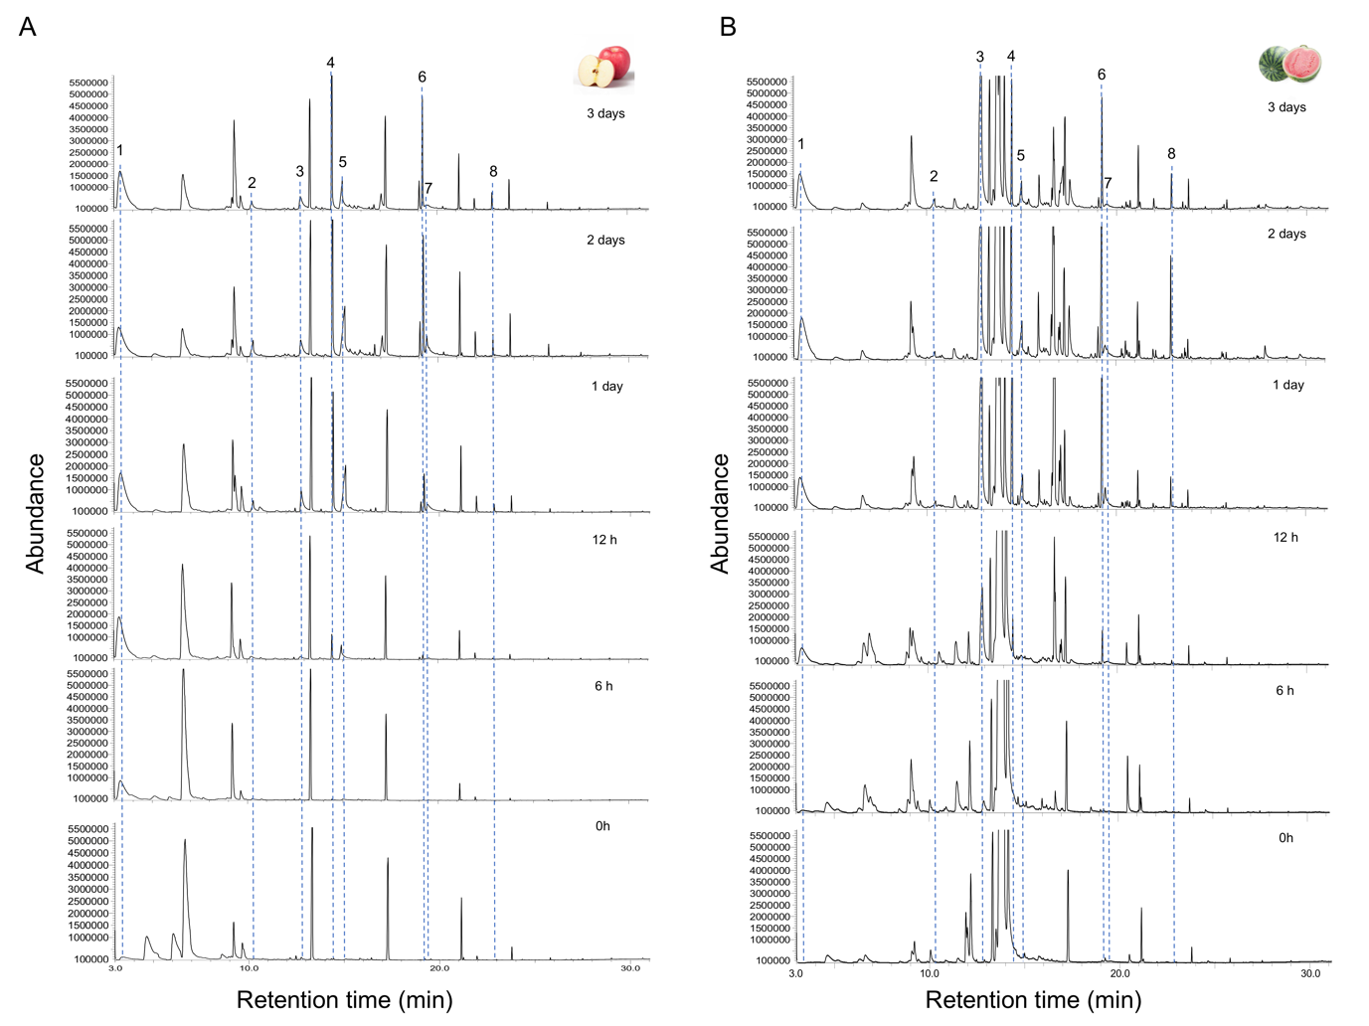
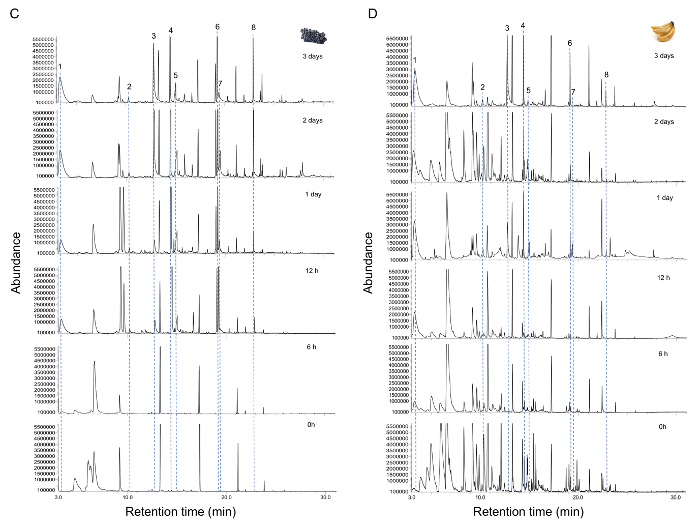

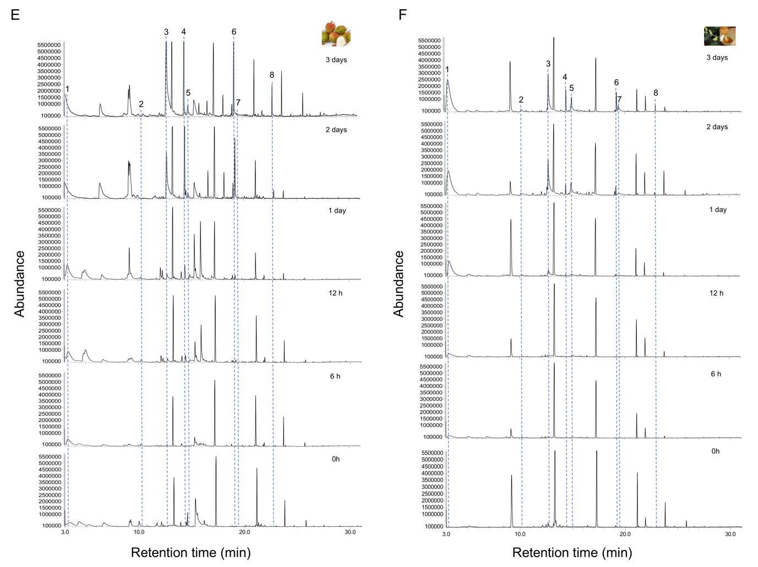
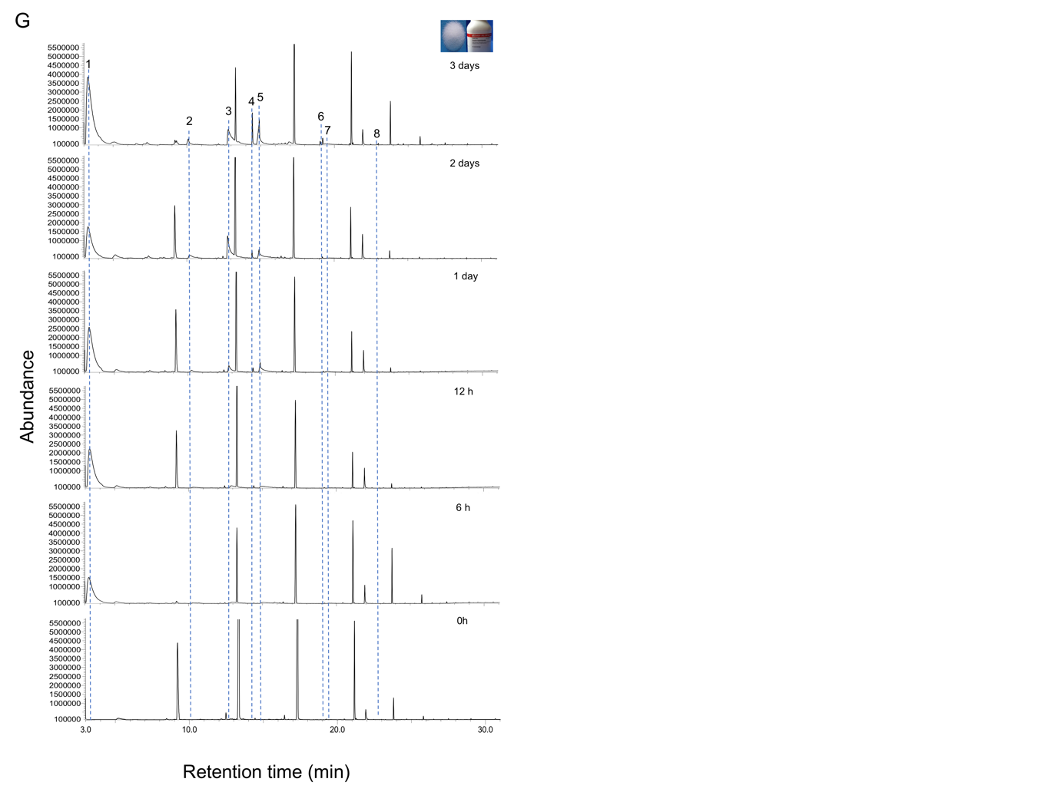

Supplemental Figure 1. The volatile profiles of different sugary substrates change with fermentation process. The volatile profiles of (A) apple; (B) watermelon; (C) grape; (D) banana; (E) litchi; (F) 25% honey solution and (G) synthetic nectar were analyzed using GC/MS at 0 h, 6 h, 12 h, 1 d, 2 d and 3 d after inoculation with Saccharomyces cerevisiae yeast. Compounds shared among different substrates produced by yeasts was identified as: 1, isoamyl alcohol; 2, hexanoic acid; 3, phenylethyl alcohol; 4, ethyl caprylate; 5, octanoic acid; 6, ethyl caprate; 7, decanoic acid; 8, ethyl laurate. Displayed chromatograms are representative examples of one to three replicates.

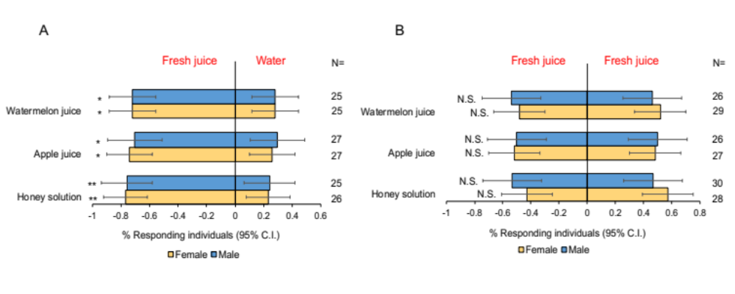

Supplemental Figure 2. Behavioral responses of female and male moths in a Y-tube olfactometer to (A) water and fresh juice and (B) fresh juice and fresh juice. The number of repetitions for each dual choice is shown on the right.

