Supplementary material

Figures
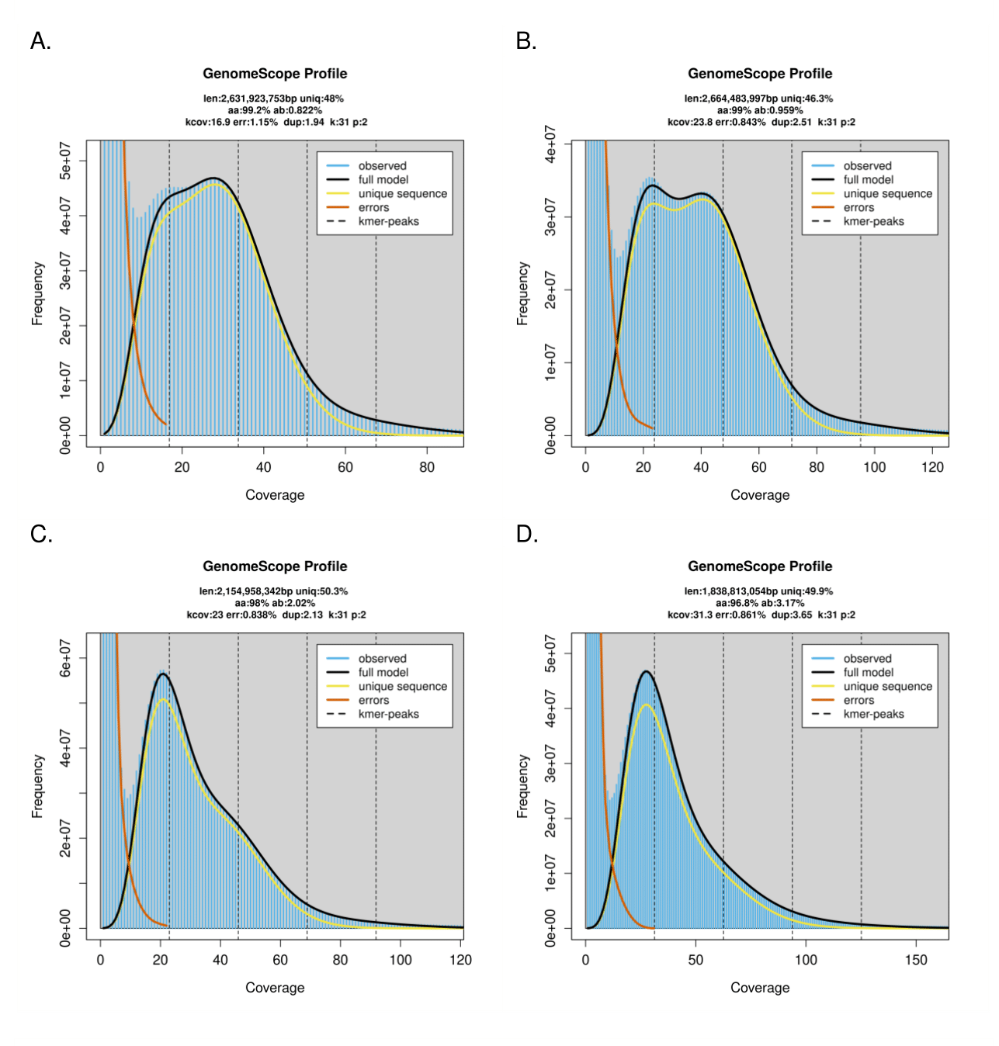
Figure S1: K-mer distribution and estimation of genome sizes and heterozygosity rates from short reads for A I. ricinus B I. hexagonus C I. persulcatus D I. pacificus.

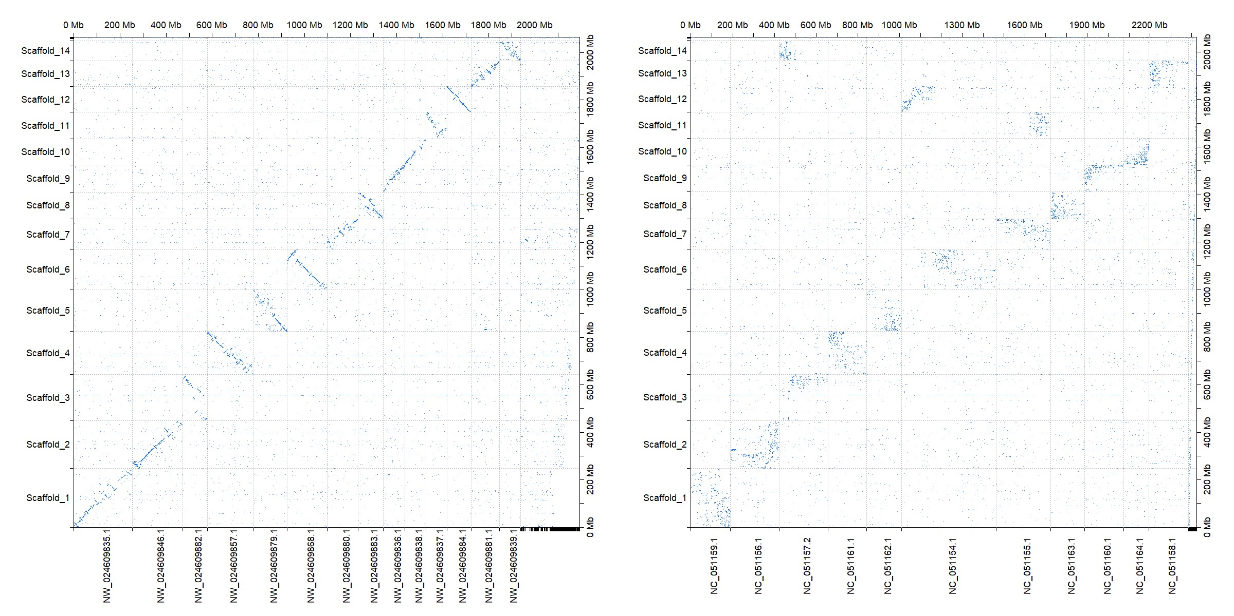
Figure S2: Synteny between the genome assembly of I. ricinus and two other tick species. A (Left panel) Parity plot between the largest scaffolds of I. scapularis (version of (De et al. 2023)) and I. ricinus (this study). Inversions may be the result of assembly errors (inversion of blocks) during super-scaffolding. The haploid chromosome number is 14 in both species. B (Right panel) Parity plot between the largest scaffolds of D. silvarum (Jia et al. 2020) and I. ricinus (this study) - haploid chromosome numbers are respectively 11 and 14.

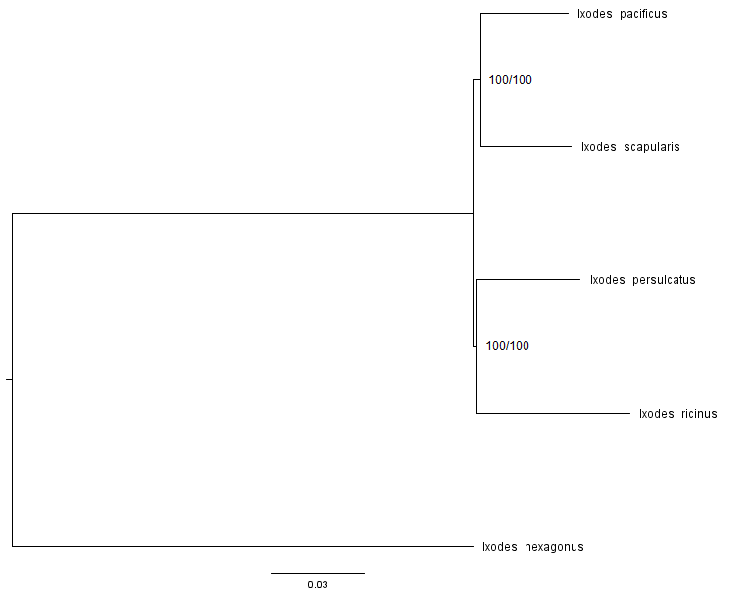
Figure S3: Phylogenetic tree of five species of the genus Ixodes, based on their complete genome. The tree was built by IQ-TREE 2 using a concatenation of 2,373 single-copy protein sequences. Branch support is shown by SH-aLRT and bootstrap values.

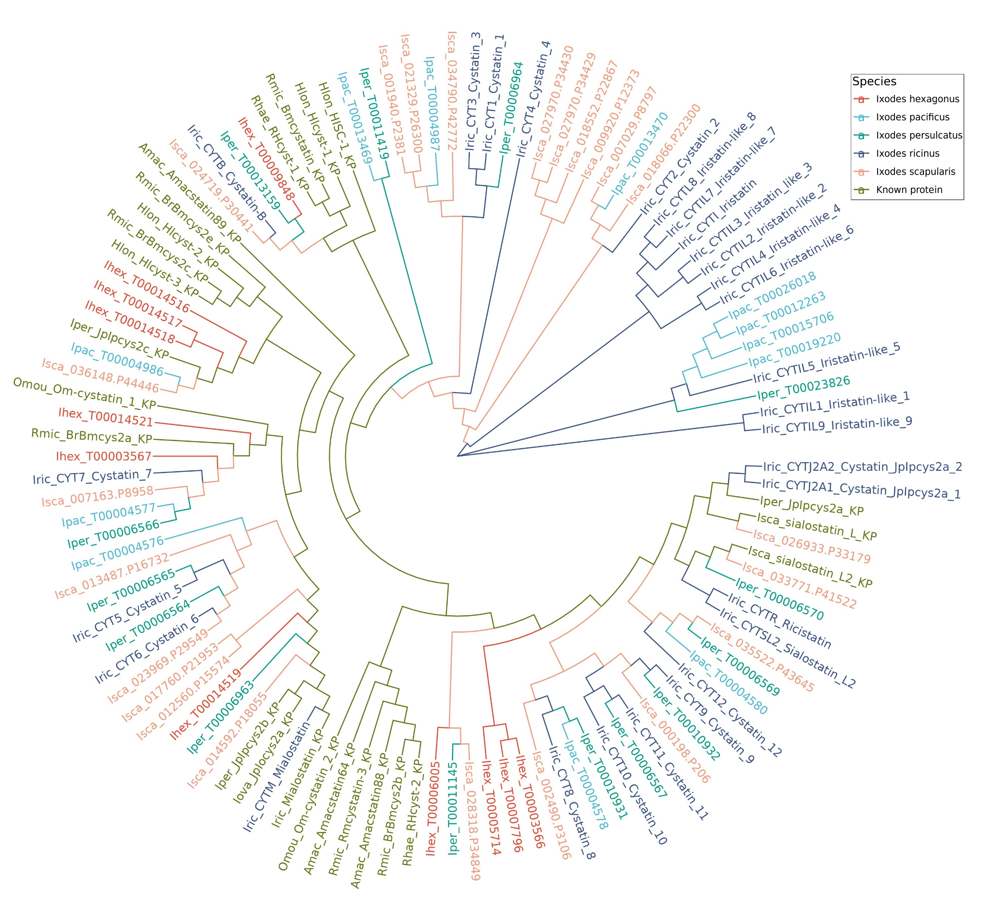
Figure S4: Phylogenetic tree of cystatins in different tick species with a clear duplication event observed for Iristatins shown in dark blue. The tree was constructed using FastME and visualized using the R software ggtree.

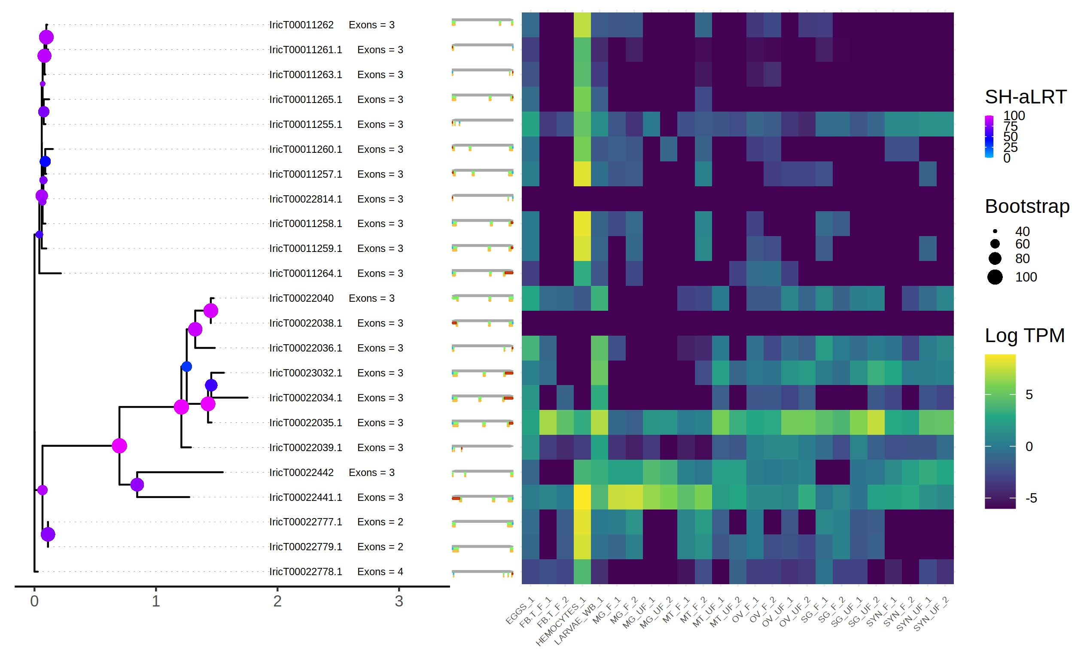
Figure S5: Expression heatmap of cystatins genes in I. ricinus tissues (salivary glands (SG), Ovaries (OV), Malpighian tubules (MT), midgut (MG), Fat body/trachea (FB_T), and hemocytes) and stages (Eggs, larvae). The suffixes F and UF respectively correspond to half-fed and unfed ticks. To the left: phylogenetic tree of SiLix family FAM006825, comprising most cystatins and iristatins, number of exons, and drawing of the structure of each gene in different exons.

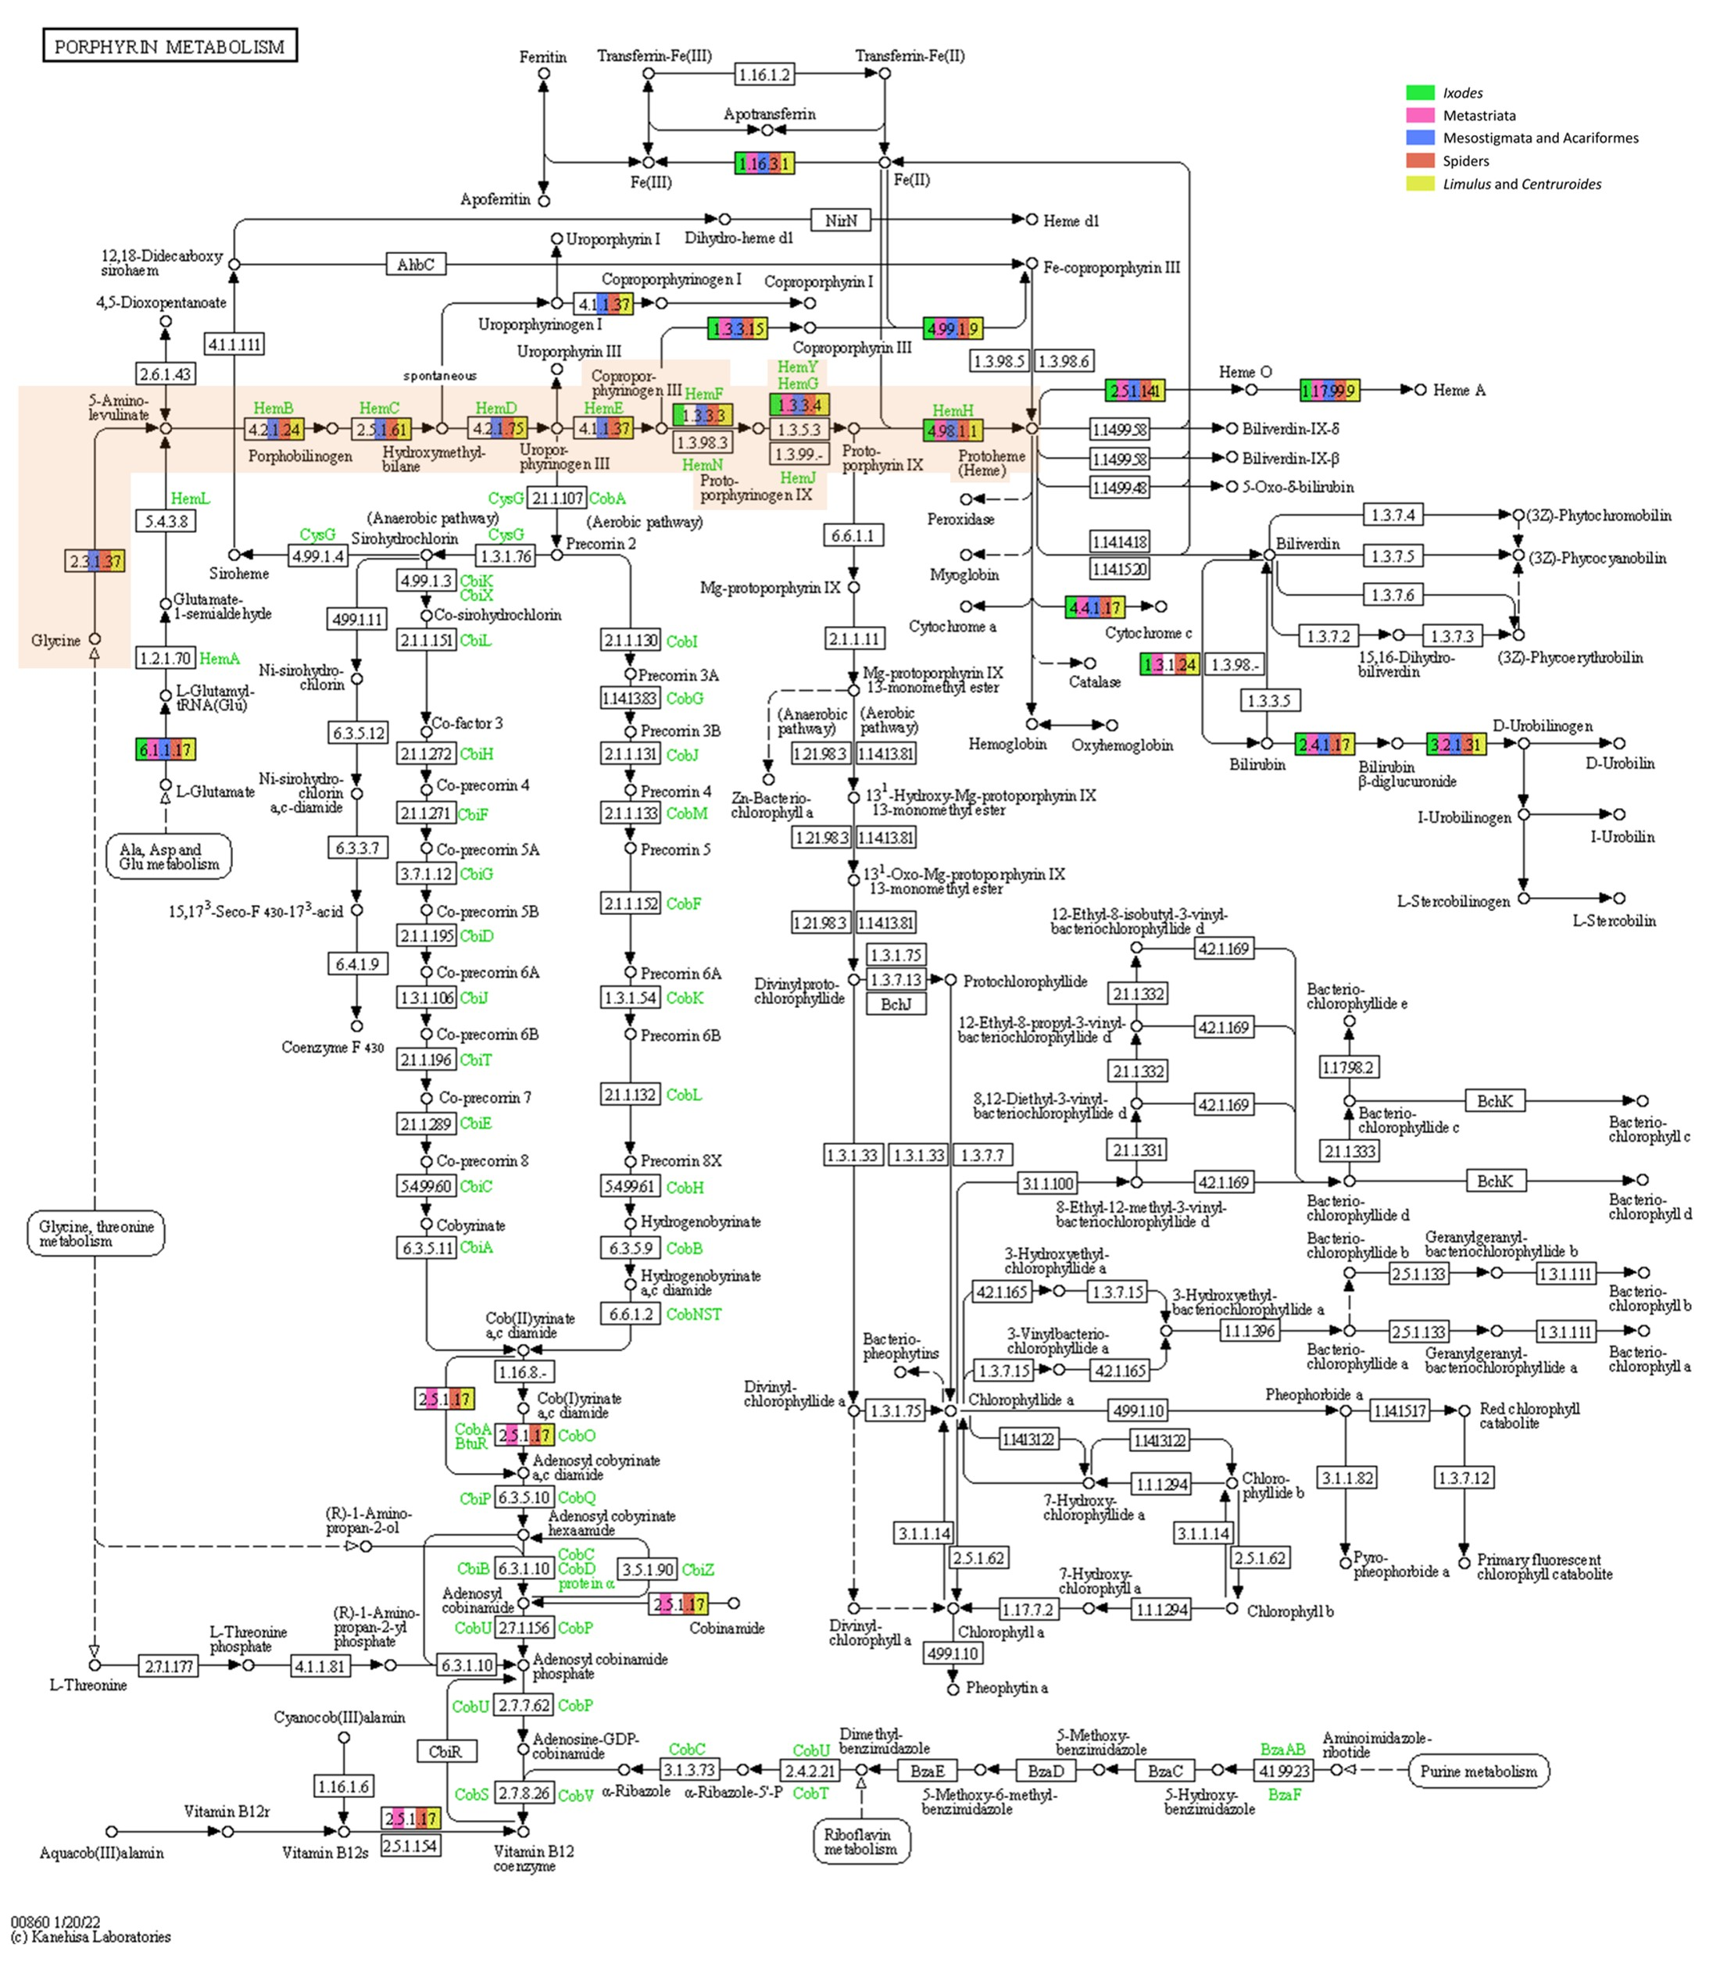
Figure S6: KEGG map of the porphyrin metabolism pathway. The biosynthesis pathway of heme is highlighted by a light orange background (color legend on the top right). Presence/absence profile of metabolic blocks was determined using KO numbers associated to each taxonomic group. Only KO numbers present in the majority of the species composing each group were kept. For example, the gene cpox (HemF enzyme) is absent from Metastriata tick species (white background) but present in Ixodes ticks (green background) and also in other groups of Chelicerata. Genes upstream of cpox in the pathway are absent from both Ixodes and Metastriata.

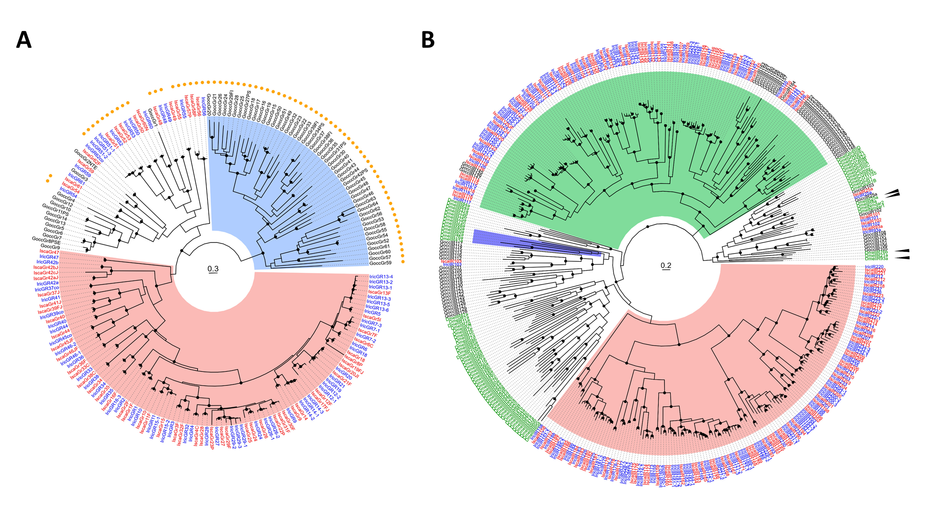
Figure S7: Evolution of tick chemosensory proteins. Trees have been midpoint rooted. Specific clades are represented by colored areas. A Maximum-likelihood phylogenetic tree of tick gustatory receptors (GRs). The tree was built using GR repertoires of the ticks I. ricinus (IricGRX, labels in blue) and I. scapularis (IscaGRX, labels in red), and of the mite G. occidentalis (GoccGRX, labels in black). Colored ranges indicate a tick-specific clade (red) and a mite-specific-clade (blue). Clades supported by an aLRT value over 0.9 are indicated by a black dot. Exterior circle: orange dots indicate mono-exonic genes. B Maximum-likelihood phylogenetic tree of tick ionotropic receptors (IRs). Color correspondence of labels: I. ricinus (IricIRX, in blue), I. scapularis (IscaIRX, in red), G. occidentalis (GoccIRX, in black) and Drosophila melanogaster (DmelX, in green). The ionotropic glutamate receptor clade was used as an outgroup. Black arrowheads show phylogenetic positions of the IR coreceptors found in D. melanogaster (IR25a, IR76b, IR8a and IR93a). The clades highlighted in red and green are respectively tick specific and acari specific. The clade highlighted in blue comprises D. melanogaster receptors involved in ammonia, amines and humidity detection. Clades supported by an aLRT value over 0.9 are indicated by a black dot.

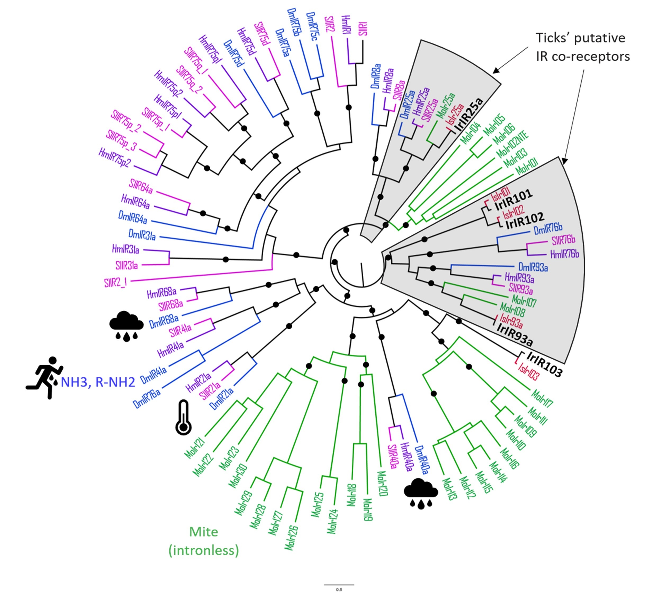
Figure S8: Phylogenetic tree of the conserved ionotropic receptors between Acari and Insects. The phylogeny was built using five I. ricinus (IrIRs, bold black) sequences and their I. scapularis (IsIRs, red) orthologs including IR25a and IR93a co-receptor IRs. Homologs from G. occidentalis (MoIRs, green) as well as D. melanogaster (DmIRs, blue) IR sequences and in two Lepidoptera species, Spodoptera littoralis (SlIRs, pink) and Heliconius melpomene (HmIRs, purple) were included for comparison. The IR93a clade was used as an outgroup. The two coreceptor clades are pictured as grey colored ranges. Pictograms designate D. melanogaster receptors’ function in humidity, temperature and sweat molecules such as ammonia and amines. Clades supported by an aLRT value over 0.9 are indicated by a black dot.

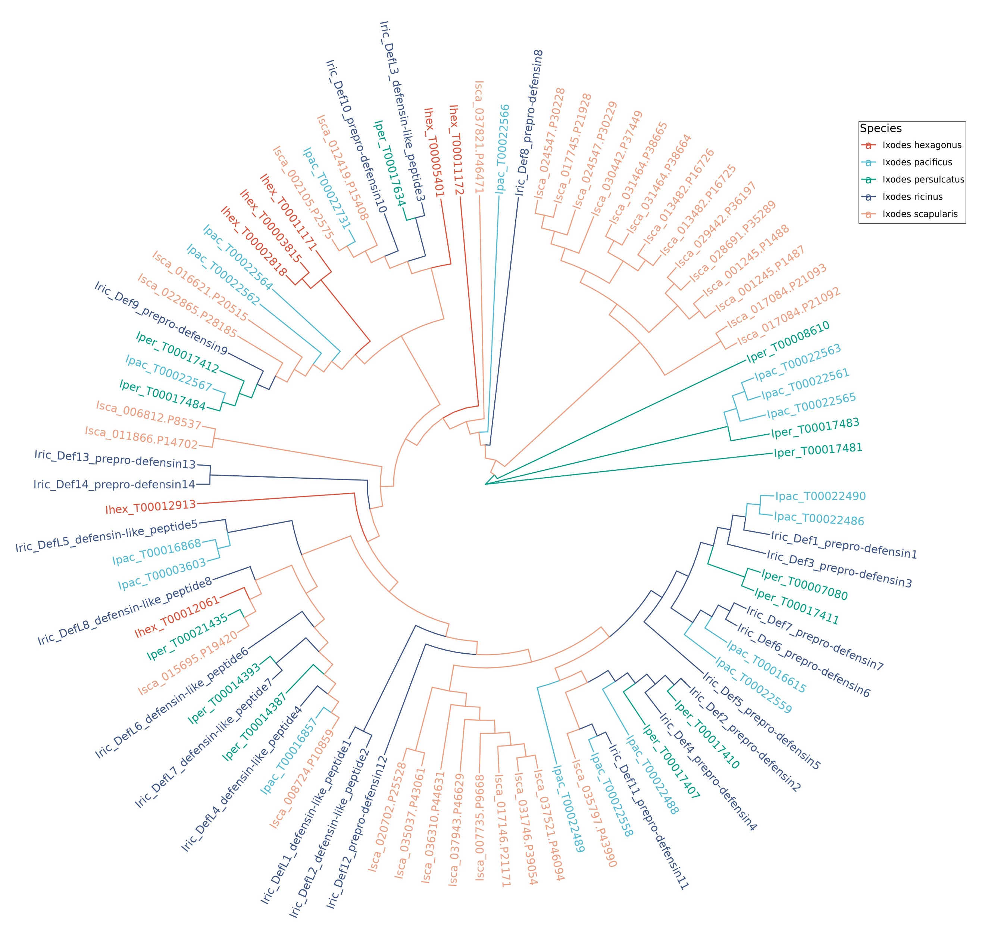
Figure S9: Phylogenetic analysis of defensins proteins in Ixodidae ticks. Cladogram illustrating the evolutionary relationships of Defensins proteins in five distinct Ixodidae tick species: I. ricinus, I. scapularis, I. persulcatus, I. pacificus, and I. hexagonus - respectively colored in dark blue, orange, green, light blue and red.

Figure S10: A Phylogeny and B expression heatmap of glutathione S-transferases (GSTs). In the heatmap, tissues or stages are: salivary glands (SG), Ovaries (OV), Malpighian tubules (MT), midgut (MG), Fat body/trachea (FB_T), and hemocytes) and stages (Eggs, larvae). The suffixes F and UF respectively correspond to half-fed and unfed ticks.
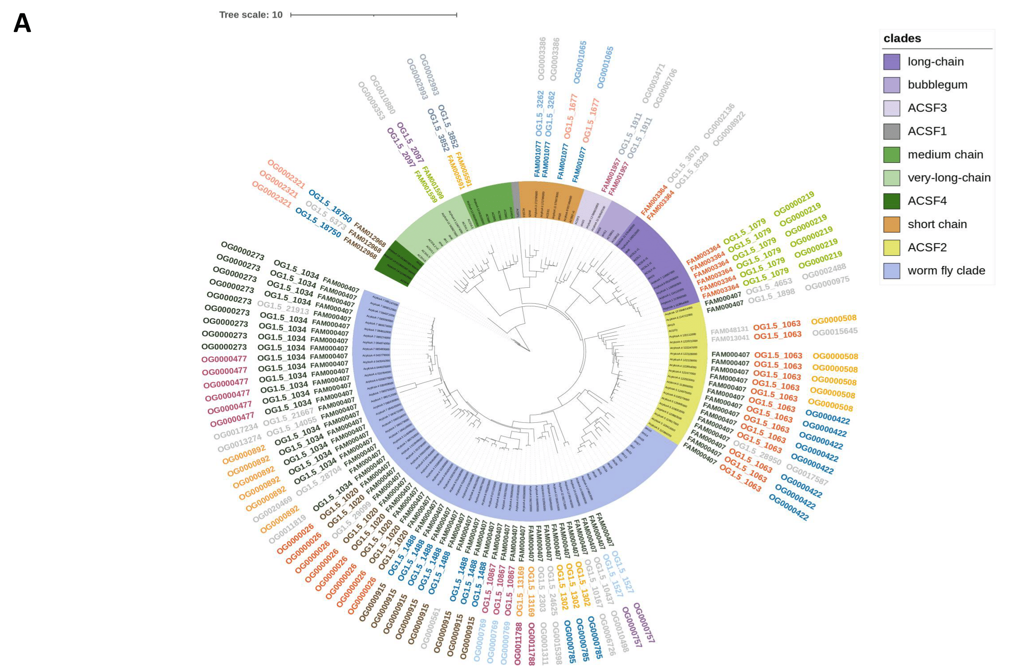
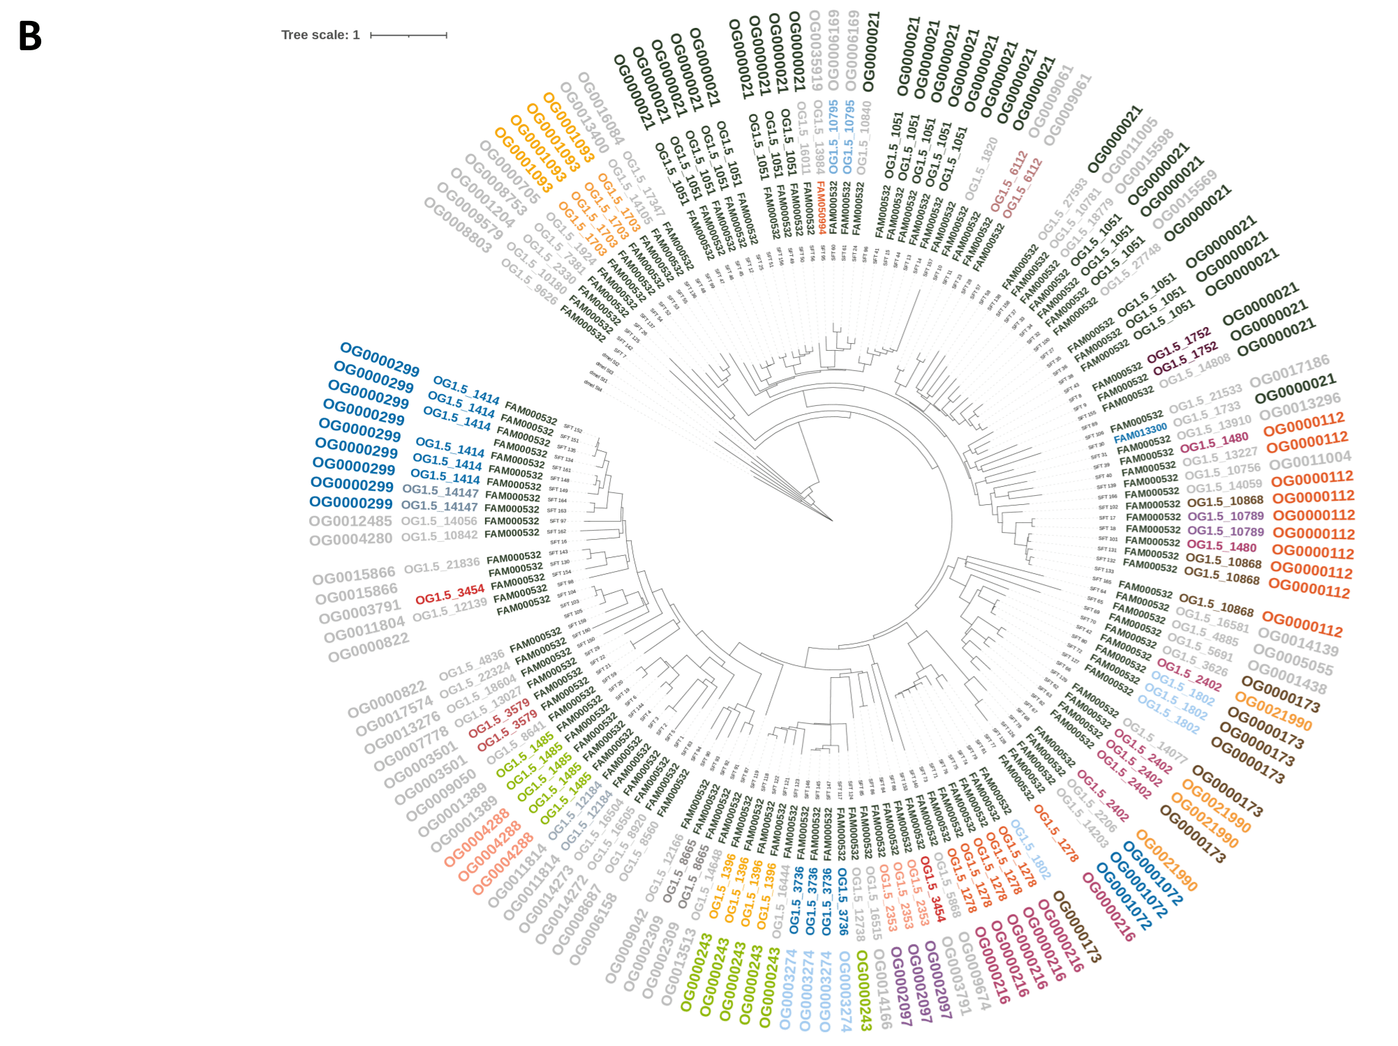
Figure S11: Comparison among three clustering methods, for two large multigenic families of I. ricinus. A Acyl-coenzyme A synthetases (ACSs). Gene names as annotated in the I. ricinus Apollo database are indicated, and grouped by clades recognised in the literature (Watkins et al. 2007) distinguished by different color ranges. B Cytosolic sulfotransferases (SULTs). The outer circles indicate the family ID of each gene as determined by SiLiX (FAMXXX), OrthoMCL (OG1.5_XXX), and OrthoFinder (OGXXX) respectively. This analysis was based on a preliminary run of SiliX run. The subsequent analyses presented in the paper were made on second run, with practically the same results, but different family numbers (e.g. here near all SULTs are clustered in FAM000432, while in the definitive run, they belong to FAM000226).

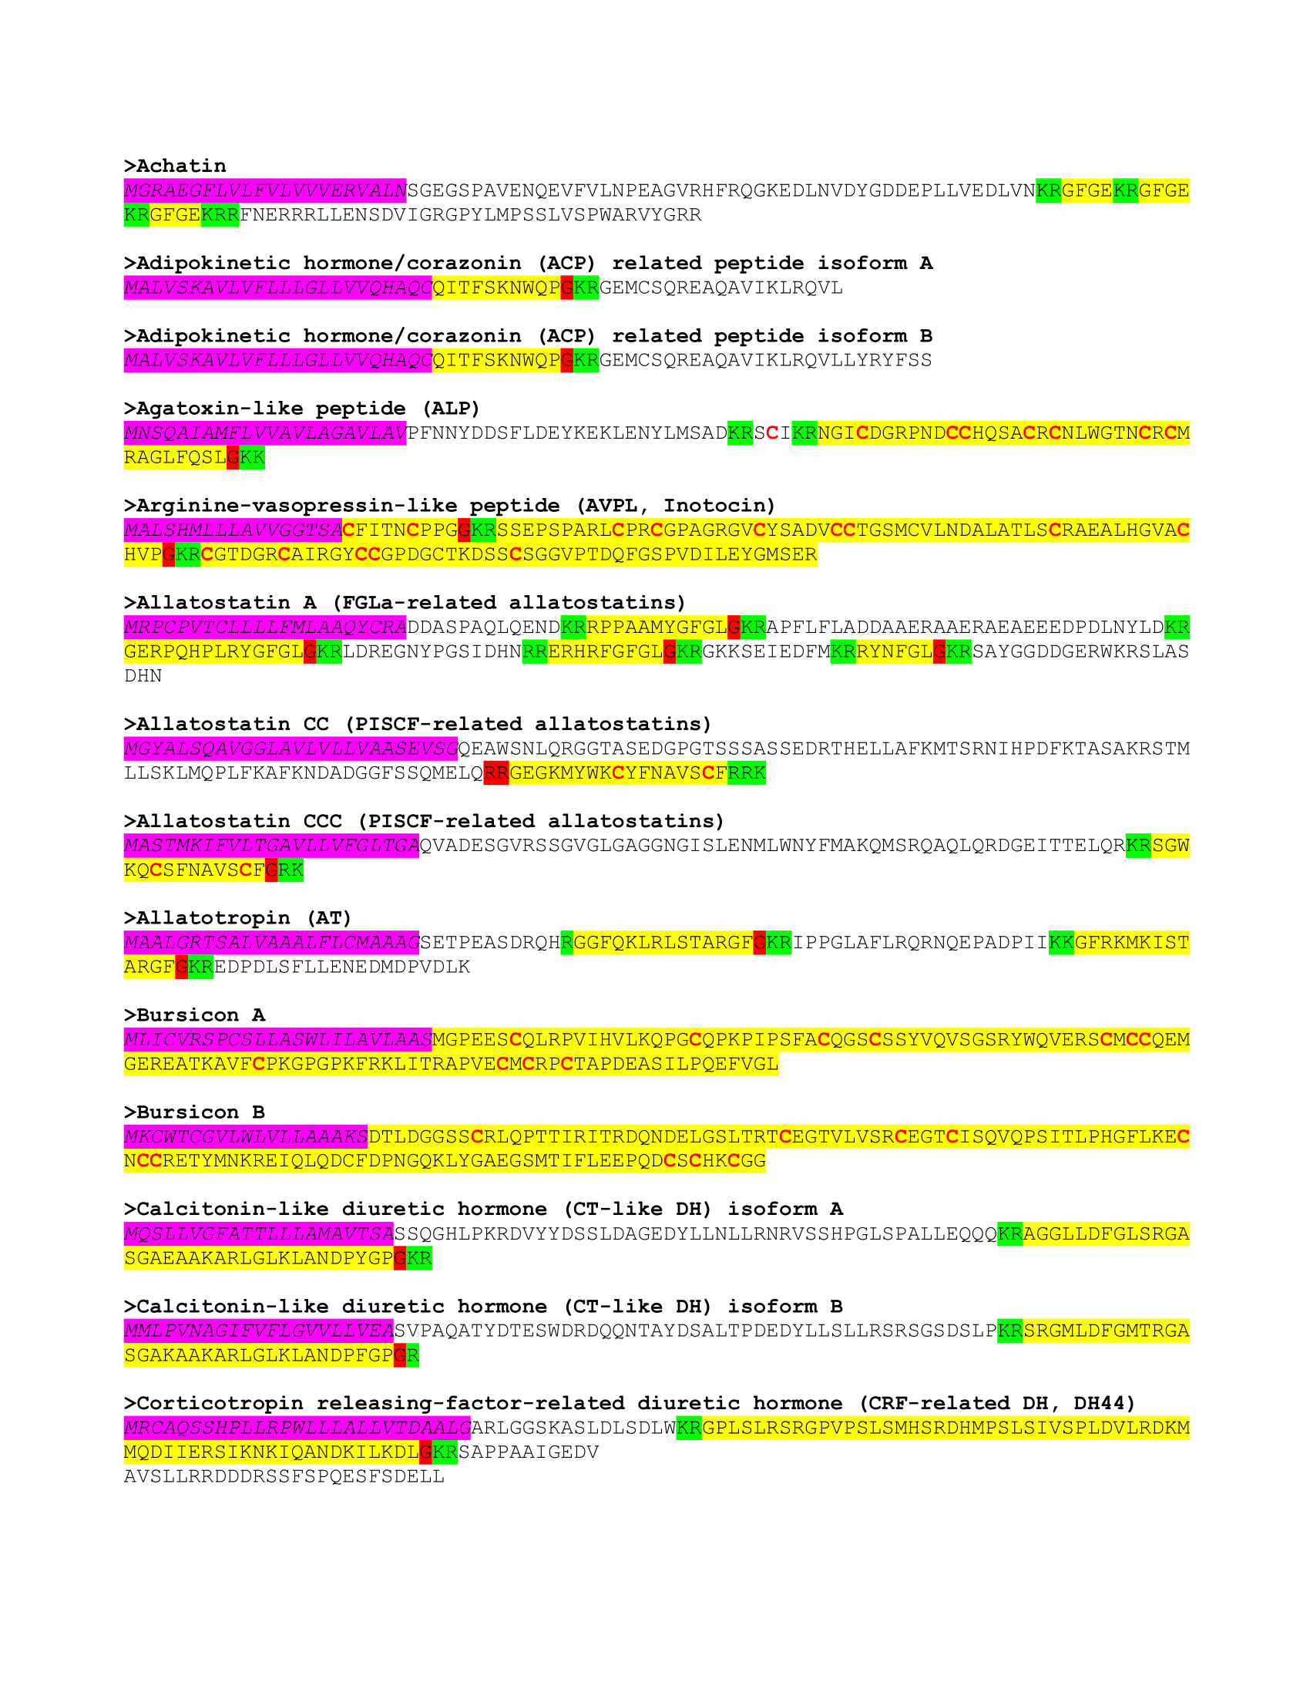
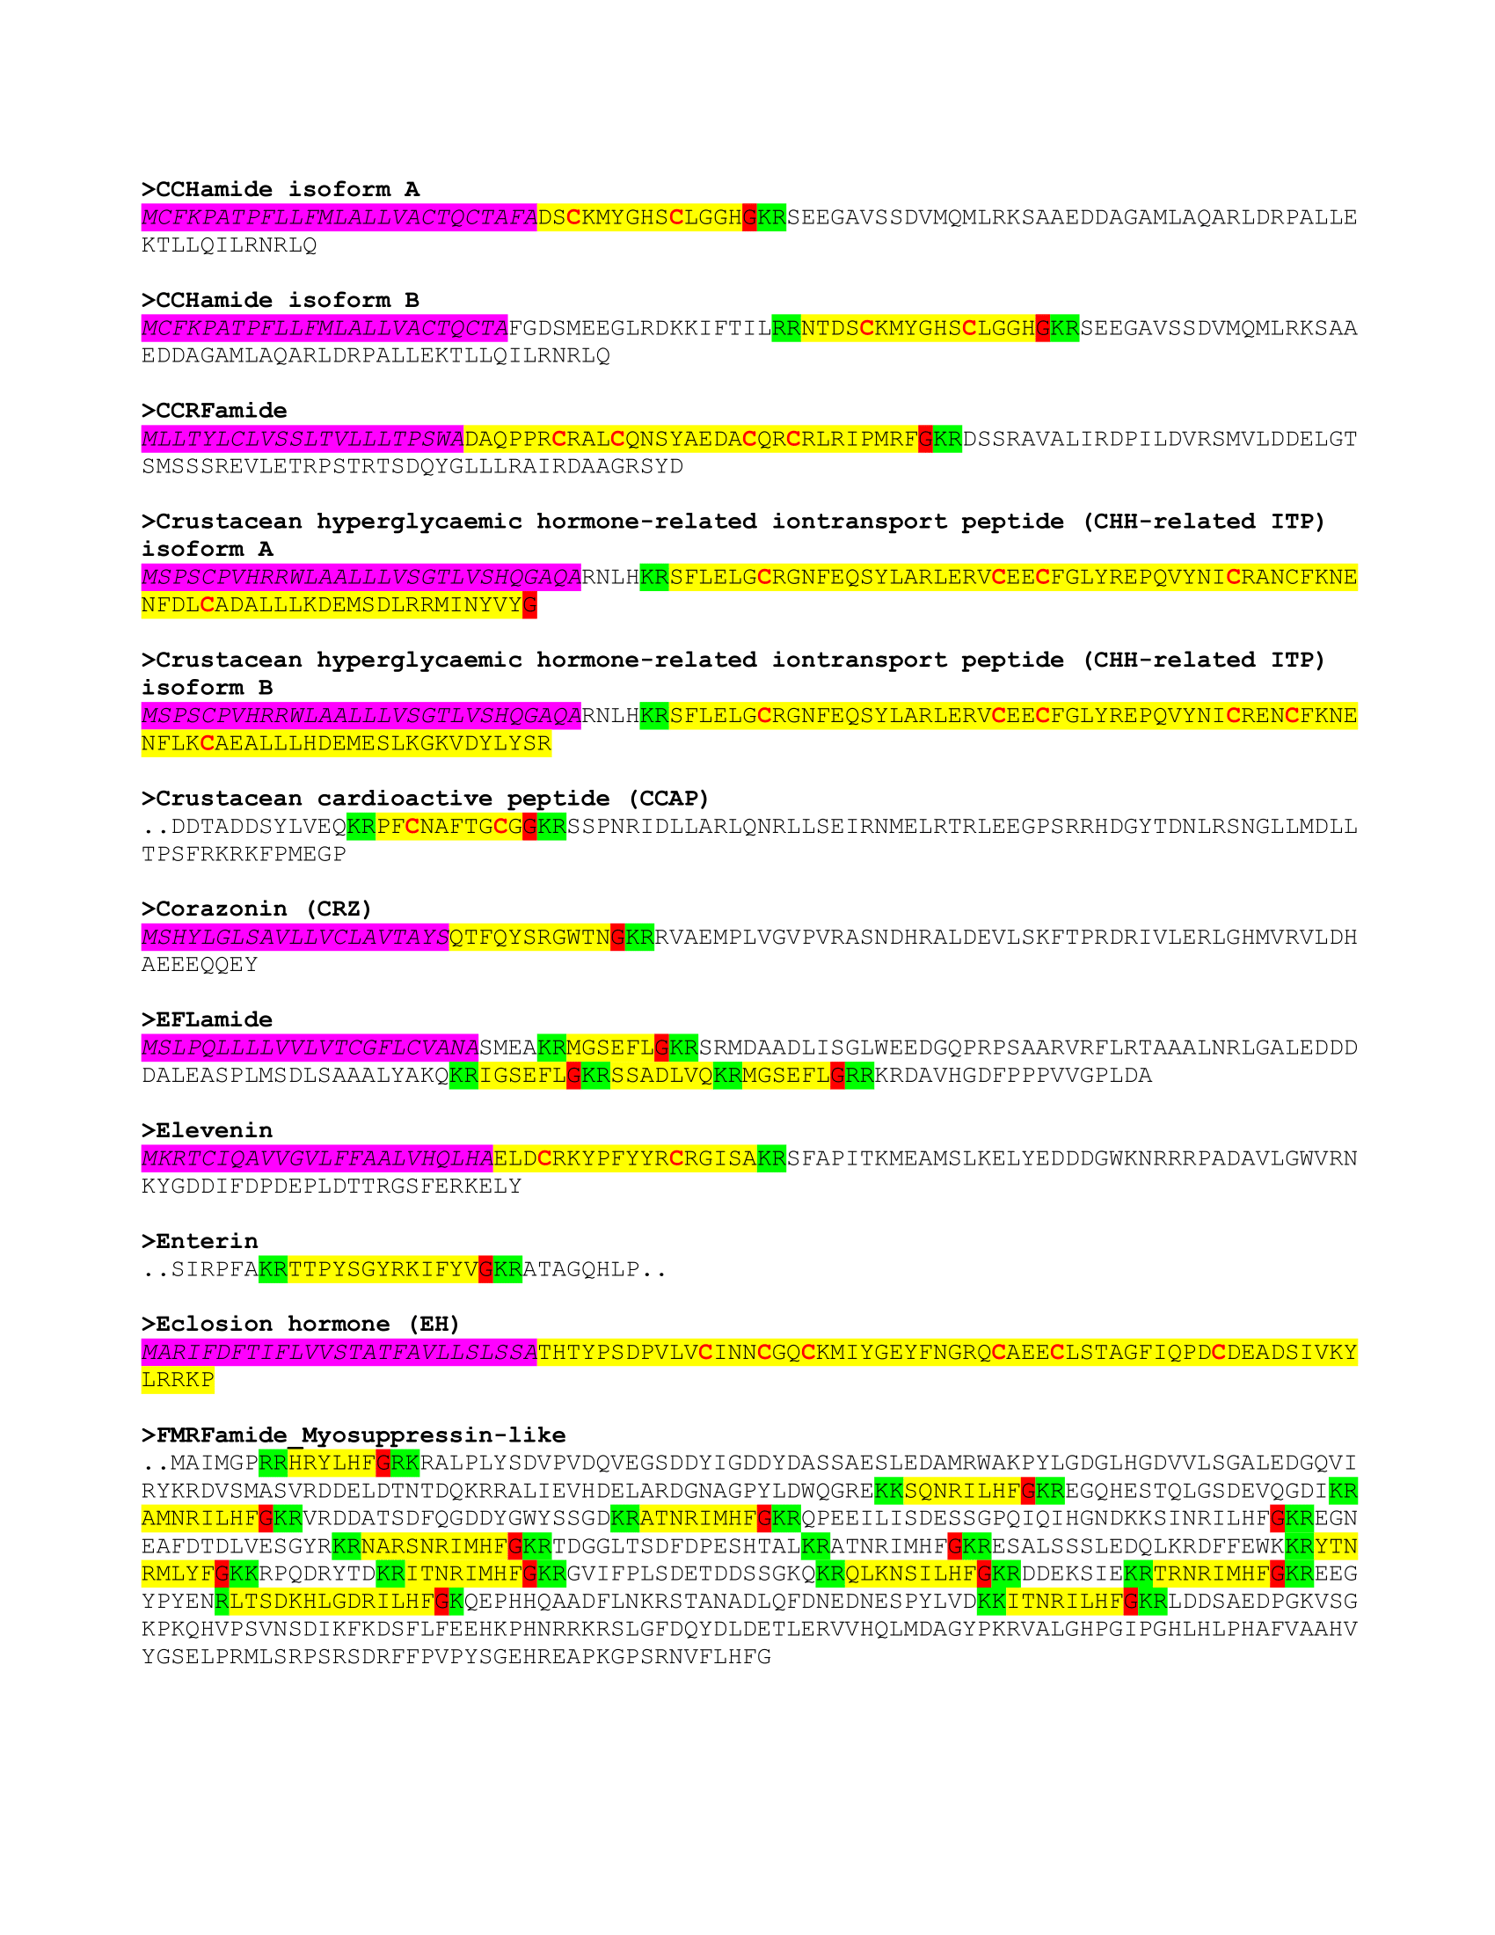
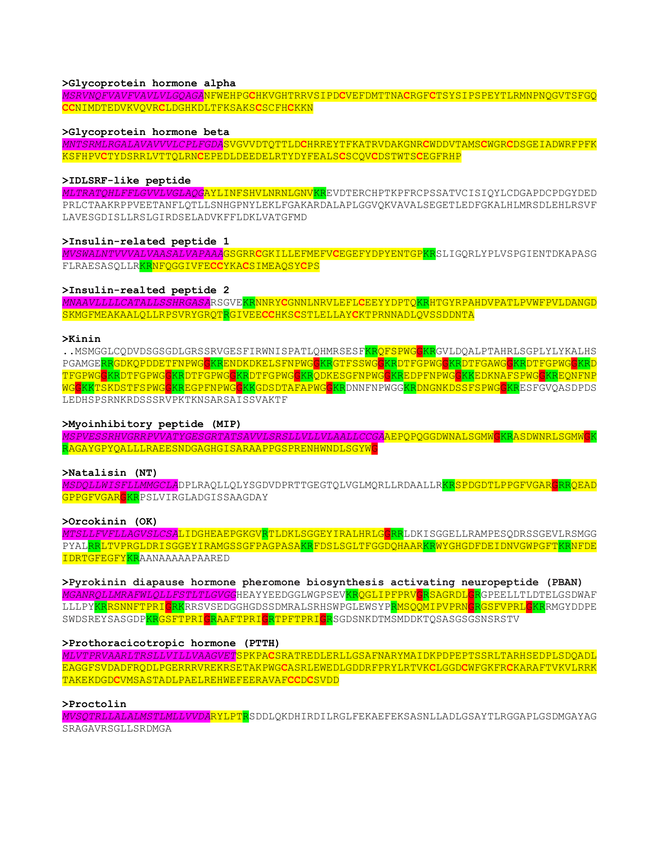
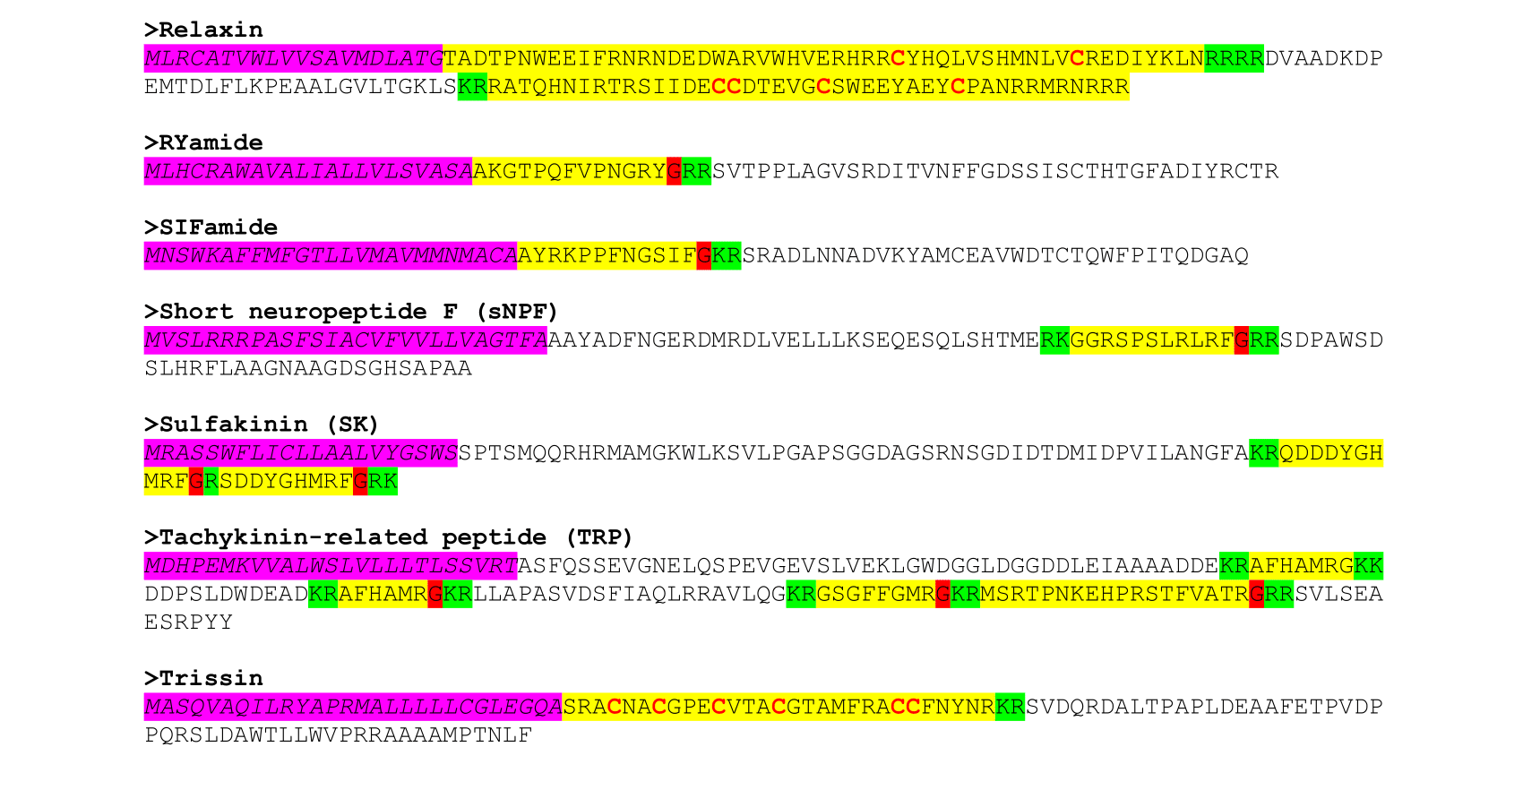
Figure S12: Predicted structures of I. ricinus neuropeptide precursors. Neuropeptide sequences were predicted and the 45 precursors are presented. Signal peptides are in italic and with a magenta background, while predicted mature neuropepFigure S12: Predicted structures of I. ricinus neuropeptide precursors.tides are in yellow. Processing (cleavage) sites for mature peptides are shaded in green and putative glycine-derived C-terminal amidation sites in red shade. Cysteines are in bold/red font.

Figure S13: Evolution of the M13 metalloproteases in the genome of I. ricinus. Phylogenetic tree of the I. ricinus sequences. Gene structure (number of exons and graphical representation of the gene model). Heatmap of expression (color scale on the right) for different tissues or stages: salivary glands (SG), Ovaries (OV), Malpighian tubules (MT), midgut (MG), Fat body/trachea (FB_T), and hemocytes) and stages (Eggs, larvae). The suffixes F and UF respectively correspond to half-fed and unfed ticks. Presence of a signal peptide (cells with a red background), Number of transmembrane domains (TMDs), Amino acid sequence of conserved motifs required for catalytic activity, if present. On the right: scales for SH-aLRT and Bootstrap tests on the nodes of the phylogenetic tree, and scale of expression level in the heatmap, in Transcripts per Million (TPM).
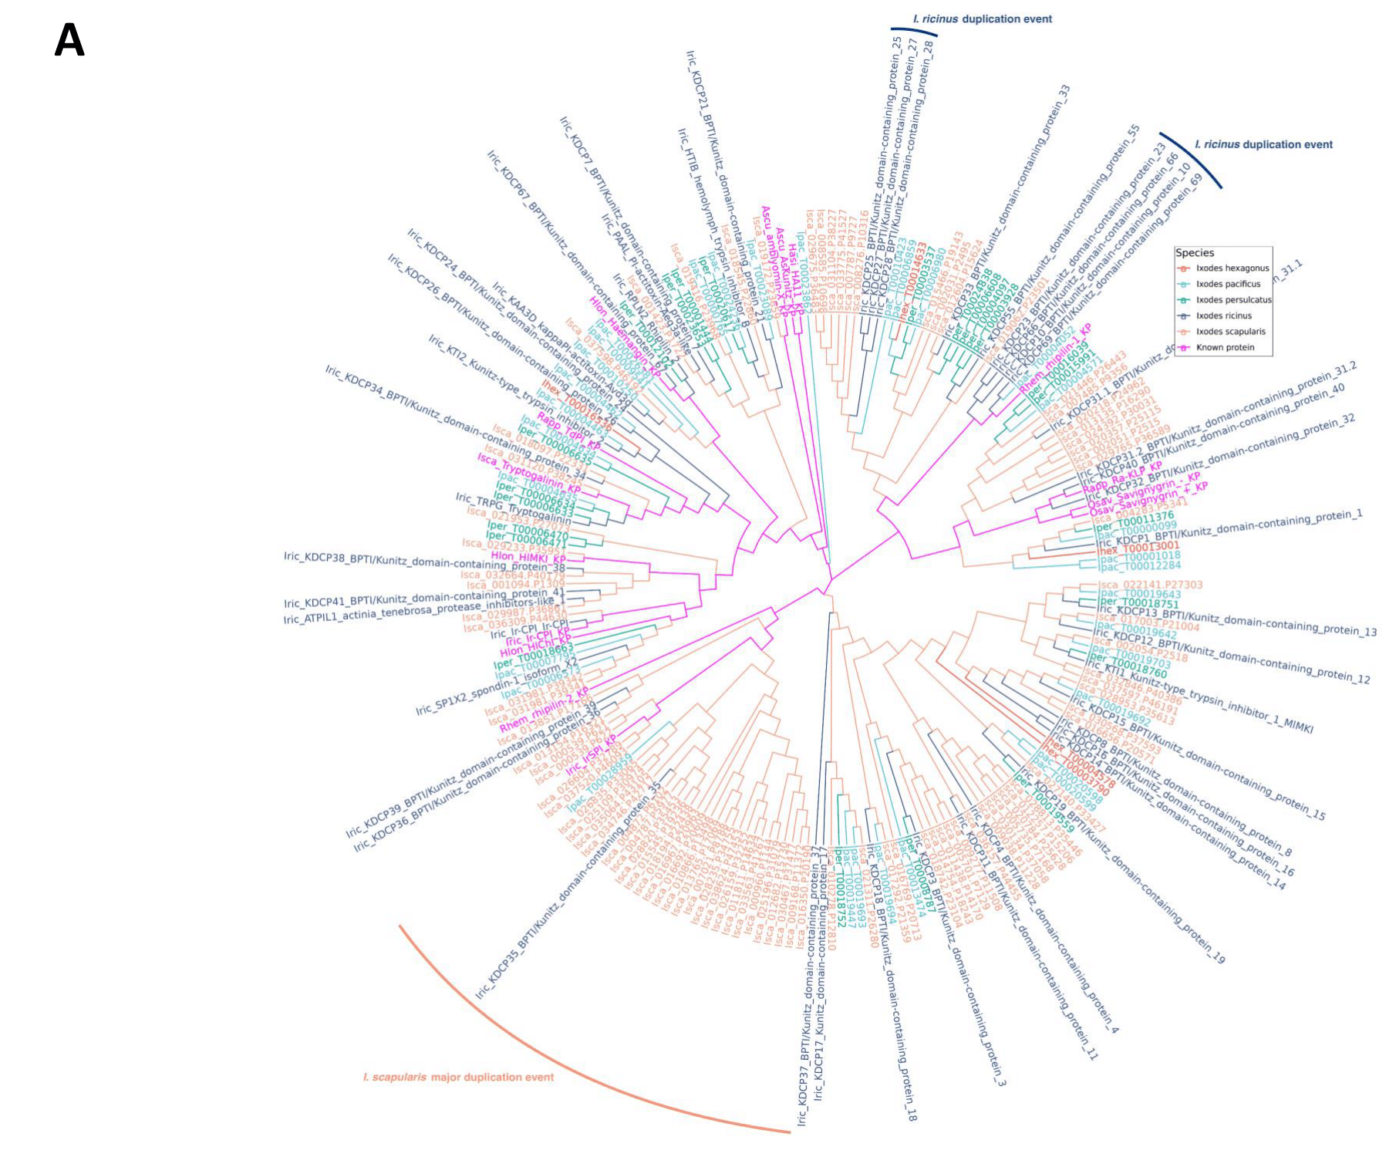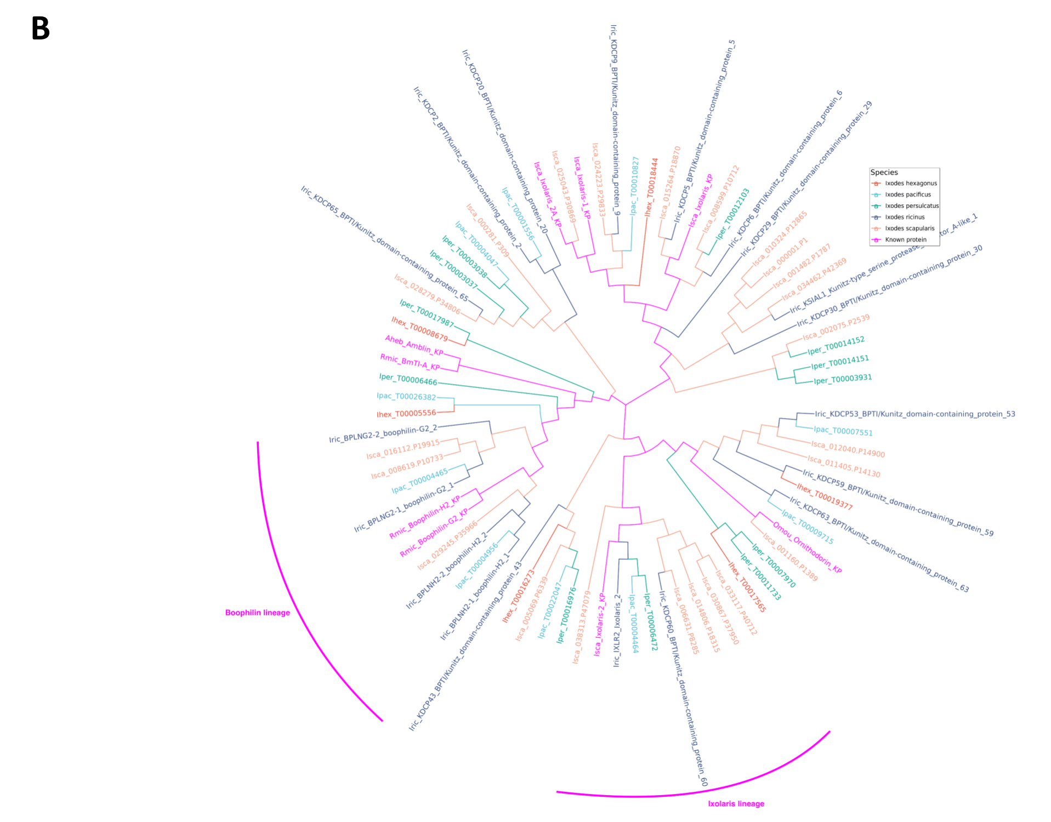
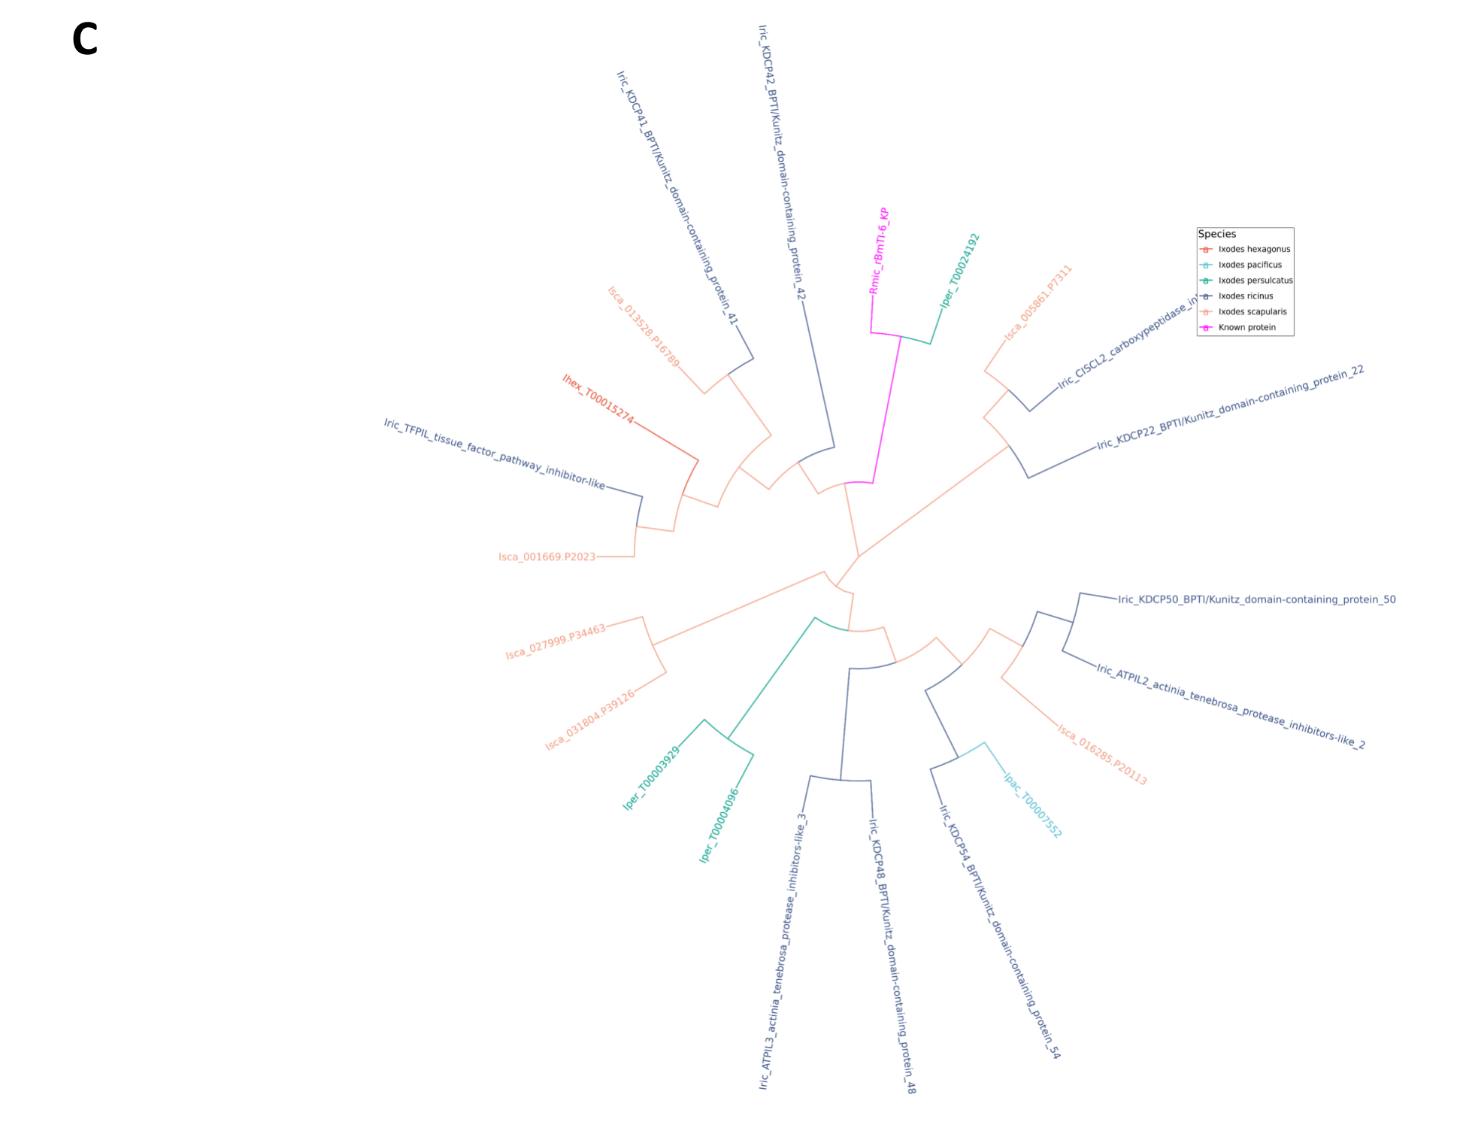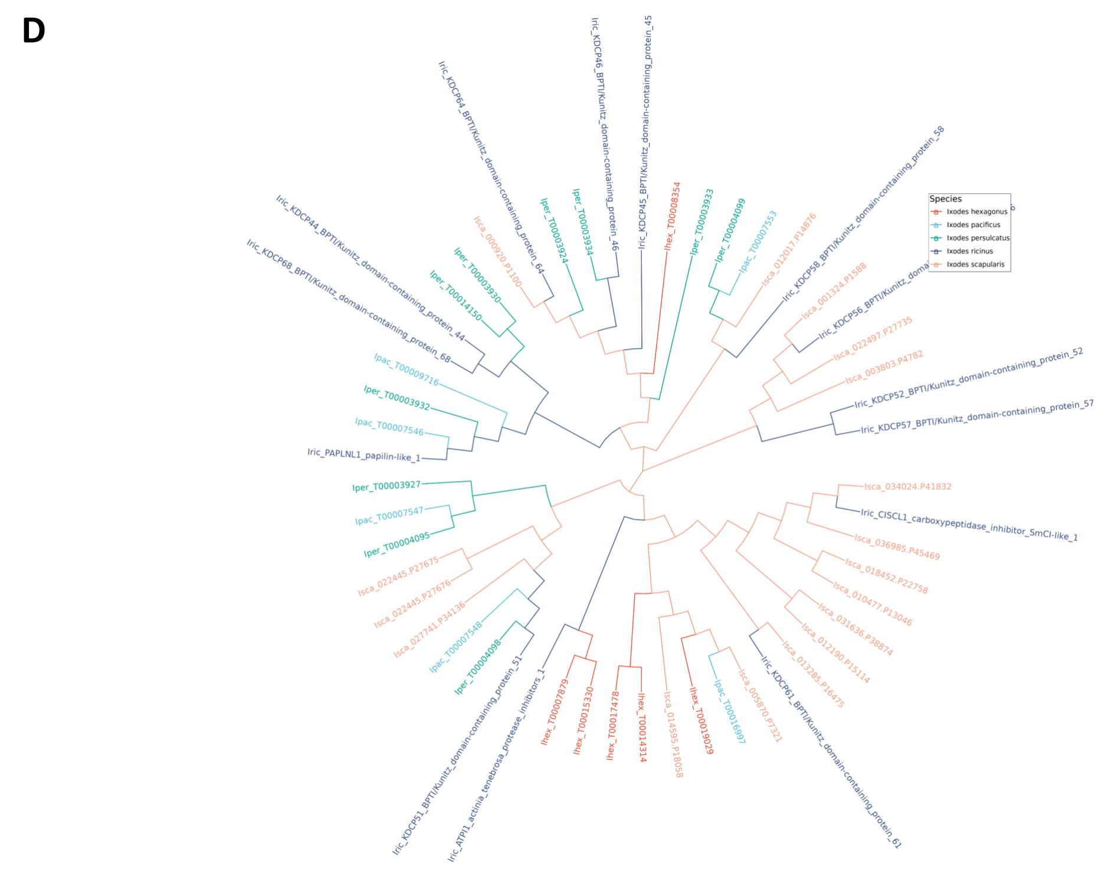
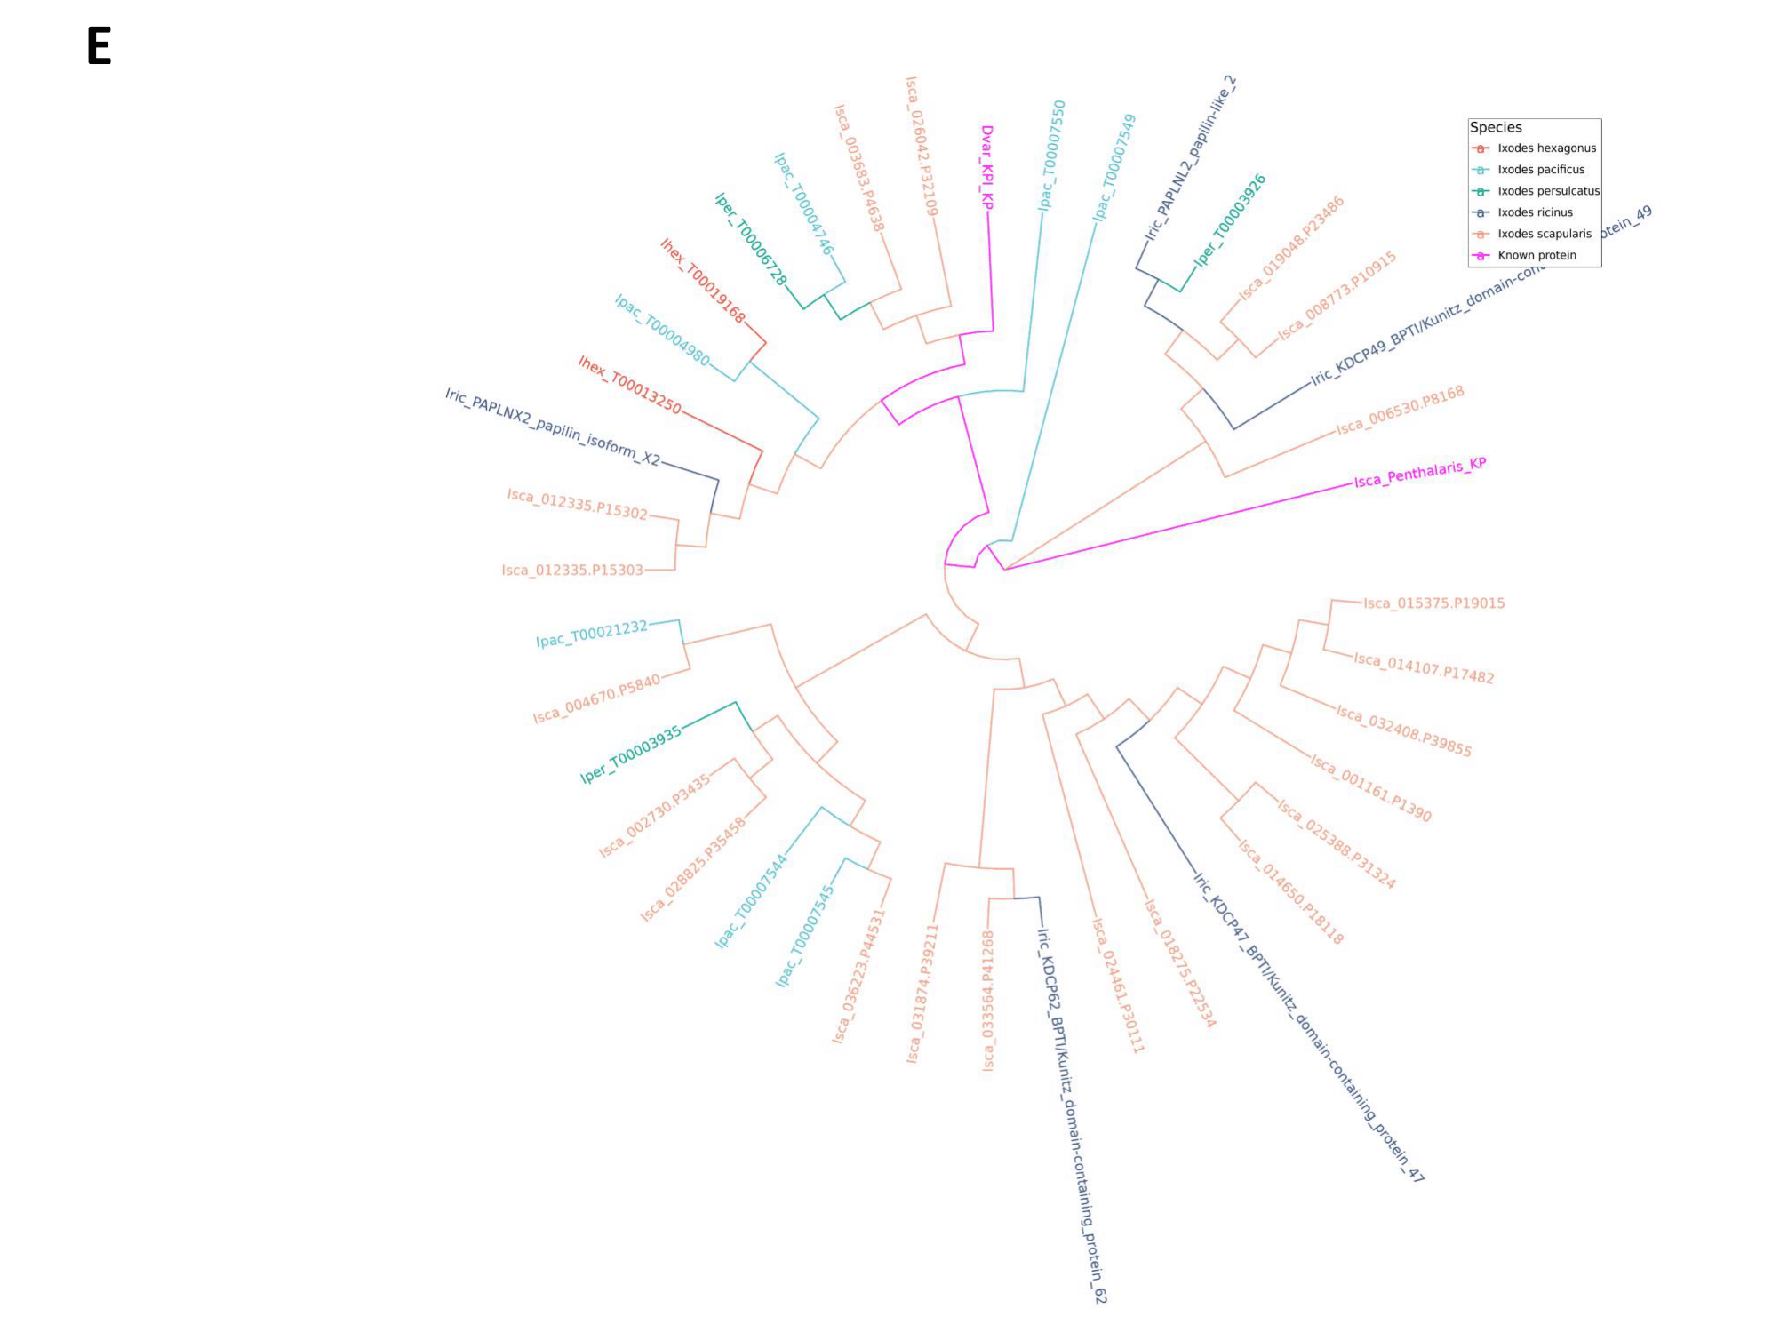
Figure S14: Phylogenetic trees of the Kunitz domain-containing proteins illustrating the monolaris (A), bilaris (B), trilaris (C), tetralaris (D) and penthalaris (E). Trees were constructed using FastME and visualized using the R software ggtree.
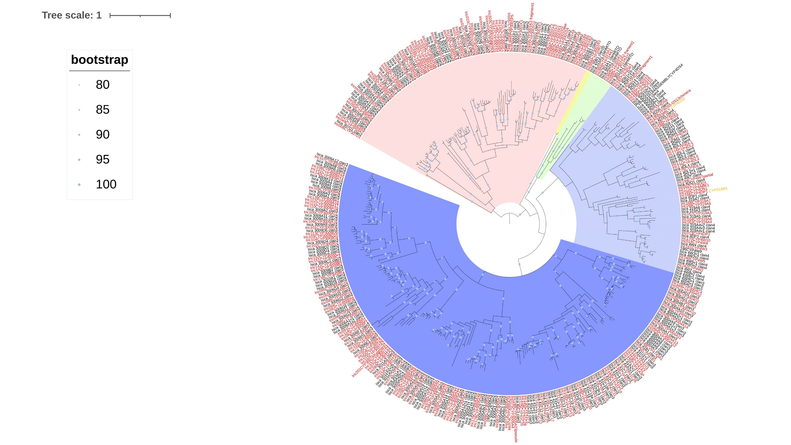
Figure S15: Phylogenetic tree of Cytochrome P450 genes in I. scapularis and I. ricinus genomes. The tree was rooted at the midpoint. Dot size on branches correspond to bootstrap values. Only values above 80 are represented. Gene labels for I. ricinus are labelled in red and for I. scapularis in black. Clan 2 members are highlighted in light pink, clan 20 in yellow, mitochondrial clan in green, clan 4 in light blue and clan 3 in dark blue.
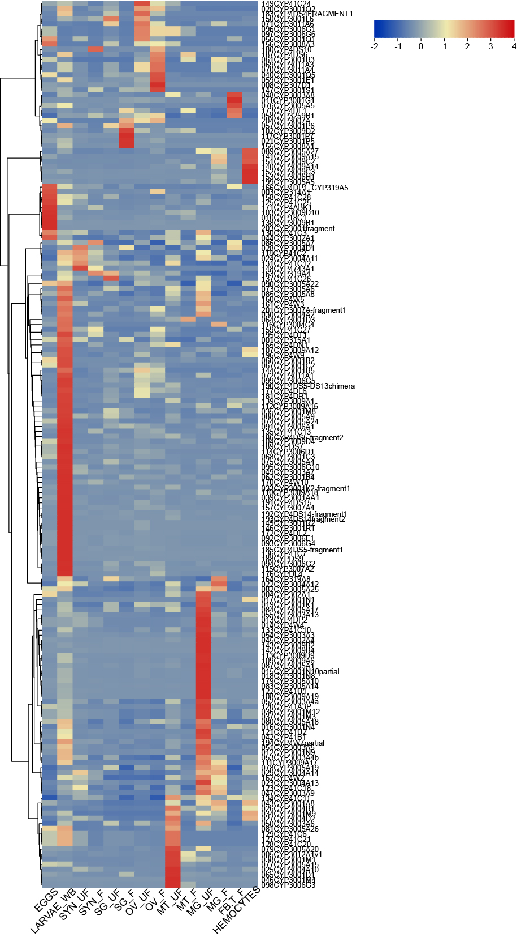
Figure S16: Heatmap of expression levels for Cytochrome P450 genes in I. ricinus (CYPs), based on RNA-Seq data. Tissues or stages were eggs, larvae synganglion, salivary glands (SG), Ovaries (OV), Malpighian tubules (MT), midgut (MG), Fat body/trachea (FB_T), and hemocytes. The suffixes F and UF respectively correspond to half-fed and unfed ticks. The color scale is given with more highly expressed IricCYPs in red and lower expressed IricCYPs in blue. Hierarchical clustering is given on the left side of the heatmap.
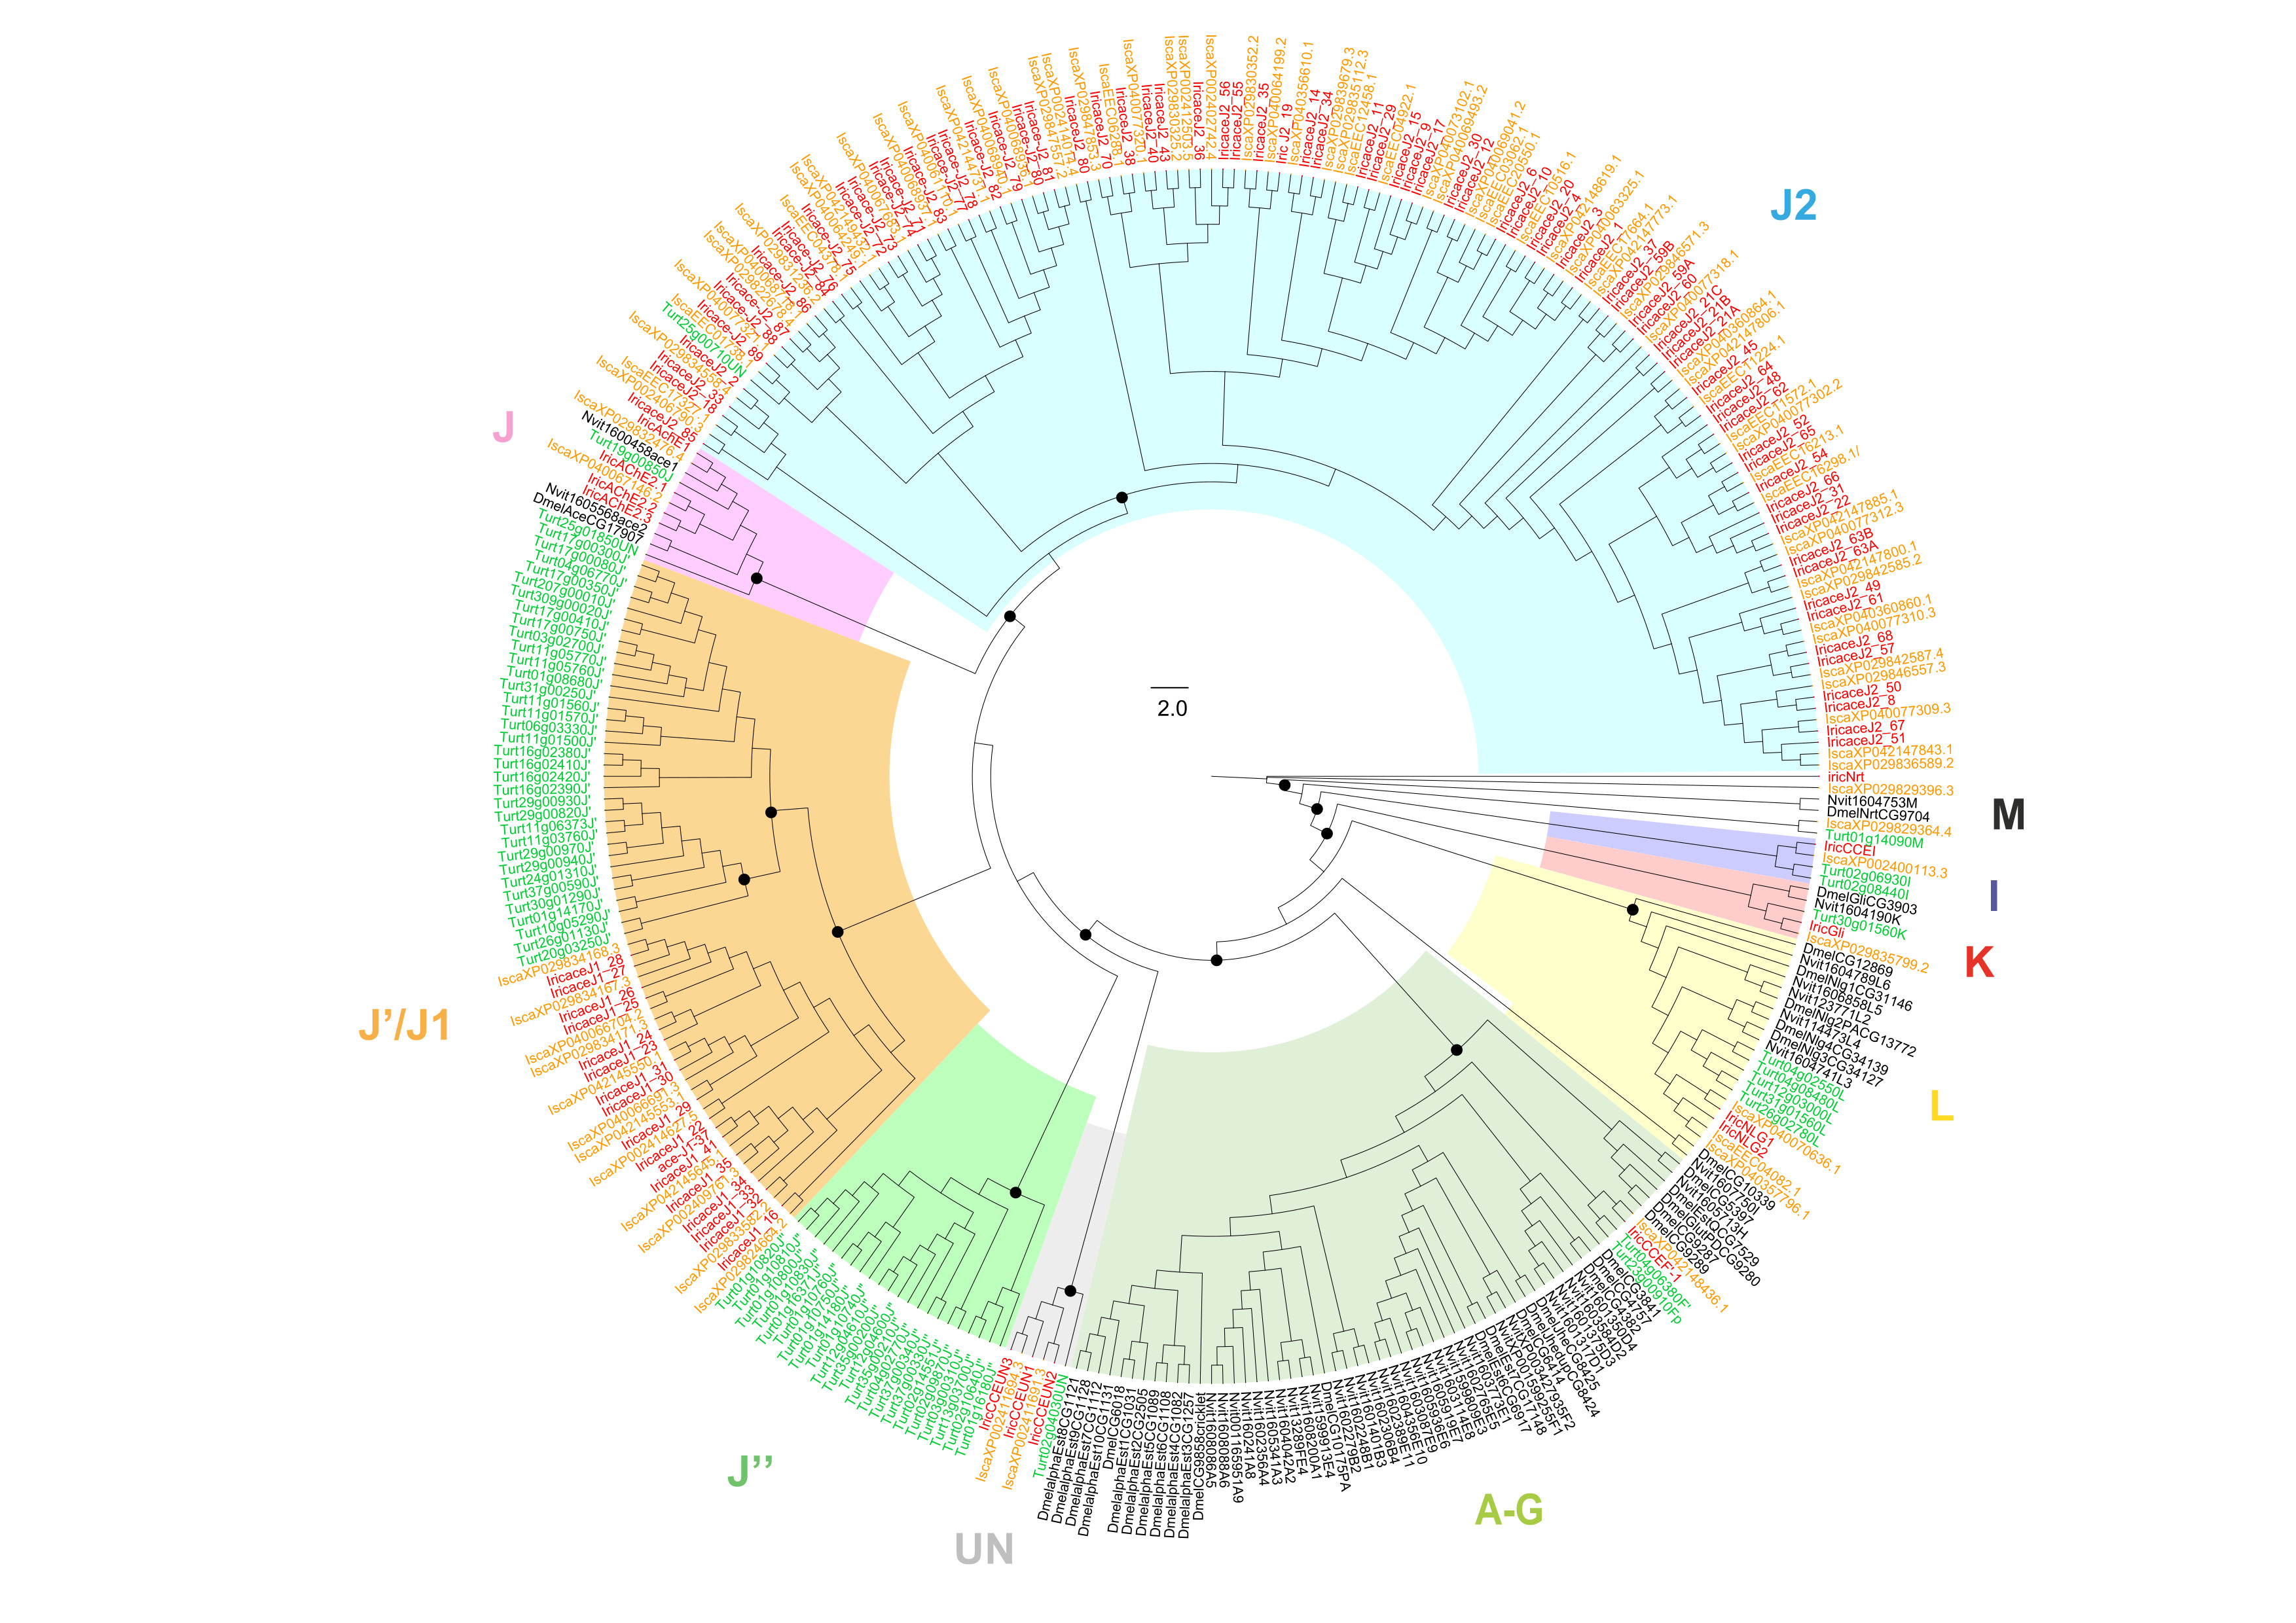
Figure S17: Phylogenetic tree of CCEs in ticks and other representative arthropod genomes. CCEs included are from I. ricinus (Iric in red), I. scapularis (Isca in orange), Tetranychus urticae (Turt in green), Nasonia vitripennis (Nvit in black) and D. melanogaster (Dmel in black). Dots on the tree correspond to bootstrap values above 0.87. Scale is given in the middle of the tree. Ticks show an important expansion of the J2 clade.

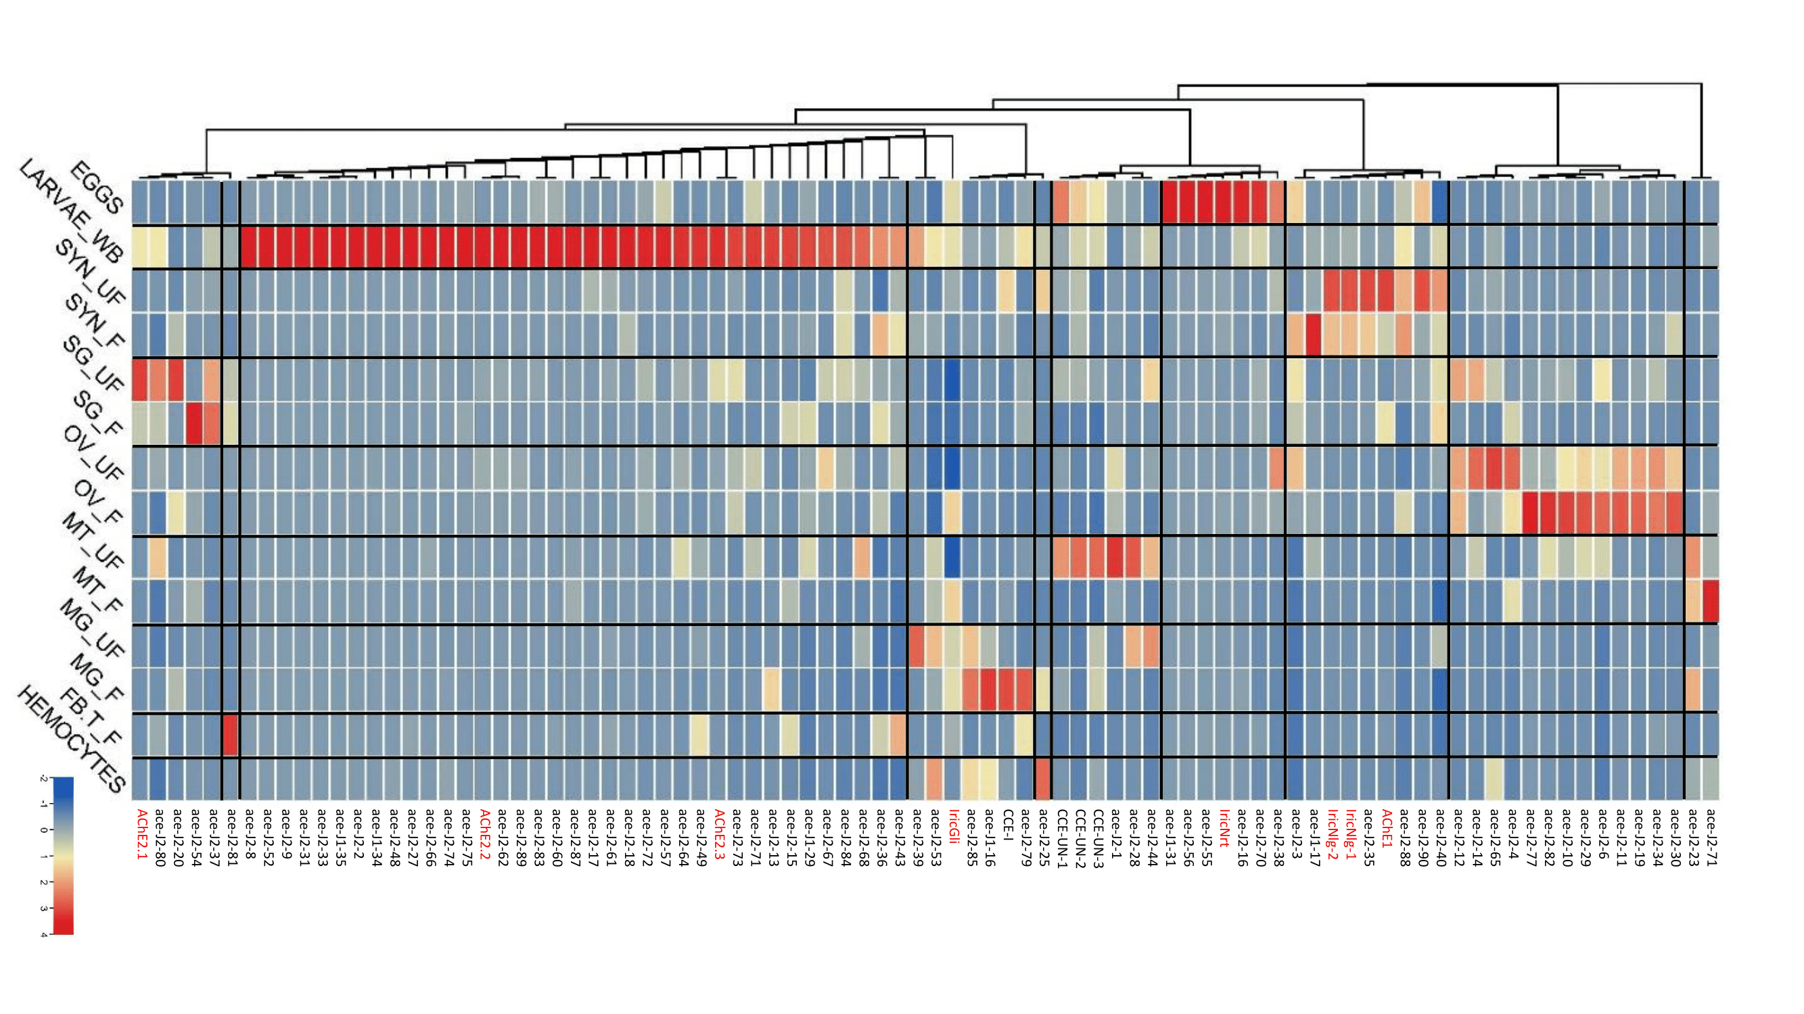
Figure S18: Heatmap of expression levels for CCEs in I. ricinus, based on RNA-Seq data. Tissues or stages were eggs, larvae synganglion, salivary glands (SG), Ovaries (OV), Malpighian tubules (MT), midgut (MG), Fat body/trachea (FB_T), and hemocytes. The suffixes F and UF respectively correspond to half-fed and unfed ticks. The color scale is given with the most highly expressed genes in red and the least expressed ones in blue. The hierarchical grouping is shown on the top of the heatmap.

Figure S19: Phylogenetic tree of ATP-binding cassette (ABC) transporters.

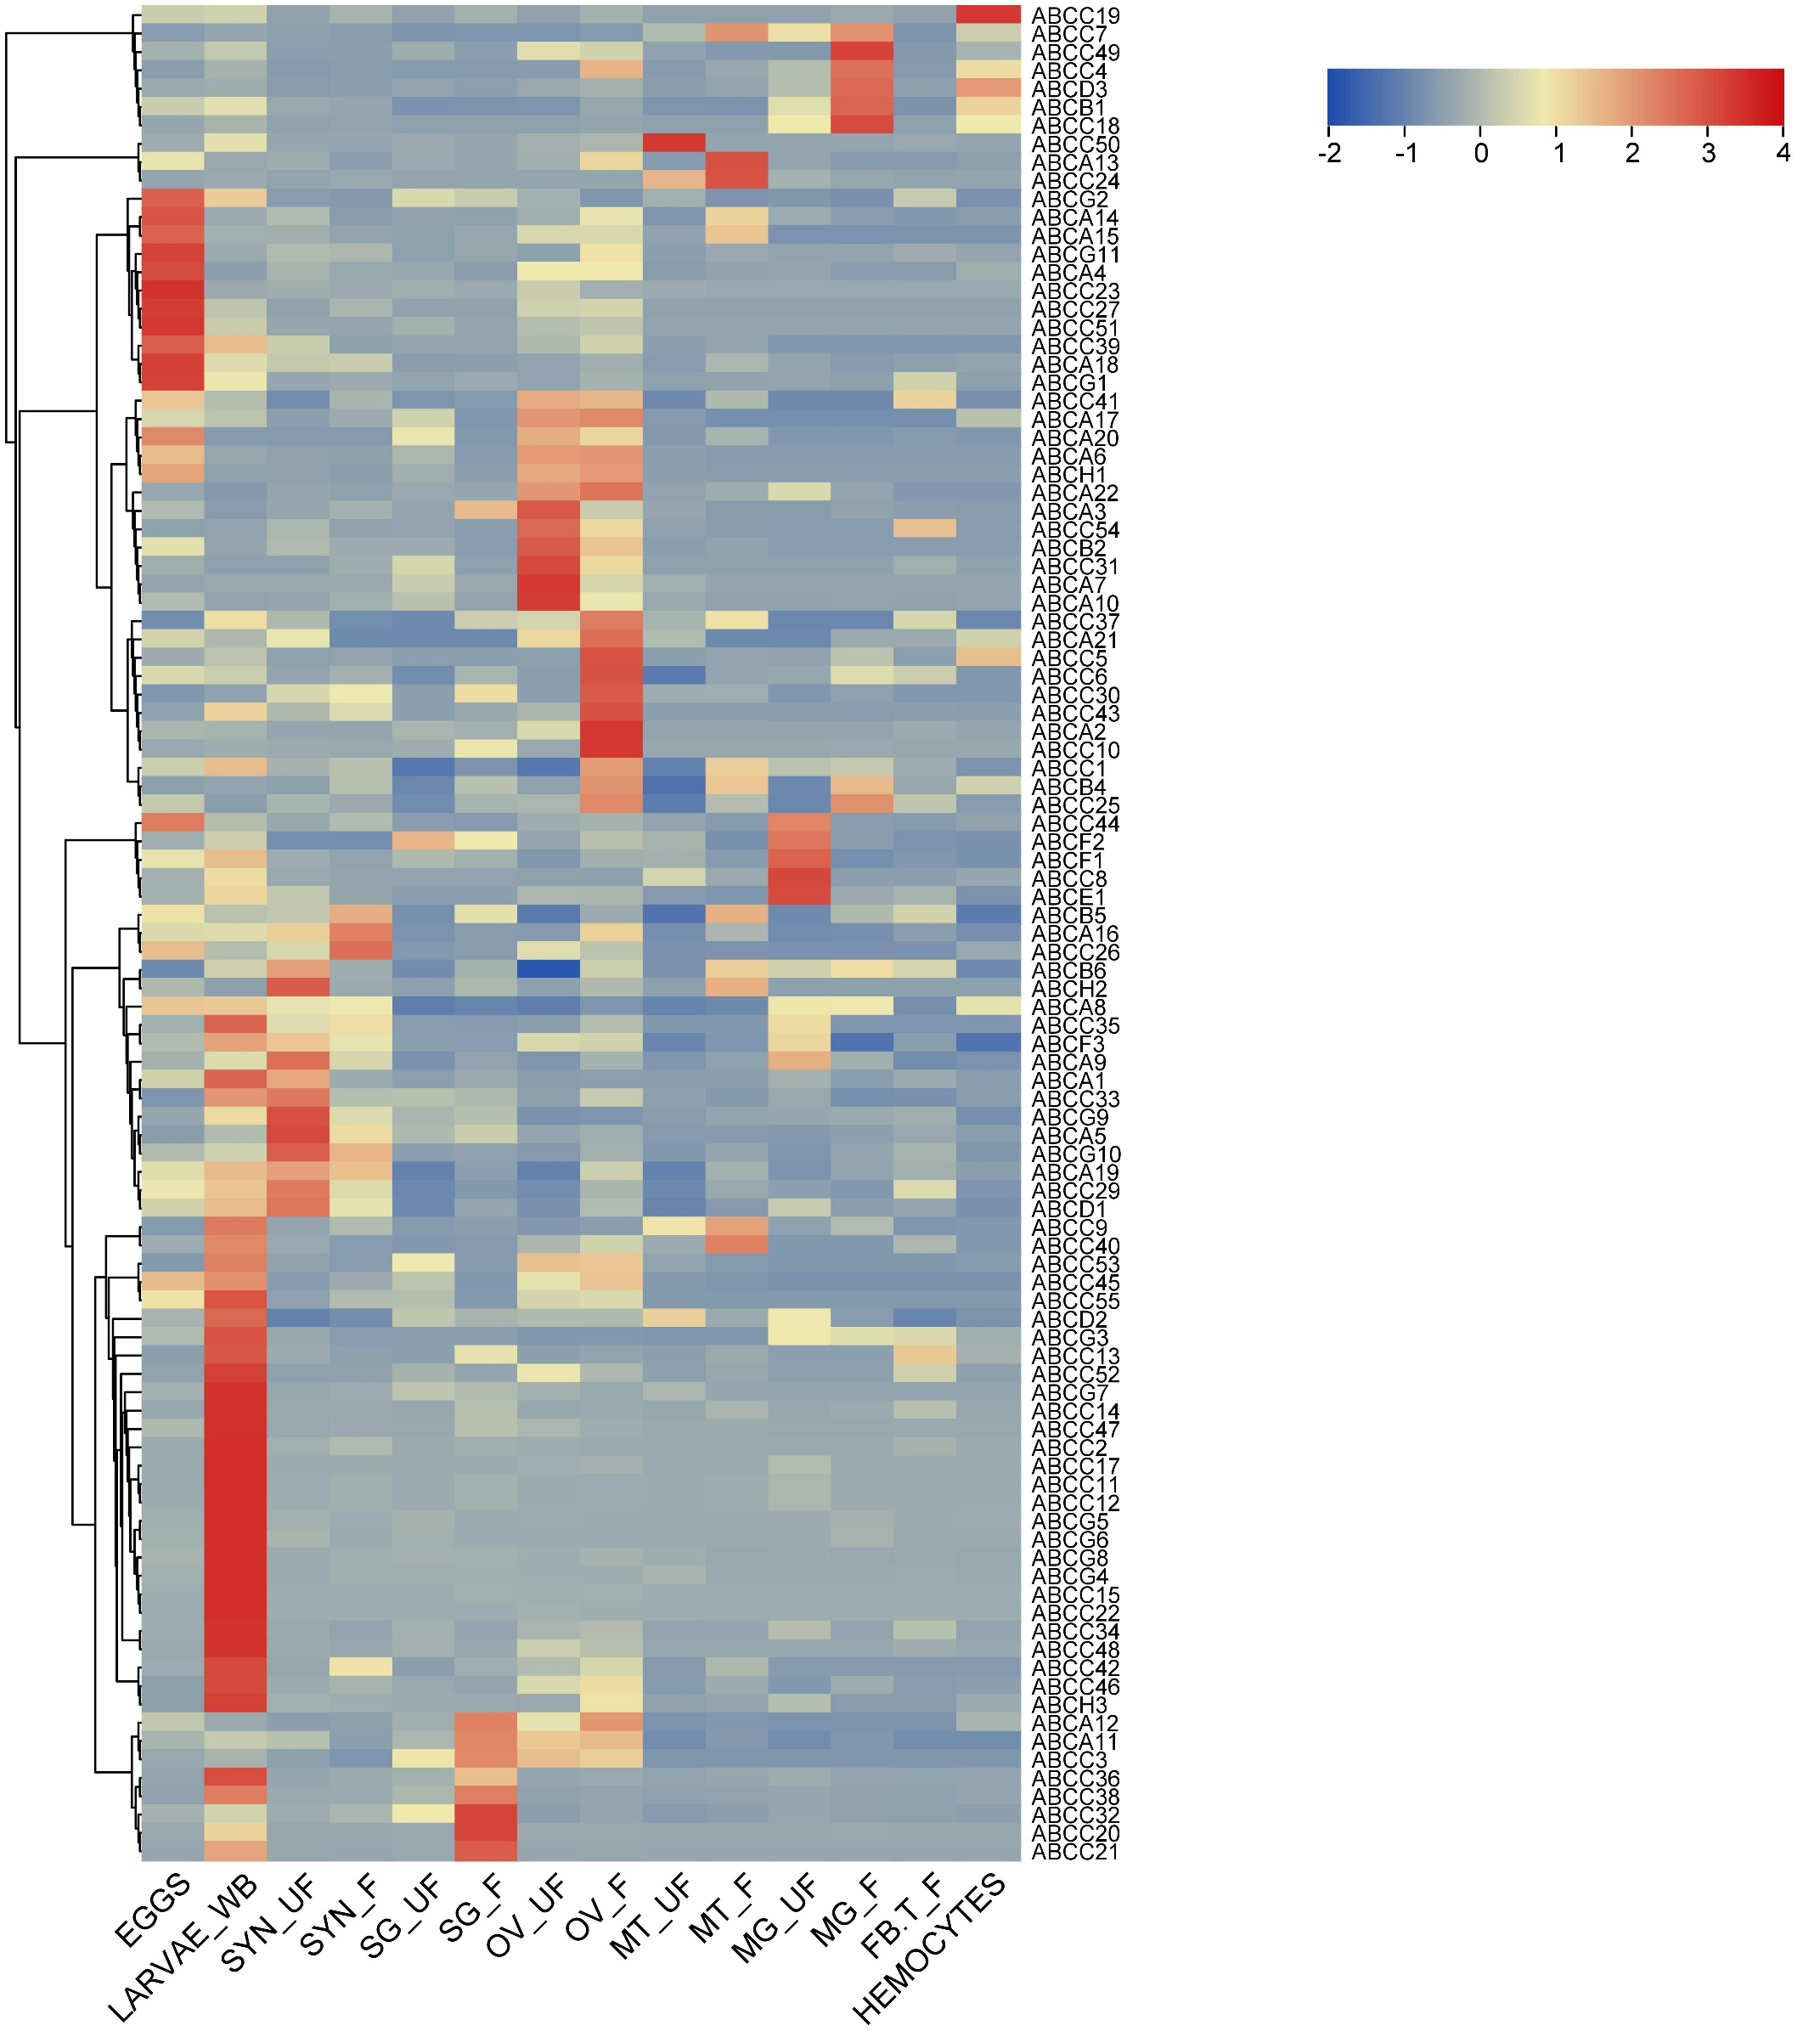
Figure S20: Heatmap of expression levels for IricABCs. Expression based on RNA-Seq data in eggs, larvae and various tissues of fed and unfed adult females. The color scale is given with the most highly expressed genes in red and the least expressed ones in blue. The hierarchical grouping is shown on the left-hand side of the heatmap.

