Supporting Information
Identification of Epinastine as CD96/PVR inhibitor for cancer immunotherapy

Xiangrui Zhang^{1†}, Lihan Zhang^{2†}, Beibei Li¹, Qingchao Wang¹, Peixin Chen¹, Ranran Shi³, Xiuman Zhou⁴, Xiaoshuang Niu⁴, Wenjie Zhai^{1,5}, Yahong Wu^{1,5}, Wenhui Shen⁶, Xiaowen Zhou¹* and Wenshan Zhao¹*

†Xiangrui Zhang and Lihan Zhang contributed equally to this work.
¹ School of Life Sciences, Zhengzhou University, Zhengzhou 450001, China
² Department of Integrated Chinese and Western Medicine, The Affiliated Cancer Hospital of Zhengzhou University & Henan Cancer Hospital, Zhengzhou 450008, China.
³ Department of Basic Medical Sciences, Luohe Medical College, Luohe 462000, China
⁴ School of Pharmaceutical Sciences (Shenzhen), Shenzhen Campus of Sun Yat-sen University, Shenzhen 518107, China
⁵ International Joint Laboratory for Protein and Peptide Drugs of Henan Province, Zhengzhou University, Zhengzhou, 450001, China
⁶ Department of Head Neck and Thyroid, The Affiliated Cancer Hospital of Zhengzhou University & Henan Cancer Hospital, Zhengzhou 450008, China.

* Corresponding authors. Tel.: +86-371-67781325.
E-mail addresses: zhouxw@zzu.edu.cn (Xiaowen Zhou) and zhaowsh07@zzu.edu.cn (Wenshan Zhao)

Supplementary Figure and Figure Legends
Figure S1
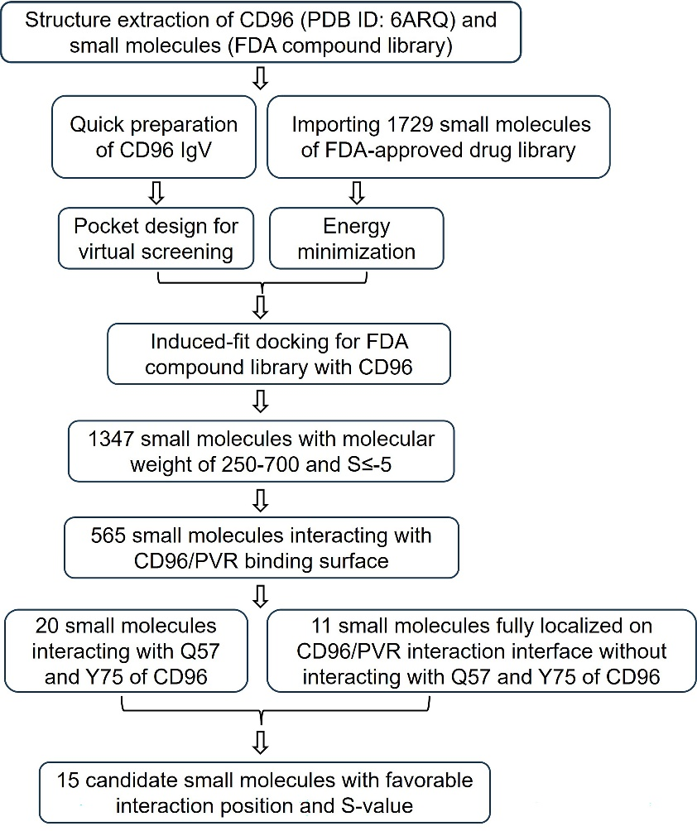
Fig. S1 Overview of the virtual screening process for identifying 15 candidate small molecules targeting CD96.
Figure S2
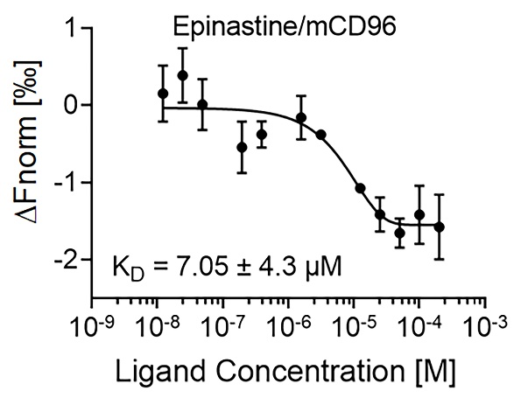
Fig. S2 The binding affinity of Epinastine to mCD96. The binding affinity of Epinastine with murine CD96 tested by MST, with K_{D} representing the binding dissociation constant. Data are presented as mean ± SEM and represent three independent experiments. Individual data values are provided in Additional file 2.
Figure S3
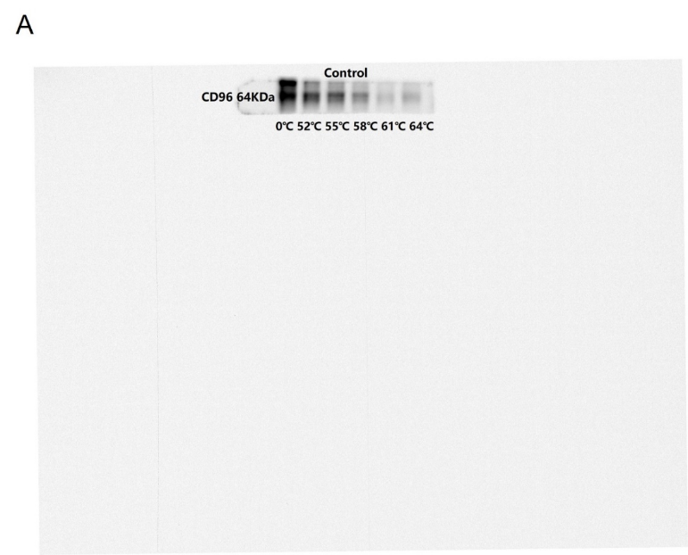
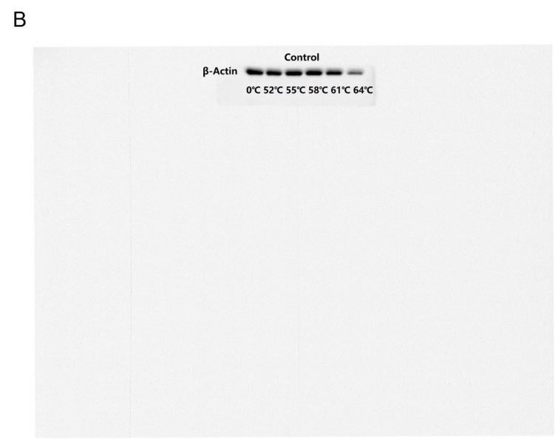
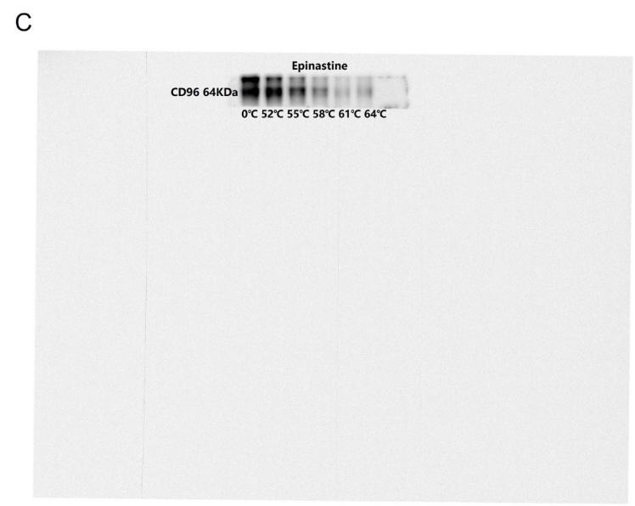
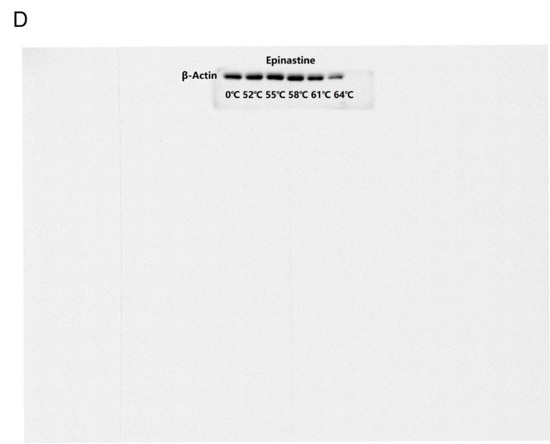
Fig. S3 The original images of the Western blotting results for CETSA analysis. A-B Original results for the CD96 band (A) and β-actin band (B) for the control group shown in Figure 5A. C-D Original results for the CD96 band (C) and β-actin band (D) for Epinastine treatment group shown in Figure 5A.
Figure S4
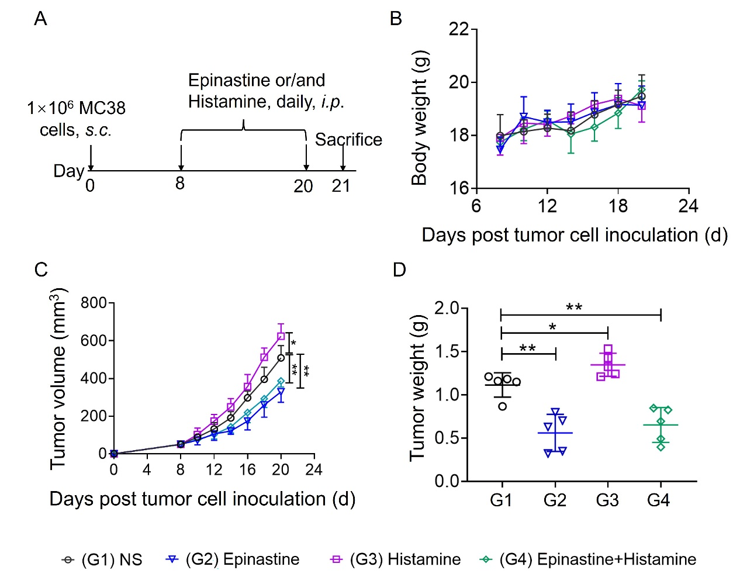
Fig. S4 The effects of Epinastine and histamine in regulating tumor growth in MC38 tumor-bearing mice. A Diagram illustrating the establishment of the MC38 mouse tumor-bearing model and the corresponding dosing regimen. B Body weight changes of mice bearing MC38 tumors throughout the treatment period. n = 5. C Curve showing the change in tumor volume of MC38 tumor-bearing mice. n = 5, * P < 0.05 and ** P < 0.01. D Tumor weight measurements of MC38 tumor-bearing mice post-treatment. Data are presented as mean ± SEM for n = 5 samples and individual data values are provided in Additional file 2. * P < 0.05 and ** P < 0.01.

Supplementary Tables
Table S1. Comprehensive data on the 15 small molecule candidates identified as potential inhibitors of CD96.
SMC number |  | Name | Structure | CAS number | Blocking rate (%)
 | SMC119 | Pyrithioxin | 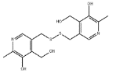 | 1098-97-1 | 3.96 ± 5.6
 | SMC576 | Glimepiride | 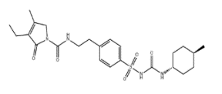 | 93479-97-1 | 1.99 ± 3.0
 | SMC577 | Probucol | 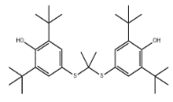 | 23288-49-5 | 5.61 ± 5.0
 | SMC578 | Flunarizine dihydrochloride | 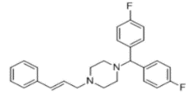 | 30484-77-6 | 10.4 ± 4.2
 | SMC579 | Silodosin | 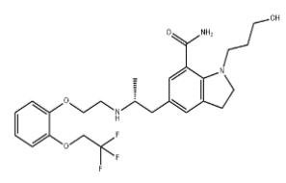 | 160970-54-7 | 4.58 ± 2.9
 | SMC580 | Mocetinostat | 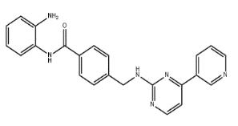 | 726169-73-9 | 2.30 ± 1.2
 | SMC581 | Cefcapene Pivoxil Hydrochloride | 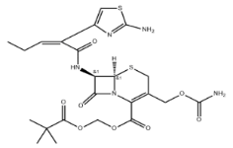 | 147816-24-8 | 14.9 ± 3.7
 | SMC582 | Trimethobenzamide hydrochloride | 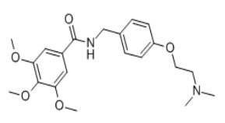 | 554-92-7 | 13.2 ± 3.1
 | SMC583 | Nestoron | 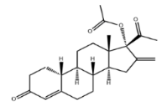 | 7759-35-5 | 23.3 ± 3.0
 | SMC584 | Maraviroc | 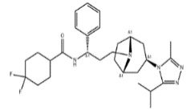 | 376348-65-1 | 20.8 ± 2.5
 | SMC585 | Nadifloxacin | 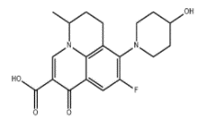 | 124858-35-1 | 27.3 ± 4.6
 | SMC586 | Lifitegrast | 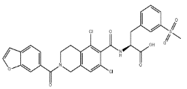 | 1025967-78-5 | 23.8 ± 5.0
 | SMC587 | Prulifloxacin | 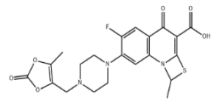 | 123447-62-1 | 31.9 ± 0.36
 | SMC588 | Epinastine | 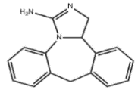 | 108929-04-0 | 35.5 ± 1.0
 | SMC589 | Sorafenib | 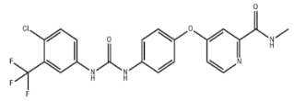 | 284461-73-0 | 35.1 ± 1.3

