The Biological large language model
- MolFormer is a Transformer-based model designed for chemical language representation learning. By incorporating a self-attention mechanism, it captures complex interactions between atoms in a molecule, enabling it to learn both local structural features and global molecular information. The model is highly scalable and can process large molecular datasets, making it particularly useful for tasks such as molecular property prediction and drug discovery. By inputting a drug's SMILES notation, MolFormer extracts high-quality molecular features for further analysis.
- ProtBert is a pre-trained language model based on the BERT architecture, specifically designed for protein sequence representation learning. It draws from the success of the BERT model in natural language processing by treating protein sequences as a "biological language." Using the self-attention mechanism, ProtBert learns the complex relationships between amino acids in protein sequences, much like how BERT processes relationships between words in text. By pre-training on large amounts of protein sequence data, ProtBert can capture both local and global features of proteins, excelling in tasks like protein property prediction, function classification, and structure prediction. By inputting protein sequence data, ProtBert extracts molecular features of the protein.
- BiomedBERT is a pre-trained language model based on the BERT architecture, specifically designed for biomedical text processing. It is pre-trained on a large corpus of biomedical literature, enabling it to understand and capture the specialized terminology, syntax, and semantic information within the biomedical field. BiomedBERT optimizes the model's ability to comprehend domain-specific vocabulary and expressions, outperforming general-purpose BERT models when handling biomedical data. We collect biological descriptions of diseases and other biological entities as input to extract features rich in domain-specific knowledge.

Algorithm training and Complexity

Algorithm S1. Algorithm framework of HNF-DDA
Require: Heterogeneous network $G$, Drug SMILES, Protein sequences, Disease and other biological entities text descriptions, Known DDAs, models HNFormer $f_{θ}$ and XGBoost $f_{ω}$
1: Initialize models parameters $θ$ and $ω$
2: Generate the positive and negative drug-disease subgraphs
3: Computing initial embeddings $H^{init}$ with MolFormer, ProtBert and BiomedBERT
4: Generate complete node embeddings $H^{0}$ with Eq. (1) and Eq. (2)
5: for each node $u$ in $G$ do
6: Calculate $L_{n}$ by Eq. (13)
7: if $u$ is drug or disease nodes do
8: Calculate $L_{sub}$ by Eq. (12)
9: end for
10: for each layer $l$ in HNFormer model do
11: for each edge $e$ in $E$ do
12: Calculate $L_{e}$ by Eq. (14)
13: end for
14: end for
15: Calculate $L$ by Eq. (15)
16: Update parameters $θ$
17: return drug and disease embeddings ($H_{drug}$, $H_{disease}$), HNFormer model $f_{θ}$
18: Generate initialize negative DDAs sample
19: Update parameters $ω$
20: return the prediction score of DDAs, XGBoost model $f_{ω}$

The model training process of HNF-DDA is outlined in Algorithm S1. Next, we perform a complexity analysis of HNF-DDA. Since the initial feature vector extraction and subgraph sampling belong to the data preprocessing phase, they are not included in the complexity analysis. Therefore, the complexity consists of two parts: (1) the time complexity of HNFormer learning node representations, which depends on the architecture of HNFormer. HNFormer updates node embeddings in each layer with a complexity of $O(N)$. The subgraph and marginal loss in each layer require $O(N)$ and $O(E)$, respectively, and the final classification loss is $O(N)$. Therefore, the time complexity of HNFormer is $O(L(N+E)+N)$, where $L$ is the total number of layers in HNFormer, $N$ and $E$ are the numbers of nodes and edges in the heterogeneous network, respectively. The space complexity of HNFormer is $O(L∙N∙F+E)$, where $F$ is the dimensions of node features. (2) The time and space complexity of predicting DDA (Drug-Disease Associations) using XGBoost depends on several factors: the number of trees $T$, the maximum depth of each tree $d$, the feature dimension of the DDA pairs $F$, and the number of known DDA pairs $Z$. Therefore, the time complexity is $O(T⋅Z⋅F⋅d)$, and the space complexity is $O(T⋅2^{d}+Z⋅F)$.

Compared Methods Details
Among the compared methods, the results for all methods except DDAGDL and FuHLDR are directly obtained from the DREAMwalk paper. This decision is made to ensure consistency and fairness in comparison, as the same heterogeneous dataset from DREAMwalk was utilized. For DDAGDL and FuHLDR methods, we used the source code and default parameters to extract the features of drugs and diseases. Then use XGBoost classifier to obtain the prediction results. The parameters of the XGBoost classifier are the same as in this paper, and the ten-fold cross-validation experiment is repeated 10 times for both.

Parameter Settings for XBGoost
Table S1. Parameter Settings of XBGoost in HetioNet and KEGG datasets, respectively.
Datasets | HetioNet | KEGG
gamma | 0 | 0
learning_rate | 0.01 | 0.01
max_depth | 15 | 35
n_estimators | 950 | 3500
min_child_weight | 1 | 1
subsample | 0.9 | 0.9
colsample_bytree | 0.08 | 0.05

Subgraph path length
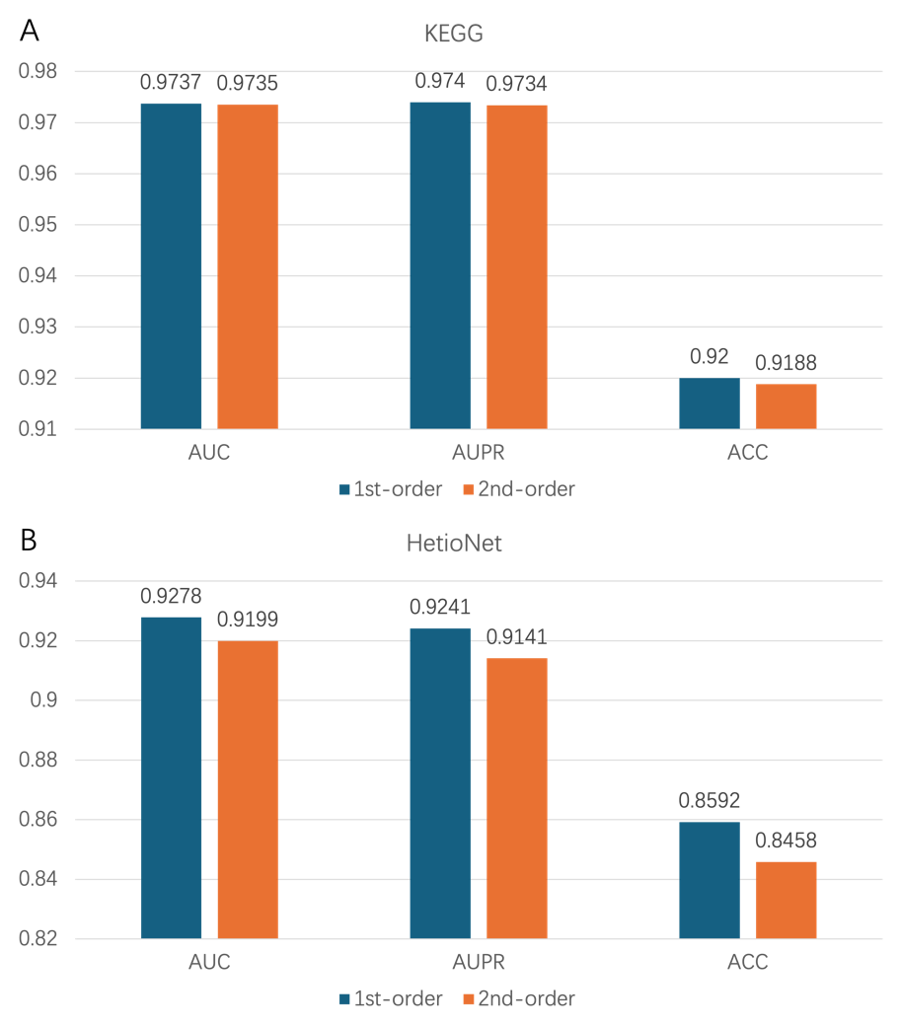
Figure S1. 1st-order vs 2nd-order prediction performance. 1st-order and 2nd-order refer to the prediction performance of taking the common first-order and second-order neighbors of drugs and diseases when sampling the subgraph, respectively.

