Supplementary Information.
GraphGIM: Rethinking Molecular Graph Contrastive Learning via Geometry Image
Modeling
Chaoyi Li^{1†}, Hongxin Xiang^{1†,} Wenjie Du², Tengfei Ma¹,Haowen Chen¹, Xiangxiang Zeng¹, Lei Xu^{3*}
¹ College of Information Science and Engineering, Hunan University, Changsha, China.
²School of Software Engineering, University of Science and Technology of China, Hefei, 230026, Anhui, China.
³School of Electronic and Communication Engineering, Shenzhen Polytechnic University, Shenzhen, 518055, China.
*Corresponding authors: csleixu@szpu.edu.cn
†These authors contributed equally to this work.

Appendix A Details about the similarity matrix in Figure 1.a
Data augmentation strategies.
As shown in Figure S1, we find a high similarity between the original molecular graph and the corresponding five augmented graphs. For the details of five augmented methods, we followed the same five augmented strategies as CGIP[42] including dropN, maskN, permE, subgraph, and ’dropN+maskN+permE+subgraph’. For each strategy, we select 20% of the local area in the graph for augmentation. The details of the five data augmentation strategies in the graphs are listed below:
- Dropping atoms (dropN) randomly delete atoms and corresponding edges from the graph.
- Masking nodes (maskN) uses the mean of all node features in the graph as the feature of masking nodes.
- Permuting bonds and perturb bounds (permE) including shuffling bounds, removing bounds, and adding new bounds.
- Extracting subgraph of graph (subgraph) randomly selecting a node as the starting node, and then gradually expanding to its adjacent nodes until the predetermined number of nodes is reached. Then, the node features, edge indexes, and edge attributes of the subgraph are extracted and updated, and finally, the subgraph is obtained.
- Combing the above four strategies (all) includes dropping atoms, masking nodes, permitting bonds and perturb bounds, and extracting subgraphs.
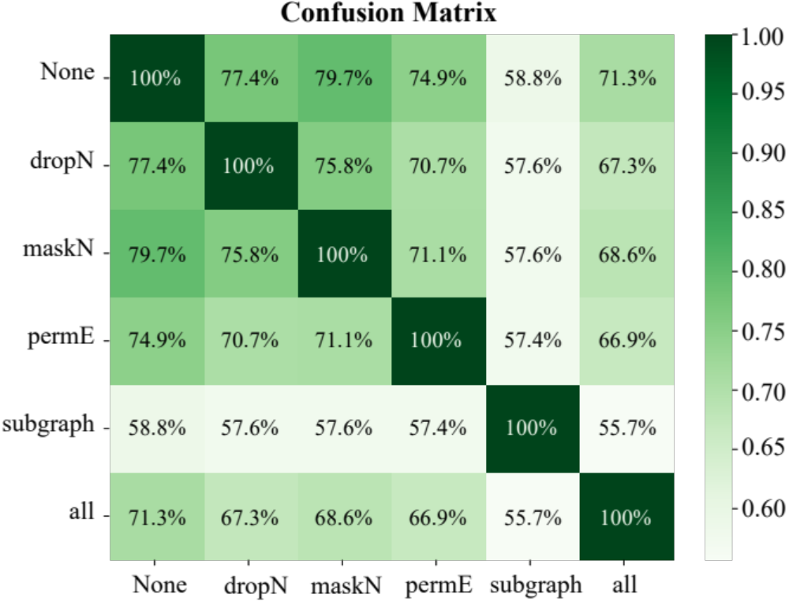
Figure S1 The similarity between the original molecular graphs and the corresponding five augmented graphs.
Data construction.
To ensure the fairness of the experiment, we pre-processed the graph features of 2 million molecules from IEM in five augmentation strategies and randomly chose 200,000 features from 2 million samples for each strategy.
Implementation details.
We adopted Cosine Similarity to evaluate the similarity between graph features. After pre-processing the graph features, we calculate the cosine similarity for each graph-graph pair using the methods $sim\left(⋅\right).$
$$\begin{aligned}sim\left(A,B\right)=\frac{A⋅B}{|A||B|}\#（A1）\end{aligned}$$
where $sim\left(⋅\right)$ represents the function of calculating cosine similarity, $A,$ $B$ stands for different graph features, and $||$ denotes the Euclidean norm.
Appendix B Implementation details of Figure 1.b
Image-graph pairs construction.
To ensure the fairness of the experiment, we select the same dataset in IEM[44] which contains 2 million molecules and 8 million molecular images, and then pre-processed the multi-view 3D geometric images to obtain visual features. By the way, we also obtain molecular graphs by using RDKit and then forward propagate graph $G$ to graph encoder GIN to obtain the global graph representation. To align the feature dimension between visual features and graph representations, we used a projection head to map the dimension of graph representation (300) to the same latent space (512). Finally, we obtain the features of 2 million image-graph pairs.
Graph-graph pairs construction.
To fully explore the similarity of graph-graph pairs, we use the augmented strategy ’dropN+maskN+permE+subgraph’ and constructed 2 million graph-graph pairs which contain 2 million molecular graphs and 2 million augmentation graphs. Then we forward propagate graph $G$ and augmentation $G^{'}$ to graph encoder GIN to obtain the global graph representation. Finally, we used a projection head to map the dimension of graph representation (300) to the same latent space (512). Finally, we obtain the features of 2 million image-graph pairs.
The Probability Distribution of Similarity.
After the construction of the image-graph and graph-graph pairs. We follow the Equation A1 to calculate the Cosine Similarity and draw a distribution histogram.
Appendix C Comparison of GraphGIM with Other Methods
As shown in Table S1, we compared the performance of two categories of methods ‘graph+image’ and ‘graph+graph’ on benchmark datasets. It is obvious that ‘graph+image’ overperforms ‘graph+graph’. The result proves that images have a stronger ability to boost the performance of 2D graphs and 3D graphs.
Table S1 The performance of four methods using graph contrastive learning. In this table, the best performance and second-best performance are marked with bold, underline separately, and the evaluation metric is ROC-AUC(%).
Methods | GraphCL | GraphMVP | CGIP | GraphGIM
#average | 70.64 | 71.69 | 71.94 | 72.66
Appendix D Implementation details of cross-modal retrieval analysis
Method
To compute the Top-k recall (R@k), we follow the method below, where we take the sample size of 100 as an example. In the sample, we calculate the cosine similarity between each query sample and all other retrieved samples ( if we conduct the image-to-graph retrieval, we choose the image as the query sample and the graph as the retrieved sample), then we rank the 10,000 (The square of the sample size 100) pairs by the value of cosine similarity. If the retrieved sample is in the Top-k, we think it’s a valid image-to-graph retrieval.
Metric
We use Top-k recall (R@k, higher is better), a commonly used metric to evaluate the performance of retrieval systems, especially in cross-modal retrieval tasks. In particular, R@k measures the percentage of test queries that have at least one correct item among the top K-ranked results. It reflects how well the model ranks the correct results at the top, with a higher Top-k Recall indicating more accurate ranking by the model.
Calculation Process
For each query, we computed the cosine similarity between query and value and retrun the Top-k most relevant results. If at least one of the Top-k, the query is considered successful. The final Top-k recall is the ratio of successful queries to all queries. The performance can be evaluated for different values of K (such as 1, 3, 5, 10, 20, 50), allowing us to assess the system’s effectiveness at various retrieval result levels. For example, in R@1, a query is considered successful only if the top-ranked result is relevant, while in R@10, the query is successful if any of the top 10 results contains a relevant match.
Appendix E Details of the Dataset
MoleculeNet is a common dataset library designed for molecular machine-learning tasks, covering a variety of biological and chemical domains. In this paper, we use eight benchmark datasets for downstream tasks. The following section is a detailed introduction to the 8 datasets.
BBBP(Blood-Brain Barrier Penetration)
- Task: Predict whether a molecule can cross the blood-brain barrier(BBB). The blood-brain barrier is a significant obstacle in the design of drugs for the central nervous system, as it limits the effectiveness of many drugs.
- Dataset Description: The BBBP dataset contains information on whether molecules can cross the blood-brain barrier. Each sample is labeled as either capable or incapable of crossing the barrier. In total, the dataset includes 2,039 molecules.
Tox21(Toxicology 21)
- Task: Predict the toxicity of chemical compounds. The Tox21 dataset consists of multiple tasks aimed at predicting the toxicity of compounds on various biological targets using machine learning methods.
- Dataset Description: The Tox21 dataset contains data on the interaction between compounds and various biological targets, including the activation or inhibition of specific cellular signaling pathways. Each compound has multiple labels indicating its toxicity towards different targets. In total, the dataset includes 7,831 molecules.
ToxCast
- Task: Predict the toxicity response of chemicals to biological systems. ToxCast aims to predict the effects of chemicals on various biological pathways through machine learning techniques.
- Dataset Description: The ToxCast dataset contains data on the activity of chemicals against a large number of biological targets, covering various cellular signaling pathways, gene expression, enzyme activity, etc. In total, the dataset includes 8,575 molecules.
Sider
- Task: Predict drug side effects. The Sider dataset contains the relationship between drugs and their known side effects, aiming to help identify potential side effects of drugs.
- Dataset Description: The Sider dataset includes around 140 drugs and their associated side effects. Each drug is associated with multiple side effects, and the model needs to predict possible side effects based on the drug’s features. In total, the dataset includes 1,427 molecules.
ClinTox
- Task: Predict the clinical toxicity of drugs. The ClinTox dataset focuses on the toxic effects of drugs in clinical settings, particularly hepatotoxicity and cardiotoxicity.
- Dataset Description: The ClinTox dataset includes a set of drugs and their known toxicity responses in clinical trials, including liver and heart toxicity labels.
MUV(Maximum Unbiased Validation)
- Task: Perform molecular activity prediction. The MUV dataset contains activity data of a variety of small molecules, primarily used to test the generalization ability of models in chemical space.
- Dataset Description: The MUV dataset is designed to evaluate the generalization ability of molecular activity prediction models by providing a diverse set of chemical molecules, helping assess the model’s performance on unseen chemical data.
HIV(HIV Inhibition)
- Task: Predict the inhibition of the HIV virus by a compound. The HIV dataset includes the interactions between different molecules and the HIV virus, with the goal of predicting whether a molecule can inhibit HIV.
- Dataset Description: The HIV dataset includes chemical compounds and their inhibition activity against HIV. Each compound is labeled as either inhibiting or not inhibiting HIV.
BACE(Beta-site APP Cleaving Enzyme)
- Task: Predict whether a compound can inhibit BACE enzyme activity. BACE is an important target associated with Alzheimer’s disease.
- Dataset Description: The BACE dataset includes data on the inhibitory activity of compounds against BACE enzyme, aiming to develop drugs that can effectively inhibit BACE.

