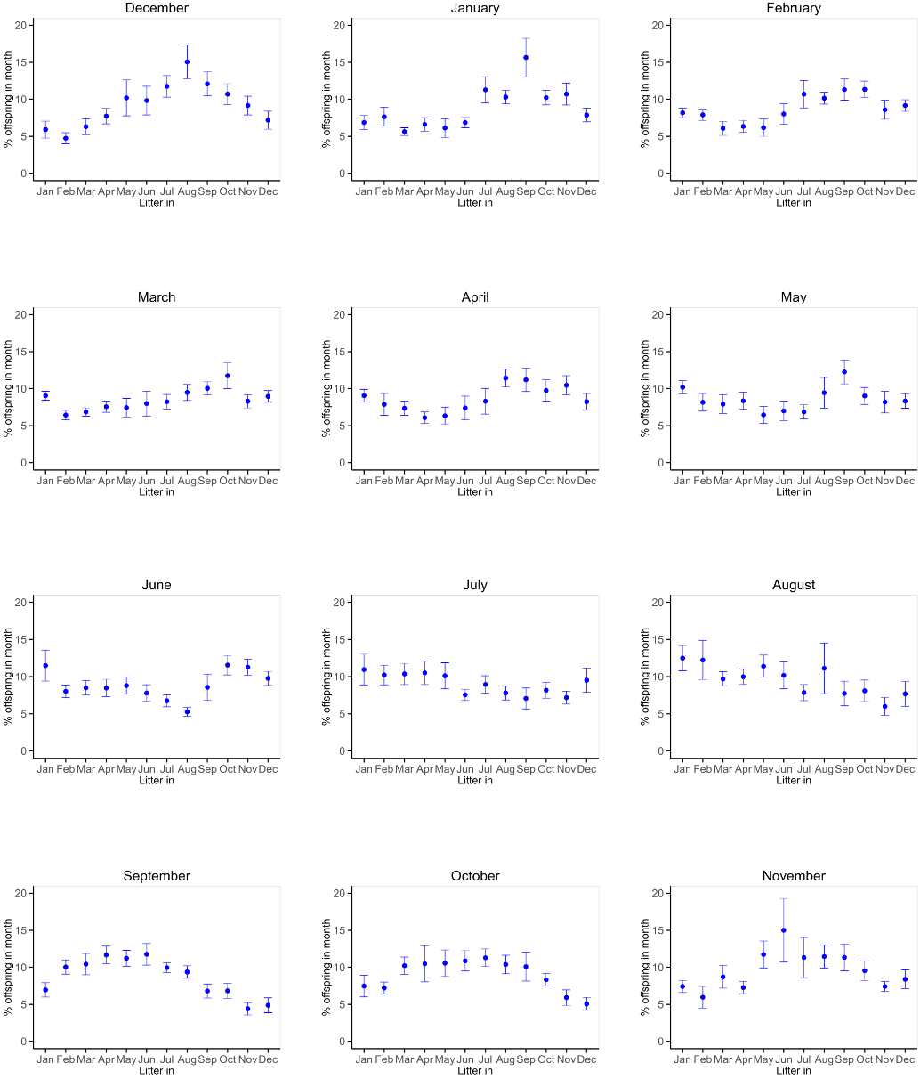
Fig. S1. Distribution of offspring production throughout the year according to the mothers’ month of birth. Offspring produced within 12 months after the production of the first litter (first litter included) were considered and expressed as the (%) of the total offspring that were produced within this 12-month period. Average values of aggregated data 5 years intervals are shown. Results reflecting the breeding patterns of P. maniculatus females (dams) are shown. SEM is indicated.

Fig. S2. Dot plot of the coefficient of correlation (R) of breeding preferences modeled by SINE model for animals born in each of the indicated month in different Peromyscus stocks.
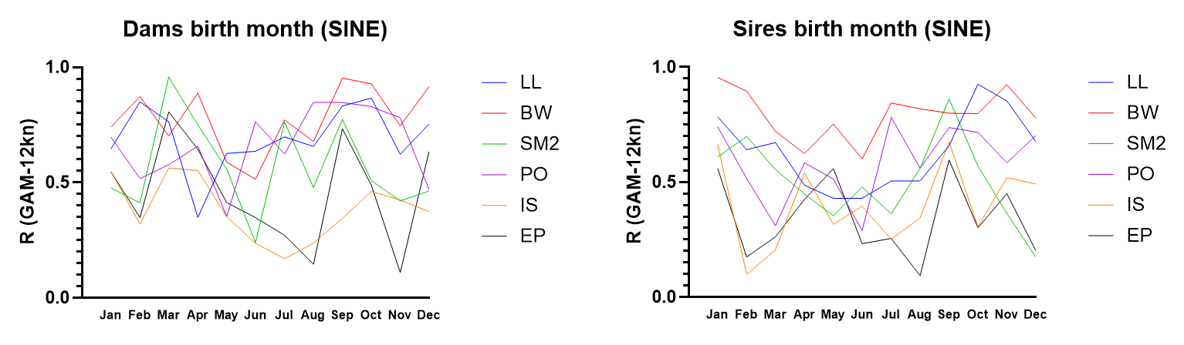

Fig. S3. R values of 12-knots GAM described in Figure 2 for different birth months of different Peromyscus stocks, in dams and sires.
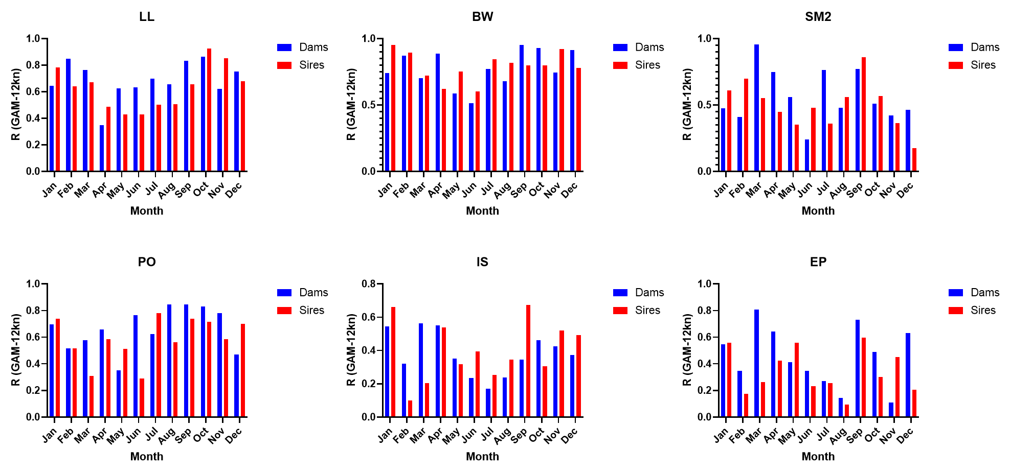

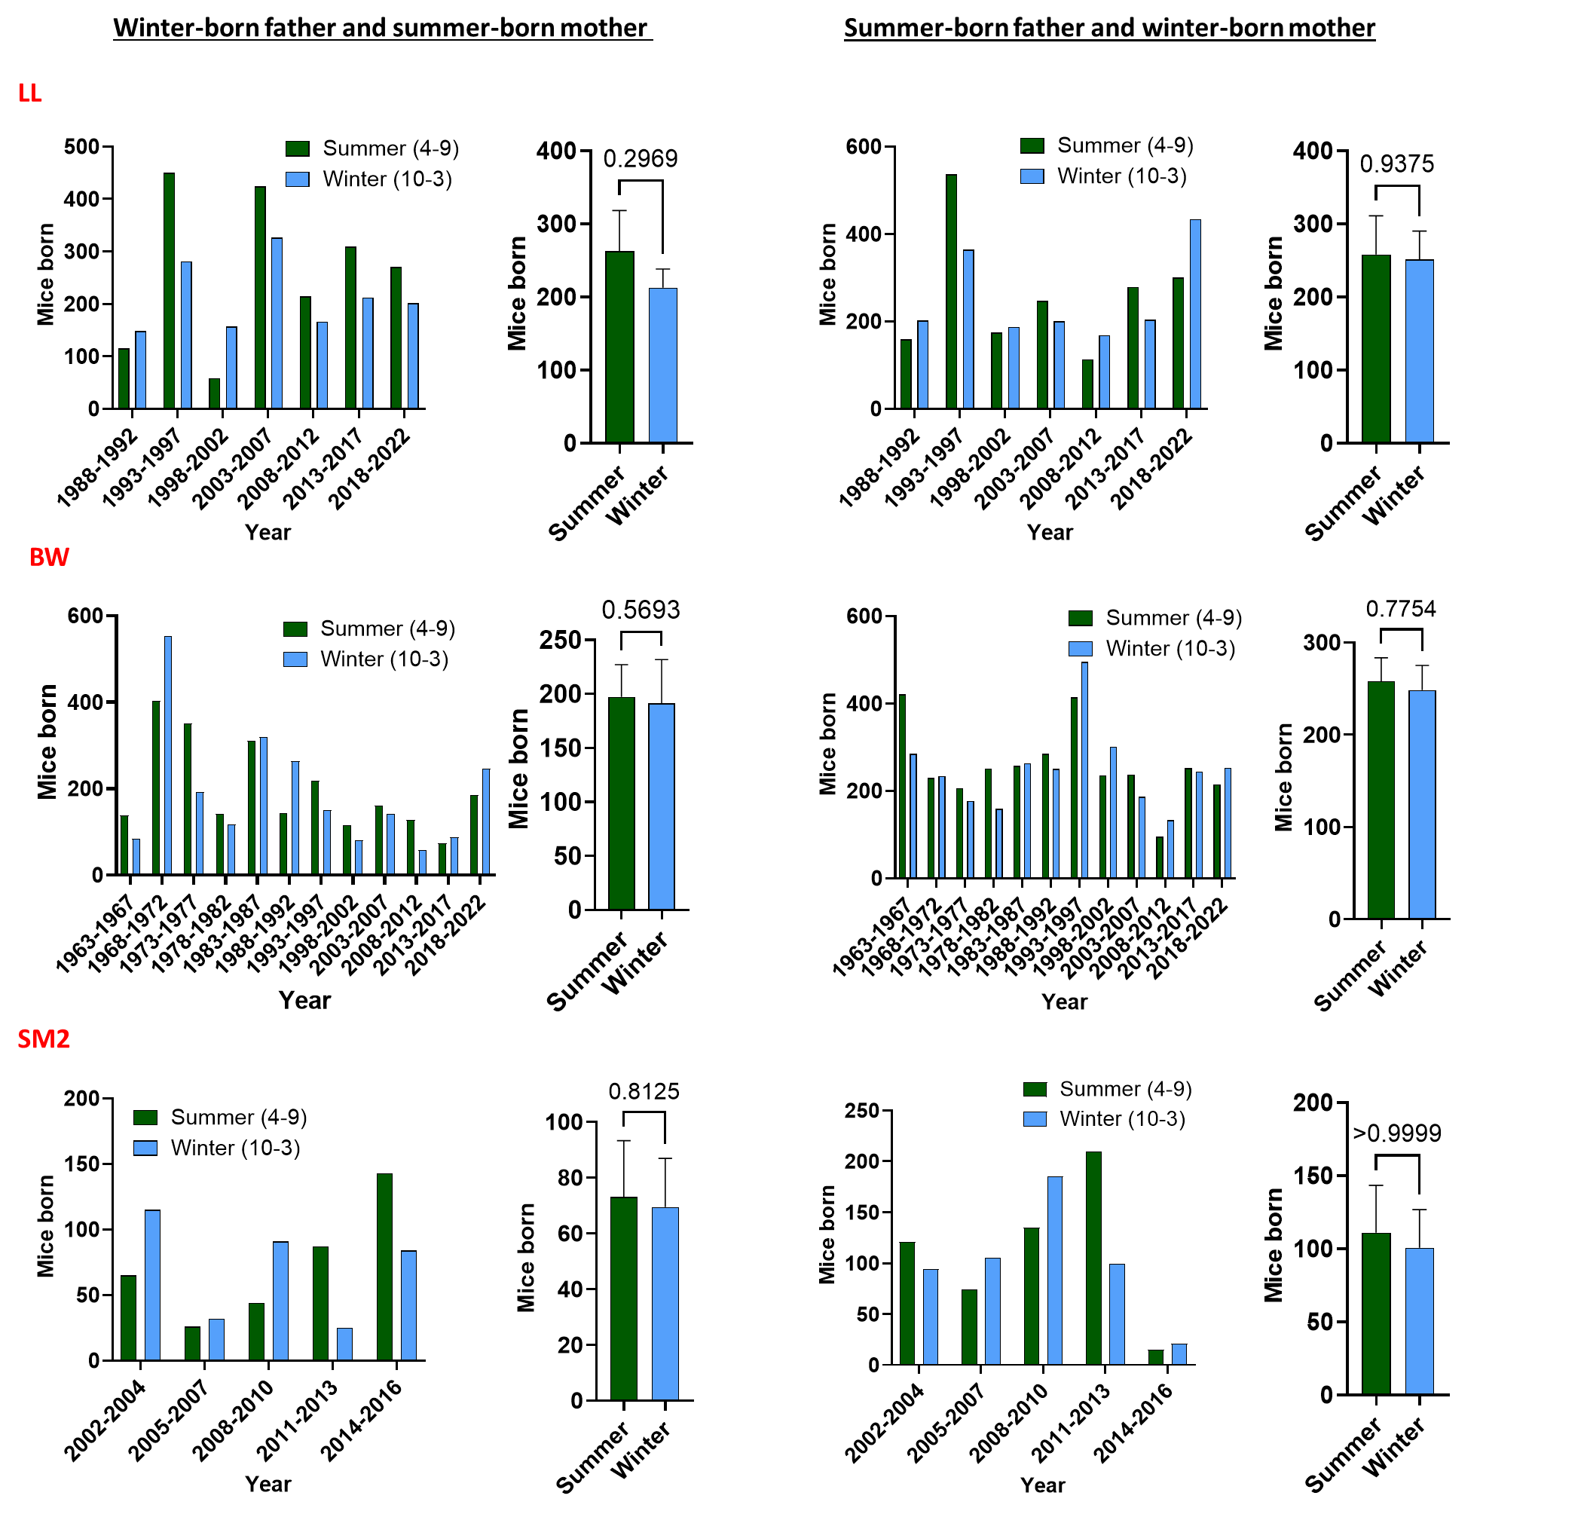
Fig. S4. Offspring produced in the winter or summer by winter-born father and summer-born mother (left) or summer-born father and winter-born mother (right) respectively for the polygamous P. leucopus (LL), P. maniculatus bardii (BW), and the high-altitude stock P. maniculatus sonoriensis (SM2). Within each panel, both numbers of mice produced during the indicated time periods (left) and aggregate number of mice (right) is shown. Results were analyzed by Wilcoxon test and P values are indicated.

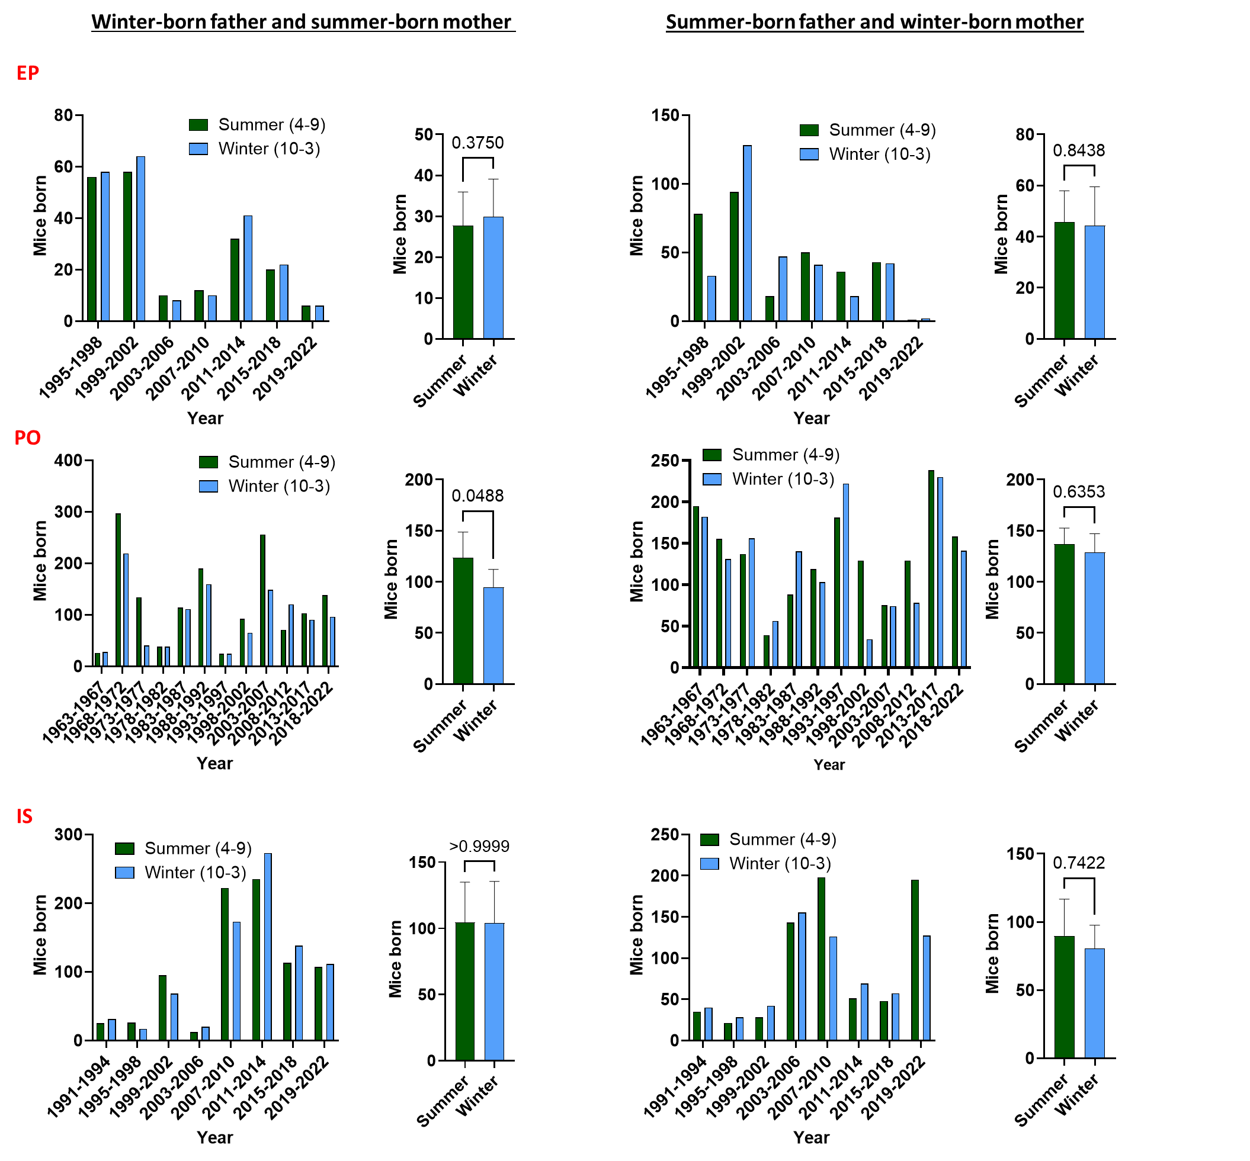
Fig. S5. Offspring produced in the winter or summer by winter-born father and summer-born mother (left) or summer-born father and winter-born mother (right) respectively for the monogamous P. eremicus (EP), P. polionotus (PO), and P. californicus (IS). Within each panel, both numbers of mice produced during the indicated time periods (left) and aggregate number of mice (right) is shown. Results were analyzed by Wilcoxon test and P values are indicated.

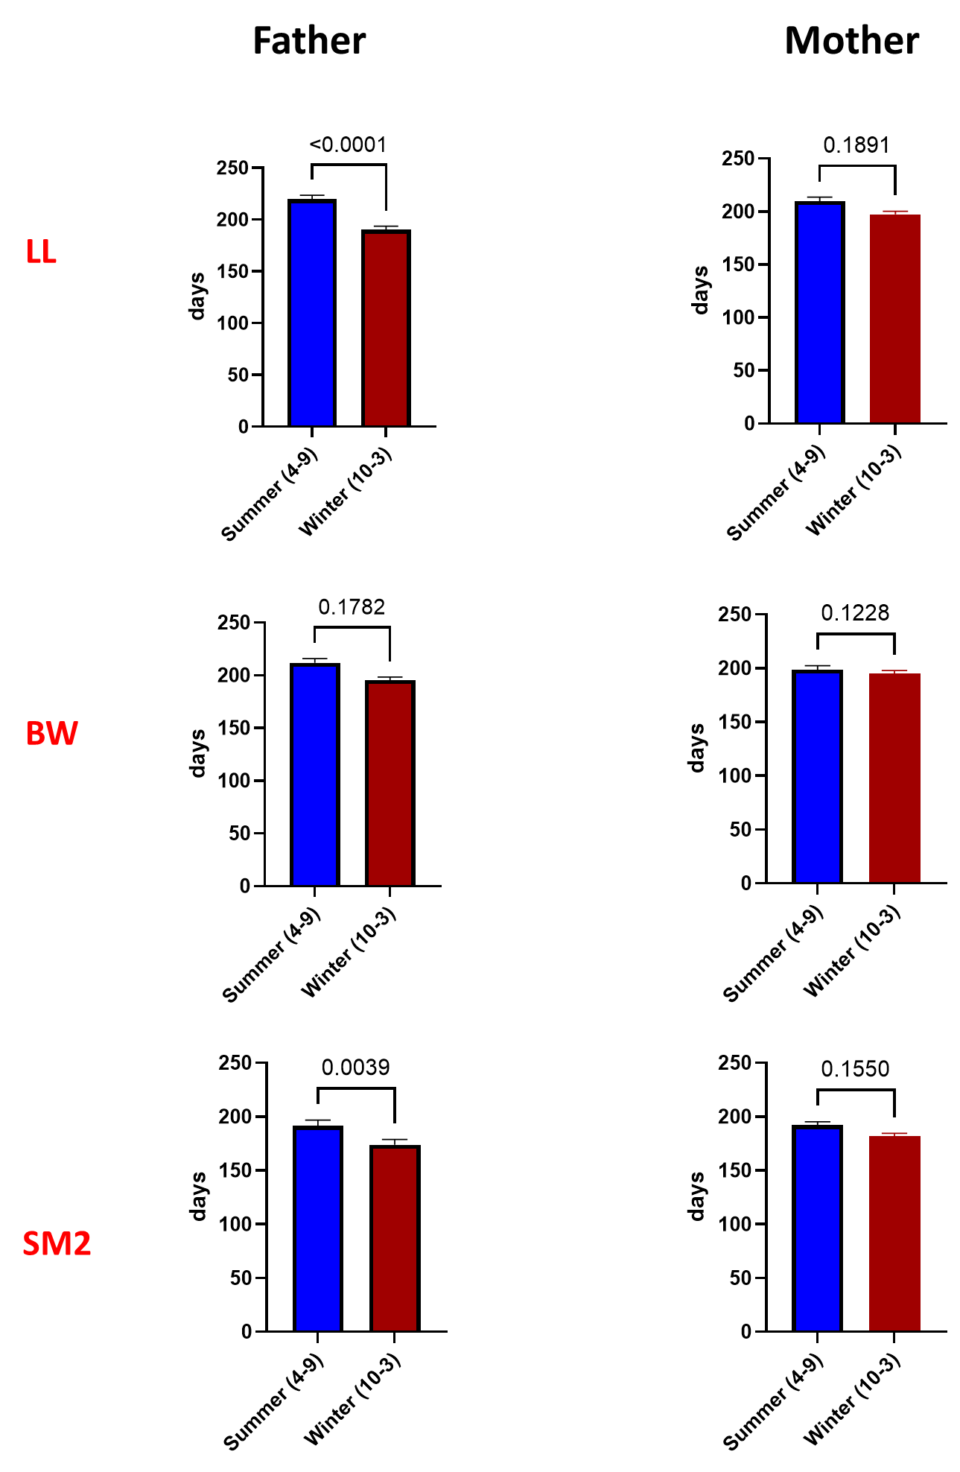
Fig. S6. Days for first litter when fathers (left) or mothers (right) were born in winter or summer, for each of the LL, BW and SM2 stocks, as indicated. Results were analyzed by Mann-Whitney test and P values are indicated.

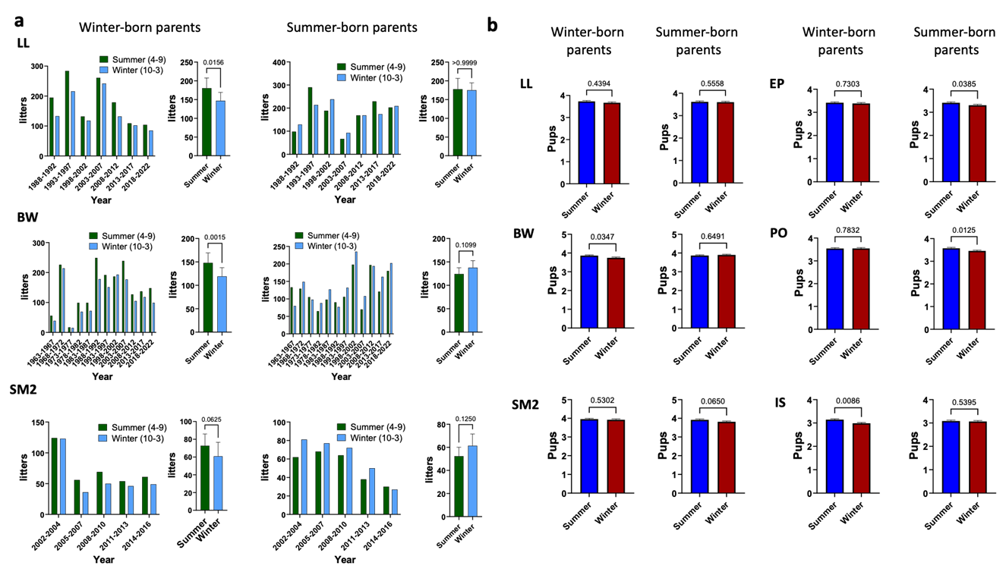
Fig. S7. Summer breeding and litter numbers. a. Number of litters in winter or summer by winter (left) or summer-born (right) parents for the polygamous P. leucopus (LL), P. maniculatus bairdii (BW), and the high-altitude stock P. maniculatus sonoriensis (SM2). Within each panel, both birth events that occurred during the indicated time periods (left) and aggregate birth events (right) is shown. Results were analyzed by Wilcoxon test and P values are indicated. Error bars indicate SE. b. Litter size for different Peromyscus stocks born in winter or summer, by winter –born or summer-born parents, as indicated. Results were analyzed by Mann-Whitney test and P values are indicated. Error bars indicate SE.

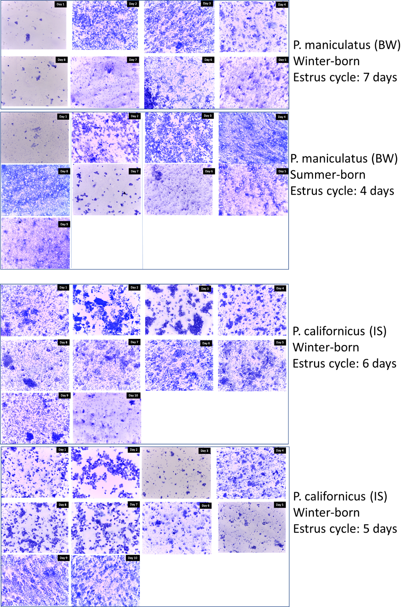
Fig. S8. Deer mouse vaginal cytology for assessment of estrus cycle duration. Species and birth season are indicated.

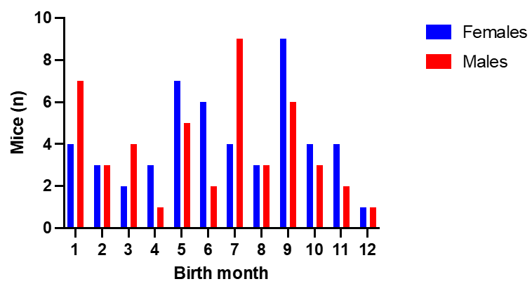
Fig. S9. Distribution of mice (n=96) used for the methylation analysis in relation to their birth month. Males and females are indicated.

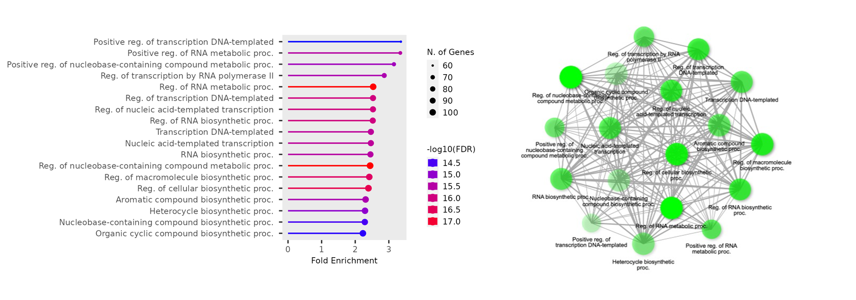
Fig. S10. CpGs following circannual rhythm in methylation in Peromyscus. Biological function prediction for CpGs exhibiting circannual methylation (sorted by FDR). Bar graphs are shown in top and biological function networks in the bottom.

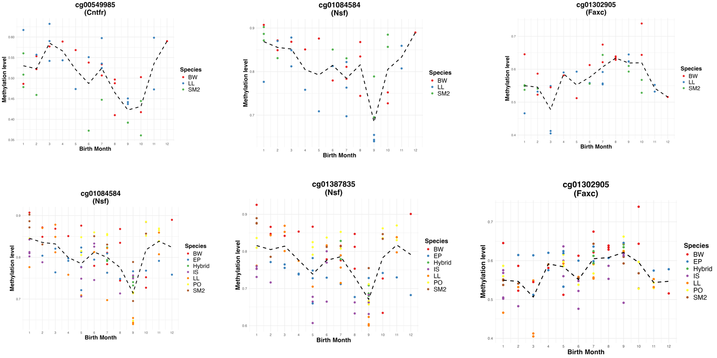
Fig. S11. Circannual methylation in representative CpGs in polygamous (top) or both polygamous and monogamous (bottom) Peromyscus stocks. Stock name is indicated in the right.

Fig. S12. Position of CpGs that are differentially methylated in a season-specific manner in polygamous and monogamous Peromyscus.
