Additional file
Deep Learning-Based Dipeptidyl Peptidase IV Inhibitor Screening, Experimental Validation, and GaMD/LiGaMD Analysis
Yi He^{1,†}, Yan Zhang^{1,†}, Minghao Liu¹, Jiaying Li¹, Wannan Li^{1,*}, Weiwei Han^{1,*}
Affiliation: ¹ Key Laboratory for Molecular Enzymology and Engineering of Ministry of Education, Edmond Fischer Cell Signaling Laboratory, College of Life Sciences, Jilin University, 2699 Qianjin Street, Changchun 130012, China
* Corresponding author.
E-mail address: weiweihan@jlu.edu.cn (W. Han), liwannan@jlu.edu.cn (W. Li).
† These authors contributed equally to this work.

Additional file
Figure S1. PDB download of human DPP4 crystal structure and weight combination diagram.
Figure S2. 100 Vina molecular docking cluster diagram.
Figure S3. Kernel density estimation (KDE) plots (left) and scatter plots (right) of predicted values for active and decoy molecules using (A,B)ConPLeX , (C,D)KPGT, and (E,F)Vina.
Figure S4. Dictionary of Secondary Structure of Proteins.
Figure S5. Time-dependent distance measurements between Glu206 and Ser592 were used to monitor the conformational dynamics of the DPP4 propeller flap during GaMD simulations.
Figure S6. Representative binding conformations of four ligands at their PMF minima identified from LiGaMD simulations.

Table S1. Small molecule DPP4 screening model.

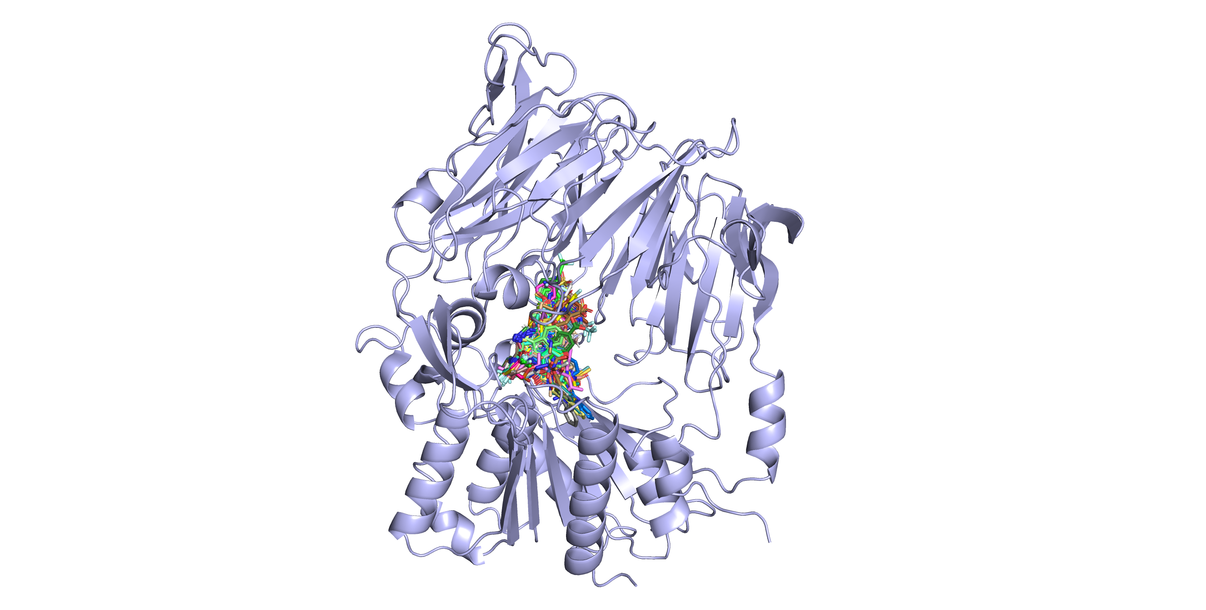
Figure S1. PDB download of human DPP4 crystal structure and weight combination diagram

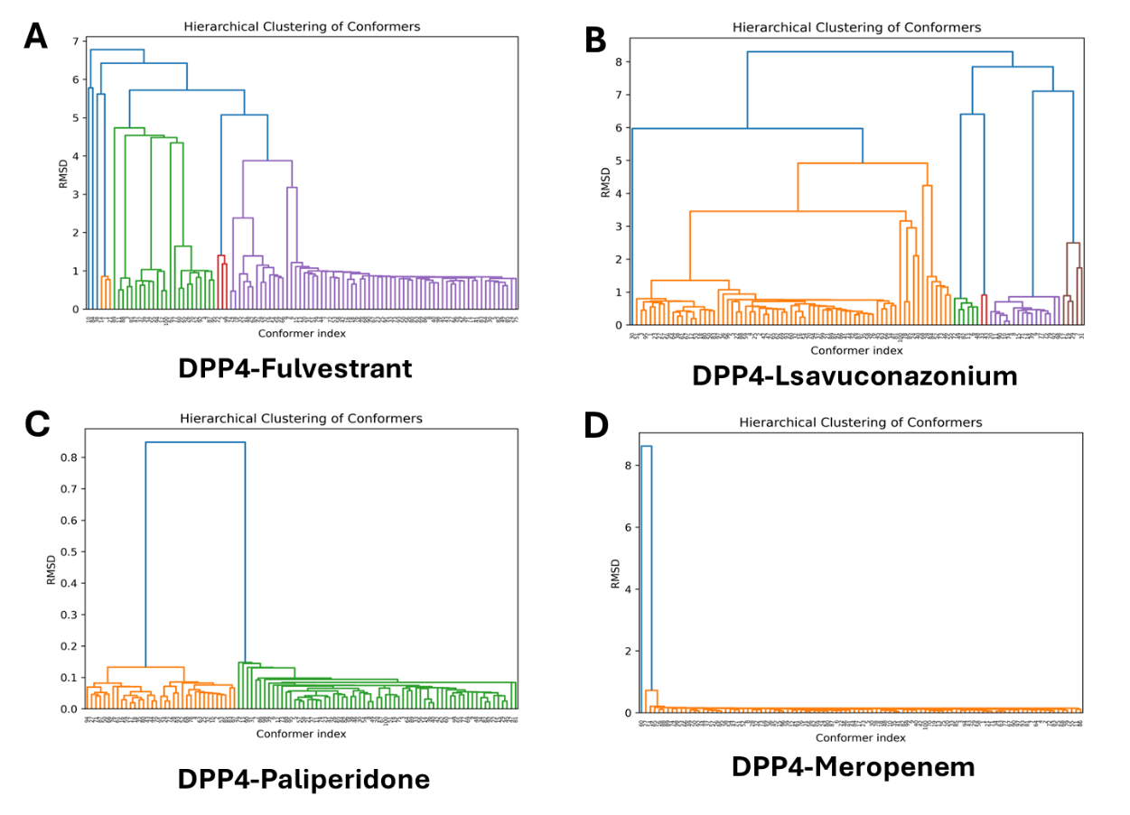
Figure S2. 100 Vina molecular docking cluster diagram

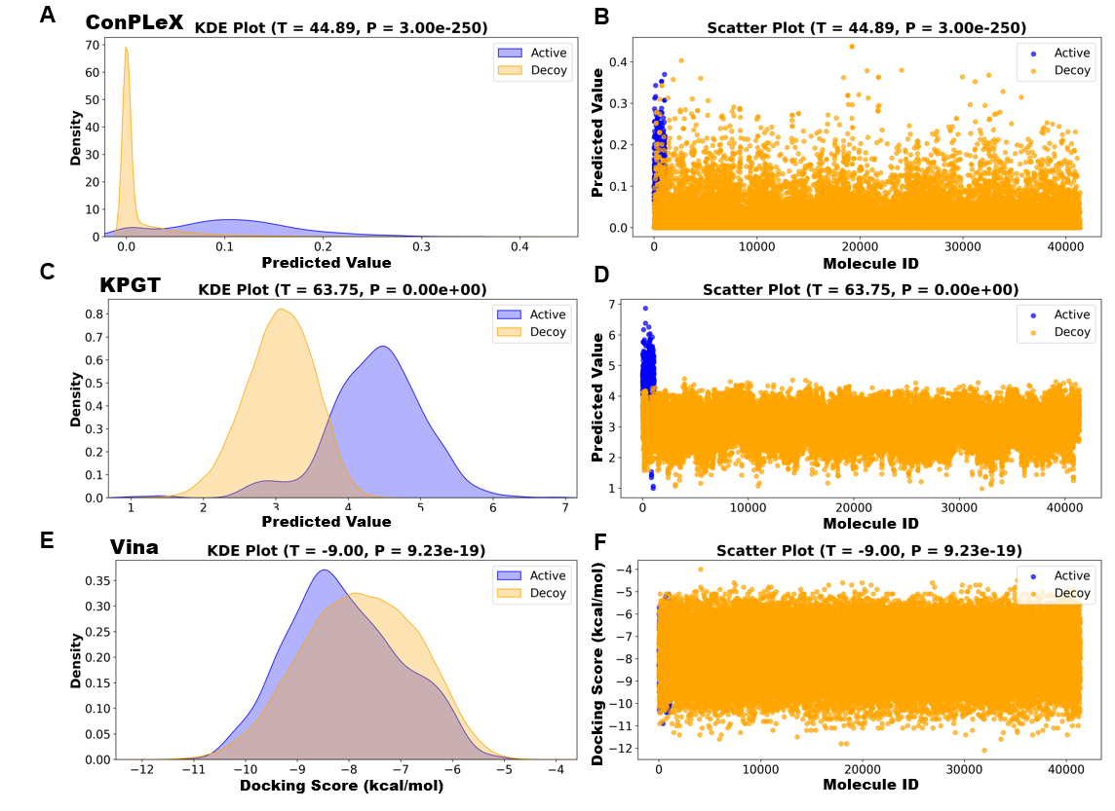
Figure S3. Kernel density estimation (KDE) plots (left) and scatter plots (right) of predicted values for active and decoy molecules using (A,B)ConPLeX , (C,D)KPGT, and (E,F)Vina.
We evaluated the ability of different models to identify decoy molecules using Kernel Density Estimation (KDE) curves and scatter plots of predicted values. As shown in Figure S3A, the predicted values for decoy molecules by the ConPLeX model are highly concentrated near zero, indicating that the model effectively identifies most decoy molecules and predicts them as inactive. In Figure S3C, the KDE curve of the KPGT model shows that the predicted pIC₅₀ values for active molecules are overall shifted to the right, significantly higher than those of decoy molecules, which aligns well with real-world expectations. As shown in Figure S3E, by contrast, AutoDock Vina, a traditional molecular docking method, exhibits relatively poor discriminative ability. The KDE curves for active and decoy molecules largely overlap, with almost no clear boundary. Of course, there is a possibility that ConPLeX was trained using active molecules from the DUDE dataset. However, KPGT was barely trained with decoy molecules, so overall, we believe that combining these three models may offer certain advantages.
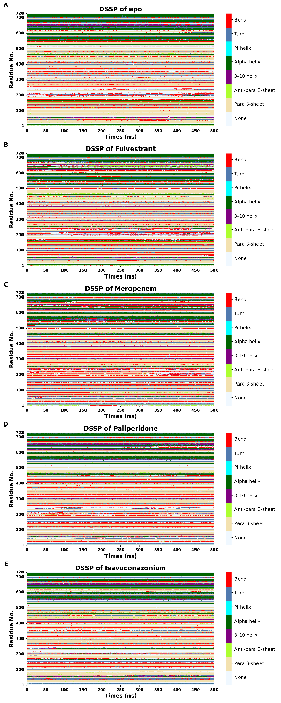
Figure S4. Dictionary of Secondary Structure of Proteins

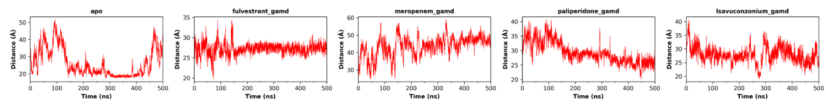
Figure S5. Time-dependent distance measurements between Glu206 and Ser592 were used to monitor the conformational dynamics of the DPP4 propeller flap during GaMD simulations.

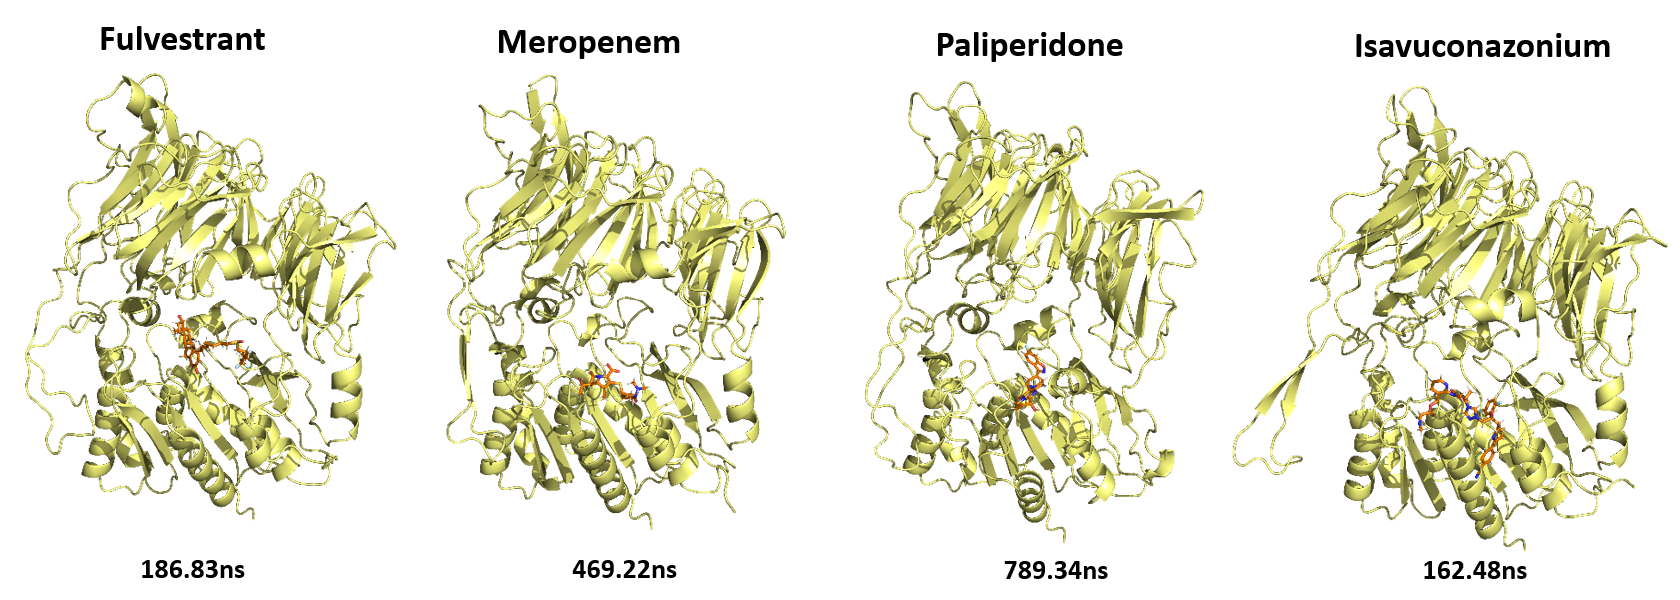
Figure S6. Representative binding conformations of four ligands at their PMF minima identified from LiGaMD simulations.
Table S1. Small molecule DPP4 screening model
Model Name | Algorithms | Input | Metrics | Reference | Date & Time
SVMDLF | SVM | MACCS structure fingerprint | TP,FN,FP,TN,SE,SP,Q | https://onlinelibrary.wiley.com/doi/10.1111/cbdd.13037 | 2017
Machine Learning Model | NB, RP | molecular properties and topological fingerprints | ACC = 0.828 MCC = 0.649 | https://link.springer.com/article/10.1007/s10822-017-0009-6 | 2017
TVBGSA_QSAR | TVBGSA | BGSA | MSEtrain=3.57,MSEtest=4.306 | https://doi.org/10.1080/1062936X.2019.1607899 | 2019
Classification Analysis_SDN | SVM,DT,NN | Dimensionally reduced fingerprint topology | Sensitivity=0.803；MCC=0.826 | https://doi.org/10.1063/5.0030748 | 2020
SVR_QSAR | SVR,RF | RDKit descriptor calculation, fingerprinting, and CDK fingerprints and molecular properties | ACC=0.922 | https://doi.org/10.1016/j.compbiolchem.2021.107597 | 2021
Particle Swarm Optimization_SVM | POS,SVM | Molecular weight, polarity, water disease, volume, buried residues, and acceptable and normalized frequencies of α-helix and β-folding | R2_train=0.79  R2_test_set=0.85 | https://doi.org/10.29207/resti.v6i6.4470 | 2022
GA_SVM_QSAR | GA,SVM | PaDEL;Descriptors such as AMR, nBondS2, and CICO | ACC=0.9869  F-1=0.9871 | https://doi.org/10.1109/ICoICT55009.2022.9914824 | 2022
DrugBAN | GCN,CNN | 2D molecular graphs representing the drug molecules and protein sequences | ACC=0.9832；auPRC=0.28 | https://doi.org/10.3390/molecules28217381 | 2023
GA_QSAR | GA | QSAR model was composed of seven key molecular property parameter | R2=0.816, MSE= 0.026 | https://doi.org/10.1080/07391102.2023.2237594 | 2023

