Supplementary information

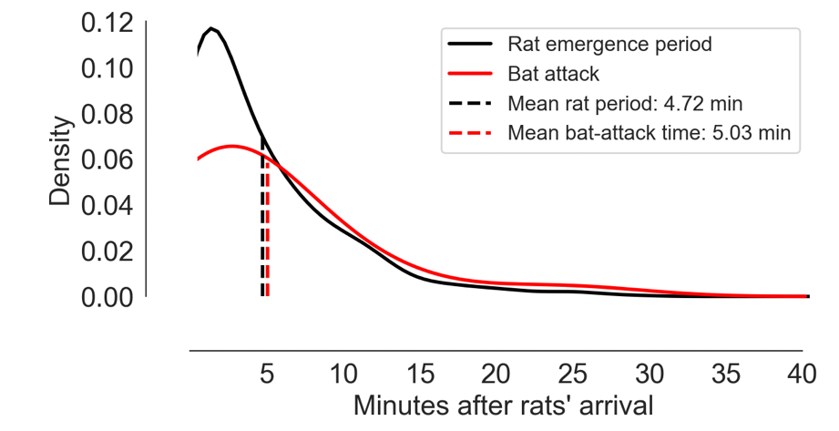
Figure S1. The distribution of 629 rat arrival periods in relation to the distribution of 31 bat attacks (also see video S4).

Supplementary tables
Supplementary table 1. Vigilance behaviors and foraging success of bats in relation to other bat presence and foraging alone with scanning/landing duration.
Behavior | Metric | Foraging alone | Bat present | P value (statistic)*
Scanning first | Probability | 27% (163/594) | 40% (104/261) | <0.001 (12.0)
Scanning first | Scanning duration (seconds) | 4.5 ($±$9.2) | 5.2 ($±$13.6) | 0.018 (7.1e4)
Foraging success | Probability | 85% (504/594) | 66% (171/261) | <0.001 (39.0)
Foraging success | Landing duration (seconds) ** | 9.9 ($±$ 11.7) | 11.9 ($±$25.6) | 0.715 (4.2e5)
* P values and their statistics (in parentheses) from χ² test for the rate/probability, and Mann Whitney U test for the durations.

** Only for successful foraging events.

Supplementary table 2. Summary of the best logistic regression model for the probability of acquiring food on the platform when a rat was present (with 'month' treated as a categorical variable)
Predictor | Estimate | SE | t-Statistic | p-Value
Intercept | -0.513 | 0.430 | -1.192 | 0.233
Bat landing duration (seconds) | 0.044 | 0.008 | 5.823 | <0.001
Minutes after rat arrival | -0.058 | 0.018 | -3.172 | 0.002
Month (Jan) | -0.362 | 0.546 | -0.664 | 0.507
Month (Feb) | -1.265 | 0.471 | -2.687 | 0.007
Month (Mar) | 0.126 | 0.568 | 0.223 | 0.824
Month (Apr) | 0.352 | 0.411 | 0.857 | 0.391
Month (May) | -0.112 | 0.425 | -0.264 | 0.792
Hours after sunset | 0.092 | 0.030 | 3.105 | 0.002

