Additional file 2 for

Temporal changes in amino acid profiles coordinate mosquito physiology and egg maturation in Aedes aegypti

Yusuke Kato, Ayano Oi, Naoshi Dohmae, Fumiaki Obata *, and Chisako Sakuma *

*Joint corresponding authors: Fumiaki Obata and Chisako Sakuma
Email: Fumiaki Obata: fumiaki.obata@riken.jp; Chisako Sakuma: chisako.sakuma@riken.jp

This PDF file includes:

Figures S1 – S6

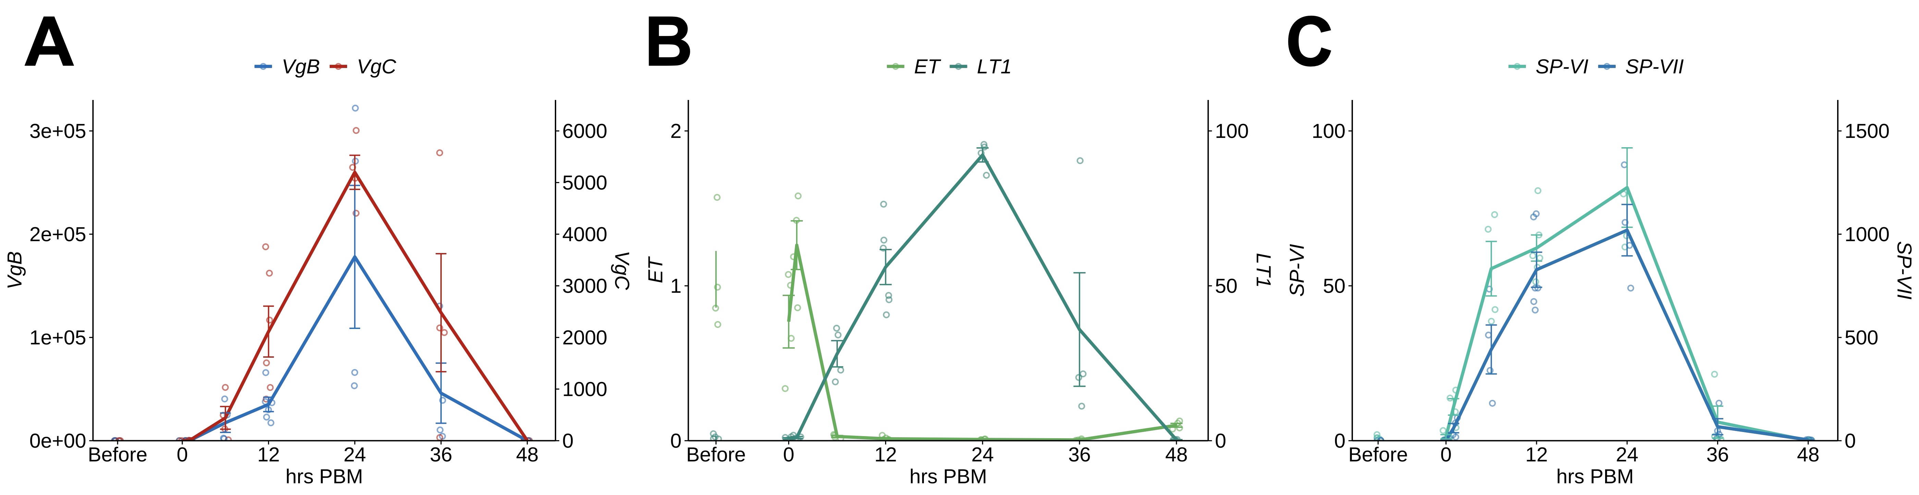
Fig. S1. Time-course expression of vitellogenin genes and major peptidases.
Whole-body RNA expression profiles of genes involved in egg maturation after blood feeding, normalized to pre-blood meal levels (mean ± SEM, n = 4–6): (A) vitellogenin family genes (VgB, VgC) induced after blood ingestion; (B) trypsins (ET: Early trypsin; LT1: Late trypsin-1),; (C) serine endopeptidases (SP-VI: Serine endopeptidase-VI; SP-VII: Serine endopeptidase-VII).

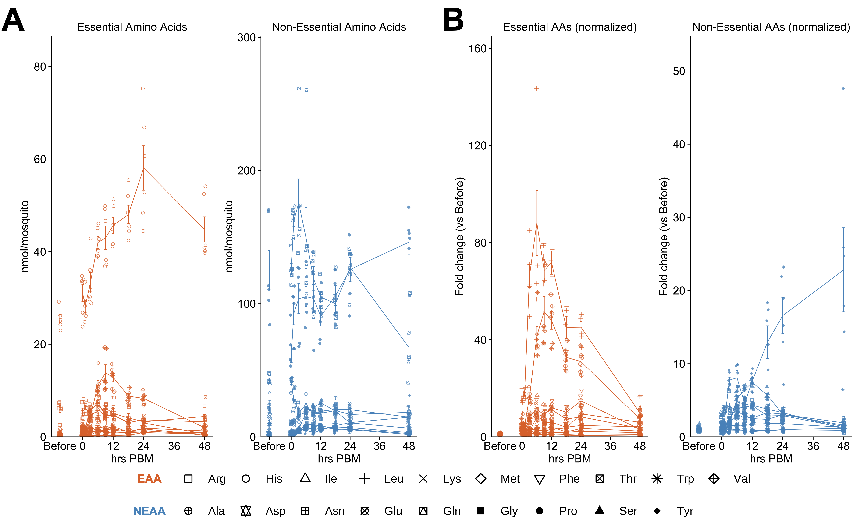

Fig. S2. Temporal concentration profiles of free non-essential amino acids in mosquitoes.
Temporal profiles of free amino acids shown as (A) absolute concentrations and (B) relative values normalized to pre-blood meal levels. Bars represent mean ± SEM at each time point (n = 6).

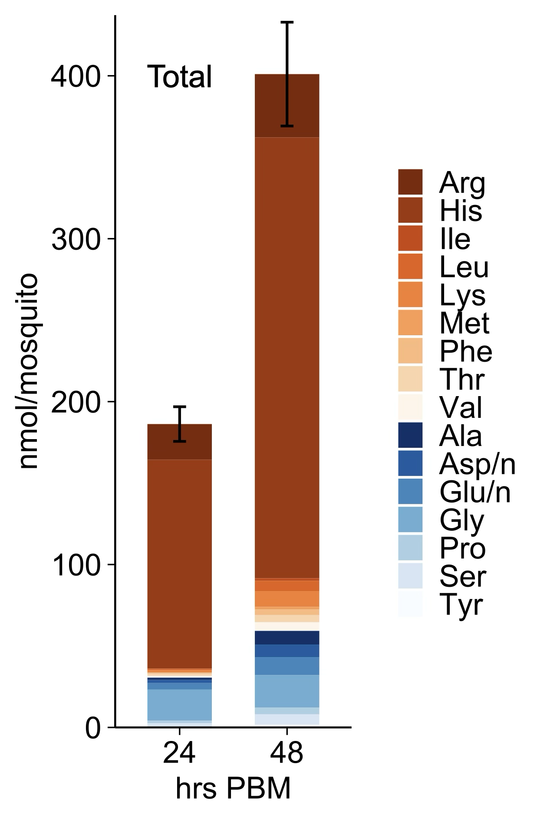

Fig. S3. Time-course changes in the stacked amounts of total amino acids in excreta.
Stacked bar plots show the amounts of individual total amino acids (protein-bound + free), with each amino acid represented by a different color. Bars show the mean ± SEM at each time point (n = 4).

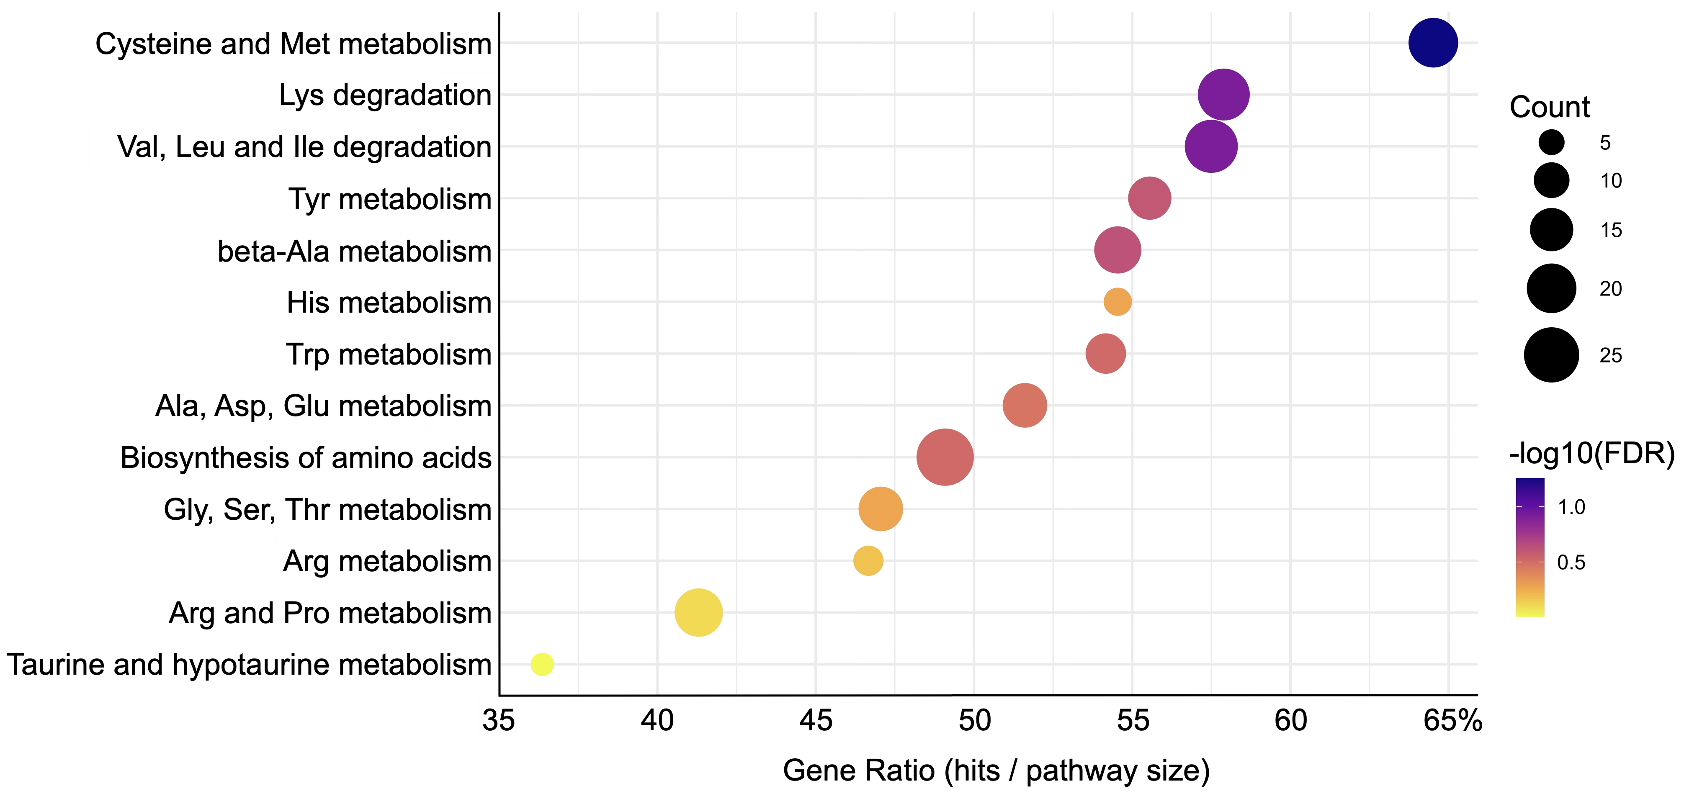

Fig. S4. KEGG enrichment of amino acid metabolic pathways.
Differentially expressed genes (FDR < 0.05) were mapped to KEGG pathways, and enrichment analysis was restricted to amino acid–related pathways for visualization. The dot plot displays the top enriched pathways ranked by gene ratio. The x-axis represents the gene ratio (hits/pathway size), dot size indicates the number of enriched genes, and dot color reflects statistical significance (−log10[FDR]).

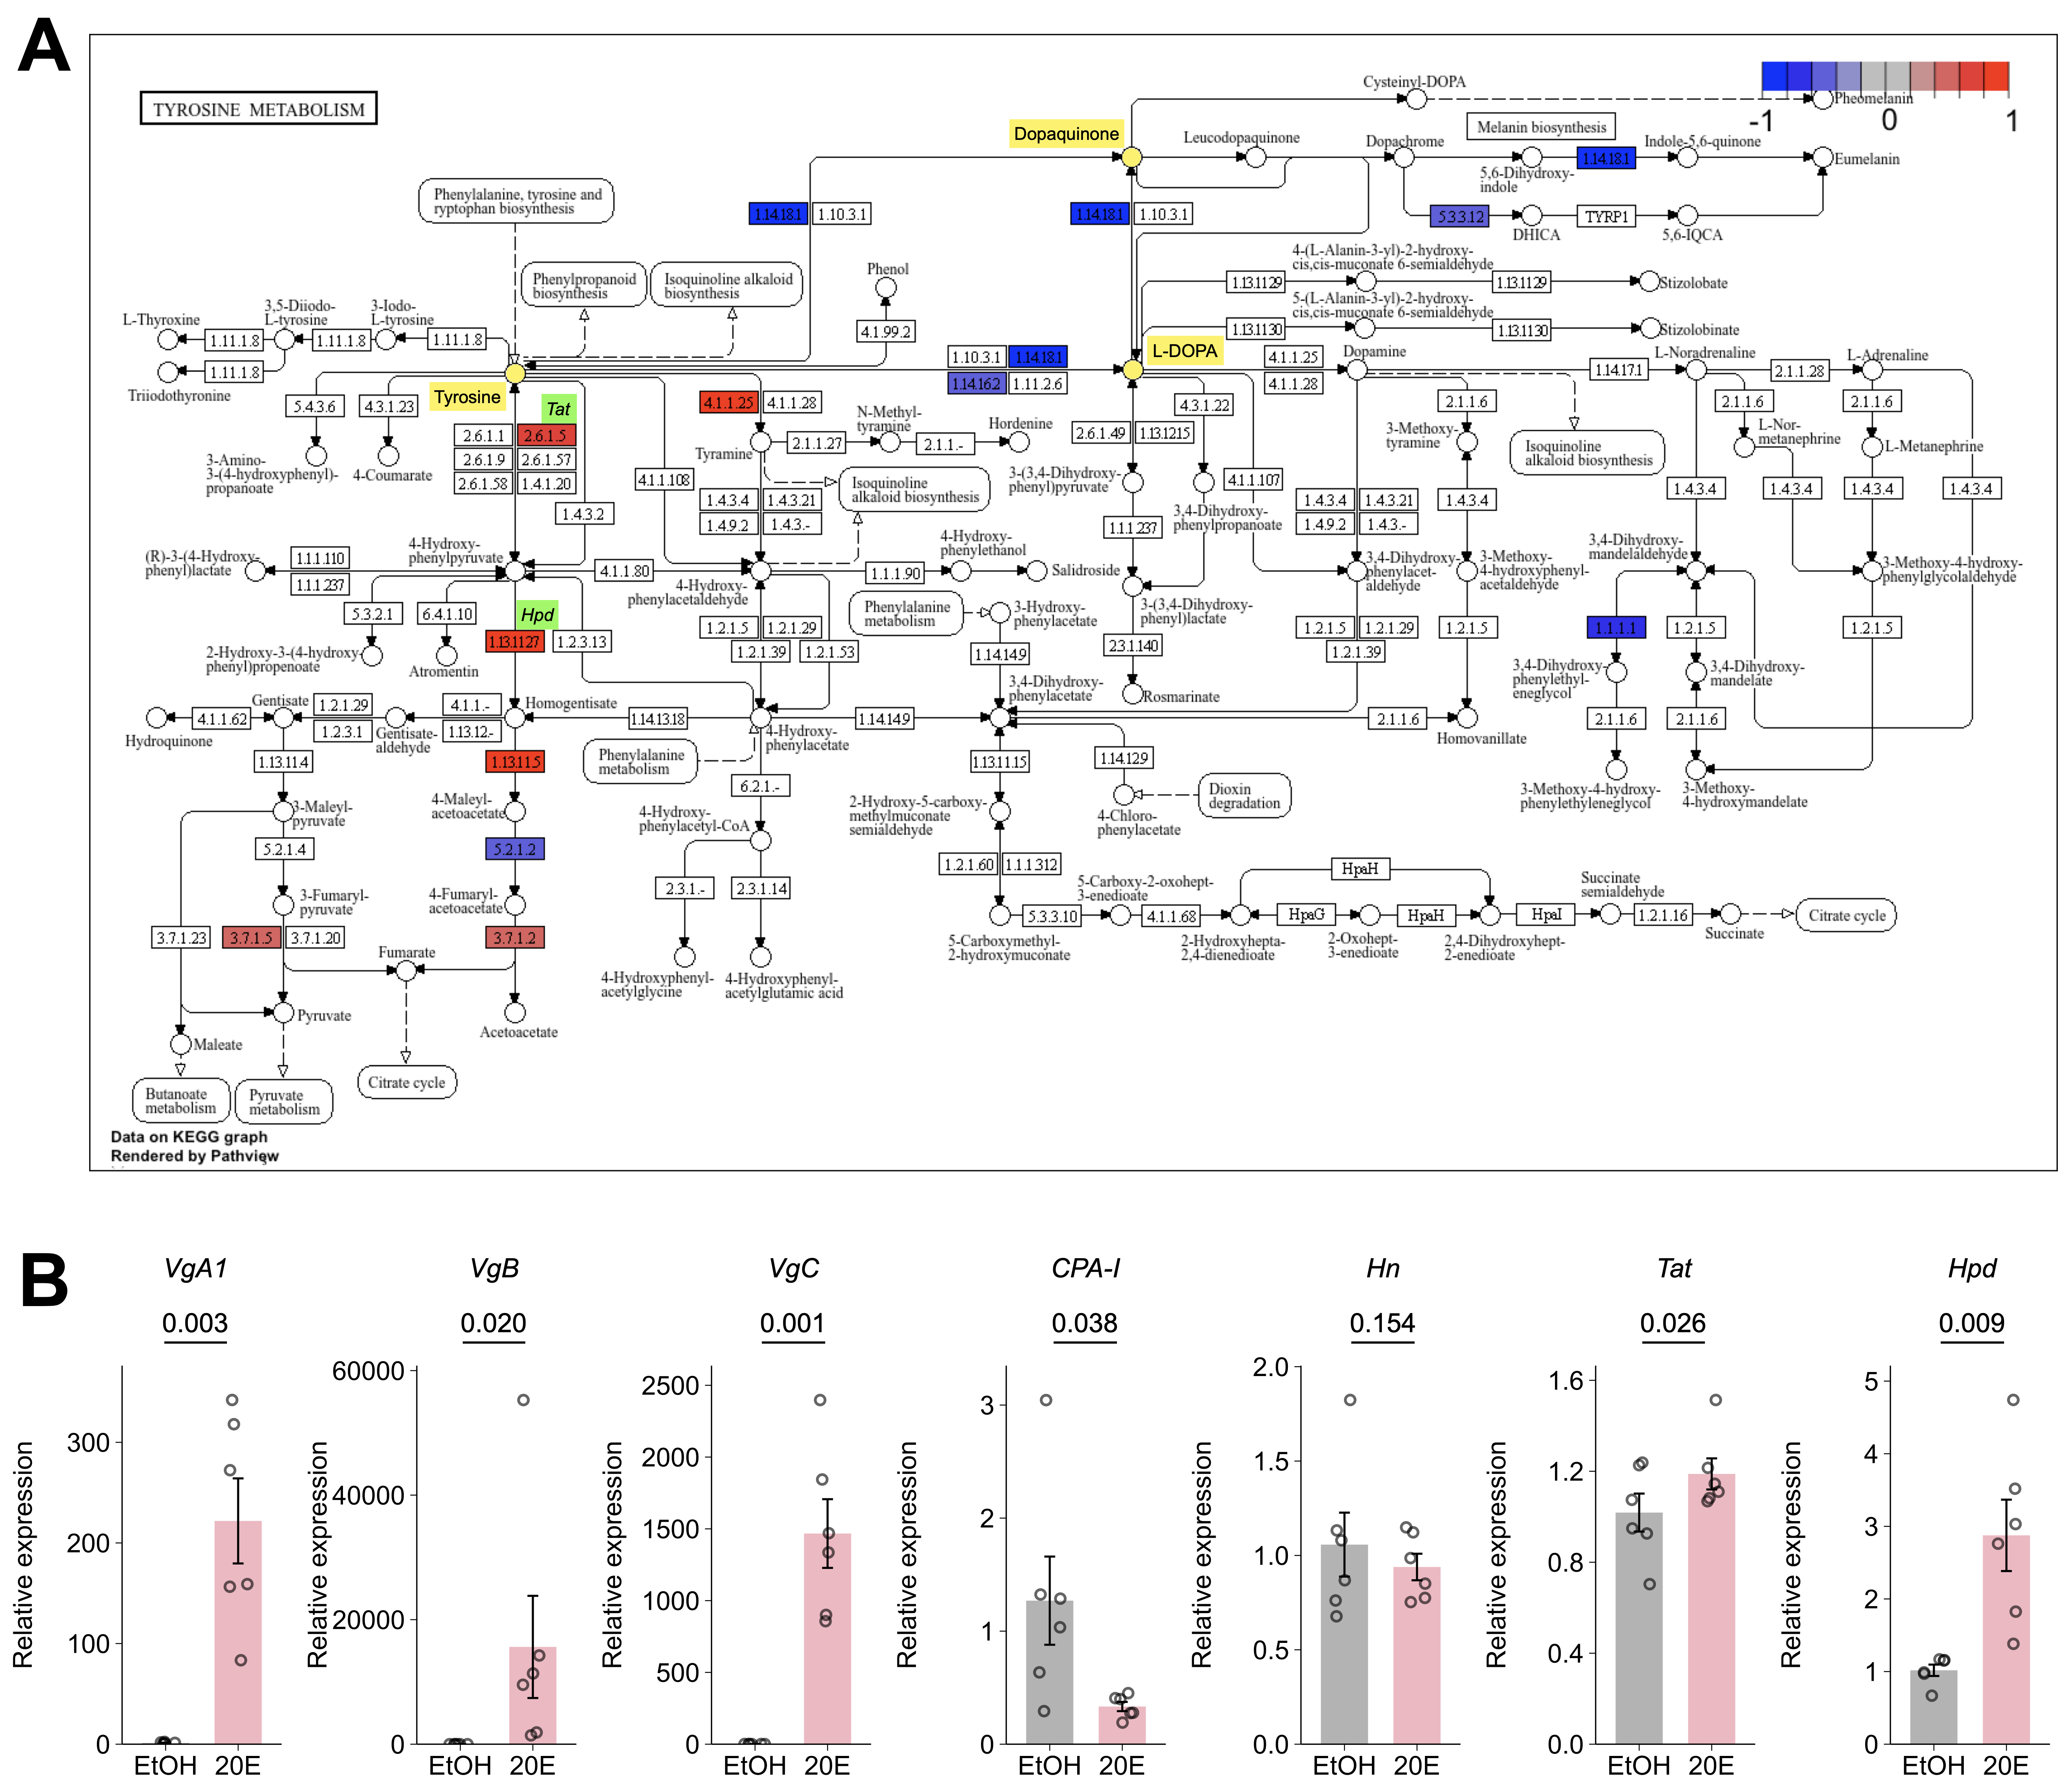

Fig. S5. Gene expression analysis after 20E injection.
(A) RNA-seq analysis of tyrosine-centered metabolic pathways. KEGG pathway diagrams were generated with pathview, with differentially expressed genes (DEGs) mapped onto the pathway. Node colors indicate shrunken log₂ fold changes (20E vs. vehicle; DESeq2): red = up-regulated, blue = down-regulated, following the default pathview color scale (±1 range). (B) qPCR analysis of Vg family genes (VgA1, VgB, VgC), CPA-I and tyrosine metabolism-related genes (Hn, Tat, Hpd) at 6 hours after 20E injection. Statistical analysis: Welch’s t-tests. All bars represent mean ± SEM.

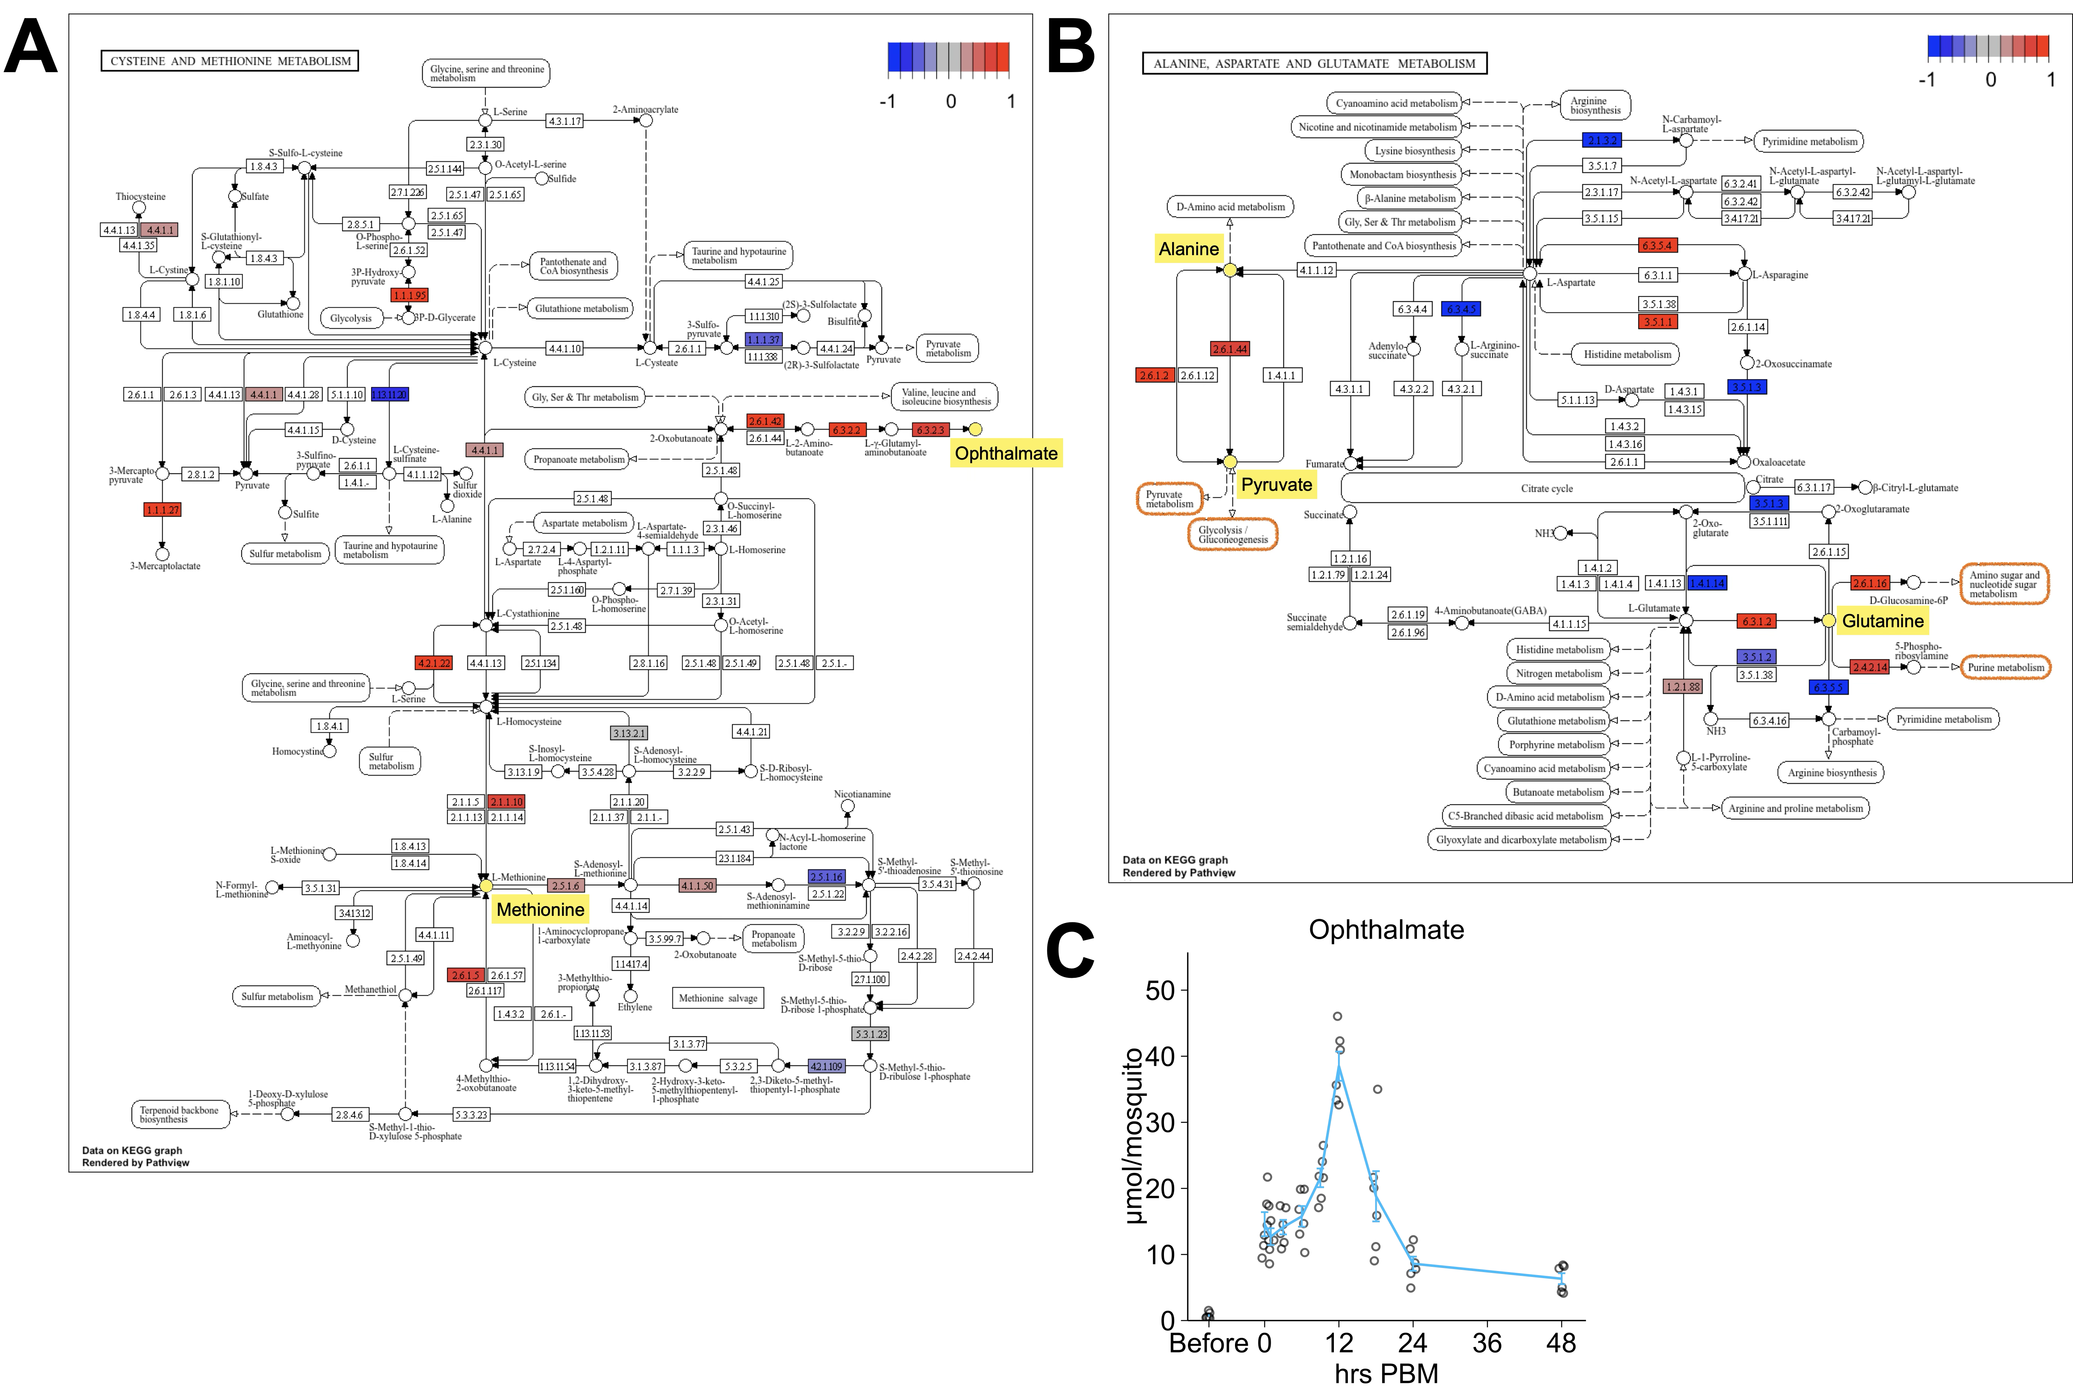

Fig. S6. Expression changes in metabolic pathways centered on specific amino acids.
(A) cysteine and methionine, (B) alanine, aspartate, and glutamate. (C) Temporal profiles of ophthalmate concentrations shown as absolute values. Bars represent mean ± SEM at each time point (n = 6).

