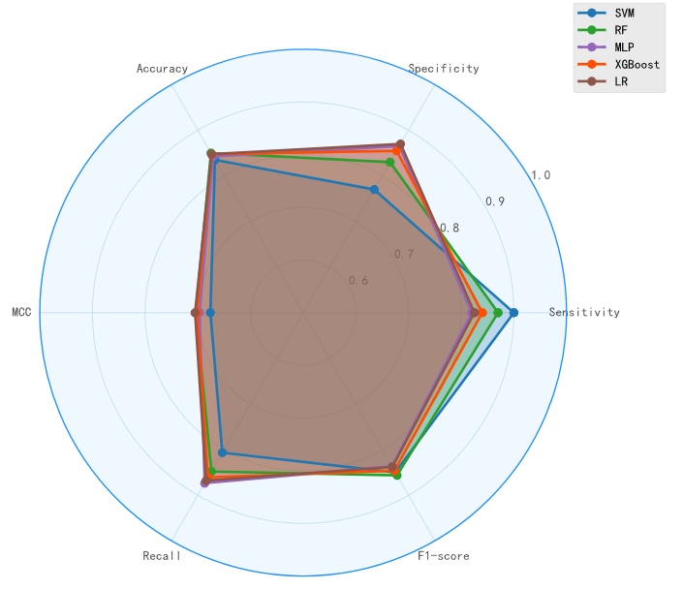

Fig. S1 The performance of five different machine learning algorithms using the ESM-derived features (Additional file 1: Table S10). From these results, the differences in predictive performance among these models were relatively minor.
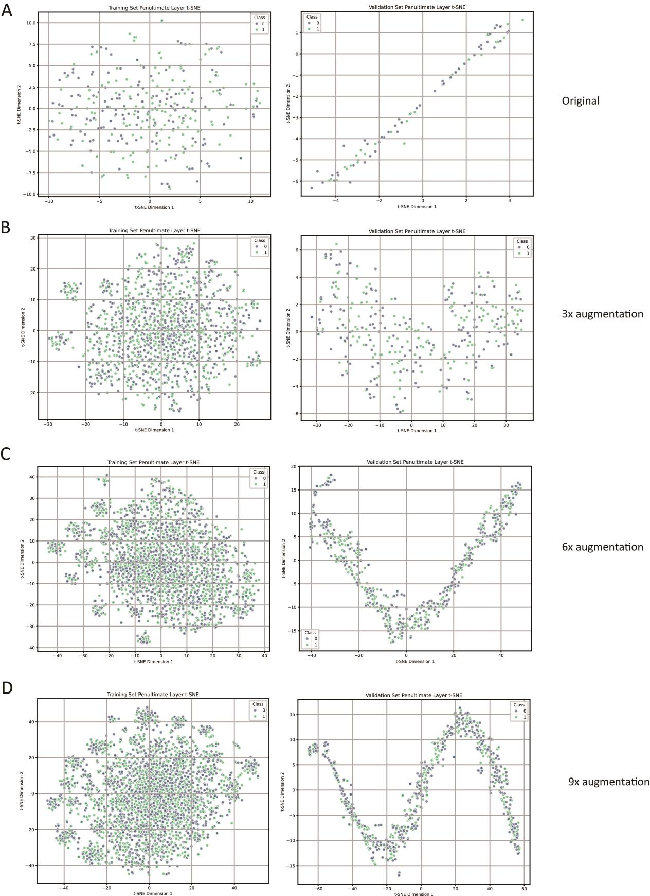
Fig. S2 The latent distribution of the data during deep learning modeling from different magnitudes of data augmentation.

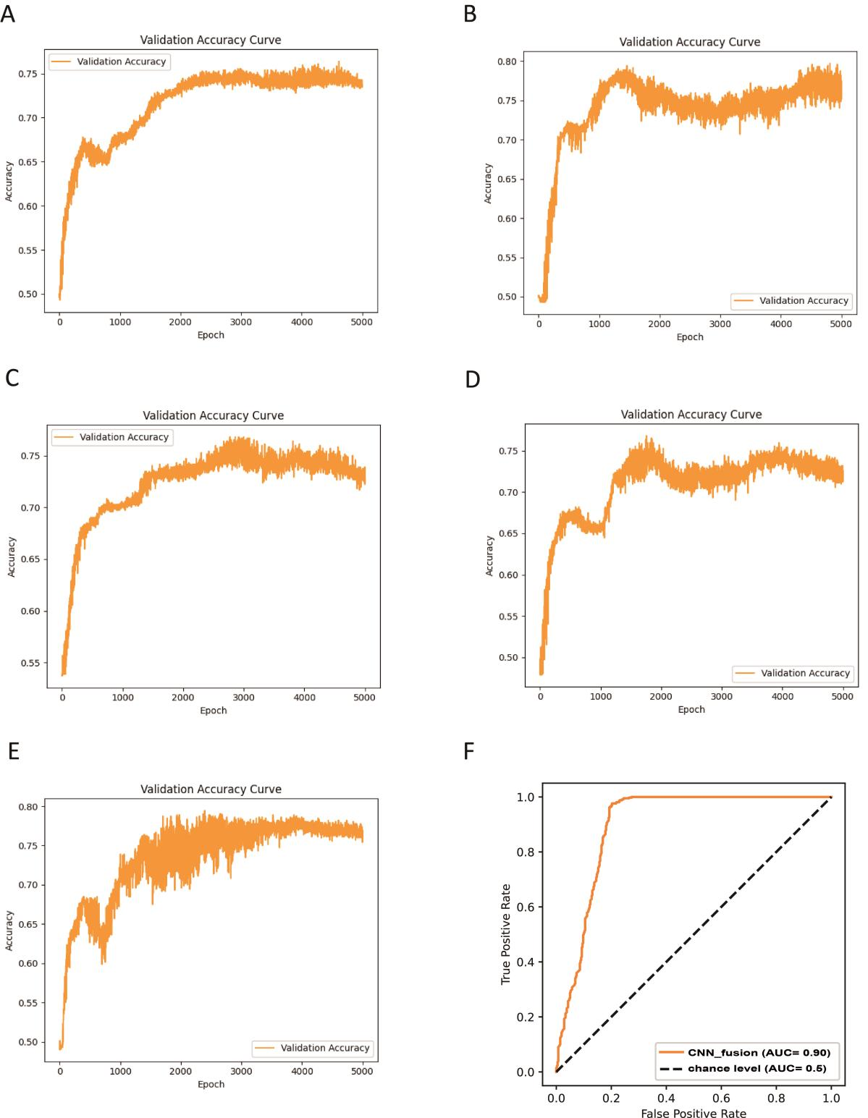
Fig. S3 Construction of deep learning models based on data augmentation and alternative embedding strategy by integrating features derived from DDE, AAC_TPC, CKSAAP (k = 2), and CTriad (k = 4). (A-E) These subplots A-E show the validation accuracy across training epochs for each fold during cross-validation. The accuracy tends to stabilize after approximately 2000 epochs, ultimately converging to a validation accuracy above 75% in all folds. (F) The overall receiver operating characteristic (ROC) curve, which evaluates the model’s classification performance across various thresholds. The area under the curve (AUC) is 0.90, indicating excellent overall discriminative ability of the model.

