Original picture of Fig. 3B and 3C
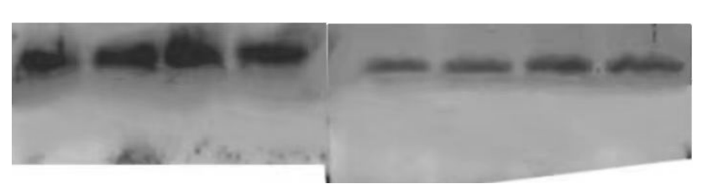
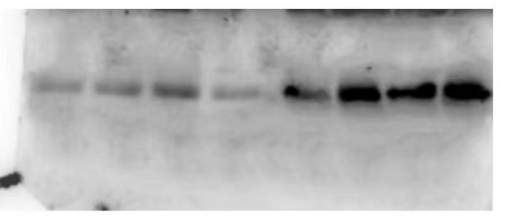

Original picture of Fig. 6C
IP
TaARL2
TaPAL
HC

WCL

IB: HA

IB: HA-TaFBK34

IB: FLAG
FLAG-TaARL2
FLAG-TaSkp1
FLAG-TaPAL
FLAG-TaGFP

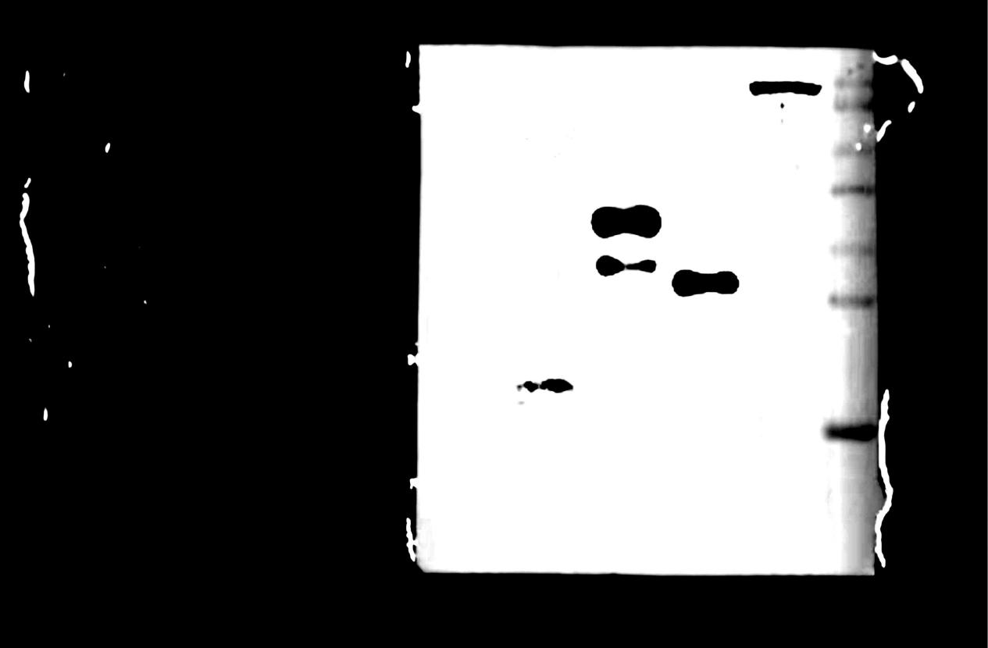
FLAG-TaNADH

Original picture of Fig. 8 A and B
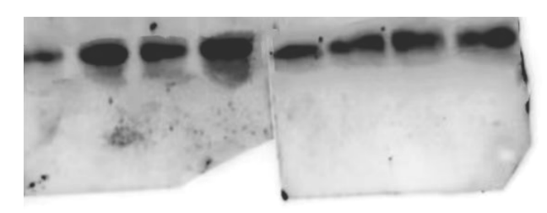

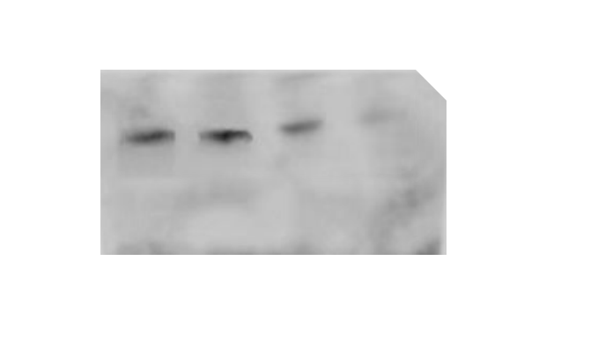

Original picture of Additional file 2 Fig. S2

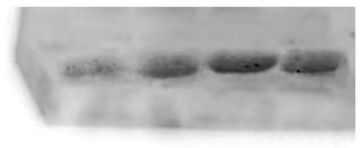

Original picture of Additional file 2 Fig. S3

