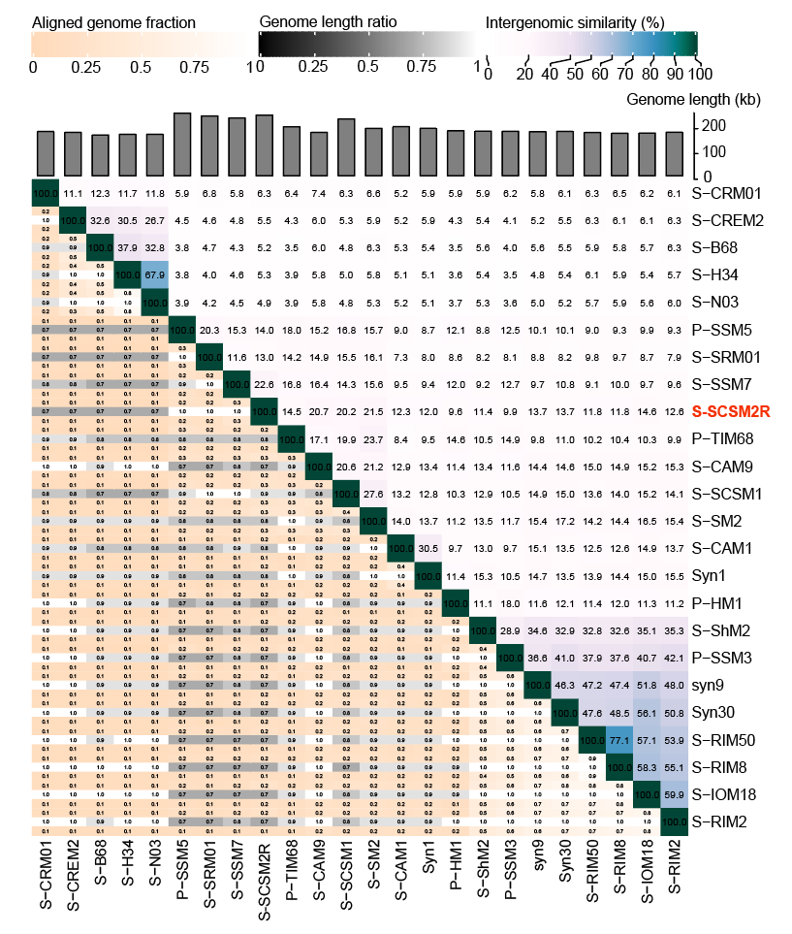Fig. S1. Intergenomic similarities among S-SCSM2R and 24 T4-like cyanophages calculated by VIRIDIC.

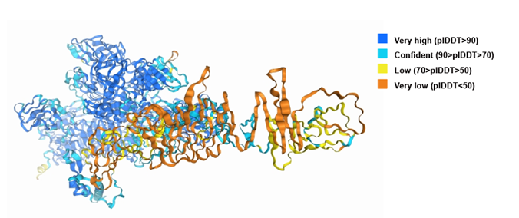
Fig.S2. Predicted structure of the putative receptor-binding protein of cyanophage S-SCSM2R. Different colored regions represent varying levels of model confidence. Deep blue regions indicate very high confidence (plDT >90), meaning that the structural predictions in these areas are very reliable. Light blue regions indicate high confidence (70< plDDT ≤90), yellow regions indicate medium confidence (50< plDDT ≤70), and orange regions indicate low confidence (plDDT ≤50).
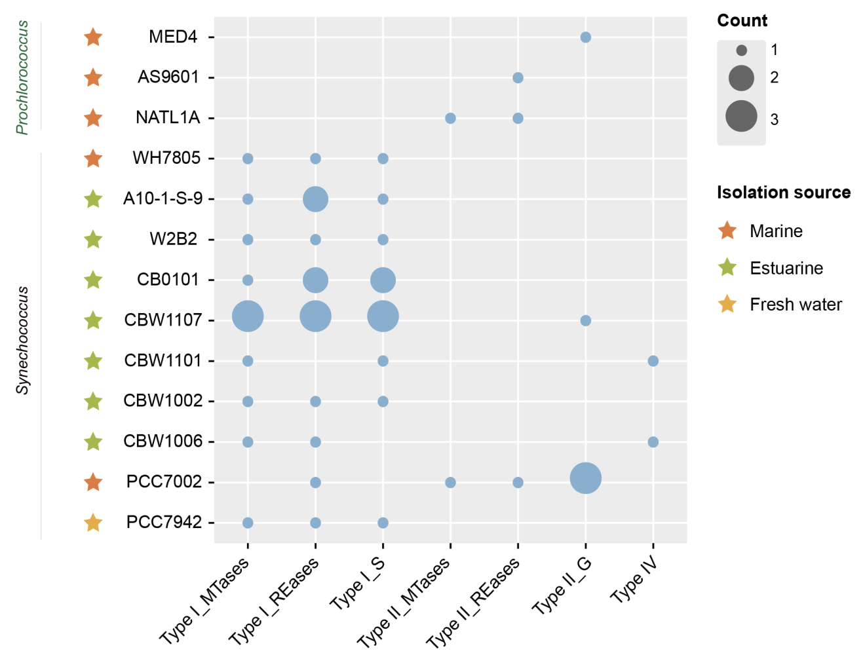
Fig. S3. Distribution of R-M systems in the host cyanobacteria.

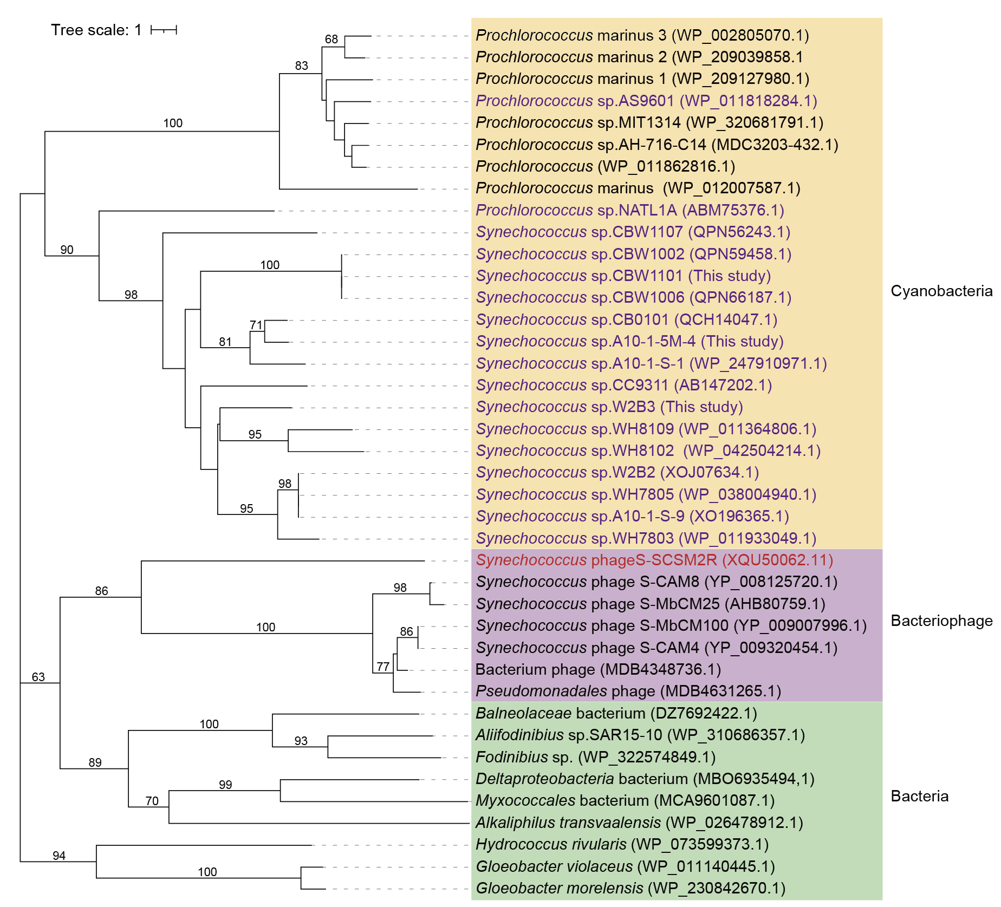
Fig. S4. Phylogenetic tree constructed based on the amino acid sequences of the S-SCSM2R purS homolog genes. Bootstrap values were calculated based on 100 replicates and are only shown at nodes >50%. Phage S-SCSM2R is labeled in red; the host picocyanobacteria strains in this study were labeled in purple. A homolog search of the S-SCSM2R purS genes in the NR database provided amino acid sequences for the construction of a phylogenetic tree.

