Additional file 2
The Gentiana rigescens genome and transcriptome for the investigation of flower repetitive blooming
Yang et al.

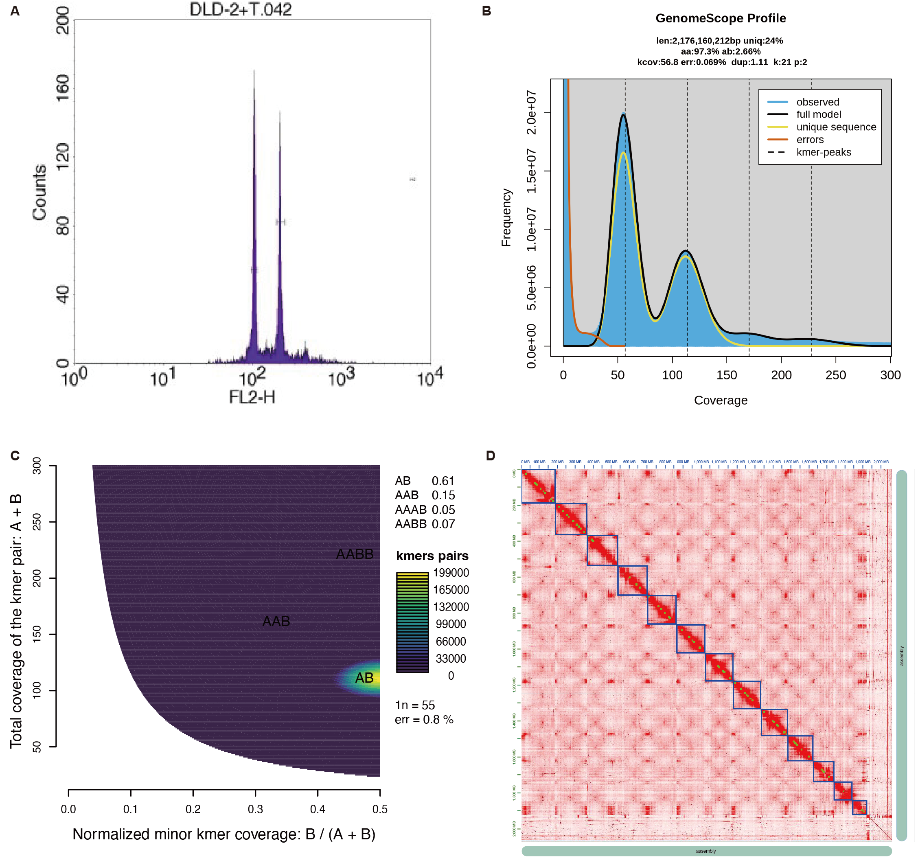
Fig. S1 Determination of genome size of G. rigescens by flow cytometry and Hi-C interactome.
A: The flow cytometry of G. rigescens. B: Estimated genome size of G. rigescens using 21-mer analysis. C: Ploidy prediction of G. rigescens. D: The Hi-C interactome map of G. rigescens.

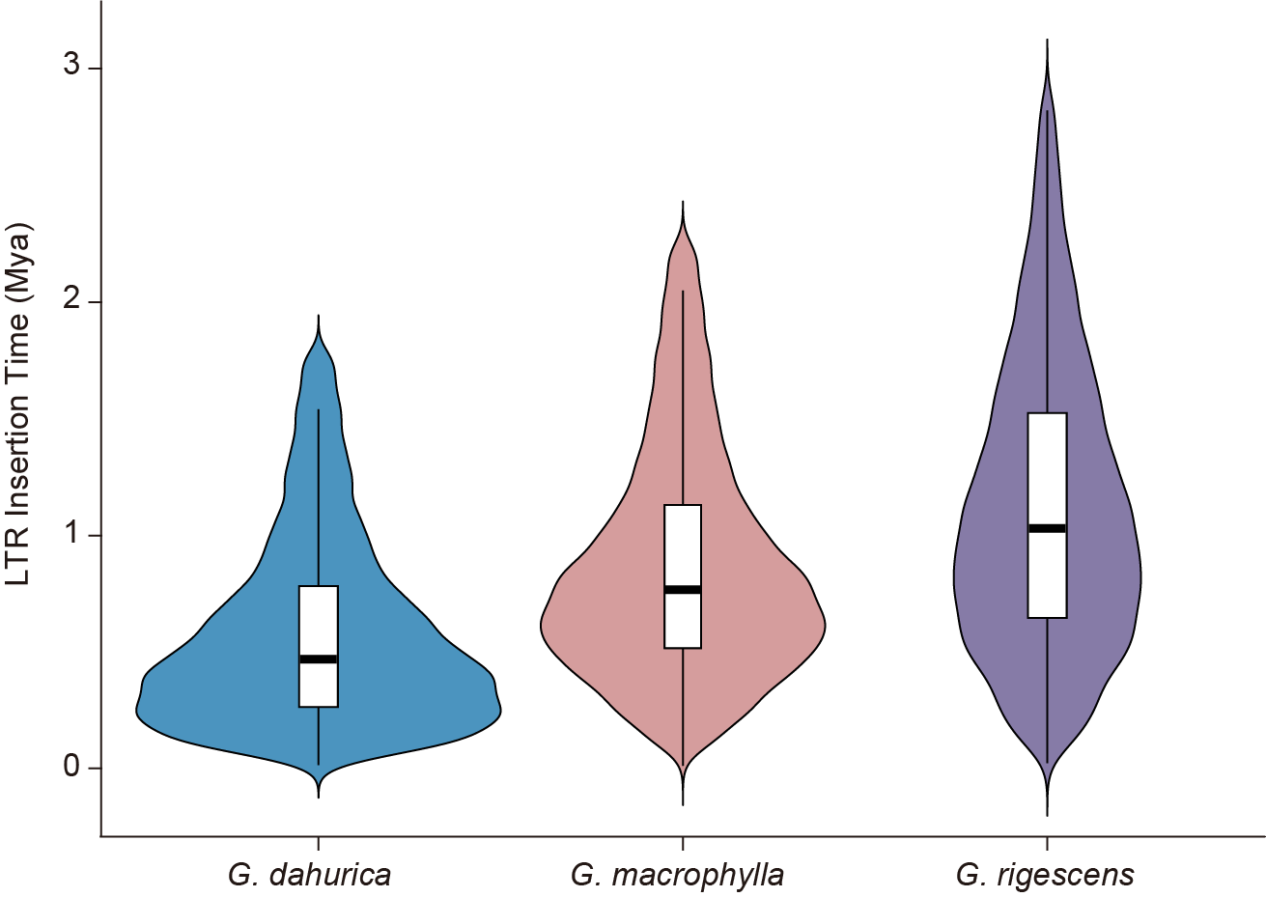
Fig. S2 LTR retrotransposon (LTR-RT) insertion times of 3 Gentiana species.

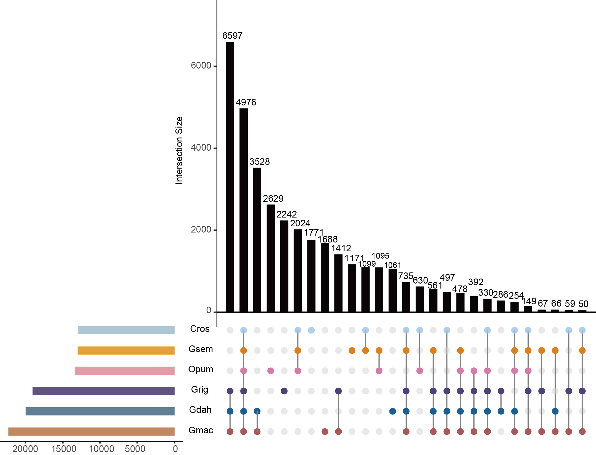
Fig. S3 Upset plot showing orthogroups from six Gentianales species. Cros: C. roseus, Gsem: G. sempervirens, Opum: O. pumila, Grig: G. rigescens, Gdah: G. dahurica, Gmac: G. macrophylla. Only intersections containing ≥50 orthogroups are shown; smaller intersections have been omitted for clarity.

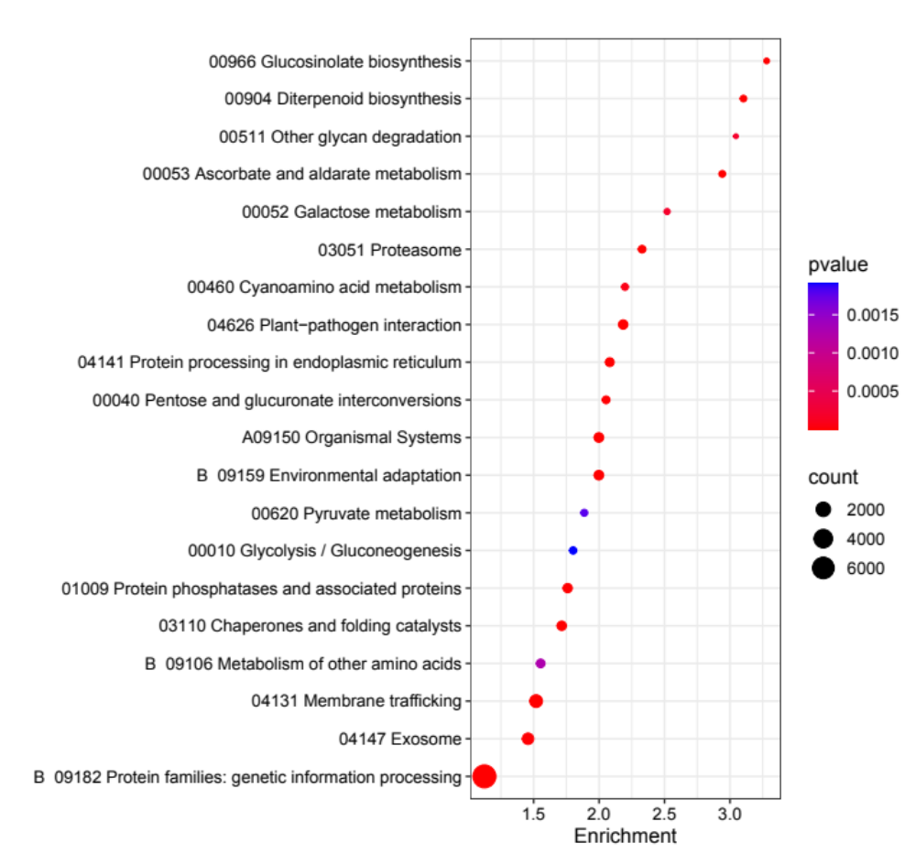
Fig. S4 KEGG enrichment analysis of species-specific orthogroups in G. rigescens (Top 20).

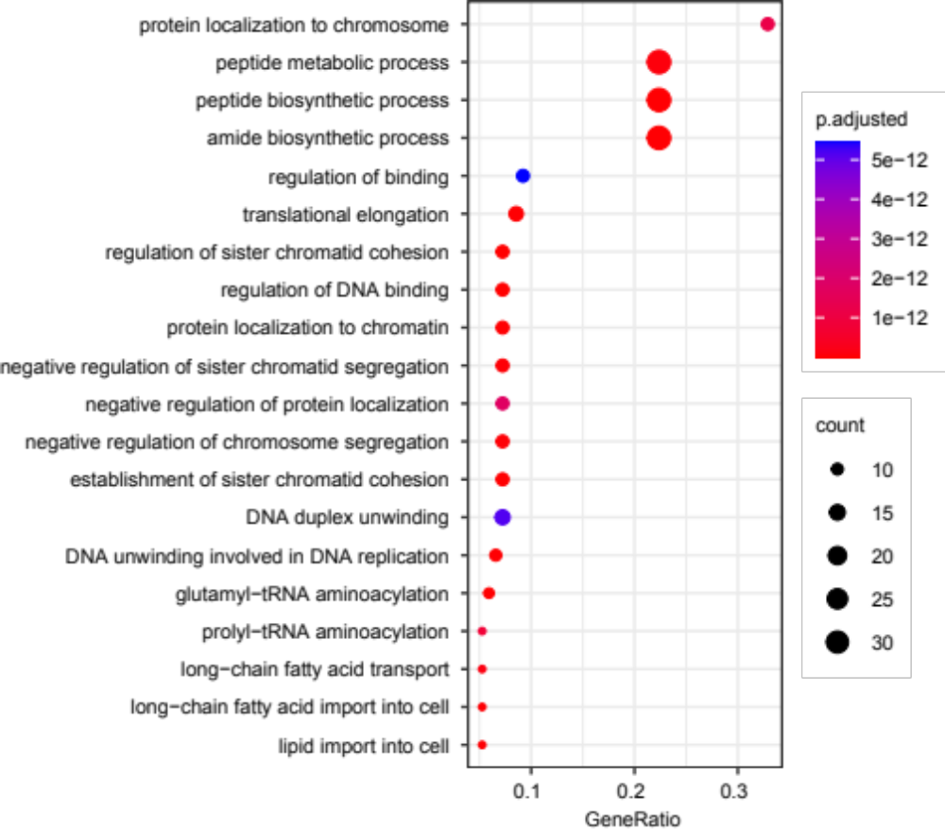
Fig. S5 GO enrichment analysis of expanded gene families in G. rigescens.

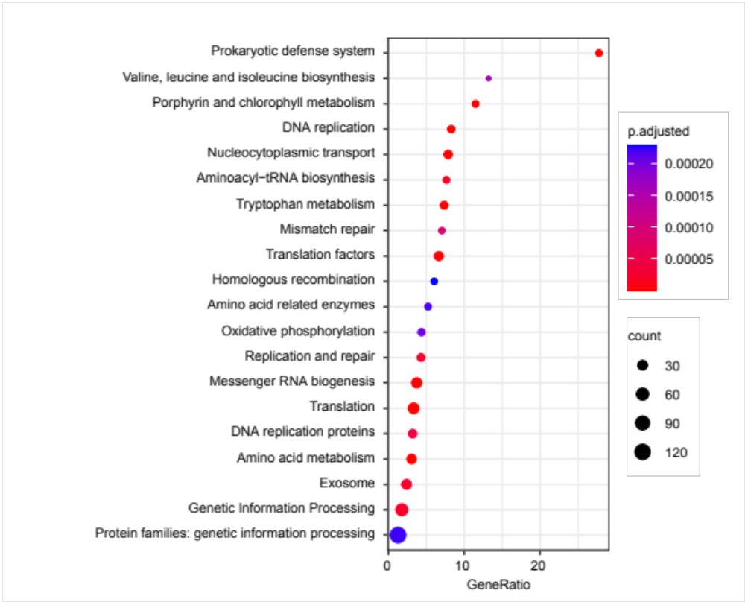
Fig. S6 KEGG enrichment analysis of expanded gene families in G. rigescens (Top 20).

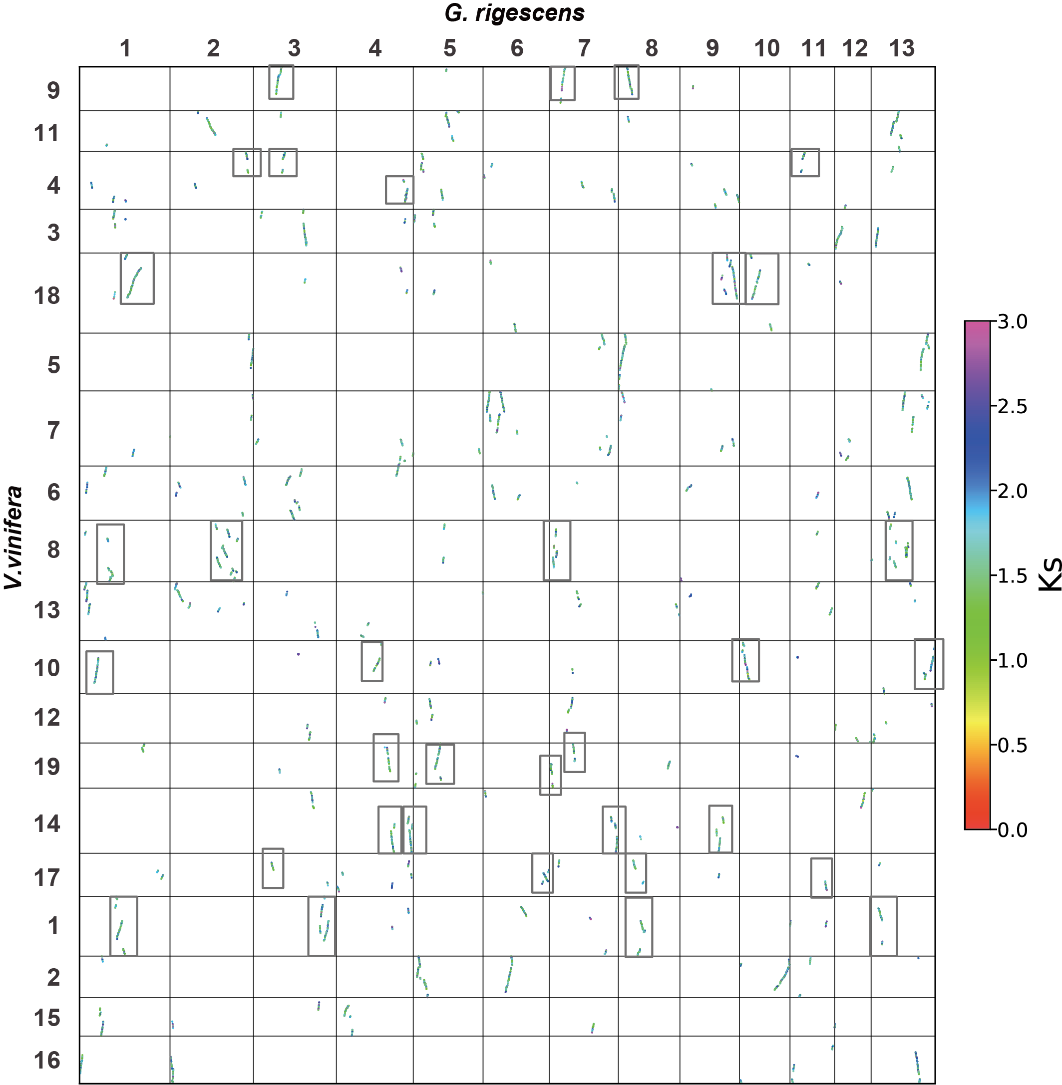
Fig. S7 Dotplot comparing the G. rigescens and V. vinifera genomes.

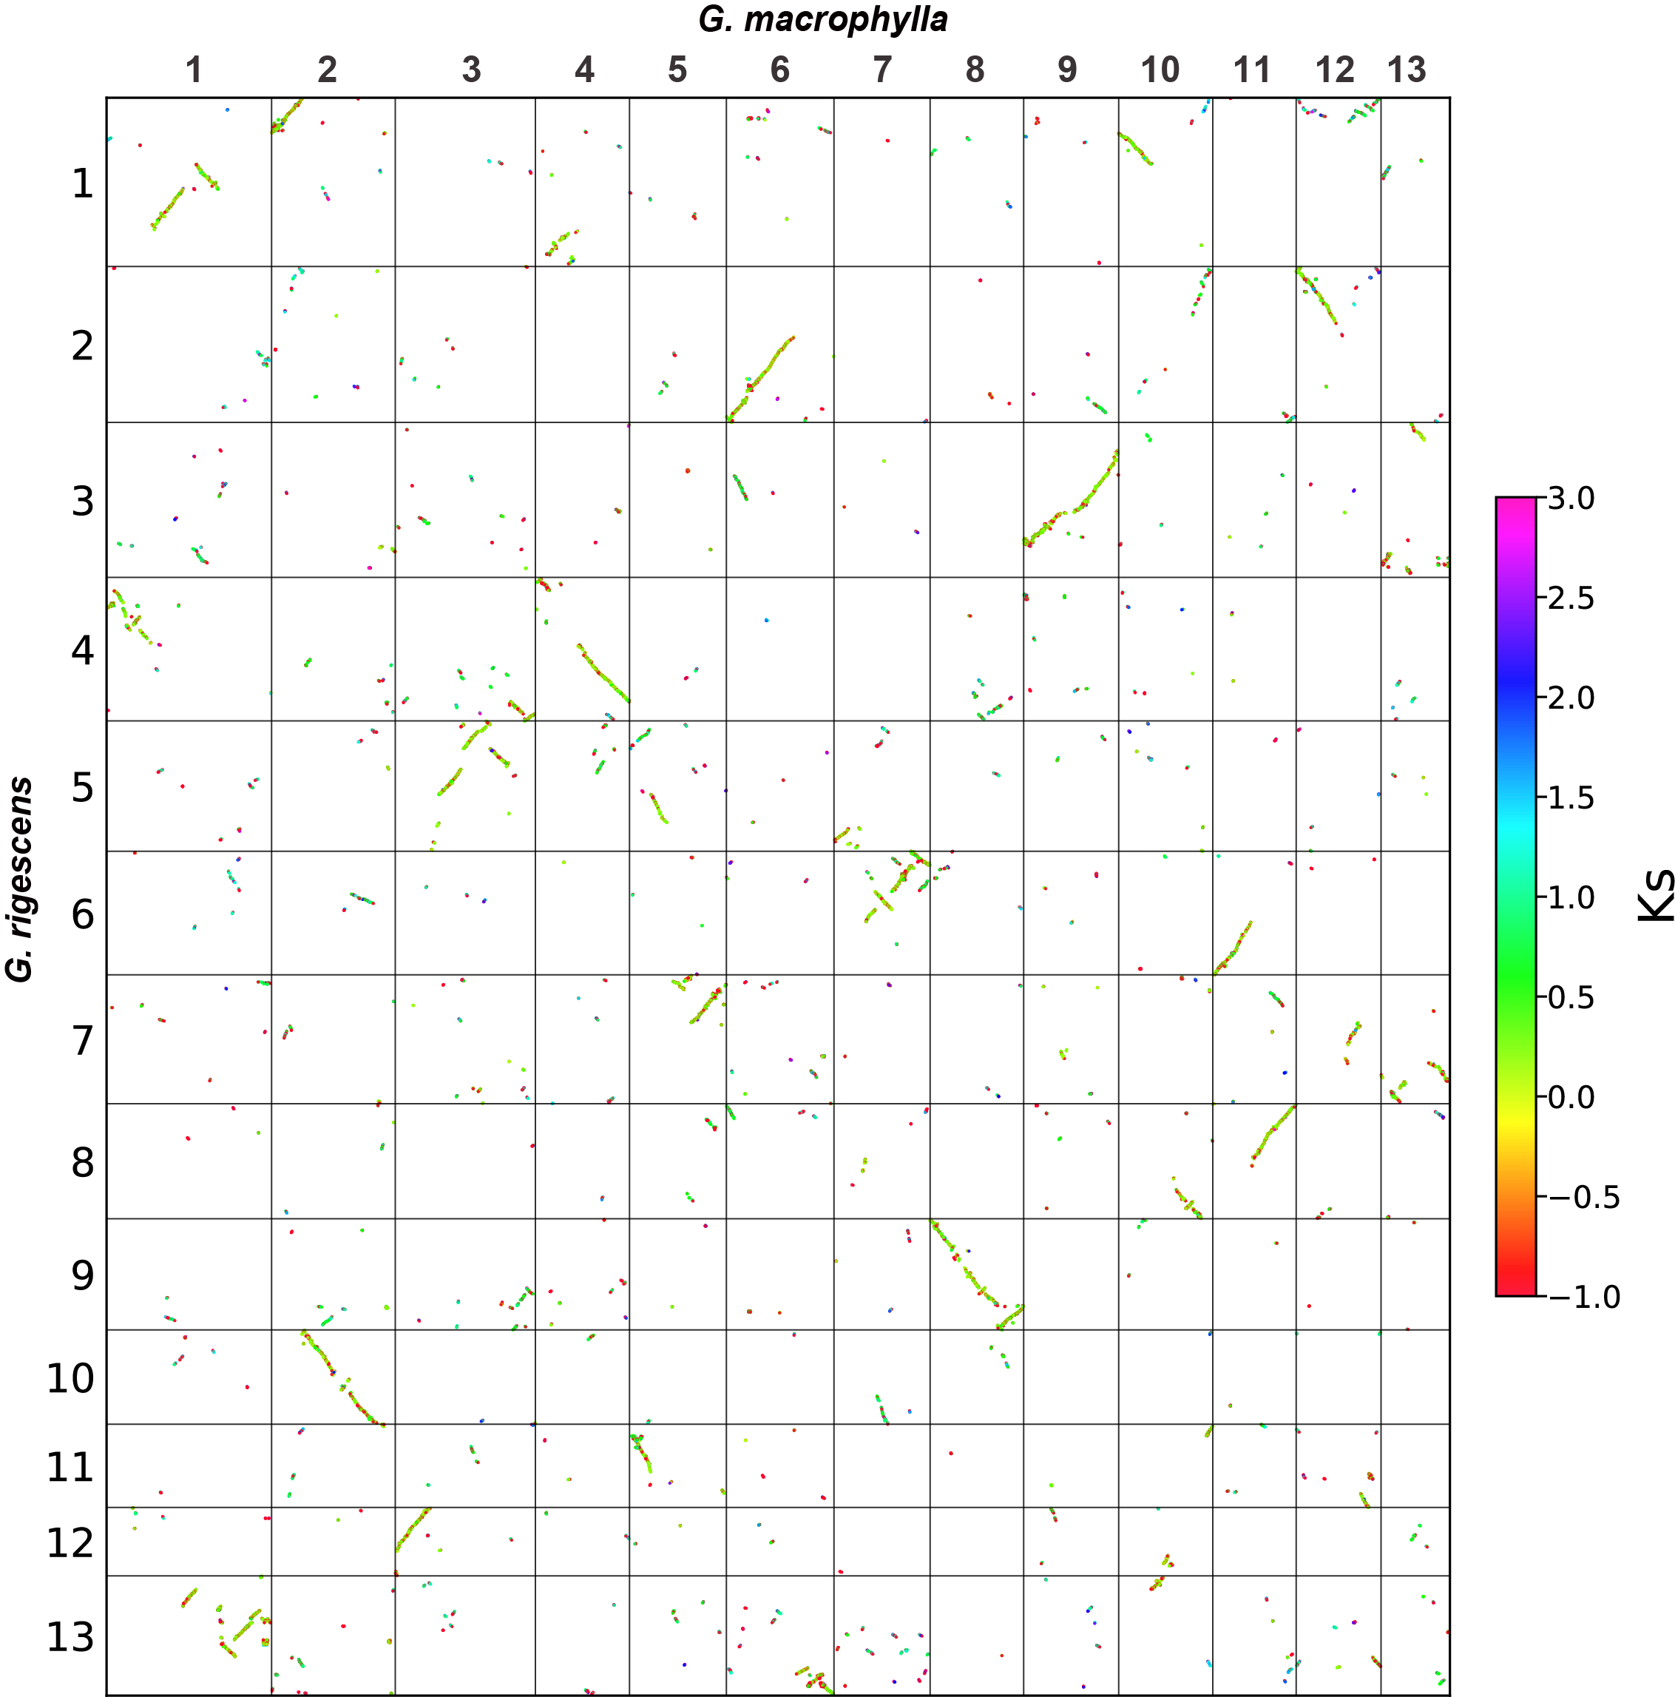
Fig. S8 Dotplot comparing the G. rigescens and G. macrophylla genomes.

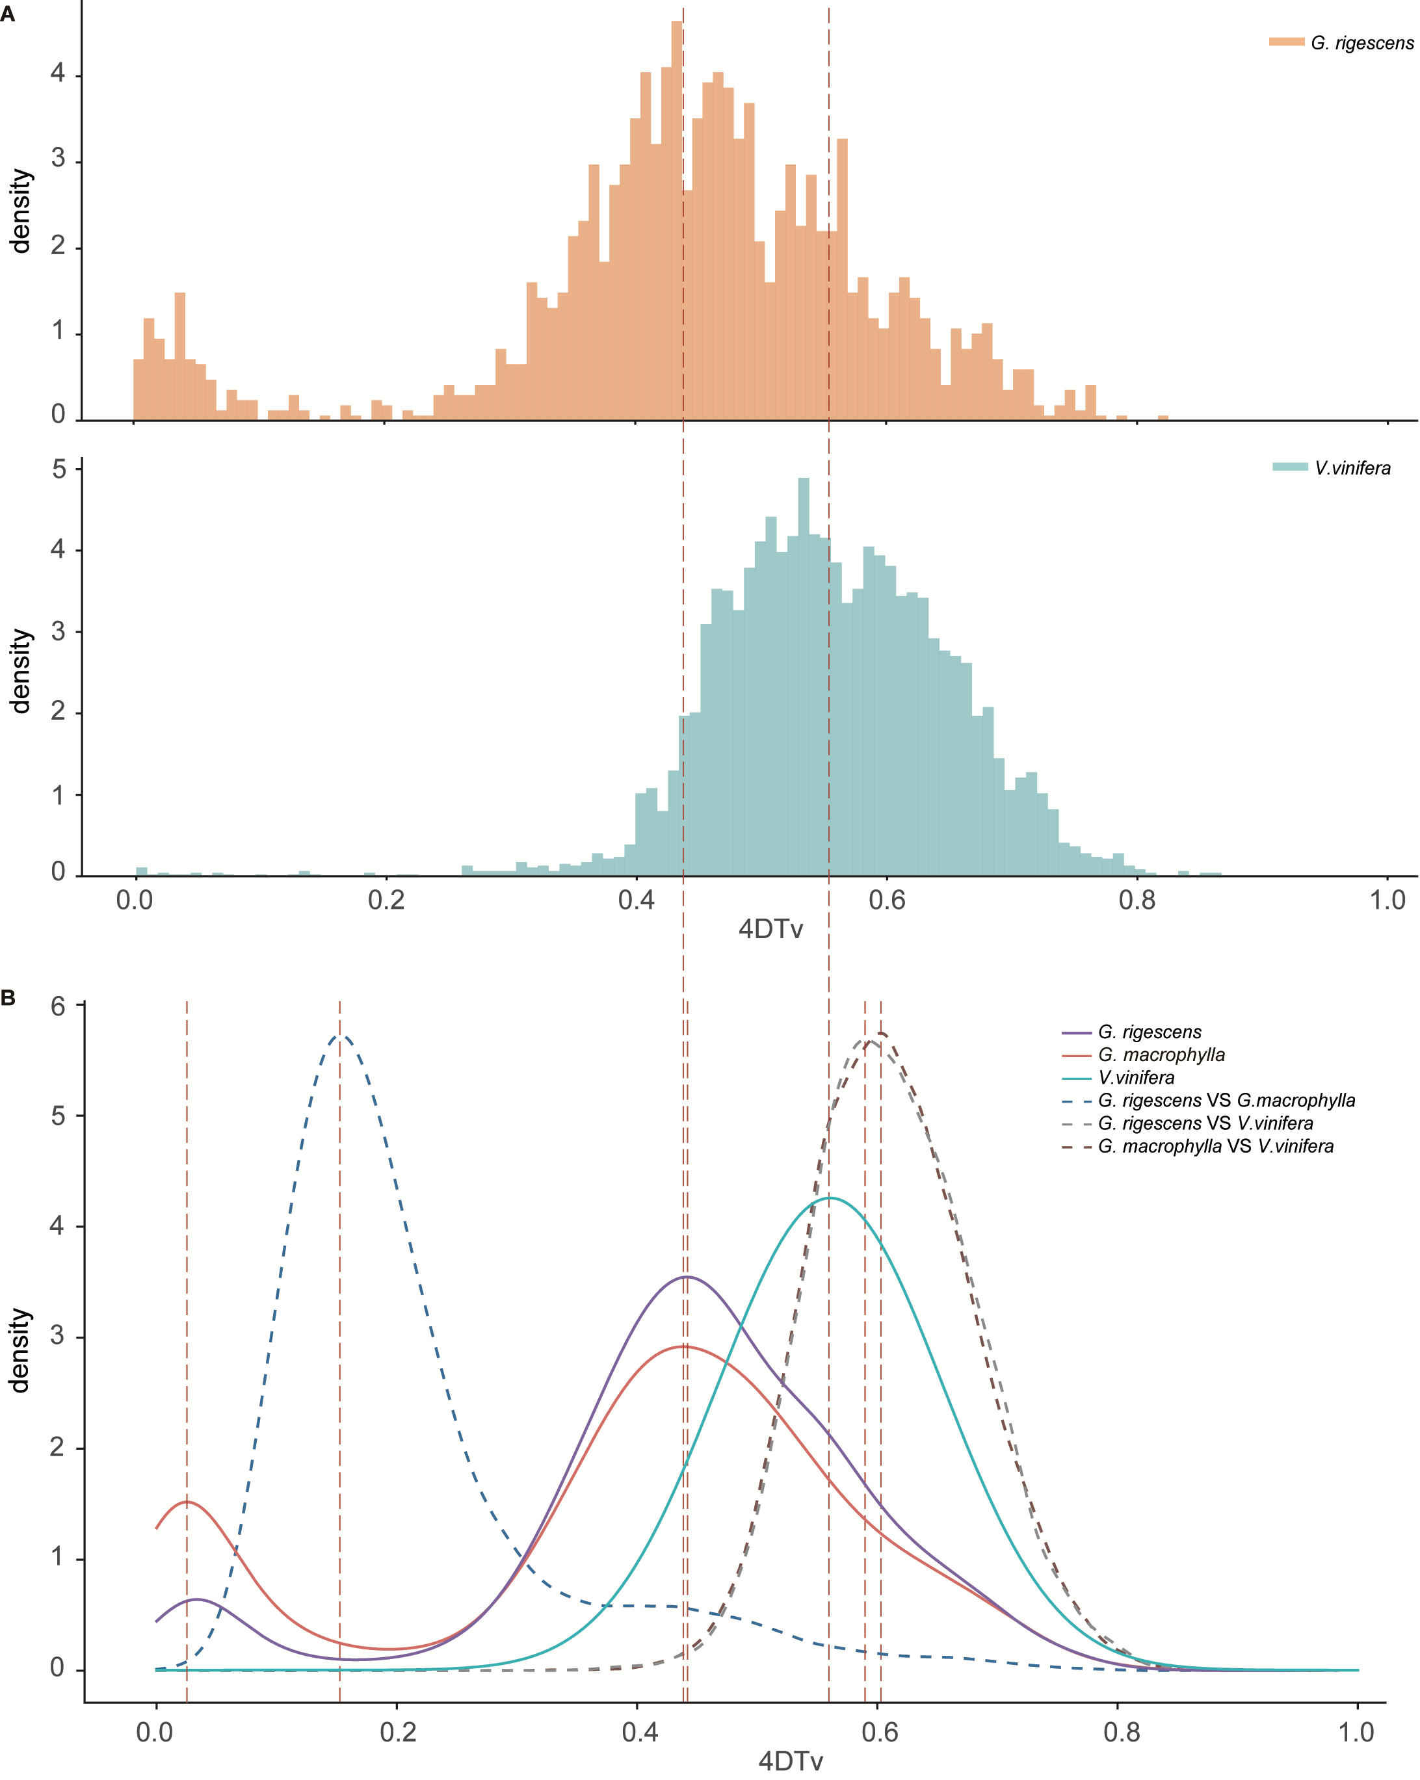
Fig. S9 The distribution of 4DTv value of intraspecific and interspecific collinear blocks. A: The histogram of 4DTv value distribution of G. rigescens and V. vinifera interspecific. B: distribution of 4DTv value of intraspecific and interspecific collinear blocks.

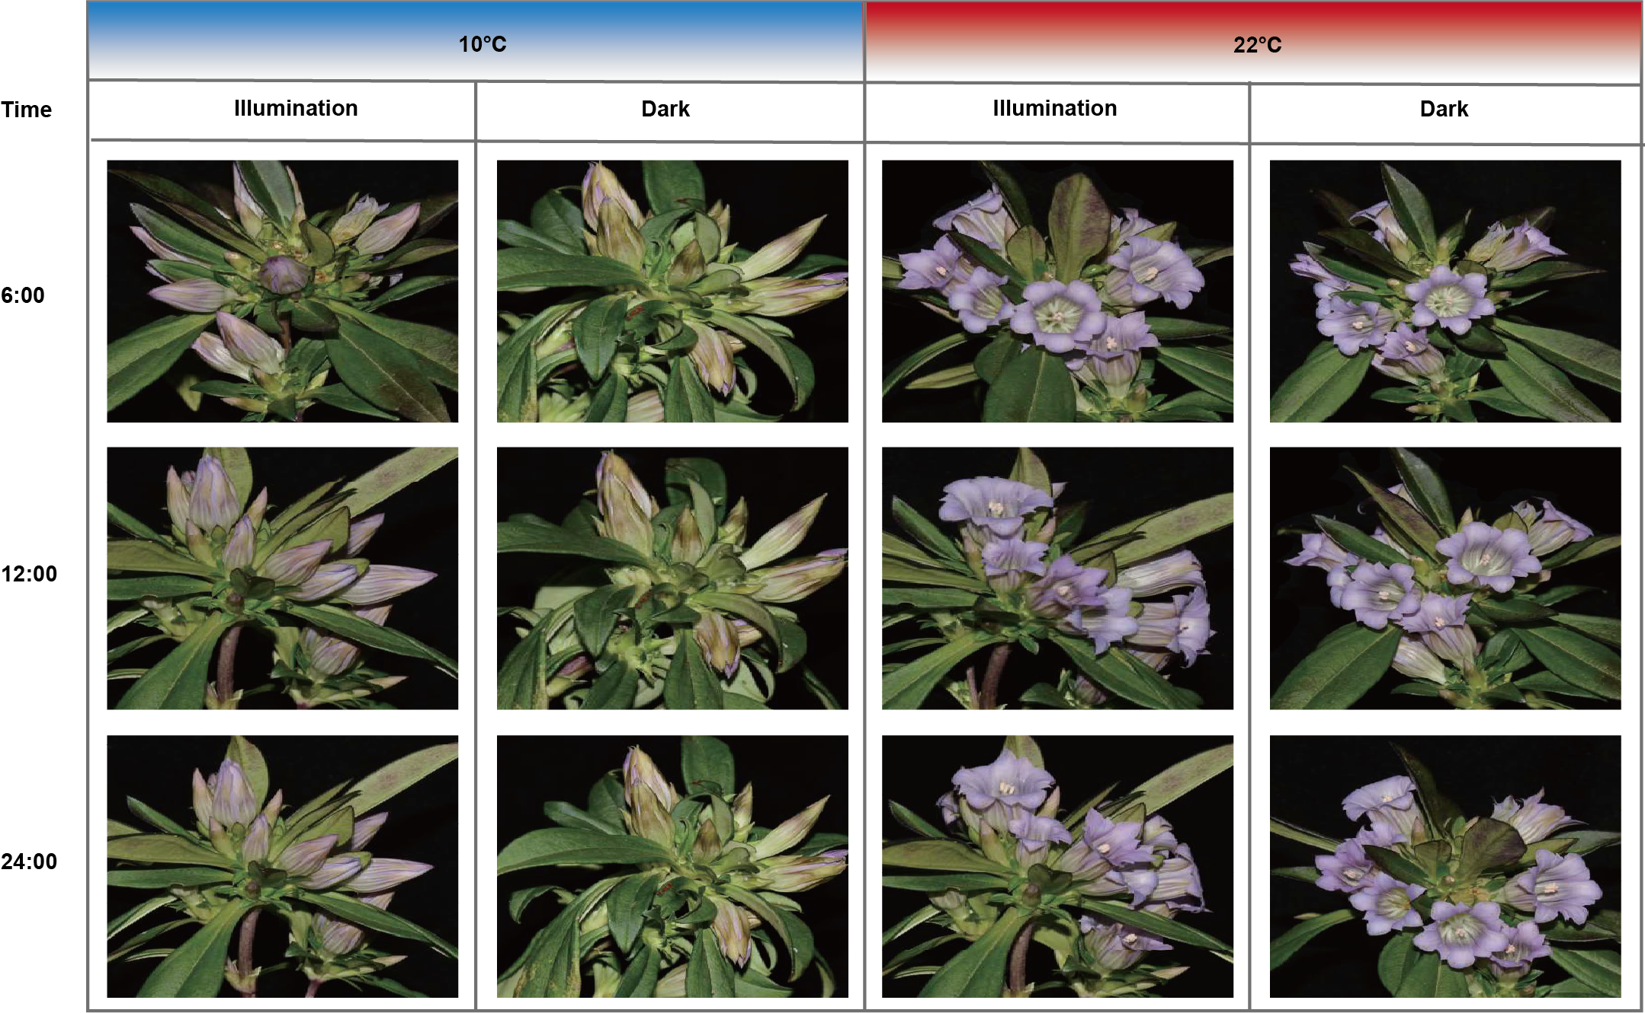
Fig. S10 Flower opening and closing observation under different temperature, time and light regimes. Illumination: 10000Lx and darkness, temperature: 10 ℃ and 22 ℃, the flowers were cultured for three days and photographed at 6:00, 12:00 and 24:00 every day.

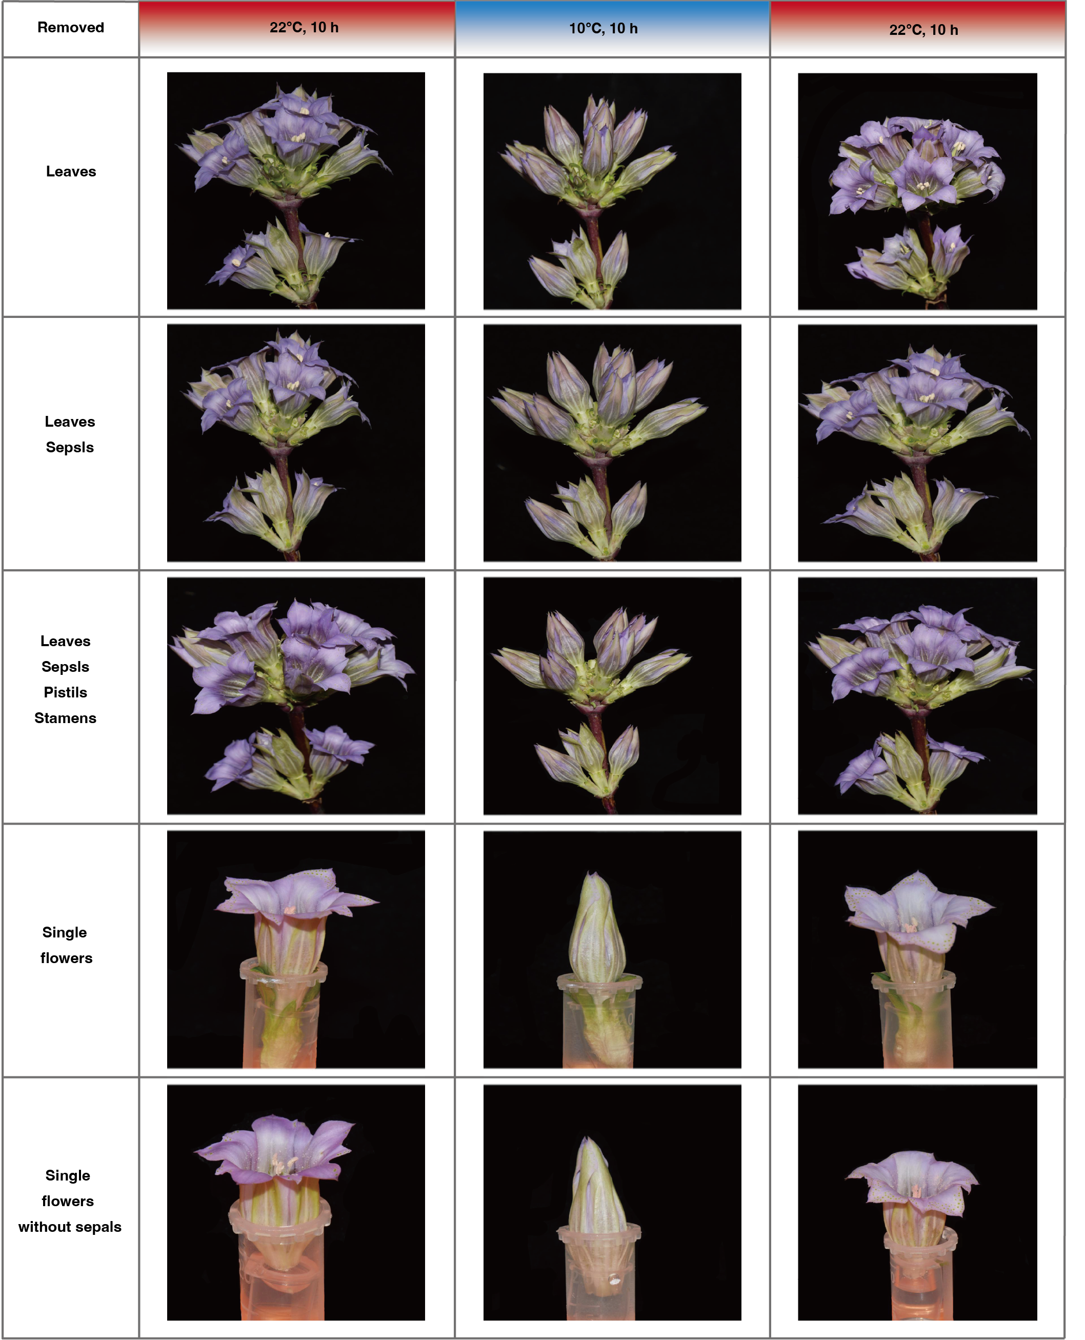
Fig. S11 Flower organ removed to determines the sensing part. The different part of flower was removed and cultured at 22 ℃, 10 ℃ and 22 ℃ for 10h, and then the subsequent opening and closing of the excised flowers recorded. Each treatment contained 30 plants.
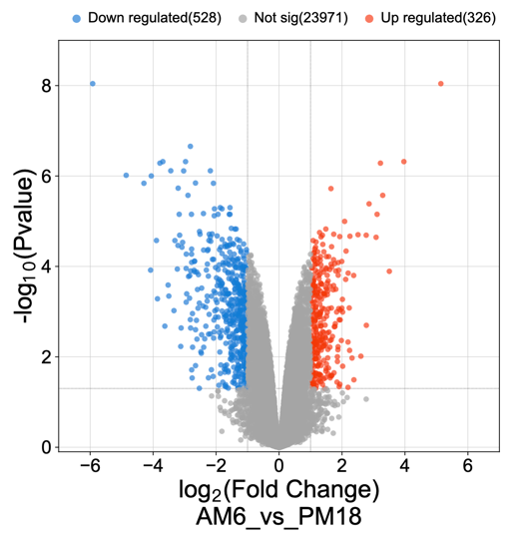
Fig. S12 Volcano plots of AM6 and PM6.
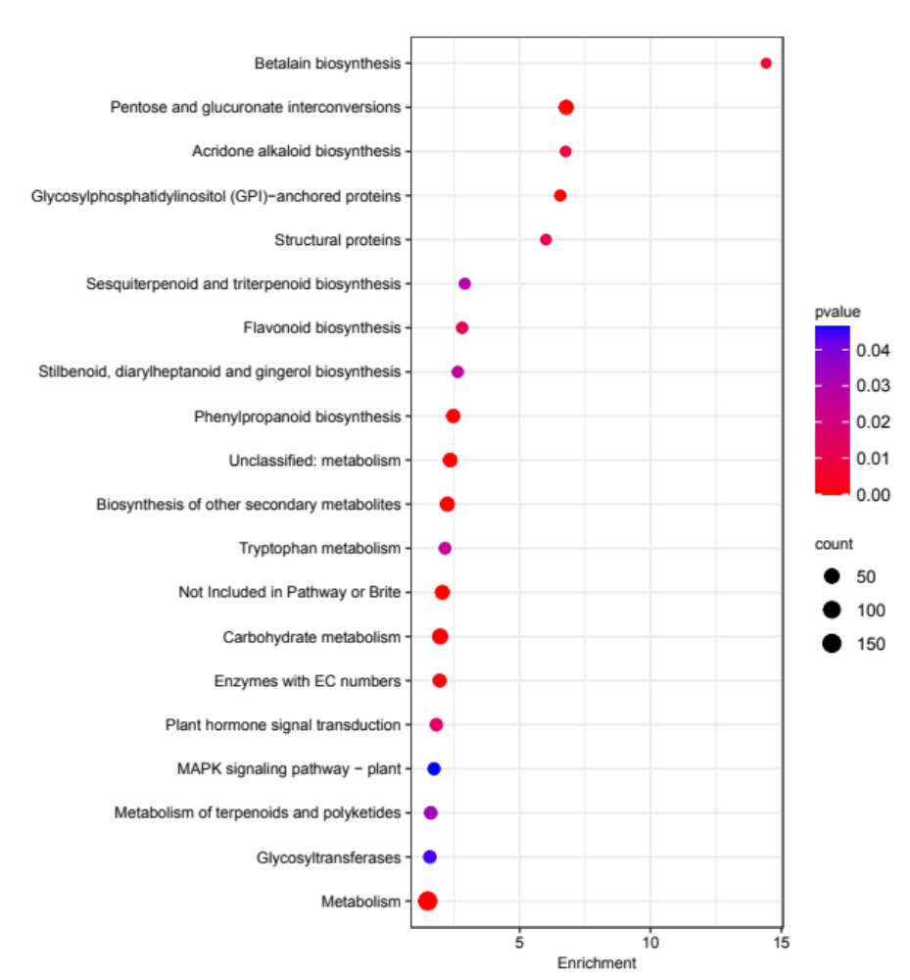
Fig. S13 KEGG enrichment analysis of DEGs (Top 20).

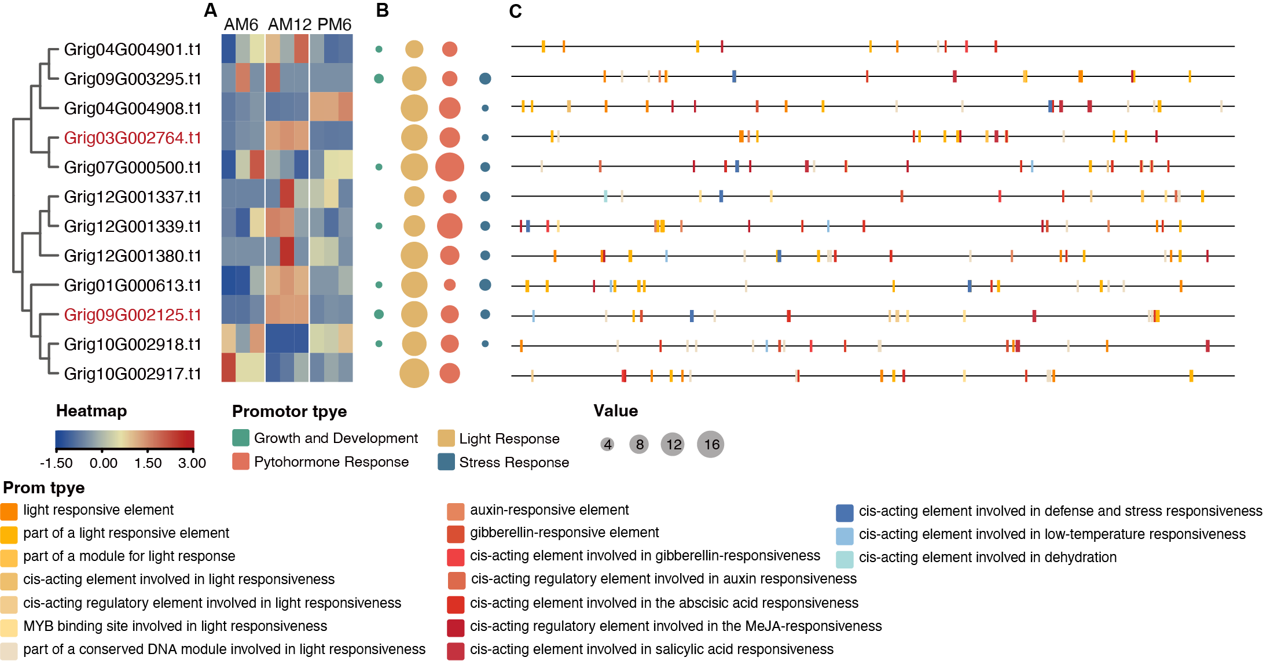
Fig. S14 ANN gene family analysis. A: The heatmap of ANN gene family in G. rigescens genome. B: The number of cis-acting elements in ANN gene promoter regions. C: The distribution of cis-acting elements in ANN gene promoter regions.

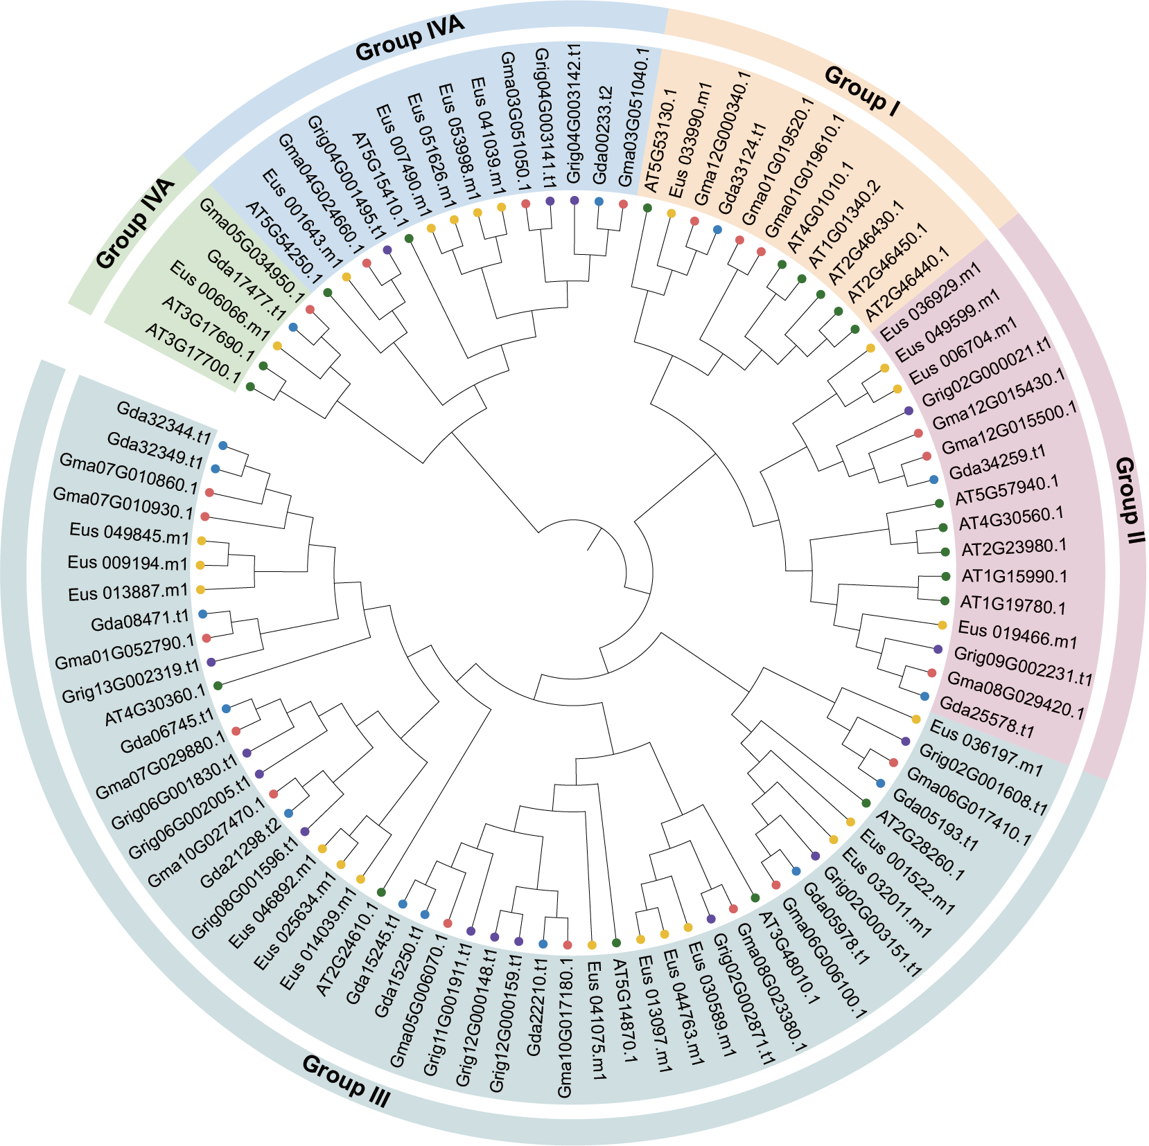
Fig. S15 CNGC gene family phylogenetic tree of 5 species.

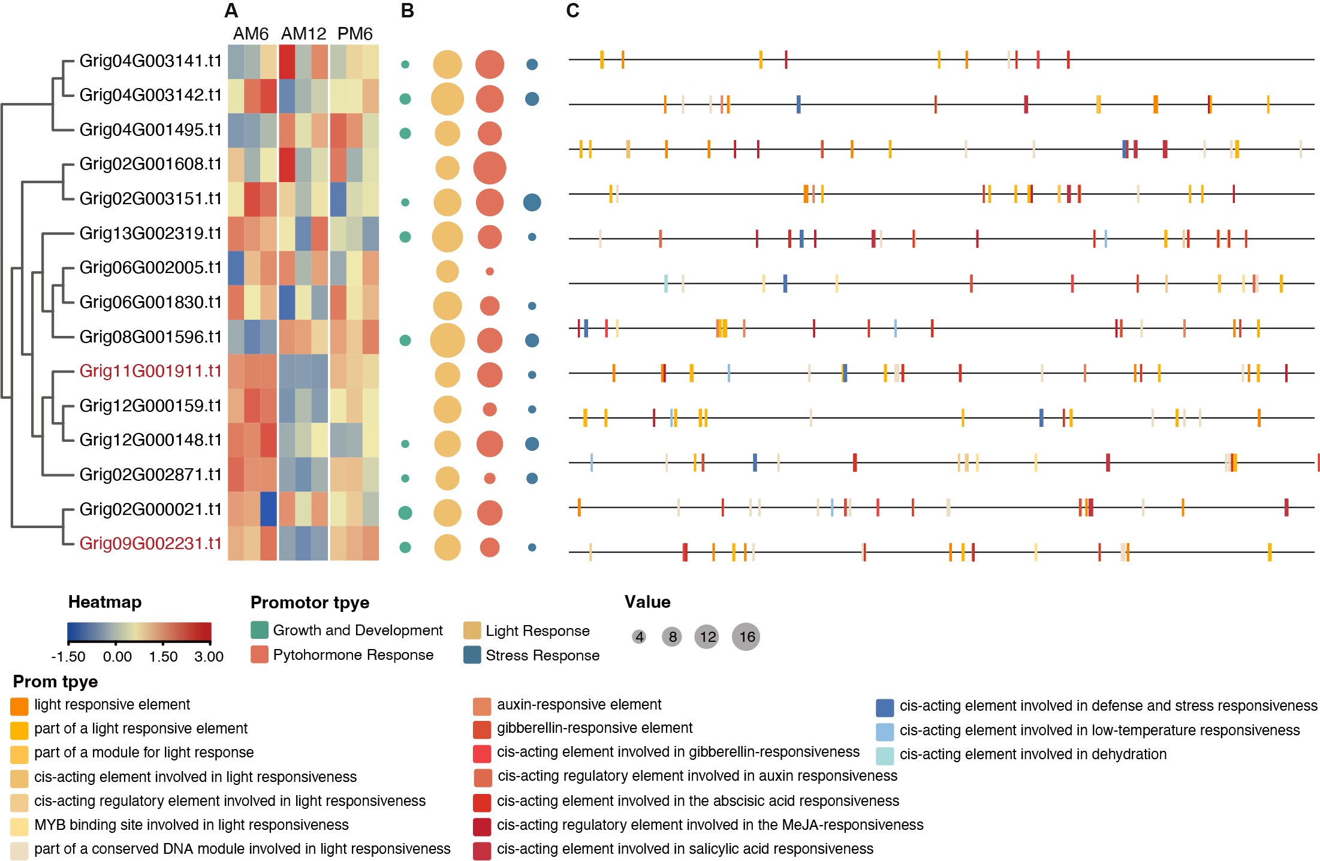
Fig. S16 CNGC gene family analysis. A: The heatmap of CNGC gene family in G. rigescens genome. B: The number of cis-acting elements in CNGC gene promoter regions. C: The distribution of cis-acting elements in CNGC gene promoter regions.

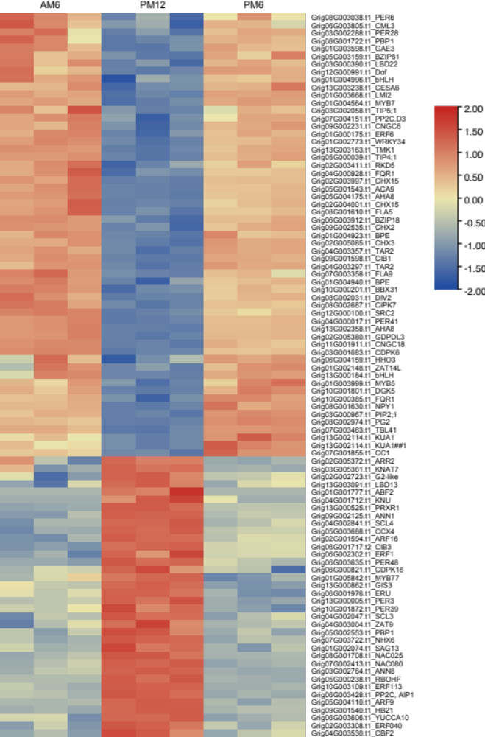
Fig. S17 The heatmap of putative regulation network related genes in G. rigescens petal movement.

